 | crop estimates committee | 
 | oesskattingskomitee
From/Van: Mr Baldwin Netshifhefhe
Tel: 012 319 8043  Fax/Faks: 012 319 8031  E-mail/E-pos: BaldwinN@daff.gov.za
Web page/Webblad: www.daff.gov.za/statistics and economic reports or www.sagis.org.za/CEC: Crop Estimates
EMBARGO: 14:30

The area planted estimate and seventh production forecast for summer crops for 2019 is hereby released.
Hiermee word die oppervlakte- en sewende produksieskatting vir somergewasse vir 2019 vrygestel.

SUMMER CROPS – AREA PLANTED AND SEVENTH PRODUCTION FORECAST: 2019
SOMERGEWASSE – OPPERVLAKTE- EN SEWENDE PRODUKSIESKATTING: 2019
CROP/GEWAS | Area planted/  Opp beplant  2019 |  | 7th forecast/  7de skatting  2019 | 6th forecast/  6de skatting  2019 |  | Area planted/  Opp beplant  2018 |  |  | Final crop/  Finale oes  2018 |  |  | Change/  Verandering/
CROP/GEWAS | Ha |  | Tons | Tons |  | Ha |  |  | Tons |  |  | %
CROP/GEWAS | (A) |  | (B) | (C) |  | (D) |  |  | (E) |  |  | (B) ÷ (C)
Commercial/Kommersieël:
White maize/Witmielies | 1 298 400 |  | 5 572 240 | 5 572 240 |  | 1 268 100 |  |  | 6 540 000 |  |  | -
Yellow maize/Geelmielies | 1 002 100 |  | 5 444 420 | 5 406 620 |  | 1 050 750 |  |  | 5 970 000 |  |  | +0,70
Total Maize/Totale Mielies | 2 300 500 |  | 11 016 660 | 10 978 860 |  | 2 318 850 |  |  | 12 510 000 |  |  | +0,34
Sunflower seed/Sonneblomsaad | 515 350 |  | 680 940 | 655 640 |  | 601 500 |  |  | 862 000 |  |  | +3,86
Soybeans/Sojabone | 730 500 |  | 1 170 345 | 1 170 345 |  | 787 200 |  |  | 1 540 000 |  |  | -
Groundnuts/Grondbone | 20 050 |  | 18 880 | 18 880 |  | 56 300 |  |  | 57 000 |  |  | -
Sorghum | 50 500 |  | 147 300 | 153 950 |  | 28 800 |  |  | 115 000 |  |  | -4,32
Dry beans/Droëbone | 59 300 |  | 66 355 | 66 355 |  | 53 360 |  |  | 69 360 |  |  | -
Non-Commercial Maize/Nie-Kommersiële Mielies
Total Maize/Totaal Mielies | 296 000 |  | 549 180 | 549 180 |  | 314 835 |  | 593 975 |  |  | -
Maize/Mielies: Commercial/Kommersieël + Non-Commercial/Nie-Kommersieël
Total Maize RSA/Totaal Mielies RSA |  | 2 596 500 | 11 565 840 |  | 11 528 040 |  | 2 633 685 |  |  | 13 103 975 |  |  | +0,33
Note: Estimate is for calendar year, e.g. production season 2018/19 = 2019
Nota: Skatting is vir kalenderjaar, bv. produksie-seisoen 2018/19 = 2019

27 August/Augustus 2019

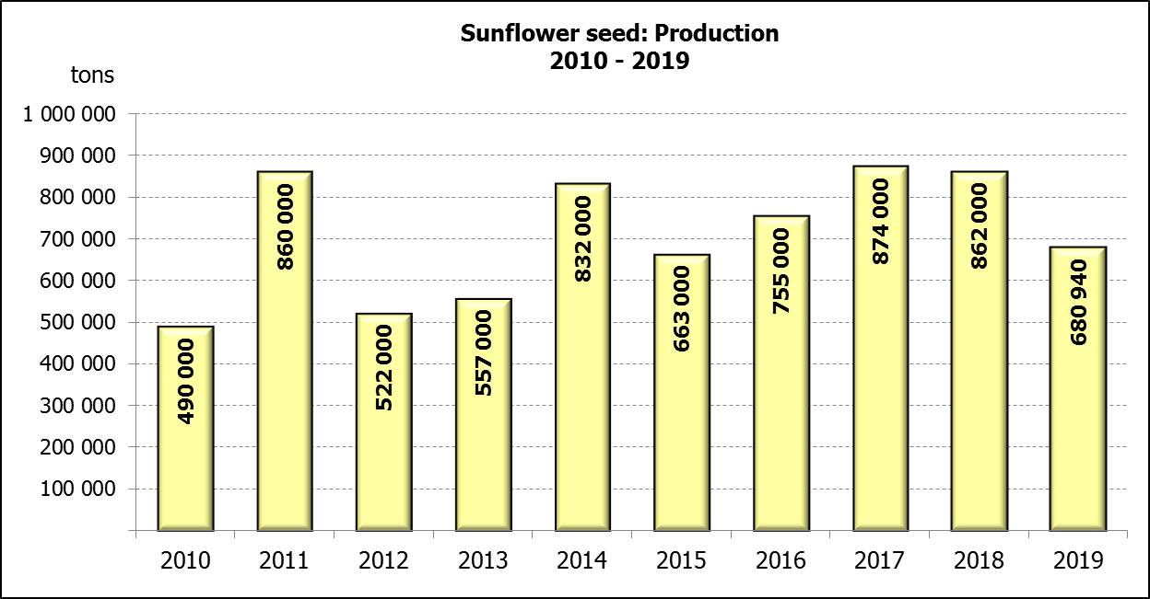

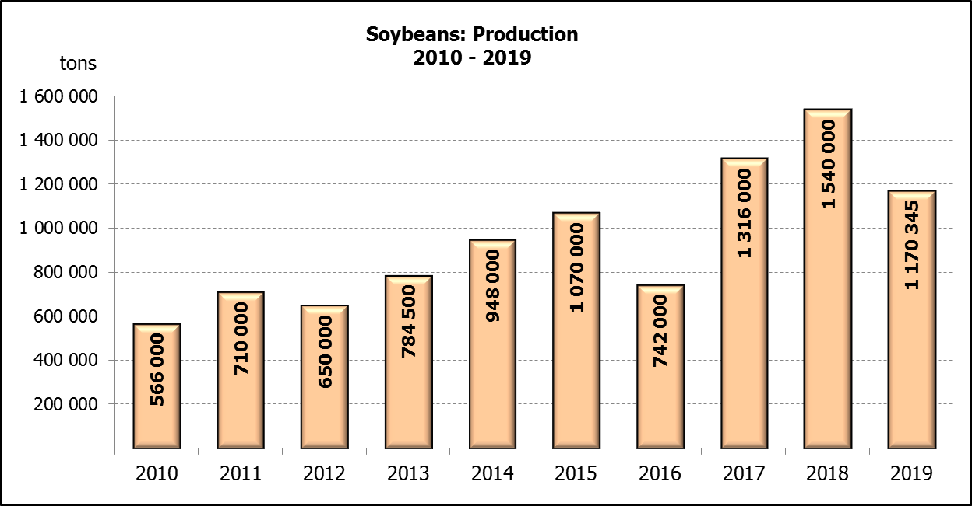
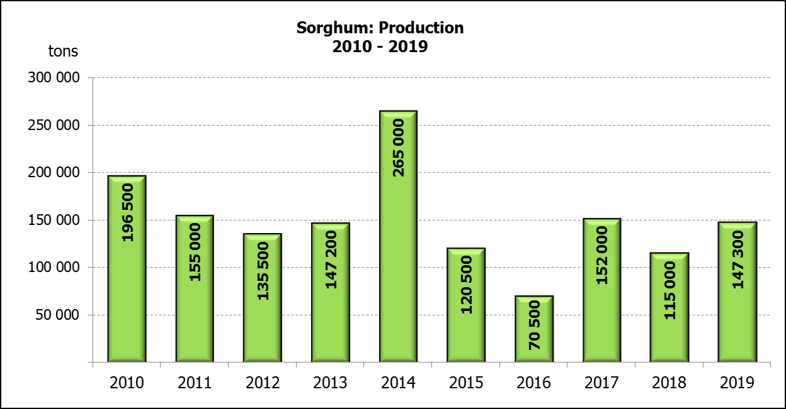

WHITE AND YELLOW MAIZE – AREA PLANTED AND SEVENTH PRODUCTION FORECAST: 2019
WIT- EN GEELMIELIES – OPPERVLAKTE EN SEWENDE PRODUKSIESKATTING: 2019

Provinsie/  Province | Area planted/  Oppervlakte beplant  2019 |  |  | 7th forecast/  7de skatting  2019 |  |  | Area planted/  Oppervlakte beplant  2018 |  |  | Final crop/  Finale oes  2018
Provinsie/  Province | White/  Wit  Ha | Yellow/  Geel  Ha | Total/  Totaal  Ha | White/  Wit  Tons | Yellow/  Geel  Tons | Total/  Totaal  Tons | White/  Wit  Ha | Yellow/  Geel  Ha | Total/  Totaal  Ha | White/  Wit  Tons | Yellow/  Geel  Tons | Total/  Totaal  Tons
Western Cape/Wes-Kaap | 400 | 3 400 | 3 800 | 3 600 | 30 600 | 34 200 | 0 | 3 750 | 3 750 | 0 | 33 750 | 33 750
Northern Cape/Noord-Kaap | 3 400 | 43 500 | 46 900 | 39 440 | 626 400 | 665 840 | 3 600 | 43 000 | 46 600 | 41 300 | 628 000 | 669 300
Free State/Vrystaat | 650 000 | 380 000 | 1 030 000 | 2 795 000 | 1 596 000 | 4 391 000 | 644 000 | 410 000 | 1 054 000 | 3 350 000 | 1 925 000 | 5 275 000
Eastern Cape/Oos-Kaap | 3 800 | 10 200 | 14 000 | 22 800 | 67 320 | 90 120 | 3 500 | 11 000 | 14 500 | 21 700 | 71 500 | 93 200
KwaZulu-Natal | 45 000 | 54 000 | 99 000 | 270 000 | 388 800 | 658 800 | 45 000 | 50 000 | 95 000 | 280 000 | 380 000 | 660 000
Mpumalanga | 145 000 | 338 000 | 483 000 | 812 000 | 1 892 800 | 2 704 800 | 140 000 | 340 000 | 480 000 | 812 000 | 2 005 000 | 2 817 000
Limpopo | 12 800 | 18 000 | 30 800 | 83 200 | 117 000 | 200 200 | 12 000 | 21 000 | 33 000 | 90 000 | 141 700 | 231 700
Gauteng | 48 000 | 60 000 | 108 000 | 259 200 | 336 000 | 595 200 | 50 000 | 62 000 | 112 000 | 275 000 | 356 500 | 631 500
North West/Noordwes | 390 000 | 95 000 | 485 000 | 1 287 000 | 389 500 | 1 676 500 | 370 000 | 110 000 | 480 000 | 1 670 000 | 428 550 | 2 098 550
Total/Totaal | 1 298 400 | 1 002 100 | 2 300 500 | 5 572 240 | 5 444 420 | 11 016 660 | 1 268 100 | 1 050 750 | 2 318 850 | 6 540 000 | 5 970 000 | 12 510 000

SUNFLOWER SEED – AREA PLANTED AND SEVENTH PRODUCTION FORECAST: 2019
SONNEBLOMSAAD – OPPERVLAKTE EN SEWENDE PRODUKSIESKATTING: 2019

Province/  Provinsie | Area planted/  Opp beplant  Ha | 7th forecast/  7de skatting  Tons | Area planted/  Opp beplant  Ha | Final crop/  Finale oes  Tons
Province/  Provinsie | 2019 | 2019 | 2018 | 2018
Western Cape/Wes-Kaap | - | - | 100 | 100
Northern Cape/Noord-Kaap | 950 | 1 140 | 1 600 | 1 920
Free State/Vrystaat | 270 000 | 391 500 | 314 000 | 490 000
Eastern Cape/Oos-Kaap | 100 | 250 | - | -
KwaZulu-Natal | - | - | - | -
Mpumalanga | 4 500 | 4 500 | 2 300 | 2 180
Limpopo | 61 000 | 61 000 | 45 000 | 36 000
Gauteng | 3 800 | 3 800 | 5 500 | 5 600
North West/Noordwes | 175 000 | 218 750 | 233 000 | 326 200
Total/Totaal | 515 350 | 680 940 | 601 500 | 862 000
SOYBEANS – AREA PLANTED AND SEVENTH PRODUCTION FORECAST: 2019
SOJABONE – OPPERVLAKTE EN SEWENDE PRODUKSIESKATTING: 2019

Province/  Provinsie | Area planted/  Opp beplant  Ha | 7th forecast/  7de skatting  Tons | Area planted/  Opp beplant  Ha | Final crop/  Finale oes  Tons
Province/  Provinsie | 2019 | 2019 | 2018 | 2018
Western Cape/Wes-Kaap | 100 | 10 | 800 | 1 200
Northern Cape/Noord-Kaap | 1 550 | 5 425 | 3 000 | 10 500
Free State/Vrystaat | 301 000 | 391 300 | 345 000 | 552 000
Eastern Cape/Oos-Kaap | 1 150 | 1 380 | 2 400 | 2 900
KwaZulu-Natal | 33 000 | 99 000 | 40 000 | 124 000
Mpumalanga | 310 000 | 511 500 | 310 000 | 672 700
Limpopo | 16 200 | 46 980 | 20 000 | 54 000
Gauteng | 31 500 | 66 150 | 30 000 | 61 500
North West/Noordwes | 36 000 | 48 600 | 36 000 | 61 200
Total/Totaal | 730 500 | 1 170 345 | 787 200 | 1 540 000

GROUNDNUTS – AREA PLANTED AND SEVENTH PRODUCTION FORECAST: 2019
GRONDBONE – OPPERVLAKTE EN SEWENDE PRODUKSIESKATTING: 2019

Province/  Provinsie | Area planted/  Opp beplant  Ha | 7th forecast/  7de skatting  Tons | Area planted/  Opp beplant  Ha | Final crop/  Finale oes  Tons
Province/  Provinsie | 2019 | 2019 | 2018 | 2018
Western Cape/Wes-Kaap | - | - | - | -
Northern Cape/Noord-Kaap | 1 200 | 2 520 | 2 800 | 7 000
Free State/Vrystaat | 11 500 | 8 625 | 22 000 | 21 150
Eastern Cape/Oos-Kaap | - | - | - | -
KwaZulu-Natal | - | - | - | -
Mpumalanga | - | - | - | -
Limpopo | 1 850 | 3 885 | 3 500 | 7 350
Gauteng | - | - | - | -
North West/Noordwes | 5 500 | 3 850 | 28 000 | 21 500
Total/Totaal | 20 050 | 18 880 | 56 300 | 57 000

SORGHUM – AREA PLANTED AND SEVENTH PRODUCTION FORECAST: 2019
SORGHUM – OPPERVLAKTE EN SEWENDE PRODUKSIESKATTING: 2019

Province/  Provinsie | Area planted/  Opp beplant  Ha | 7th forecast/  7de skatting  Tons | Area planted/  Opp beplant  Ha | Final crop/  Finale oes  Tons
Province/  Provinsie | 2019 | 2019 | 2018 | 2018
Western Cape/Wes-Kaap | - | - | - | -
Northern Cape/Noord-Kaap | - | - | - | -
Free State/Vrystaat | 8 000 | 27 200 | 6 300 | 25 200
Eastern Cape/Oos-Kaap | - | - | - | -
KwaZulu-Natal | 500 | 1 500 | 500 | 2 200
Mpumalanga | 7 500 | 37 500 | 7 500 | 40 500
Limpopo | 25 000 | 57 500 | 5 000 | 15 500
Gauteng | 1 000 | 3 200 | 1 500 | 4 950
North West/Noordwes | 8 500 | 20 400 | 8 000 | 26 650
Total/Totaal | 50 500 | 147 300 | 28 800 | 115 000

DRY BEANS – AREA PLANTED AND SEVENTH PRODUCTION FORECAST: 2019
DROëBONE – OPPERVLAKTE EN SEWENDE PRODUKSIESKATTING: 2019

Province/  Provinsie | Area planted/  Opp beplant  Ha | 7th forecast/  7de skatting  Tons | Area planted/  Opp beplant  Ha | Final crop/  Finale oes  Tons
Province/  Provinsie | 2019 | 2019 | 2018 | 2018
Western Cape/Wes-Kaap | 100 | 180 | 20 | 30
Northern Cape/Noord-Kaap | 1 000 | 1 400 | 540 | 1 080
Free State/Vrystaat | 27 000 | 28 350 | 26 000 | 28 600
Eastern Cape/Oos-Kaap | 400 | 720 | 300 | 450
KwaZulu-Natal | 3 500 | 4 025 | 3 000 | 3 600
Mpumalanga | 7 500 | 6 750 | 7 000 | 9 800
Limpopo | 7 800 | 12 480 | 7 500 | 15 000
Gauteng | 1 500 | 1 950 | 1 000 | 1 200
North West/Noordwes | 10 500 | 10 500 | 8 000 | 9 600
Total/Totaal | 59 300 | 66 355 | 53 360 | 69 360

CONFIDENTIALITY ISSUES that CEC members are committed to adhere to on the day of the meeting
- Personal items such as laptops, handbags, cell phones, etc. are not allowed in the venue during the meeting
- No member is allowed to leave the meeting before 12:00 in order to prevent disclosure of the information
- The embargo time for the release of crop estimates information is 14:30
- No member is allowed to discuss crop estimates information with anyone other than a member of the Committee before the embargo time
- Only the Chairperson, or a member appointed by the Chairperson, may release the figures to the media
- Members must regard the detail of any information that was collected for and/or discussed during the meeting, as confidential
- Individual information received for crop estimate purposes is treated strictly confidential, and is not divulged for any other purposes

AREA ESTIMATE AND SEVENTH PRODUCTION FORECAST OF SUMMER CROPS (2019 PRODUCTION SEASON)/
OPPERVLAKTE- EN SEWENDE PRODUKSIESKATTING VIR SOMERGEWASSE (2019 PRODUKSIE-SEISOEN)
27 AUGUST/AUGUSTUS 2019

Summer field crops – 2019  Commercial maize: The size of the expected commercial maize crop has been set at 11,017 mill. tons, which is 0,34% or 37 800 tons more than the previous forecast of 10,979 mill. tons. The area estimate for maize is 2,301 mill. ha, while the expected yield is 4,79 t/ha.  The estimated maize crop is 12% smaller than the 2018 crop. The three main maize producing areas, namely the Free State, Mpumalanga and North West provinces are expected to produce 80% of the 2019 crop.  The area estimate for white maize is 1,298 mill. ha & for yellow maize the area estimate is 1,002 mill. ha.  The production forecast of white maize remained unchanged at 5,572 mill. tons. The yield for white maize is 4,29 t/ha. In the case of yellow maize the production forecast is 5,444 mill. tons, which is 0,70% or 37 800 tons more than the 5,407 mill. tons of the previous forecast. The yield for yellow maize is 5,43 t/ha.  Sunflower seed: The production forecast for sunflower seed increased by 3,86% or 25 300 tons to 680 940 tons. The area estimate for sunflower seed is 515 350 ha, while the expected yield is 1,32 t/ha.  Other crops: The production forecast for soybeans remained unchanged at 1,170 mill. tons. The estimated area planted to soybeans is 730 500 ha and the expected yield is 1,60 t/ha.  The expected groundnut crop also remained unchanged at 18 880 tons, with an expected yield of 0,94 t/ha. The area estimate for groundnuts is 20 050 ha.  The production forecast for sorghum decreased by 4,32% or 6 650 tons, from 153 950 tons to 147 300 tons. The area estimate for sorghum is 50 500 ha and the expected yield is 2,92 t/ha.  In the case of dry beans, the production forecast remained unchanged at 66 355 tons. The area estimate of dry beans is 59 300 ha, with an expected yield of 1,12 t/ha.  Please note that the eighth production forecast for summer field crops for 2019 will be released on 26 September 2019. |  | Somergewasse – 2019  Kommersiële mielies: Die grootte van die verwagte kommersiële mielie-oes is op 11,017 milj. ton gestel, wat 0,34% of 37 800 ton meer is as die vorige skatting van 10,979 milj. ton. Die skatting van die oppervlakte onder mielies is 2,301 milj. ha, terwyl die verwagte opbrengs 4,79 t/ha is.  Die geskatte mielie-oes is 12% kleiner as die 2018-oes. Die drie belangrikste mielieproduserende gebiede, nl. die Vrystaat, Mpumalanga en Noordwes provinsies, gaan na verwagting 80% van die 2019-oes produseer.  Die oppervlak onder witmielies is 1,298 milj. ha en vir geelmielies is die oppervlak 1,002 milj. ha.  Die produksieskatting van witmielies is onveranderd gelaat op 5,572 milj. ton. Die opbrengs van witmielies is 4,29 t/ha. In die geval van geelmielies is die produksieskatting 5,444 milj. ton, wat 0,70% of 37 800 ton meer is as die 5,407 milj. ton van die vorige skatting. Die opbrengs van geelmielies is 5,43 t/ha.  Sonneblomsaad: Die produksieskatting vir sonneblomsaad het toegeneem met 3,86% of 25 300 ton na 680 940 ton. Die oppervlakteskatting vir sonneblomsaad is 515 350 ha, terwyl die verwagte opbrengs 1,32 t/ha is.  Ander gewasse: Die produksieskatting van sojabone is onveranderd gelaat op 1,170 milj. ton. Die geskatte oppervlakte beplant van sojabone is 730 500 ha en die verwagte opbrengs is 1,60 t/ha.  Die verwagte grondbone-oes is ook onveranderd gelaat op 18 880 ton, met ’n verwagte opbrengs van 0,94 t/ha. Die oppervlakteskatting vir grondbone is 20 050 ha.  Die produksieskatting van sorghum het afgeneem met 4,32% of 6 650 ton, van 153 950 ton tot 147 300 ton. Die oppervlakteskatting vir sorghum is 50 500 ha, en die verwagte opbrengs is 2,92 t/ha.  In die geval van droëbone is die produksieskatting onveranderd gelaat op 66 355 ton. Die oppervlakte beplant met droëbone is 59 300 ha, en die verwagte opbrengs is 1,12 t/ha.  Neem asseblief kennis dat die agtste produksieskatting vir somergewasse vir 2019, op 26 September 2019 vrygestel sal word.
Information is available on the internet at http://www.daff.gov.za/statistics and economic reports or http://www.sagis.org.za, as from 14:30 on the date of the relevant meeting of the Crop Estimates Committee. |  | Inligting is beskikbaar op die internet by http://www.daff.gov.za/statistics and economic reports of by http://www.sagis.org.za, vanaf 14:30 op die dag van die toepaslike vergadering van die Oesskattingskomitee.

The non-commercial agricultural sectors’ production estimate for maize for 2019 is hereby released. /
Hiermee word die nie-kommersiële landbou-sektor se produksieskatting vir mielies vir 2019 vrygestel.

NON-COMMERCIAL MAIZE – AREA PLANTED AND PRODUCTION ESTIMATE: 2019
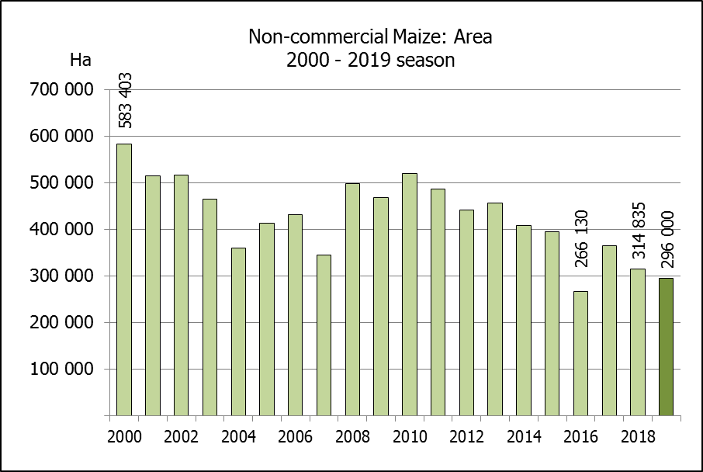
NIE-KOMMERSIëLE MIELIES – OPPERVLAKTE- EN PRODUKSIESKATTING: 2019
CROP/GEWAS | Area planted/  Opp beplant  2019 | Production/  Produksie  2019 | Area planted/  Opp beplant  2018 | Final crop/  Finale oes  2018 | Change/  Verandering
CROP/GEWAS | Ha | Tons | Ha | Tons | %
CROP/GEWAS | (A) | (B) | (C) | (D) | (B) ÷ (D)
Non-commercial agriculture/Nie-kommersiële landbou:
White maize/Witmielies | 221 300 | 379 460 | 236 644 | 414 162 | -8,38
Yellow maize/Geelmielies | 74 700 | 169 720 | 78 191 | 179 813 | -5,61
Maize/Mielies | 296 000 | 549 180 | 314 835 | 593 975 | -7,54
The area planted to maize in the non-commercial agricultural sector is estimated at 296 000 ha, which represents a decrease of 5,98%, compared to the 314 835 ha of the previous season. The expected maize crop for this sector is 549 180 tons, which is 7,54% less than the 593 975 tons of last season. It is important to note that about 43% of the maize produced in the non-commercial sector, is planted in the Eastern Cape, followed by KwaZulu-Natal with 27%.
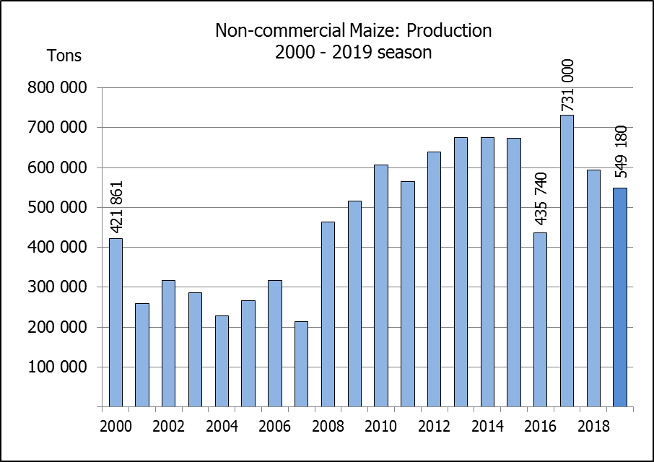
Die oppervlakte beplant met mielies in die nie-kommersiële landbou-sektor word geskat op 296 000 ha, wat ‘n afname van 5,98 % verteenwoordig in vergelyking met die 314 835 ha van die vorige seisoen. Die verwagte mielie-oes van dié sektor is 549 180 ton, wat 7,54% minder is as die 593 975 ton van die vorige seisoen. Dit is belangrik om daarop te let dat ongeveer 43% van die mielies wat geproduseer word in die nie-kommersiële sektor, in die Oos-Kaap geplant word, gevolg deur KwaZulu-Natal met 27%.

The revised area estimate and first production forecast for winter cereals for the 2019 is hereby released. /
Hiermee word die hersiene oppervlakte- en eerste produksieskatting vir wintergewasse vir 2019 vrygestel.

WINTER CEREALS – REVISED AREA PLANTED AND FIRST PRODUCTION FORECAST: 2019 PRODUCTION SEASON
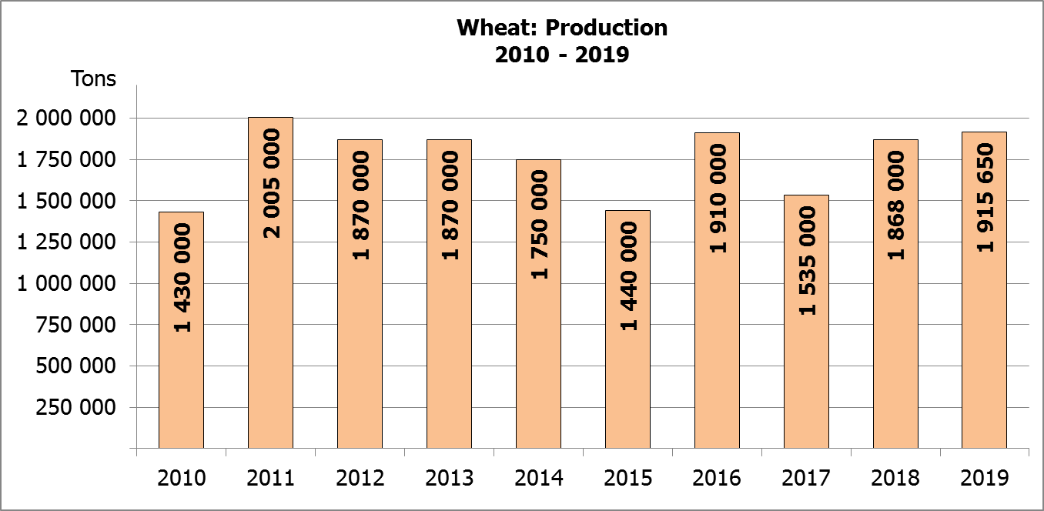
WINTERGEWASSE – HERSIENE OPPERVLAKTE- EN EERSTE PRODUKSIESKATTING: 2019-PRODUKSIESEISOEN
CROP/GEWAS | Area planted/  Opp beplant  2019 | 1st forecast/  1ste skatting  2019 | Area planted/  Opp beplant  2018 | Final crop/  Finale oes  2018 | Change/  Verandering
CROP/GEWAS | Ha | Tons | Ha | Tons | %
CROP/GEWAS | (A) | (B) | (C) | (D) | (B) ÷ (D)
Commercial/Kommersieel:
Wheat/Koring | 537 000 | 1 915 650 | 503 350 | 1 868 000 | +2,55
Malting barley/Moutgars | 131 960 | 401 460 | 119 000 | 421 500 | -4,75
Canola/Kanola | 74 000 | 103 600 | 77 000 | 104 500 | -0,86
Cereal oats/Hawermout | 25 000 | 40 000 | 19 235 | 32 700 | 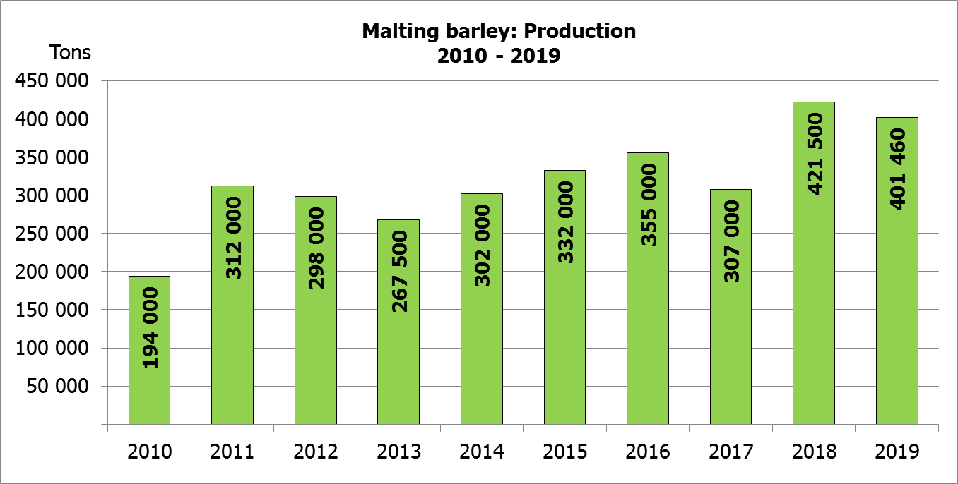  +22,32
* Note: Estimate is for calendar year, e.g. production season 2019/20 = 2019
* Nota: Skatting is vir kalenderjaar, bv. produksie-seisoen 2019/20 = 2019

WHEAT – REVISED AREA PLANTED AND FIRST PRODUCTION FORECAST: 2019
KORING – HERSIENE OPPERVLAKTE- EN EERSTE PRODUKSIESKATTING: 2019
Province/  Provinsie | Area planted/  Opp beplant  Ha | 1st forecast/  1ste skatting  Tons | Area planted/  Opp beplant  Ha | Final crop/  Finale oes  Tons
Province/  Provinsie | 2019 | 2019 | 2018 | 2018
Western Cape/Wes-Kaap | 325 000 | 861 250 | 318 000 | 890 500
Northern Cape/Noord-Kaap | 37 500 | 281 250 | 38 000 | 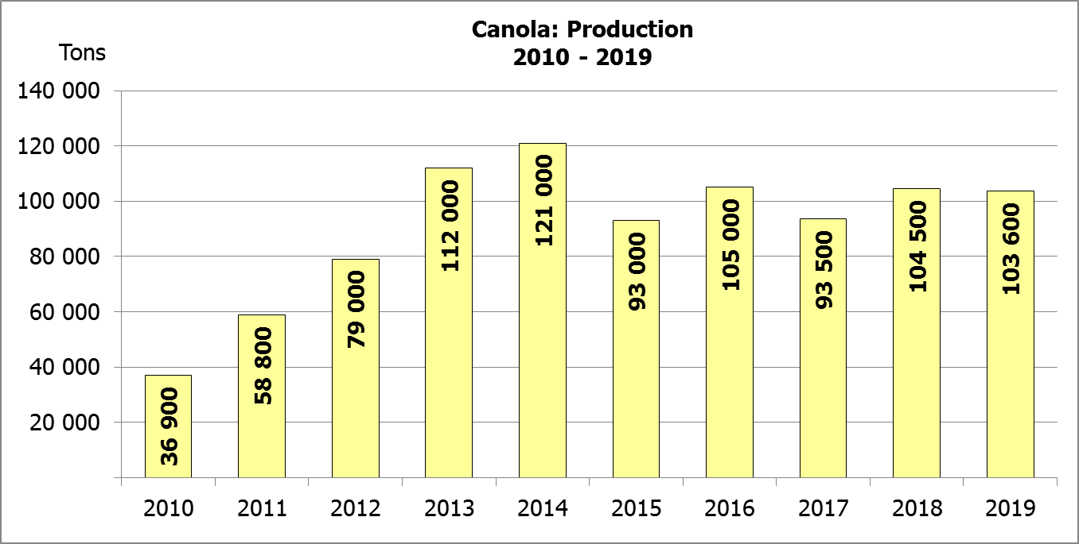  294 500
Free State/Vrystaat | 125 000 | 462 500 | 100 000 | 385 000
Eastern Cape/Oos-Kaap | 3 100 | 20 150 | 1 650 | 10 730
KwaZulu-Natal | 7 500 | 45 750 | 7 000 | 43 400
Mpumalanga | 4 000 | 26 000 | 3 500 | 22 740
Limpopo | 20 000 | 128 000 | 20 000 | 128 000
Gauteng | 1 400 | 8 400 | 1 200 | 7 800
North West/Noordwes | 13 500 | 82 350 | 14 000 | 85 330
Total/Totaal | 537 000 | 1 915 650 | 503 350 | 1 868 000

REVISED AREA ESTIMATE AND FIRST PRODUCTION FORECAST OF WINTER CROPS (2019) /
HERSIENE OPPERVLAKTEKSKATTING EN EERSTE PRODUKSIESKATTING VAN WINTERGEWASSE (2019)
27 AUGUST/ AUGUSTUS 2019
Winter cereal crops - 2019 production season  Wheat: The expected production of wheat is 1,916 mill. tons, which is 2,55% or 47 650 tons more than the previous seasons’ crop of 1,868 mill. tons, whilst the expected yield is 3,57 t/ha.  The expected production in the Western Cape is 861 250 tons (45%), which is 29 250 tons less than the 890 500 tons produced in the previous season. In the Free State, the expected production is 462 500 tons (24%), which is 77 500 tons more than the previous seasons’ crop of 385 000 tons. In the Northern Cape, 281 250 tons (15%) is expected to be produced – 13 250 tons less than the 294 500 tons produced in the previous season.  The area estimate for wheat was revised to 537 000 ha, which is 50 ha higher than the 536 950 ha of the previous forecast. An estimated 325 000 ha or 61 % is planted in the Western Cape, 125 000 ha or 23 % in the Free State and 37 500 ha or 7 % in the Northern Cape.  Other crops: The production forecast for malting barley is 401 460 tons, which is 4,75% or 20 040 tons less than the previous seasons’ crop of 421 500 tons. The area planted is estimated at 131 960 ha, while the expected yield is 3,04 t/ha.  The expected canola crop is 103 600 tons, which is 0,86% or 900 tons less than the previous seasons’ crop of 104 500 tons. The area estimate for canola is 74 000 ha, with an expected yield of 1,40 t/ha.  The revised area estimate for oats (cereals) for the 2019 season is 25 000 ha and the expected crop is 40 000 tons. The expected yield is 1,60 t/ha.  Please note that the second production forecast for winter cereals for 2019 will be released on 26 September 2019. |  | Wintergewasse - 2019 produksie-seisoen  Koring: Die verwagte produksie vir koring is 1,916 milj. ton, wat 2,55% of 47 650 ton meer is as die vorige seisoen se oes van 1,868 milj. ton, terwyl die verwagte opbrengs 3,57 t/ha is.  Die verwagte produksie in die Wes-Kaap is 861 250 ton (45%), wat 29 250 ton minder is as die 890 500 ton geproduseer in die vorige seisoen. In die Vrystaat is die verwagte produksie 462 500 ton (24%), wat 77 500 ton meer is as die vorige seisoen se oes van 385 000 ton. In die Noord-Kaap is die beraamde produksie 281 250 ton (15%) – 13 250 ton minder as die 294 500 ton geproduseer in die vorige seisoen.  Die oppervlakteskatting vir koring is hersien na 537 000 ha, wat 50 ha hoër is as die 536 950 ha teenoor die vorige skatting. Die beraamde oppervlakte geplant in die Wes-Kaap is 325 000 ha of 61 %, die Vrystaat is 125 000 ha of 23 % en 37 500 ha of 7 % is in die Noord-Kaap.  Ander gewasse: Die produksieskatting vir moutgars is 401 460 ton, wat 4,75% of 20 040 ton minder is as die vorige seisoen se oes van 421 500 ton. Die oppervlakte beplant word beraam op 131 960 ha, terwyl die verwagte opbrengs 3,04 t/ha beloop.  Die verwagte kanola-oes is 103 600 ton, wat 0,86% of 900 ton minder is as die vorige seisoen se oes van 104 500 ton. Die oppervlakteskatting vir kanola is 74 000 ha, met ŉ verwagte opbrengs van 1,40 t/ha.  Die hersiene oppervlakteskatting vir hawer (ontbytgraan) vir die 2019-seisoen is 25 000 ha en die verwagte oes is 40 000 ton. Die verwagte opbrengs is 1,60 t/ha.  Neem asseblief kennis dat die tweede produksieskatting vir wintergewasse vir 2019 op 26 September 2019 vrygestel sal word.

Information is available on the internet at http://www.daff.gov.za/links/crop estimates or http://www.sagis.org.za, as from 14:30 on the date of the relevant meeting of the Crop Estimates Committee. |  | Inligting is beskikbaar op die internet by http://www.daff.gov.za/links/crop estimates of by http://www.sagis.org.za, vanaf 14:30 op die dag van die toepaslike vergadering van die Oesskattingskomitee.

