 | crop estimates committee
 | oesskattingskomitee
From/Van: Mr Baldwin Netshifhefhe  Tel: 012 319 8043/32  Fax/Faks: 012 319 8031  E-mail/E-pos: BaldwinN@dalrrd.gov.za  Web page/Webblad: www.dalrrd.gov.za/statistics and economic reports or  www.sagis.org.za/CEC: Crop Estimates EMBARGO: 14:30 |  |  | 

The area planted estimate and third production forecast for summer crops for 2023 is hereby released.
Hiermee word die oppervlakte- en derde produksieskatting vir somergewasse vir 2023 vrygestel.

SUMMER CROPS – AREA PLANTED AND THIRD PRODUCTION FORECAST: 2023
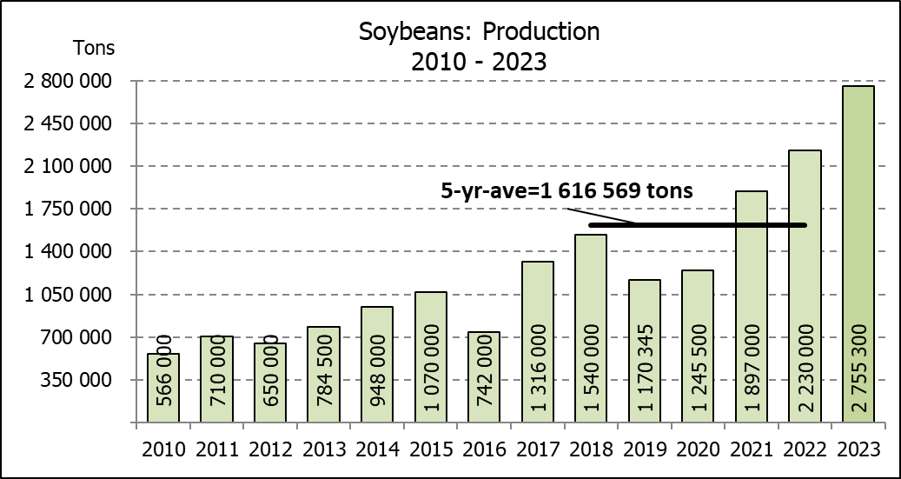
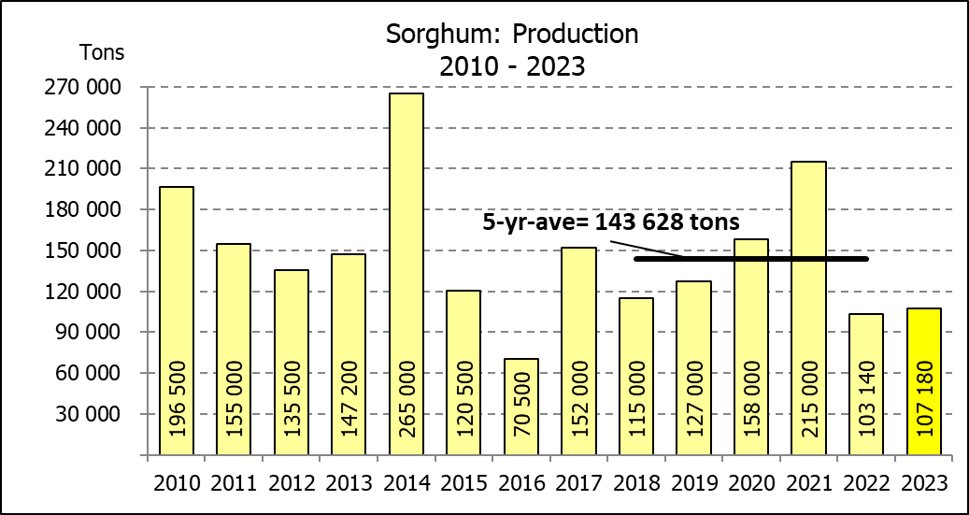
SOMERGEWASSE – OPPERVLAKTE- EN DERDE PRODUKSIESKATTING: 2023
CROP/GEWAS | Area planted/  Opp beplant  2023 | 3rd forecast/  3de skatting  2023 | 2nd forecast/  2de skatting  2023 | Area planted/  Opp beplant  2022 | Final crop/  Finale oes  2022 | Change/  Verandering/
CROP/GEWAS | Ha | Tons | Tons | Ha | Tons | %
CROP/GEWAS | (A) | (B) | (C) | (D) | (E) | (B) ÷ (C)
Commercial/Kommersieël:
White maize/Witmielies | 1 521 300 | 8 361 175 | 8 344 375 | 1 575 000 | 7 850 000 | +0,20
Yellow maize/Geelmielies | 1 064 800 | 7 528 600 | 7 535 150 | 1 048 000 | 7 620 000 | -0,09
Total Maize/Totale Mielies | 2 586 100 | 15 889 775 | 15 879 525 | 2 623 000 | 15 470 000 | +0,06
Sunflower seed/Sonneblomsaad | 555 700 | 797 610 | 797 610 | 670 700 | 845 550 | -
Soybeans/Sojabone | 1 148 300 | 2 755 300 | 2 710 150 | 925 300 | 2 230 000 | +1,67
Groundnuts/Grondbone | 31 300 | 49 080 | 49 080 | 43 400 | 48 500 | -
Sorghum | 34 000 | 107 180 | 109 400 | 37 200 | 103 140 | -2,03
Dry beans/Droëbone | 36 650 | 46 710 | 47 930 | 42 900 | 52 590 | -2,55
Non-Commercial Maize/Nie-Kommersiële Mielies
Total Maize/Totale Mielies | 358 620 | 664 040 | N/A | 378 800 | 667 000 | N/A
Maize/Mielies: Commercial/Kommersieël + Non-Commercial/Nie-Kommersieël
Total Maize RSA/Totaal Mielies RSA | 2 944 720 | 16 553 815 | N/A | 3 001 800 | 16 137 000 | N/A
Note: Estimate is for calendar year, e.g. production season 2022/23 = 2023
Nota: Skatting is vir kalenderjaar, bv. produksie-seisoen 2022/23 = 2023

The Crop Estimates Committee comprises officials of the following institutions:
Department of Agriculture, Land Reform and Rural Development; Provincial Departments of Agriculture; various ARC-Institutes (Soil, Climate and Water; Small Grains Institute; and
Grain Crops Institute); BFAP and Statistics SA.
26 April 2023
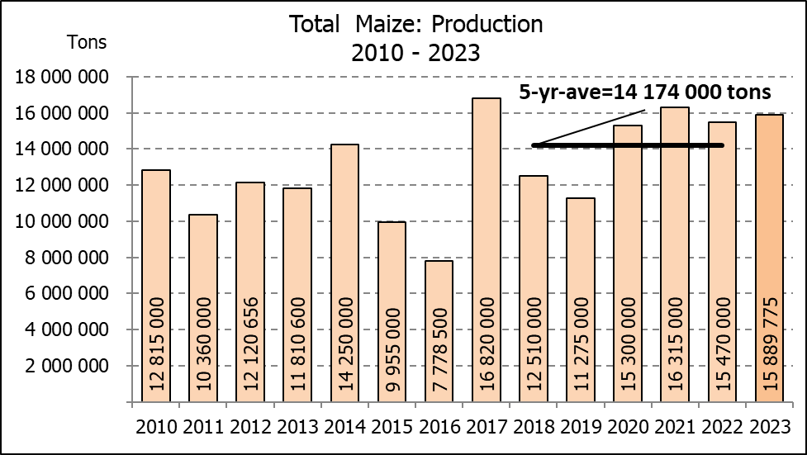

WHITE AND YELLOW MAIZE – AREA PLANTED AND THIRD PRODUCTION FORECAST: 2023
WIT- EN GEELMIELIES – OPPERVLAKTE EN DERDE PRODUKSIESKATTING: 2023

Provinsie/  Province | Area planted/  Oppervlakte beplant  2023 |  |  | 3rd forecast/  3de skatting  2023 |  |  | Area planted/  Oppervlakte beplant  2022 |  |  | Final crop/  Finale oes  2022
Provinsie/  Province | White/  Wit  Ha | Yellow/  Geel  Ha | Total/  Totaal  Ha | White/  Wit  Tons | Yellow/  Geel  Tons | Total/  Totaal  Tons | White/  Wit  Ha | Yellow/  Geel  Ha | Total/  Totaal  Ha | White/  Wit  Tons | Yellow/  Geel  Tons | Total/  Totaal  Tons
Western Cape/Wes-Kaap | 250 | 3 500 | 3 750 | 2 375 | 32 900 | 35 275 | 500 | 3 500 | 4 000 | 4 750 | 32 900 | 37 650
Northern Cape/Noord-Kaap | 1 000 | 43 500 | 44 500 | 12 000 | 639 450 | 651 450 | 3 000 | 42 000 | 45 000 | 36 000 | 672 000 | 708 000
Free State/Vrystaat | 780 000 | 401 000 | 1 181 000 | 4 407 000 | 2 586 450 | 6 993 450 | 826 500 | 398 000 | 1 224 500 | 3 801 900 | 2 547 800 | 6 349 700
Eastern Cape/Oos-Kaap | 5 750 | 25 000 | 30 750 | 40 250 | 187 500 | 227 750 | 6 000 | 20 500 | 26 500 | 40 800 | 157 900 | 198 700
KwaZulu-Natal | 49 000 | 65 000 | 114 000 | 308 700 | 526 500 | 835 200 | 52 000 | 59 000 | 111 000 | 322 400 | 489 700 | 812 100
Mpumalanga | 156 500 | 352 000 | 508 500 | 1 017 250 | 2 464 000 | 3 481 250 | 165 000 | 350 000 | 515 000 | 1 072 500 | 2 554 000 | 3 626 500
Limpopo | 16 800 | 22 800 | 39 600 | 117 600 | 182 400 | 300 000 | 15 500 | 25 000 | 40 500 | 102 300 | 202 500 | 304 800
Gauteng | 56 000 | 52 000 | 108 000 | 358 400 | 374 400 | 732 800 | 56 500 | 56 000 | 112 500 | 361 600 | 403 200 | 764 800
North West/Noordwes | 456 000 | 100 000 | 556 000 | 2 097 600 | 535 000 | 2 632 600 | 450 000 | 94 000 | 544 000 | 2 107 750 | 560 000 | 2 667 750
Total/Totaal | 1 521 300 | 1 064 800 | 2 586 100 | 8 361 175 | 7 528 600 | 15 889 775 | 1 575 000 | 1 048 000 | 2 623 000 | 7 850 000 | 7 620 000 | 15 470 000

SUNFLOWER SEED – AREA PLANTED AND THIRD PRODUCTION FORECAST: 2023
SONNEBLOMSAAD – OPPERVLAKTE EN DERDE PRODUKSIESKATTING: 2023

Province/  Provinsie | Area planted/  Opp beplant  Ha | 3rd forecast/  3de skatting  Tons | Area planted/  Opp beplant  Ha | Final crop/  Finale oes  Tons
Province/  Provinsie | 2023 | 2023 | 2022 | 2022
Western Cape/Wes-Kaap | - | - | - | -
Northern Cape/Noord-Kaap | 2 500 | 6 250 | 2 500 | 6 250
Free State/Vrystaat | 290 000 | 449 500 | 357 000 | 499 800
Eastern Cape/Oos-Kaap | 700 | 1 400 | 300 | 750
KwaZulu-Natal | 300 | 600 | - | -
Mpumalanga | 5 000 | 7 250 | 3 500 | 5 250
Limpopo | 100 000 | 105 000 | 110 000 | 77 000
Gauteng | 2 200 | 2 860 | 2 400 | 3 000
North West/Noordwes | 155 000 | 224 750 | 195 000 | 253 500
Total/Totaal | 555 700 | 797 610 | 670 700 | 845 550
SOYBEANS – AREA PLANTED AND THIRD PRODUCTION FORECAST: 2023
SOJABONE – OPPERVLAKTE EN DERDE PRODUKSIESKATTING: 2023

Province/  Provinsie | Area planted/  Opp beplant  Ha | 3rd forecast/  3de skatting  Tons | Area planted/  Opp beplant  Ha | Final crop/  Finale oes  Tons
Province/  Provinsie | 2023 | 2023 | 2022 | 2022
Western Cape/Wes-Kaap | - | - | - | -
Northern Cape/Noord-Kaap | 1 000 | 3 750 | 800 | 3 000
Free State/Vrystaat | 565 000 | 1 327 750 | 415 000 | 912 500
Eastern Cape/Oos-Kaap | 4 300 | 12 900 | 3 000 | 9 000
KwaZulu-Natal | 44 000 | 158 400 | 39 000 | 150 000
Mpumalanga | 305 000 | 671 000 | 300 000 | 710 000
Limpopo | 26 000 | 88 400 | 22 500 | 76 500
Gauteng | 48 000 | 105 600 | 45 000 | 99 000
North West/Noordwes | 155 000 | 387 500 | 100 000 | 270 000
Total/Totaal | 1 148 300 | 2 755 300 | 925 300 | 2 230 000

GROUNDNUTS – AREA PLANTED AND THIRD PRODUCTION FORECAST: 2023
GRONDBONE – OPPERVLAKTE EN DERDE PRODUKSIESKATTING: 2023

Province/  Provinsie | Area planted/  Opp beplant  Ha | 3rd forecast/  3de skatting Tons | Area planted/  Opp beplant  Ha | Final crop/  Finale oes  Tons
Province/  Provinsie | 2023 | 2023 | 2022 | 2022
Western Cape/Wes-Kaap | - | - | - | -
Northern Cape/Noord-Kaap | 2 000 | 4 800 | 2 400 | 6 000
Free State/Vrystaat | 12 300 | 19 680 | 19 000 | 20 900
Eastern Cape/Oos-Kaap | - | - | - | -
KwaZulu-Natal | - | - | - | -
Mpumalanga | - | - | - | -
Limpopo | 2 000 | 5 100 | 2 000 | 4 600
Gauteng | - | - | - | -
North West/Noordwes | 15 000 | 19 500 | 20 000 | 17 000
Total/Totaal | 31 300 | 49 080 | 43 400 | 48 500

SORGHUM – AREA PLANTED AND THIRD PRODUCTION FORECAST: 2023
SORGHUM – OPPERVLAKTE EN DERDE PRODUKSIESKATTING: 2023

Province/  Provinsie | Area planted/  Opp beplant  Ha | 3rd forecast/  3de skatting Tons | Area planted/  Opp beplant  Ha | Final crop/  Finale oes  Tons
Province/  Provinsie | 2023 | 2023 | 2022 | 2022
Western Cape/Wes-Kaap | - | - | - | -
Northern Cape/Noord-Kaap | - | - | - | -
Free State/Vrystaat | 5 200 | 17 680 | 7 800 | 20 700
Eastern Cape/Oos-Kaap | - | - | - | -
KwaZulu-Natal | 100 | 400 | 200 | 740
Mpumalanga | 8 500 | 39 950 | 9 000 | 43 650
Limpopo | 15 500 | 37 200 | 15 000 | 26 250
Gauteng | 100 | 450 | 200 | 800
North West/Noordwes | 4 600 | 11 500 | 5 000 | 11 000
Total/Totaal | 34 000 | 107 180 | 37 200 | 103 140

DRY BEANS – AREA PLANTED AND THIRD PRODUCTION FORECAST: 2023
DROëBONE – OPPERVLAKTE EN DERDE PRODUKSIESKATTING: 2023

Province/  Provinsie | Area planted/  Opp beplant  Ha | 3rd forecast/  3de skatting Tons | Area planted/  Opp beplant  Ha | Final crop/  Finale oes  Tons
Province/  Provinsie | 2023 | 2023 | 2022 | 2022
Western Cape/Wes-Kaap | 100 | 180 | 100 | 150
Northern Cape/Noord-Kaap | 450 | 990 | 600 | 1 080
Free State/Vrystaat | 14 000 | 11 900 | 15 500 | 13 950
Eastern Cape/Oos-Kaap | 200 | 360 | 200 | 300
KwaZulu-Natal | 2 100 | 3 150 | 2 300 | 2 760
Mpumalanga | 5 000 | 6 750 | 6 000 | 6 600
Limpopo | 8 000 | 14 400 | 10 400 | 18 200
Gauteng | 800 | 880 | 800 | 800
North West/Noordwes | 6 000 | 8 100 | 7 000 | 8 750
Total/Totaal | 36 650 | 46 710 | 42 900 | 52 590

CONFIDENTIALITY ISSUES that CEC members are committed to adhere to on the day of the meeting
- Personal items such as laptops, handbags, cell phones, etc. are not allowed in the venue during the meeting
- No member is allowed to leave the meeting before 12:00 in order to prevent disclosure of the information
- The embargo time for the release of crop estimates information is 14:30
- No member is allowed to discuss crop estimates information with anyone other than a member of the Committee before the embargo time
- Only the Chairperson, or a member appointed by the Chairperson, may release the figures to the media
- Members must regard the detail of any information that was collected for and/or discussed during the meeting, as confidential
- Individual information received for crop estimate purposes is treated strictly confidential, and is not divulged for any other purposes

AREA ESTIMATE AND THIRD PRODUCTION FORECAST OF SUMMER CROPS (2023 PRODUCTION SEASON)/
OPPERVLAKTE- EN DERDE PRODUKSIESKATTING VIR SOMERGEWASSE (2023 PRODUKSIE-SEISOEN)
26 APRIL 2023

Summer field crops – 2023  Commercial maize: The size of the expected commercial maize crop has been set at 15,890 mill. tons, which is 0,06% or 10 250 tons more than the previous forecast of 15,880 mill. tons. The area estimate for maize is 2,586 mill. ha and the expected yield is 6,14 t/ha.  The estimated maize crop is 2,71% or 419 775 tons larger than the 2022 crop. The three main maize producing areas, namely the Free State, Mpumalanga and North West provinces are expected to produce 82% of the 2023 crop.  The production forecast of white maize is 8,361 mill. tons, which is 0,20% or 16 800 tons more than the 8,344 mill. tons of the previous forecast. The area estimate for white maize is 1,521 mill. ha and the expected yield is 5,50 t/ha.  In the case of yellow maize, the production forecast is 7,529 mill. tons, which is 0,09% or 6 550 tons less than the 7,535 mill. tons of the previous forecast. The area estimate for yellow maize is 1,065 mill. ha and the yield is 7,07 t/ha.  The yield per ha for the Mpumalanga province was based on scientific and objective results provided by the ARC. Please note that the objective results for the Free State and North West provinces will be available in May 2023.  Other summer crops:  Sunflower seed: The production forecast for sunflower seed remained unchanged at 797 610 tons. The area estimate for sunflower seed is 555 700 ha, while the expected yield is 1,44 t/ha.  Other crops: The production forecast for soybeans increased by 1,67% or 45 150 tons to 2,755 mill. tons. The estimated area planted to soybeans is 1,148 mill. ha and the expected yield is 2,40 t/ha.  The expected groundnut crop remained unchanged at 49 080 tons. For groundnuts, the area estimate is 31 300 ha, with an expected yield of 1,57 t/ha.  The production forecast for sorghum is 107 180 tons, which is 2,03% or 2 220 tons less than the 109 400 tons of the previous forecast. The area estimate for sorghum is 34 000 ha and the expected yield is 3,15 t/ha.  In the case of dry beans, the production forecast is 46 710 tons. The area estimate of dry beans is 36 650 ha, with an expected yield of 1,27 t/ha.  Please note that the fourth production forecast for summer field crops for 2023 will be released on 25 May 2023. |  | Somergewasse – 2023  Kommersiële mielies: Die grootte van die verwagte kommersiële mielie-oes is op 15,890 milj. ton gestel, wat 0,06% of 10 250 ton meer is as die vorige skatting van 15,880 milj. ton. Die oppervlakteskatting vir mielies is 2,586 milj. ha en die verwagte opbrengs is 6,14 t/ha.  Die geskatte mielie-oes is 2,71% of 419 775 ton groter as die 2022-oes. Die drie belangrikste mielieproduserende gebiede, nl. die Vrystaat, Mpumalanga en Noordwes provinsies, gaan na verwagting 82% van die 2023-oes produseer.  Die produksieskatting van witmielies is 8,361 milj. ton, wat 0,20% of 16 800 ton meer is as die 8,344 milj. ton van die vorige skatting. Die oppervlakteskatting vir witmielies is 1,521 milj. ha en die verwagte opbrengs is 5,50 t/ha.  In die geval van geelmielies is die produksieskatting 7,529 milj. ton, wat 0,09% of 6 550 ton minder is as die 7,535 milj. ton van die vorige skatting. Die oppervlakteskatting vir geelmielies is 1,065 milj. ha en die opbrengs is 7,07 t/ha.  Die opbrengs-bepaling per ha vir die Mpumalanga provinsie is gebaseer op wetenskaplike en objektiewe resultate verstrek deur die LNR. Neem kennis dat die objektiewe resultate vir die Vrystaat en Noordwes provinsies, in Mei 2023 gerapporteer sal word.  Ander somergewasse:  Sonneblomsaad: Die produksieskatting vir sonneblomsaad is onveranderd gelaat op 797 610 ton. Die oppervlakteskatting vir sonneblomsaad is 555 700 ha, terwyl die verwagte opbrengs 1,44 t/ha is.  Ander gewasse: Die produksieskatting van sojabone is verhoog met 1,67% of 45 150 ton na 2,755 milj. ton. Die geskatte oppervlakte beplant van sojabone is 1,148 milj. ha en die verwagte opbrengs is 2,40 t/ha.  Die verwagte grondbone-oes is onveranderd gelaat op 49 080 ton. Vir grondbone is die oppervlakteskatting 31 300 ha, terwyl the verwagte opbrengs 1,57 t/ha is.  Die produksieskatting van sorghum is 107 180 ton, wat 2,03% of 2 220 ton minder is as die 109 400 ton van die vorige skatting. Die oppervlakteskatting vir sorghum is 34 000 ha, en die verwagte opbrengs is 3,15 t/ha.  In die geval van droëbone is die produksieskatting 46 710 ton. Die oppervlakte beplant met droëbone is 36 650 ha, en die verwagte opbrengs is 1,27 t/ha.  Neem asseblief kennis dat die vierde produksieskatting vir somergewasse vir 2023, op 25 Mei 2023 vrygestel sal word.

The preliminary non-commercial agricultural sectors’ production estimate for maize for 2023 is hereby released. /
Hiermee word die voorlopige nie-kommersiële landbou-sektor se produksieskatting vir mielies vir 2023 vrygestel.

NON-COMMERCIAL MAIZE – PRELIMINARY AREA PLANTED AND PRODUCTION ESTIMATE: 2023
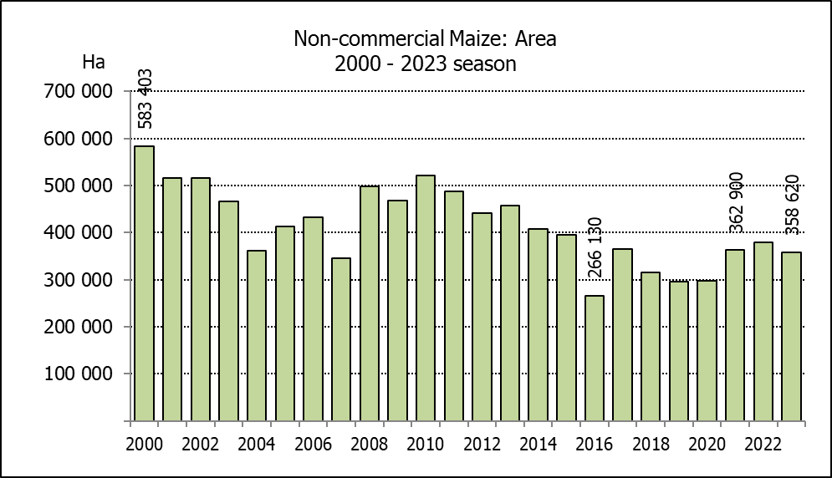
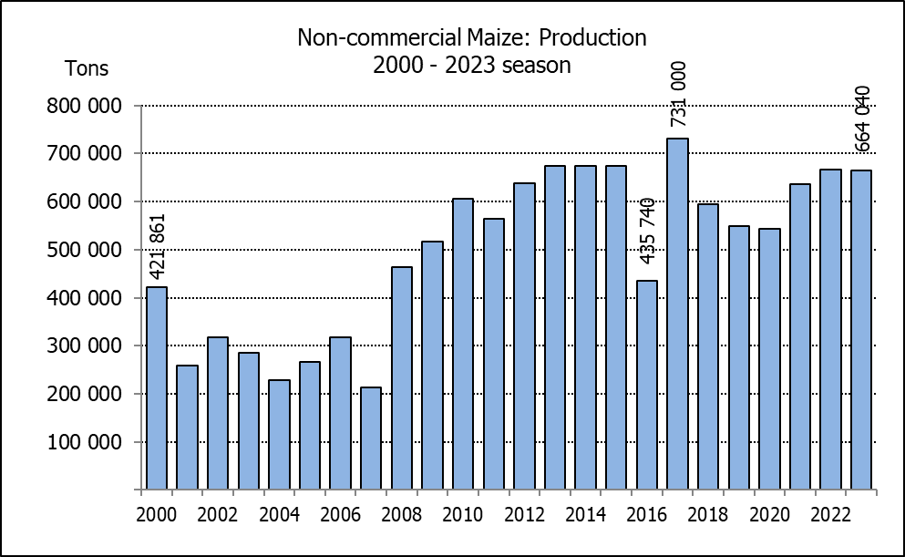
NIE-KOMMERSIëLE MIELIES – VOORLOPIGE OPPERVLAKTE- EN PRODUKSIESKATTING: 2023
CROP/GEWAS | Area planted/  Opp beplant  2023 | Production/  Produksie  2023 | Area planted/  Opp beplant  2022 | Final crop/  Finale oes  2022 | Change/  Verandering
CROP/GEWAS | Ha | Tons | Ha | Tons | %
CROP/GEWAS | (A) | (B) | (C) | (D) | (B) ÷ (D)
Non-commercial agriculture/Nie-kommersiële landbou:
White maize/Witmielies | 278 655 | 472 765 | 296 950 | 482 000 | -1,92
Yellow maize/Geelmielies | 79 965 | 191 275 | 81 850 | 185 000 | +3,39
Maize/Mielies | 358 620 | 664 040 | 378 800 | 667 000 | -0,44
The preliminary area planted to maize in the non-commercial agricultural sector is estimated at 358 620 ha, which represents a decrease of 5,33%, compared to the 378 800 ha of the previous season. The expected maize crop for this sector is 664 040 tons, which is 0,44% less than the 667 000 tons of last season. It is important to note that about 48% of the maize produced in the non-commercial sector, is planted in the Eastern Cape, followed by KwaZulu-Natal with 21%.
Die voorlopige oppervlakte beplant met mielies in die nie-kommersiële landbou-sektor word geskat op 358 620 ha, wat ’n afname van 5,33% verteenwoordig in vergelyking met die 378 800 ha van die vorige seisoen. Die verwagte mielie-oes van dié sektor is 664 040 ton, wat 0,44% minder is as die 667 000 ton van die vorige seisoen. Dit is belangrik om daarop te let dat ongeveer 48% van die mielies wat geproduseer word in die nie-kommersiële sektor, in die Oos-Kaap geplant word, gevolg deur KwaZulu-Natal met 21%.

The intentions to plant winter cereals for the 2023 production season is hereby released. /
Hiermee word die voorneme om wintergewasse te plant vir die 2023 produksie-seisoen vrygestel.
WINTERGEWASSE – VOORNEME OM TE PLANT: 2023
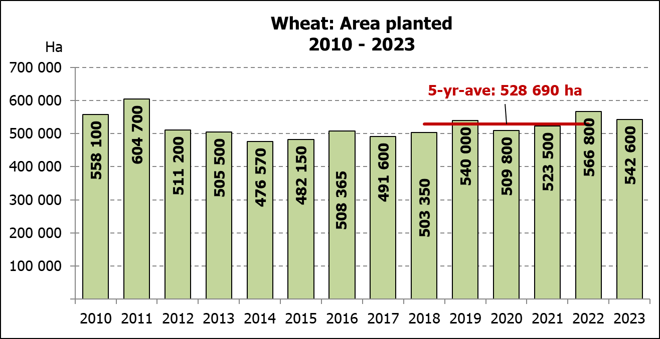
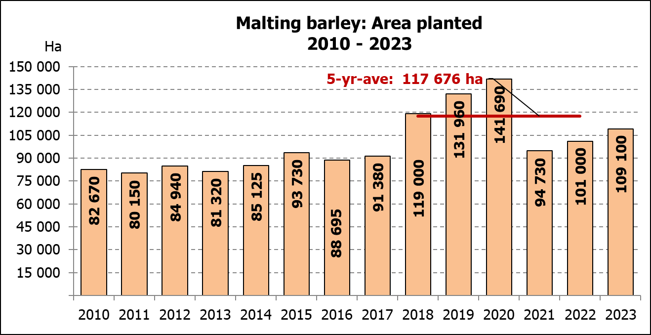
WINTER CEREALS –INTENTIONS TO PLANT: 2023
GEWAS/CROP | Voorneme/  Intentions*  2023 | Opp beplant/  Area planted  2022 | Finale skatting/  Final estimate  2022 | Verandering/  Change
GEWAS/CROP | Ha | Ha | Tons | %
GEWAS/CROP | (A) | (B) | (C) | (A) ÷ (B)
Wheat/Koring | 542 600 | 566 800 | 2 088 590 | -4,27
Malting barley/Moutgars | 109 100 | 101 000 | 308 675 | +8,02
Canola/Kanola | 127 500 | 123 510 | 210 530 | +3,23
Cereal oats/Hawermout | 29 600 | 27 000 | 29 900 | +9,63
Sweet lupines/Soetlupine | 11 500 | 21 000 | 15 750 | -45,24
Total winter cereals/Totaal wintergewasse | 820 300 | 839 310 | 2 653 445 | -2,26

* Based on conditions at the middle of April 2023 / Gebaseer op toestande soos teen middel April 2023.
KORING – VOORNEME OM TE PLANT: 2023
WHEAT – INTENTIONS TO PLANT: 2023
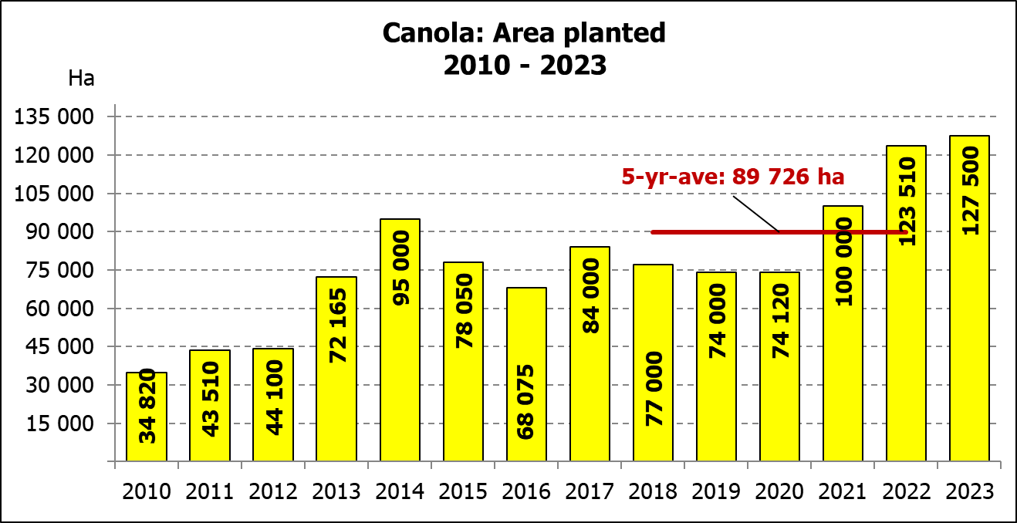
Provinsie/  Province | Voorneme/  Intentions  Ha | Opp beplant/  Area planted  Ha | Finale skatting/  Final estimate  Tons
Provinsie/  Province | 2023 | 2022 | 2022
Wes-Kaap/Western Cape | 362 500 | 360 000 | 918 000
Noord-Kaap/Northern Cape | 40 000 | 47 000 | 324 300
Vrystaat/Free State | 77 000 | 96 000 | 432 000
Oos-Kaap/Eastern Cape | 6 300 | 6 000 | 40 200
KwaZulu-Natal | 8 500 | 9 200 | 60 720
Mpumalanga | 4 100 | 4 000 | 27 600
Limpopo | 31 000 | 29 000 | 185 600
Gauteng | 1 200 | 1 100 | 7 370
Noordwes/North West | 12 000 | 14 500 | 92 800
Totaal/Total | 542 600 | 566 800 | 2 088 590
2023: Intentions/Voornemens

INTENTIONS TO PLANT WINTER CROPS FOR 2023 / VOORNEME OM WINTERGEWASSE AAN TE PLANT VIR 2023

Winter cereal crops – 2023  Producers’ intentions to plant winter cereals are mainly based on the results of a non-probability survey conducted by the Directorate: Statistics and Economic Analysis of the Department of Agriculture, Land Reform and Rural Development and reflects the position as at the middle of April 2023. Inputs were also received from the representatives of the respective Provincial Departments of Agriculture.  The figures for wheat represent the total number of hectares that are intended to be planted for grain, excluding any hectares that will be planted for fodder and grazing.  Early indications are that producers intend to plant 542 600 ha of wheat for the 2023 production season. This is 4,27% or 24 200 ha less than the 566 800 ha planted to wheat in 2022.  The main producing areas are within the Western Cape with 362 500 ha (67%), followed by the Free State with 77 000 ha (14%) and the Northern Cape with 40 000 ha (7%).  The expected area planted to malting barley is 109 100 ha, which is 8,02% or 8 100 ha more than the 101 000 ha of the previous year. The expected area planted to canola is also 127 500 ha, which is 3,23% or 3 990 ha more than the 123 510 ha planted in 2022. Producers intend to plant 29 600 ha of cereal oats, which is 9,63 or 2 600 ha more than the 27 000 ha of the previous season. The expected area planted to sweet lupines is 11 500 ha, which is 45,24% or 9 500 ha less than the previous season.  Please note that the preliminary area estimate of winter crops for 2023 will be released on 26 July 2023. |  | Wintergewasse – 2023  Produsente se voorneme om wintergewasse te plant is hoofsaaklik gebaseer op die resultate van ’n nie-ewekansige opname onderneem deur die Direktoraat: Statistiek en Ekonomiese Analise van die Departement van Landbou, Grondhervorming en Landelike Ontwikkeling en weerspieël die situasie teen die middel van April 2023. Insette is ook ontvang vanaf die verteenwoordigers van die onderskeie Provinsiale Departemente van Landbou.  Die syfers vir koring verteenwoordig die totale aantal hektare wat werklik beplant gaan word vir graan, uitgesluit alle hektare wat beplant gaan word vir groenvoer en weiding.  Vroeë aanduidings is dat produsente van voorneme is om 542 600 ha koring te plant vir die 2023-produksie-seisoen. Dit is 4,27% of 24 200 ha minder koring aangeplant as die 566 800 ha in 2022.  Die grootste produserende gebiede is in die Wes-Kaap, met 362 500 ha (67%), gevolg deur die Vrystaat met 77 000 ha (14%) en die Noord-Kaap met  40 000 ha (7%).  Die verwagte aanplantings van moutgars is 109 100 ha – 8,02% of 8 100 ha meer as die 101 000 ha van die vorige jaar. Die verwagte aanplantings van kanola is ook 127 500 ha, wat 3,23% of 3 990 ha meer is as die 123 510 ha wat aangeplant was in 2022. Produsente is van voorneme om 29 600 ha hawermout te plant, wat 9,63% of 2 600 ha meer is as die 27 000 ha van die vorige seisoen. Die verwagte aanplantings van soetlupine is 11 500 ha, wat 45,24% of 9 500 ha minder is as die vorige seisoen.  Neem asseblief kennis dat die voorlopige oppervlakteskatting vir wintergewasse vir 2023 op 26 Julie 2023 vrygestel sal word.
Information is available on the internet at http:// www.dalrrd.gov.za/statistics or http://www.sagis.org.za, as from 14:30 on the date of the relevant meeting of the Crop Estimates Committee. |  | Inligting is beskikbaar op die internet by http://www.dalrrd.gov.za/statistics of by http://www.sagis.org.za, vanaf 14:30 op die dag van die toepaslike vergadering van die Oesskattingskomitee.

