 | crop estimates committee | 
 | oesskattingskomitee
From/Van: M. Ellen Matsei
Tel: 012 319 8454  Fax/Faks: 012 319 8031  E-mail/E-pos: DAS@daff.gov.za
Web page/Webblad: www.daff.gov.za/statistics and economic reports or www.sagis.org.za/CEC: Crop Estimates
EMBARGO: 15:30

The area planted estimate and third production forecast for summer crops for 2017 is hereby released.
Hiermee word die oppervlakte- en derde produksieskatting vir somergewasse vir 2017 vrygestel.

SUMMER CROPS – AREA PLANTED AND THIRD PRODUCTION FORECAST: 2017
SOMERGEWASSE – OPPERVLAKTE- EN DERDE PRODUKSIESKATTING: 2017
CROP/GEWAS  The Crop Estimates Committee comprises officials of the following institutions:  Department of Agriculture, Forestry and Fisheries; Provincial Departments of Agriculture; various ARC-Institutes (Soil, Climate and Water; Small Grains Institute;  and Grain Crops Institute); and Statistics SA. | Area planted/  Opp beplant  2017 | 3rd forecast/  3de skatting  2017 | 2nd forecast/  2de skatting  2017 | Area planted/  Opp beplant  2016 | Final crop/  Finale oes  2016 | Change/  Verandering
 | Ha | Tons | Tons | Ha | Tons | %
 | (A) | (B) | (C) | (D) | (E) | (B) ÷ (C)
Commercial/Kommersieel:
White maize/Witmielies | 1 643 100 | 8 618 400 | 8 513 200 | 1 014 750 | 3 408 500 | +1,24
Yellow maize/Geelmielies | 985 500 | 5 917 300 | 5 810 300 | 932 000 | 4 370 000 | +1,84
Total Maize/Totale Mielies | 2 628 600 | 14 535 700 | 14 323 500 | 1 946 750 | 7 778 500 | +1,48
Sunflower seed/Sonneblomsaad | 635 750 | 853 470 | 896 060 | 718 500 | 755 000 | -4,75
Soybeans/Sojabone | 573 950 | 1 233 130 | 1 162 425 | 502 800 | 742 000 | +6,08
Groundnuts/Grondbone | 56 000 | 86 600 | 86 600 | 22 600 | 17 680 | -
Sorghum | 42 350 | 153 480 | 153 480 | 48 500 | 70 500 | -
Dry beans/Droëbone | 45 050 | 67 150 | 65 275 | 34 400 | 35 445 | +2,87
TOTAL/TOTAAL | 3 981 700 | 16 929 530 | 16 687 340 | 3 273 550 | 9 399 125 | +1,45
Note: Estimate is for calendar year, e.g. production season 2016/17 = 2017
Nota: Skatting is vir kalenderjaar, bv. produksie-seisoen 2016/17 = 2017

25 April 2017

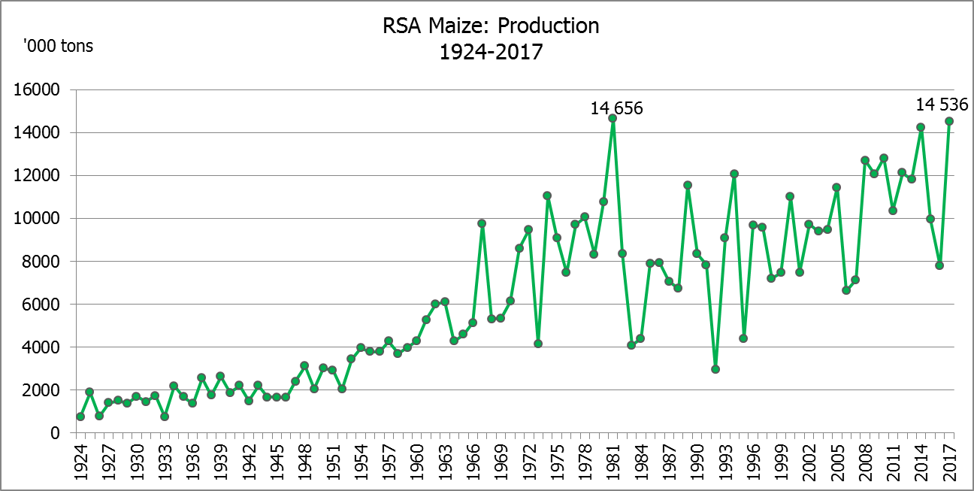

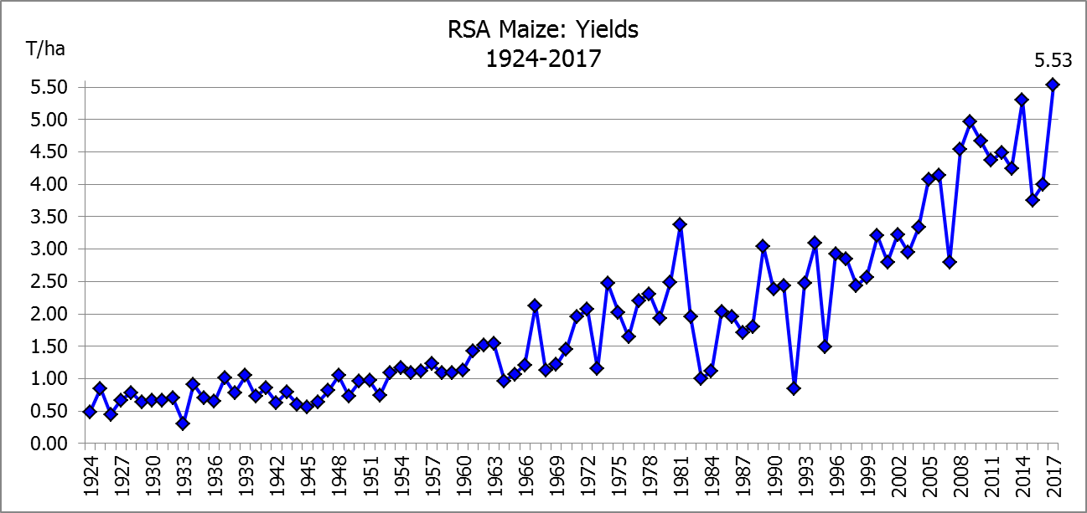

WHITE AND YELLOW MAIZE – AREA PLANTED AND THIRD PRODUCTION FORECAST: 2017
WIT- EN GEELMIELIES – OPPERVLAKTE EN DERDE PRODUKSIESKATTING: 2017

Provinsie/  Province | Area planted/  Oppervlakte beplant  2017 |  |  | 3rd forecast/  3de skatting  2017 |  |  | Area planted/  Oppervlakte beplant  2016 |  |  | Final crop/  Finale oes  2016
Provinsie/  Province | White/  Wit  Ha | Yellow/  Geel  Ha | Total/  Totaal  Ha | White/  Wit  Tons | Yellow/  Geel  Tons | Total/  Totaal  Tons | White/  Wit  Ha | Yellow/  Geel  Ha | Total/  Totaal  Ha | White/  Wit  Tons | Yellow/  Geel  Tons | Total/  Totaal  Tons
Western Cape/Wes-Kaap | 200 | 2 000 | 2 200 | 2 000 | 20 000 | 22 000 | 500 | 4 000 | 4 500 | 5 000 | 40 000 | 45 000
Northern Cape/Noord-Kaap | 3 500 | 45 000 | 48 500 | 43 750 | 643 500 | 687 250 | 3 750 | 50 000 | 53 750 | 35 000 | 675 000 | 710 000
Free State/Vrystaat | 805 000 | 355 000 | 1 160 000 | 4 226 250 | 1 775 000 | 6 001 250 | 390 000 | 310 000 | 700 000 | 1 190 500 | 1 023 000 | 2 213 500
Eastern Cape/Oos-Kaap | 4 400 | 9 500 | 13 900 | 26 400 | 57 000 | 83 400 | 2 000 | 12 000 | 14 000 | 10 000 | 66 000 | 76 000
KwaZulu-Natal | 50 000 | 50 000 | 100 000 | 320 000 | 335 000 | 655 000 | 38 000 | 48 000 | 86 000 | 215 000 | 307 000 | 522 000
Mpumalanga | 160 000 | 330 000 | 490 000 | 1 040 000 | 2 112 000 | 3 152 000 | 160 000 | 330 000 | 490 000 | 752 000 | 1 567 000 | 2 319 000
Limpopo | 40 000 | 24 000 | 64 000 | 260 000 | 148 800 | 408 800 | 31 500 | 22 000 | 53 500 | 178 000 | 132 000 | 310 000
Gauteng | 60 000 | 60 000 | 120 000 | 360 000 | 342 000 | 702 000 | 49 000 | 56 000 | 105 000 | 207 000 | 235 000 | 442 000
North West/Noordwes | 520 000 | 110 000 | 630 000 | 2 340 000 | 484 000 | 2 824 000 | 340 000 | 100 000 | 440 000 | 816 000 | 325 000 | 1 141 000
Total/Totaal | 1 643 100 | 985 500 | 2 628 600 | 8 618 400 | 5 917 300 | 14 535 700 | 1 014 750 | 932 000 | 1 946 750 | 3 408 500 | 4 370 000 | 7 778 500

SUNFLOWER SEED – AREA PLANTED AND THIRD PRODUCTION FORECAST: 2017
SONNEBLOMSAAD – OPPERVLAKTE EN DERDE PRODUKSIESKATTING: 2017

Province/  Provinsie | Area planted/  Opp beplant  Ha | 3rd forecast/  3de skatting  Tons | Area planted/  Opp beplant  Ha | Final crop/  Finale oes  Tons
Province/  Provinsie | 2017 | 2017 | 2016 | 2016
Western Cape/Wes-Kaap | - | - | - | -
Northern Cape/Noord-Kaap | 250 | 250 | 500 | 600
Free State/Vrystaat | 330 000 | 462 000 | 400 000 | 440 000
Eastern Cape/Oos-Kaap | - | - | - | -
KwaZulu-Natal | 300 | 300 | - | -
Mpumalanga | 2 200 | 2 420 | 4 000 | 4 400
Limpopo | 90 000 | 81 000 | 65 000 | 48 750
Gauteng | 3 000 | 3 000 | 4 000 | 4 000
North West/Noordwes | 210 000 | 304 500 | 245 000 | 257 250
Total/Totaal | 635 750 | 853 470 | 718 500 | 755 000

SOYBEANS – AREA PLANTED AND THIRD PRODUCTION FORECAST: 2017
SOJABONE – OPPERVLAKTE EN DERDE PRODUKSIESKATTING: 2017

Province/  Provinsie | Area planted/  Opp beplant  Ha | 3rd forecast/  3de skatting  Tons | Area planted/  Opp beplant  Ha | Final crop/  Finale oes  Tons
Province/  Provinsie | 2017 | 2017 | 2016 | 2016
Western Cape/Wes-Kaap | 700 | 1 050 | 800 | 1 200
Northern Cape/Noord-Kaap | 3 000 | 10 500 | 4 000 | 13 600
Free State/Vrystaat | 240 000 | 480 000 | 174 000 | 148 000
Eastern Cape/Oos-Kaap | 1 850 | 2 775 | 1 500 | 2 100
KwaZulu-Natal | 30 500 | 86 925 | 28 000 | 66 000
Mpumalanga | 241 000 | 506 100 | 240 000 | 408 000
Limpopo | 8 500 | 28 900 | 16 000 | 38 400
Gauteng | 25 400 | 68 580 | 23 000 | 50 600
North West/Noordwes | 23 000 | 48 300 | 15 500 | 14 100
Total/Totaal | 573 950 | 1 233 130 | 502 800 | 742 000
GROUNDNUTS – AREA PLANTED AND THIRD PRODUCTION FORECAST: 2017
GRONDBONE – OPPERVLAKTE EN DERDE PRODUKSIESKATTING: 2017

Province/  Provinsie | Area planted/  Opp beplant  Ha | 3rd forecast/  3de skatting  Tons | Area planted/  Opp beplant  Ha | Final crop/  Finale oes  Tons
Province/  Provinsie | 2017 | 2017 | 2016 | 2016
Western Cape/Wes-Kaap | - | - | - | -
Northern Cape/Noord-Kaap | 4 000 | 14 000 | 5 000 | 10 000
Free State/Vrystaat | 22 000 | 33 000 | 6 500 | 2 920
Eastern Cape/Oos-Kaap | - | - | - | -
KwaZulu-Natal | - | - | - | -
Mpumalanga | - | - | - | -
Limpopo | 3 000 | 4 500 | 1 600 | 1 440
Gauteng | - | - | - | -
North West/Noordwes | 27 000 | 35 100 | 9 500 | 3 320
Total/Totaal | 56 000 | 86 600 | 22 600 | 17 680

SORGHUM – AREA PLANTED AND THIRD PRODUCTION FORECAST: 2017
SORGHUM – OPPERVLAKTE EN DERDE PRODUKSIESKATTING: 2017

Province/  Provinsie | Area planted/  Opp beplant  Ha | 3rd forecast/  3de skatting  Tons | Area planted/  Opp beplant  Ha | Final crop/  Finale oes  Tons
Province/  Provinsie | 2017 | 2017 | 2016 | 2016
Western Cape/Wes-Kaap | - | - | - | -
Northern Cape/Noord-Kaap | - | - | - | -
Free State/Vrystaat | 7 700 | 26 180 | 28 000 | 24 150
Eastern Cape/Oos-Kaap | - | - | - | -
KwaZulu-Natal | 400 | 1 600 | 500 | 1 650
Mpumalanga | 12 000 | 62 400 | 10 000 | 32 500
Limpopo | 18 000 | 50 400 | 7 000 | 9 800
Gauteng | 750 | 2 400 | - | -
North West/Noordwes | 3 500 | 10 500 | 3 000 | 2 400
Total/Totaal | 42 350 | 153 480 | 48 500 | 70 500

DRY BEANS – AREA PLANTED AND THIRD PRODUCTION FORECAST: 2017
DROëBONE – OPPERVLAKTE EN DERDE PRODUKSIESKATTING: 2017

Province/  Provinsie | Area planted/  Opp beplant  Ha | 3rd forecast/  3de skatting  Tons | Area planted/  Opp beplant  Ha | Final crop/  Finale oes  Tons
Province/  Provinsie | 2017 | 2017 | 2016 | 2016
Western Cape/Wes-Kaap | 100 | 150 | 100 | 150
Northern Cape/Noord-Kaap | 650 | 1 300 | 350 | 630
Free State/Vrystaat | 20 000 | 30 000 | 17 000 | 17 000
Eastern Cape/Oos-Kaap | 300 | 450 | 250 | 375
KwaZulu-Natal | 4 500 | 5 400 | 2 200 | 2 640
Mpumalanga | 5 500 | 7 700 | 6 000 | 6 000
Limpopo | 7 000 | 14 000 | 3 000 | 3 750
Gauteng | 1 500 | 2 100 | 2 500 | 2 500
North West/Noordwes | 5 500 | 6 050 | 3 000 | 2 400
Total/Totaal | 45 050 | 67 150 | 34 400 | 35 445

CONFIDENTIALITY ISSUES that CEC members are committed to adhere to on the day of the meeting
- Personal items such as laptops, handbags, cell phones, etc. are not allowed in the venue during the meeting
- No member is allowed to leave the meeting before 12:00 in order to prevent disclosure of the information
- The embargo time for the release of crop estimates information is 15:30
- No member is allowed to discuss crop estimates information with anyone other than a member of the Committee before the embargo time
- Only the Chairperson, or a member appointed by the Chairperson, may release the figures to the media
- Members must regard the detail of any information that was collected for and/or discussed during the meeting, as confidential
- Individual information received for crop estimate purposes is treated strictly confidential, and is not divulged for any other purposes

AREA ESTIMATE AND THIRD PRODUCTION FORECAST OF SUMMER CROPS (2017 PRODUCTION SEASON)/
OPPERVLAKTE- EN DERDE PRODUKSIESKATTING VIR SOMERGEWASSE (2017 PRODUKSIE-SEISOEN)
25 APRIL 2017

Summer field crops – 2017  Commercial maize: The size of the expected commercial maize crop has been set at 14,536 mill. tons, which is 1,48% or 212 200 tons more than the previous forecast of 14,324 mill. tons. The area estimate for maize is 2,629 mill. ha, while the expected yield is 5,53 t/ha – the highest yield ever.  The estimated maize crop is 87% bigger than the 2016 crop, which was the smallest crop since 2007. The three main maize producing areas, namely the Free State, Mpumalanga and North West provinces are expected to produce 82% of the 2017 crop.  The area estimate for white maize is 1,643 mill. ha and for yellow maize the area estimate is 985 500 ha.  The production forecast of white maize is 8,618 mill. tons, which is 1,24% or 105 200 tons more than the 8,513 mill. tons of the previous forecast. The yield for white maize is 5,25 t/ha. In the case of yellow maize the production forecast is 5,917 mill. tons, which is 1,84% or 107 000 tons more than the 5,810 mill. tons of the previous forecast. The yield for yellow maize is 6,00 t/ha.  The yield per ha for the Mpumalanga province was based on scientific and objective results provided by the National Crop Statistics Consortium (NCSC), which is led by the ARC. Please note that the objective results for the Free State and North West provinces will be available in May 2017.  Sunflower seed: The production forecast for sunflower seed is 853 470 tons, which is 4,75% or 42 590 tons less than the 896 060 tons of the previous forecast. The area estimate for sunflower seed is 635 750 ha, while the expected yield is 1,34 t/ha.  Other crops: The production forecast for soybeans is 1,233 mill. tons, which is 6,08% or 70 705 tons more than the 1,162 mill. tons of the previous forecast. It is the largest soybean crop produced in the history of SA. The estimated area planted to soybeans is 573 950 ha and the expected yield is 2,15 t/ha.  The expected groundnut crop remained unchanged at 86 600 tons. The area estimate is 56 000 ha and the expected yield is 1,55 t/ha.  The production forecast for sorghum also remained unchanged at 153 480 tons, whilst the area estimate for sorghum is 42 350 ha. The expected yield is 3,62 t/ha.  In the case of dry beans, the production forecast is 67 150 tons, which is 2,87% or 1 875 tons more than the 65 275 tons of the previous forecast. The area estimate of dry beans is 45 050 ha, with an expected yield of 1,49 t/ha.  Please note that the fourth production forecast for summer field crops for 2017 will be released on 26 May 2017. |  | Somergewasse – 2017  Kommersiële mielies: Die grootte van die verwagte kommersiële mielie-oes is op 14,536 milj. ton gestel, wat 1,48% of 212 200 ton meer is as die vorige skatting van 14,324 milj. ton. Die skatting van die oppervlakte onder mielies is 2,629 milj. ha, terwyl die verwagte opbrengs 5,53 t/ha is – die hoogste opbrengs ooit.  Die geskatte mielie-oes is 87% groter as die 2016-oes, wat die kleinste oes was sedert 2007. Die drie belangrikste mielieproduserende gebiede, nl. die Vrystaat, Mpumalanga en Noordwes provinsies, gaan na verwagting 82% van die 2017-oes produseer.  Die oppervlak onder witmielies is 1,643 milj. ha en vir geelmielies is die oppervlak 985 500 ha.  Die produksieskatting van witmielies is 8,618 miljoen ton, wat 1,24% of 105 200 ton meer is as die 8,513 milj. ton van die vorige skatting. Die opbrengs van witmielies is 5,25 t/ha. In die geval van geelmielies is die produksieskatting 5,917 milj. ton, wat 1,84% of 107 000 ton meer is as die 5,810 milj. ton van die vorige skatting. Die opbrengs van geelmielies is 6,00 t/ha.  Die opbrengs-bepaling per ha vir die Mpumalanga provinsie is gebaseer op wetenskaplike en objektiewe resultate verstrek deur die Nasionale Oesskattingskonsortium, gelei deur die LNR. Neem kennis dat die objektiewe resultate vir die Vrystaat en Noordwes provinsies, in Mei 2017 gerapporteer sal word.  Sonneblomsaad: Die produksieskatting vir sonneblomsaad is 853 470 ton, wat 4,75% of 42 590 ton minder is as die 896 060 ton van die vorige skatting. Die oppervlakteskatting vir sonneblomsaad is 635 750 ha, terwyl die verwagte opbrengs 1,34 t/ha is.  Ander gewasse: Die produksieskatting van sojabone is 1,233 milj. ton, wat 6,08% of 70 705 ton meer is as die 1,162 milj. ton van die vorige skatting. Dit is die grootste sojaboon-oes nog geproduseer in die geskiedenis van SA. Die geskatte oppervlakte beplant met sojabone is 573 950 ha en die verwagte opbrengs is 2,15 t/ha.  Die verwagte grondbone-oes is onveranderd gelaat op 86 600 ton. Die oppervlakteskatting is 56 000 ha, terwyl the verwagte opbrengs 1,55 t/ha is.  Die produksieskatting van sorghum is ook onveranderd gelaat op 153 480 ton, terwyl die oppervlakteskatting vir sorghum 42 350 ha is. Die verwagte opbrengs is 3,62 t/ha.  In die geval van droëbone is die produksieskatting 67 150 ton, wat 2,87% of 1 875 ton meer is as die 65 275 ton van die vorige skatting. Die oppervlakte beplant met droëbone is 45 050 ha, en die verwagte opbrengs is 1,49 t/ha.  Neem asseblief kennis dat die vierde produksieskatting vir somergewasse vir 2017, op 26 Mei 2017 vrygestel sal word.

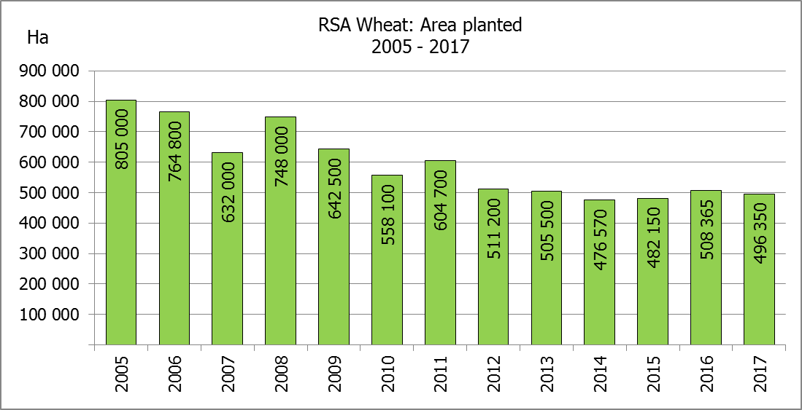
The intentions to plant winter cereals for the 2017 production season is hereby released. /
Hiermee word die voorneme om wintergewasse te plant vir die 2017 produksie-seisoen vrygestel.
WINTERGEWASSE – VOORNEME OM TE PLANT: 2017
WINTER CEREALS –INTENTIONS TO PLANT: 2017
GEWAS/CROP | Voorneme/  Intentions*  2017 | Opp beplant/  Area planted  2016 | Finale skatting/  Final estimate  2016 | Verandering/  Change
GEWAS/CROP | Ha | Ha | Tons | %
GEWAS/CROP | (A) | (B) | (C) | (A) ÷ (B)
Koring/Wheat | 496 350 | 508 365 | 1 909 540 | 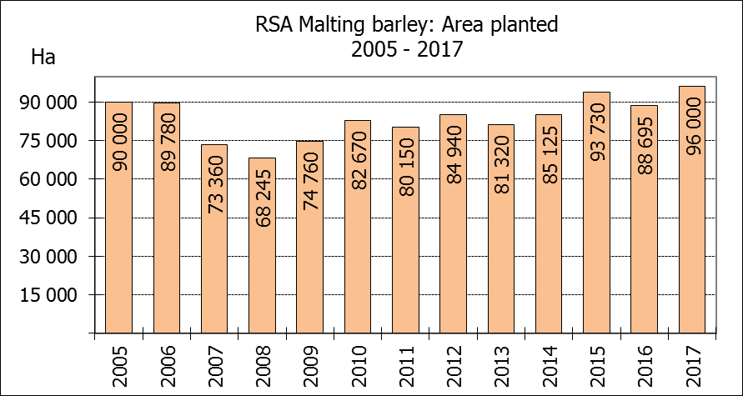  -2,36
Moutgars/Malting barley | 96 000 | 88 695 | 354 065 | +8,24
Kanola/Canola | 90 000 | 68 075 | 105 460 | +32,21
Totaal/Total | 682 350 | 665 135 | 2 369 065 | +2,59

* Based on conditions at the middle of April 2017 / Gebaseer op toestande soos teen middel April 2017.
KORING – VOORNEME OM TE PLANT: 2017
WHEAT – INTENTIONS TO PLANT: 2017

Provinsie/  Province | Voorneme/  Intentions  Ha | Opp beplant/  Area planted  Ha | Finale skatting/  Final estimate  Tons
Provinsie/  Province | 2017 | 2016 | 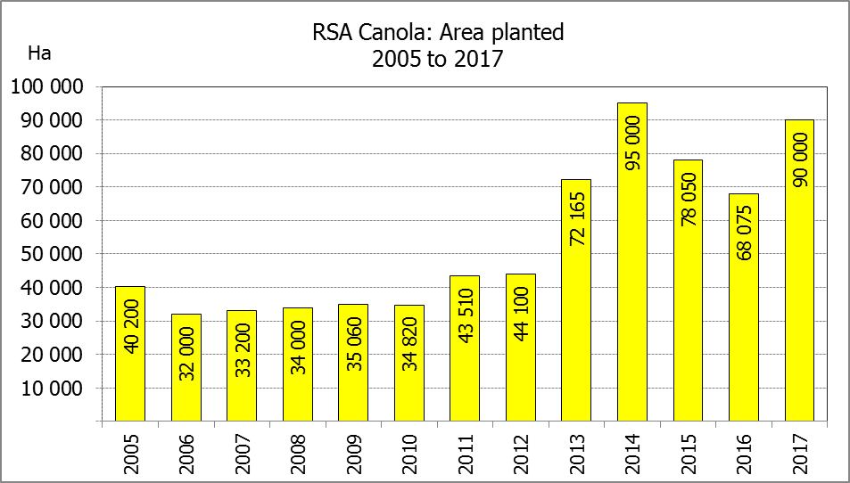  2016
Wes-Kaap/Western Cape | 325 000 | 323 000 | 1 098 200
Noord-Kaap/Northern Cape | 35 500 | 35 000 | 266 000
Vrystaat/Free State | 90 000 | 110 000 | 308 000
Oos-Kaap/Eastern Cape | 1 900 | 2 200 | 11 000
KwaZulu-Natal | 7 500 | 6 500 | 37 050
Mpumalanga | 3 300 | 2 300 | 13 800
Limpopo | 20 000 | 17 000 | 103 700
Gauteng | 350 | 365 | 2 190
Noordwes/North West | 12 800 | 12 000 | 69 600
Totaal/Total | 496 350 | 508 365 | 1 909 540

* Based on conditions at the middle of April 2017 / Gebaseer op toestande soos teen middel April 2017.

INTENTIONS TO PLANT WINTER CROPS FOR 2017 / VOORNEME OM WINTERGEWASSE AAN TE PLANT VIR 2017

Winter cereal crops – 2017  Producers’ intentions to plant winter cereals are based on the results of a non-probability survey conducted by the Directorate: Statistics and Economic Analysis of the Department of Agriculture, Forestry and Fisheries and reflects the position as at the middle of April 2017.  The figures for wheat represent the total number of hectares that are intended to be planted for grain, excluding any hectares that will be planted for fodder and grazing.  Early indications are that producers intend to plant 496 350 ha of wheat for the 2017 season. This is 2,36% or 12 015 ha less than 508 365 ha planted to wheat in 2016. The main producing areas are within the Western Cape with 325 000 ha (65%), followed by the Free State with 90 000 ha (18%) and the Northern Cape with 35 500 ha (7%).  The expected area planted to malting barley is 96 000 ha, which is 8,24% or 7 305 ha more than the 88 695 ha of the previous year. The expected area planted to canola is 90 000 ha, which is 32,21 or 21 925 ha more than the 68 075 ha planted in 2016.  Please note that the preliminary area estimate of winter crops for 2017 will be released on 26 July 2017. |  | Wintergewasse – 2017  Produsente se voorneme om wintergewasse te plant is gebaseer op die resultate van ’n nie-ewekansige opname onderneem deur die Direktoraat: Statistiek en Ekonomiese Analise van die Departement van Landbou, Bosbou en Visserye en weerspieël die situasie teen die middel van April 2017.  Die syfers vir koring verteenwoordig die totale aantal hektare wat werklik beplant gaan word vir graan, uitgesluit alle hektare wat beplant gaan word vir groenvoer en weiding.  Vroeë aanduidings is dat produsente van voorneme is om 496 350 ha koring te plant vir die 2017-produksie-seisoen. Dit is 2,36 of 12 015 ha minder koring aangeplant as in 2016. Die grootste produserende gebiede is in die Wes-Kaap, met 325 000 ha (65%), gevolg deur die Vrystaat met 90 000 ha (18%) en die Noord-Kaap met 35 500 ha (7%).  Die verwagte aanplantings van moutgars is 96 000 ha – 8,24% of 7 305 ha meer as die 88 695 ha van die vorige jaar. Die verwagte aanplantings van kanola is 90 000 ha, wat 32,21% of 21 925 ha meer is as die 68 075 ha wat aangeplant was in 2016.  Neem asseblief kennis dat die voorlopige oppervlakteskatting vir wintergewasse vir 2017 op 26 Julie 2017 vrygestel sal word.
Information is available on the internet at http://www.daff.gov.za/links/crop estimates or http://www.sagis.org.za, as from 15:30 on the date of the relevant meeting of the Crop Estimates Committee. |  | Inligting is beskikbaar op die internet by http://www.daff.gov.za/links/crop estimates of by http://www.sagis.org.za, vanaf 15:30 op die dag van die toepaslike vergadering van die Oesskattingskomitee.

