 | crop estimates committee
 | oesskattingskomitee
From/Van: Mr Baldwin Netshifhefhe  Tel: 012 319 8043/32  Fax/Faks: 012 319 8031  E-mail/E-pos: BaldwinN@dalrrd.gov.za  Web page/Webblad: www.dalrrd.gov.za/old website/statistics and economic reports or  www.sagis.org.za/CEC: Crop Estimates EMBARGO: 14:30 |  |  | 

The area planted estimate and third production forecast for summer crops for 2024 is hereby released.
Hiermee word die oppervlakte- en derde produksieskatting vir somergewasse vir 2024 vrygestel.

SUMMER CROPS – AREA PLANTED AND THIRD PRODUCTION FORECAST: 2024
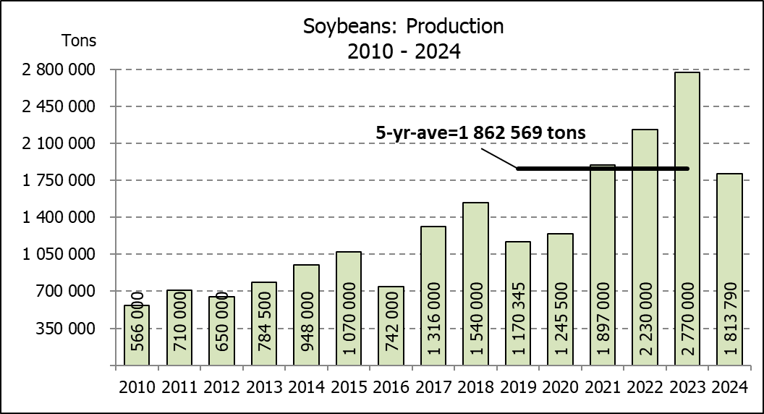
SOMERGEWASSE – OPPERVLAKTE- EN DERDE PRODUKSIESKATTING: 2024
CROP/GEWAS | Area planted/ | 3rd forecast/ | 2nd forecast/ | Area planted/ | Final crop/ | Change/
CROP/GEWAS | Opp beplant | 3de skatting | 2de skatting | Opp beplant | Finale oes | Verandering
CROP/GEWAS | 2024 | 2024 | 2024 | 2023 | 2023
CROP/GEWAS | Ha | Tons | Tons | Ha | Tons | %
CROP/GEWAS | (A) | (B) | (C) | (D) | (E) | (B) ÷ (C)
Commercial/Kommersieël:
White maize/Witmielies | 1 554 750 | 6 406 950 | 6 277 000 | 1 521 300 | 8 505 000 | 2,07%
Yellow maize/Geelmielies | 1 081 500 | 6 984 750 | 6 978 750 | 1 064 800 | 7 925 000 | 0,09%
Total Maize/Totale Mielies | 2 636 250 | 13 391 700 | 13 255 750 | 2 586 100 | 16 430 000 | 1,03%
Sunflower seed/Sonneblomsaad | 529 000 | 615 000 | 589 000 | 555 700 | 720 000 | 4,41%
Soybeans/Sojabone | 1 150 500 | 1 813 790 | 1 813 790 | 1 148 300 | 2 770 000 | 0,00%
Groundnuts/Grondbone | 41 200 | 54 960 | 57 610 | 31 300 | 53 000 | -4,60%
Sorghum | 42 100 | 94 105 | 89 630 | 34 000 | 94 360 | 4,99%
Dry beans/Droëbone | 39 550 | 54 120 | 54 120 | 36 650 | 50 260 | 0,00%
TOTAL/TOTAAL | 4 438 600 | 16 023 675 | 15 859 900 | 4 392 050 | 20 117 620 | 1,03%
Non-Commercial Maize/Nie-Kommersiële Mielies
Total Maize/Totale Mielies | 347 000 | 575 000 | N/A | 358 620 | 664 040 | N/A
Maize/Mielies: Commercial/Kommersieël + Non-Commercial/Nie-Kommersieël
Total Maize RSA/Totaal Mielies RSA | 2 983 250 | 13 966 700 | N/A | 2 944 720 | 17 094 040 | N/A
Note: Estimate is for calendar year, e.g. production season 2023/24 = 2024
Nota: Skatting is vir kalenderjaar, bv. produksie-seisoen 2023/24 = 2024
The Crop Estimates Committee comprises officials of the following institutions:
Department of Agriculture, Land Reform and Rural Development; Provincial Departments of Agriculture; various ARC-Institutes (Soil, Climate and Water; Small Grains Institute; and
Grain Crops Institute); BFAP and Statistics SA.
25 April 2024
The Crop Estimates Committee comprises officials of the following institutions:
Department of Agriculture, Land Reform and Rural Development; Provincial Departments of Agriculture; various ARC-Institutes (Soil, Climate and Water; Small Grains Institute; and Grain Crops Institute); BFAP and Statistics SA.
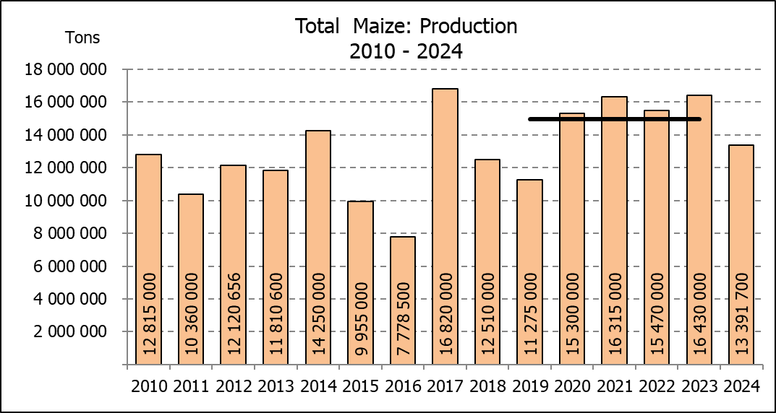

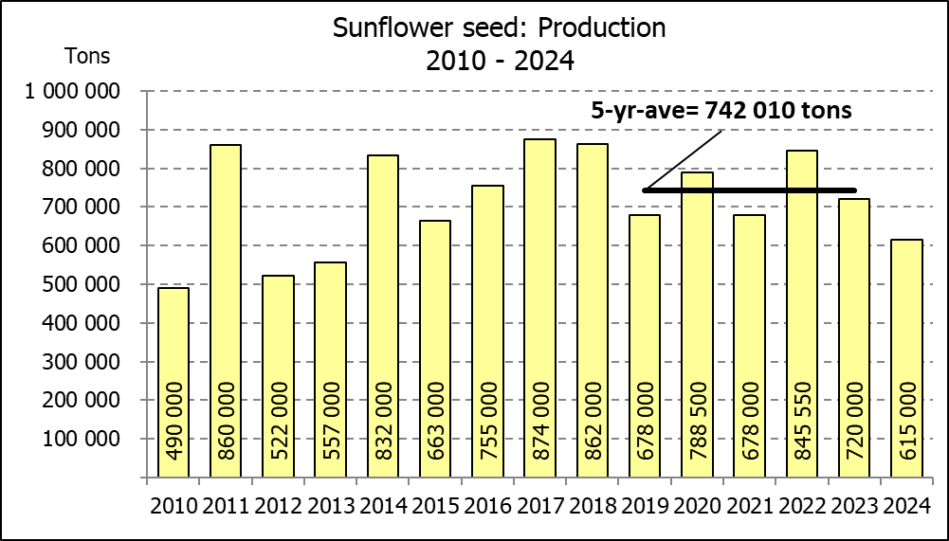

WHITE AND YELLOW MAIZE – AREA PLANTED AND SECOND PRODUCTION FORECAST: 2024
WIT- EN GEELMIELIES – OPPERVLAKTE EN TWEEDE PRODUKSIESKATTING: 2024

Provinsie/ | Area planted/ |  |  | 3rd forecast/ |  |  | Area planted/ |  |  |  | Final crop/
Province | Oppervlakte beplant |  |  | 3de skatting |  |  | Oppervlakte beplant |  |  |  | Finale oes
 | 2024 |  |  | 2024 |  |  | 2023 |  |  |  | 2023
 | White/ | Yellow/ | Total/ | White/ | Yellow/ | Total/ | White/ | Yellow/ | Total/ | White/ |  | Yellow/ | Total/
 | Wit | Geel | Totaal | Wit | Geel | Totaal | Wit | Geel | Totaal | Wit |  | Geel | Totaal
 | Ha | Ha | Ha | Tons | Tons | Tons | Ha | Ha | Ha | Tons |  | Tons | Tons
Western Cape/Wes-Kaap | 250 | 3 500 | 3 750 | 2 300 | 32 200 | 34 500 | 250 | 3 500 | 3 750 | 2 375 |  | 33 000 | 35 375
Northern Cape/Noord-Kaap | 1 500 | 42 000 | 43 500 | 18 750 | 676 200 | 694 950 | 1 000 | 43 500 | 44 500 | 12 500 |  | 696 000 | 708 500
Free State/Vrystaat | 835 000 | 415 000 | 1 250 000 | 3 590 500 | 2 178 750 | 5 769 250 | 780 000 | 401 000 | 1 181 000 | 4 446 000 |  | 2 696 000 | 7 142 000
Eastern Cape/Oos-Kaap | 6 000 | 27 000 | 33 000 | 39 600 | 191 700 | 231 300 | 5 750 | 25 000 | 30 750 | 40 250 |  | 192 500 | 232 750
KwaZulu-Natal | 47 000 | 67 000 | 114 000 | 291 400 | 576 200 | 867 600 | 49 000 | 65 000 | 114 000 | 298 900 |  | 537 000 | 835 900
Mpumalanga | 160 000 | 360 000 | 520 000 | 984 000 | 2 448 000 | 3 432 000 | 156 500 | 352 000 | 508 500 | 1 032 900 |  | 2 596 000 | 3 628 900
Limpopo | 11 000 | 15 000 | 26 000 | 72 600 | 121 500 | 194 100 | 16 800 | 22 800 | 39 600 | 114 075 |  | 187 000 | 301 075
Gauteng | 54 000 | 62 000 | 116 000 | 307 800 | 409 200 | 717 000 | 56 000 | 52 000 | 108 000 | 364 000 |  | 392 500 | 756 500
North West/Noordwes | 440 000 | 90 000 | 530 000 | 1 100 000 | 351 000 | 1 451 000 | 456 000 | 100 000 | 556 000 | 2 194 000 |  | 595 000 | 2 789 000
Total/Totaal | 1 554 750 | 1 081 500 | 2 636 250 | 6 406 950 | 6 984 750 | 13 391 700 | 1 521 300 | 1 064 800 | 2 586 100 | 8 505 000 |  | 7 925 000 | 16 430 000

SUNFLOWER SEED – AREA PLANTED AND SECOND PRODUCTION FORECAST: 2024
SONNEBLOMSAAD – OPPERVLAKTE EN TWEEDE PRODUKSIESKATTING: 2024

Province/ | Area planted/ | 3rd forecast/ | Area planted/ | Final crop/
Provinsie | Opp beplant | 3de skatting | Opp beplant | Finale oes
 | Ha | Tons | Ha | Tons
 | 2024 | 2024 | 2023 | 2023
Western Cape/Wes-Kaap | 0 | 0 | 0 | 0
Northern Cape/Noord-Kaap | 2 000 | 4 600 | 2 500 | 6 250
Free State/Vrystaat | 255 000 | 331 500 | 290 000 | 402 000
Eastern Cape/Oos-Kaap | 700 | 1 400 | 700 | 1 400
KwaZulu-Natal | 300 | 600 | 300 | 600
Mpumalanga | 3 500 | 4 900 | 5 000 | 7 140
Limpopo | 90 000 | 76 500 | 100 000 | 75 000
Gauteng | 2 500 | 3 000 | 2 200 | 2 860
North West/Noordwes | 175 000 | 192 500 | 155 000 | 224 750
Total/Totaal | 529 000 | 615 000 | 555 700 | 720 000
SOYBEANS – AREA PLANTED AND SECOND PRODUCTION FORECAST: 2024
SOJABONE – OPPERVLAKTE EN TWEEDE PRODUKSIESKATTING: 2024
Province/ | Area planted/ | 3rd forecast/ | Area planted/ | Final crop/
Provinsie | Opp beplant | 3de skatting | Opp beplant | Finale oes
 | Ha | Tons | Ha | Tons
 | 2024 | 2024 | 2023 | 2023
Western Cape/Wes-Kaap | 0 | 0 | 0 | 0
Northern Cape/Noord-Kaap | 1 200 | 4 380 | 1 000 | 3 750
Free State/Vrystaat | 545 000 | 708 500 | 565 000 | 1 330 000
Eastern Cape/Oos-Kaap | 5 300 | 14 310 | 4 300 | 12 900
KwaZulu-Natal | 47 000 | 169 200 | 44 000 | 163 000
Mpumalanga | 320 000 | 576 000 | 305 000 | 671 000
Limpopo | 21 000 | 71 400 | 26 000 | 88 500
Gauteng | 56 000 | 84 000 | 48 000 | 105 600
North West/Noordwes | 155 000 | 186 000 | 155 000 | 395 250
Total/Totaal | 1 150 500 | 1 813 790 | 1 148 300 | 2 770 000

GROUNDNUTS – AREA PLANTED AND SECOND PRODUCTION FORECAST: 2024
GRONDBONE – OPPERVLAKTE EN TWEEDE PRODUKSIESKATTING: 2024

Province/ | Area planted/ | 3rd forecast/ | Area planted/ | Final crop/
Provinsie | Opp beplant | 3de skatting | Opp beplant | Finale oes
 | Ha | Tons | Ha | Tons
 | 2024 | 2024 | 2023 | 2023
Western Cape/Wes-Kaap | 0 | 0 | 0 | 0
Northern Cape/Noord-Kaap | 4 200 | 11 970 | 2 000 | 5 300
Free State/Vrystaat | 17 000 | 23 800 | 12 300 | 21 000
Eastern Cape/Oos-Kaap | 0 | 0 | 0 | 0
KwaZulu-Natal | 300 | 795 | 0 | 0
Mpumalanga | 0 | 0 | 0 | 0
Limpopo | 1 700 | 3 995 | 2 000 | 4 700
Gauteng | 0 | 0 | 0 | 0
North West/Noordwes | 18 000 | 14 400 | 15 000 | 22 000
Total/Totaal | 41 200 | 54 960 | 31 300 | 53 000

SORGHUM – AREA PLANTED AND SECOND PRODUCTION FORECAST: 2024
SORGHUM – OPPERVLAKTE EN TWEEDE PRODUKSIESKATTING: 2024

Province/ | Area planted/ | 3rd forecast/ | Area planted/ | Final crop/
Provinsie | Opp beplant | 3de skatting | Opp beplant | Finale oes
 | Ha | Tons | Ha | Tons
 | 2024 | 2024 | 2023 | 2023
Western Cape/Wes-Kaap | 0 | 0 | 0 | 0
Northern Cape/Noord-Kaap | 0 | 0 | 0 | 0
Free State/Vrystaat | 11 500 | 16 675 | 5 200 | 14 820
Eastern Cape/Oos-Kaap | 100 | 300 | 0 | 0
KwaZulu-Natal | 100 | 350 | 100 | 400
Mpumalanga | 8 300 | 35 690 | 8 500 | 35 275
Limpopo | 18 000 | 35 100 | 15 500 | 33 325
Gauteng | 100 | 390 | 100 | 420
North West/Noordwes | 4 000 | 5 600 | 4 600 | 10 120
Total/Totaal | 42 100 | 94 105 | 34 000 | 94 360

DRY BEANS – AREA PLANTED AND SECOND PRODUCTION FORECAST: 2024
DROëBONE – OPPERVLAKTE EN TWEEDE PRODUKSIESKATTING: 2024

Province/ | Area planted/ | 3rd forecast/ | Area planted/ | Final crop/
Provinsie | Opp beplant | 3de skatting | Opp beplant | Finale oes
 | Ha | Tons | Ha | Tons
 | 2024 | 2024 | 2023 | 2023
Western Cape/Wes-Kaap | 100 | 200 | 100 | 180
Northern Cape/Noord-Kaap | 500 | 1 050 | 450 | 990
Free State/Vrystaat | 13 500 | 12 825 | 14 000 | 13 300
Eastern Cape/Oos-Kaap | 200 | 400 | 200 | 360
KwaZulu-Natal | 2 100 | 2 520 | 2 100 | 3 150
Mpumalanga | 2 600 | 4 290 | 5 000 | 7 000
Limpopo | 12 200 | 24 400 | 8 000 | 16 000
Gauteng | 850 | 935 | 800 | 880
North West/Noordwes | 7 500 | 7 500 | 6 000 | 8 400
Total/Totaal | 39 550 | 54 120 | 36 650 | 50 260

CONFIDENTIALITY ISSUES that CEC members are committed to adhere to on the day of the meeting
- Personal items such as laptops, handbags, cell phones, etc. are not allowed in the venue during the meeting
- No member is allowed to leave the meeting before 12:00 in order to prevent disclosure of the information
- The embargo time for the release of crop estimates information is 14:30
- No member is allowed to discuss crop estimates information with anyone other than a member of the Committee before the embargo time
- Only the Chairperson, or a member appointed by the Chairperson, may release the figures to the media
- Members must regard the detail of any information that was collected for and/or discussed during the meeting, as confidential
- Individual information received for crop estimate purposes is treated strictly confidential, and is not divulged for any other purposes

AREA ESTIMATE AND THIRD PRODUCTION FORECAST OF SUMMER CROPS (2024 PRODUCTION SEASON)/
OPPERVLAKTE- EN DERDE PRODUKSIESKATTING VIR SOMERGEWASSE (2024 PRODUKSIE-SEISOEN)
25 APRIL 2024

Summer field crops – 2024  Commercial maize: The size of the expected commercial maize crop has been set at 13,392 mill. tons, which is 1,03% or 135 950 tons more than the previous forecast of 13,256 mill. tons. The expected yield for maize is 5,08 t/ha.  The estimated maize crop is 18,49% or 3,038 mill. tons smaller than the 2023 crop. The three main maize producing areas, namely the Free State, Mpumalanga and North West provinces are expected to produce 80% of the 2024 crop.  The production forecast of white maize is 6,407 mill. tons, which is 2,07% or  129 950 tons more than the 6,277 mill. tons of the previous forecast. The area estimate for white maize is 1,555 mill. ha and the expected yield is 4,12 t/ha.  In the case of yellow maize, the production forecast is 6,985 mill. tons, which is 0,09% or 6 000 tons more than the 6,979 mill. tons of the previous forecast. The area estimate for yellow maize is 1,082 mill. ha and the yield is 6,46 t/ha.  The yield per ha for the Mpumalanga province was based on scientific and objective results provided by the ARC. Please note that the objective results for the Free State and North West provinces will be available in May 2024.  Other summer crops:  Sunflower seed: The production forecast for sunflower seed is 615 000 tons, which is 4,41% or 26 000 tons more than the previous forecast of 589 000 tons. The area estimate for sunflower seed is 529 000 ha, while the expected yield is 1,16 t/ha.  Other crops: The production forecast for soybeans remained unchanged at 1,814 mill. tons. The estimated area planted to soybeans is 1,151 mill. ha, with an expected yield of 1,58 t/ha.  The expected groundnut crop has been set at 54 960 tons, which is 4,60% or 2 650 tons less than the previous forecast of 57 610 tons. For groundnuts, the area estimate is 41 200 ha, with an expected yield of 1,33 t/ha.  The production forecast for sorghum is 94 105 tons, which is 4,99% or 4 475 tons more than the 89 630 tons of the previous forecast. The area estimate for sorghum is 42 100 ha and the expected yield is 2,24 t/ha.  In the case of dry beans, the production forecast remained unchanged at 54 120 tons. The area estimate of dry beans is 39 550 ha, with an expected yield of 1,37 t/ha.  Please note that the fourth production forecast for summer field crops for 2024 will be released on 28 May 2024. |  | Somergewasse – 2024  Kommersiële mielies: Die grootte van die verwagte kommersiële mielie-oes is op 13,392 milj. ton gestel, wat 1,03% of 135 950 ton meer is as die vorige skatting van 13,256 milj. ton. Die verwagte opbrengs van mielies is 5,08 t/ha.  Die geskatte mielie-oes is 18,49% of 3,038 milj. ton minder as die 2023-oes. Die drie belangrikste mielieproduserende gebiede, nl. die Vrystaat, Mpumalanga en Noordwes provinsies, gaan na verwagting 80% van die 2024-oes produseer.  Die produksieskatting van witmielies is 6,407 milj. ton, wat 2,07% of 129 950 ton meer is as die 6,277 milj. ton van die vorige skatting. Die oppervlakteskatting vir witmielies is 1,555 milj. ha en die verwagte opbrengs is 4,12 t/ha.  In die geval van geelmielies is die produksieskatting 6,985 milj. ton, wat 0,09% of  6 000 ton meer is as die 6,979 milj. ton van die vorige skatting. Die oppervlakteskatting vir geelmielies is 1,082 milj. ha en die opbrengs is 6,46 t/ha.  Die opbrengs-bepaling per ha vir die Mpumalanga provinsie is gebaseer op wetenskaplike en objektiewe resultate verstrek deur die LNR. Neem kennis dat die objektiewe resultate vir die Vrystaat en Noordwes provinsies, in Mei 2024 gerapporteer sal word.  Ander somergewasse:  Sonneblomsaad: Die produksieskatting vir sonneblomsaad is 615 000 ton, wat 4,41% of 26 000 ton meer is as die vorige skatting van 589 000 ton. Die oppervlakteskatting vir sonneblomsaad is 529 000 ha, terwyl die verwagte opbrengs 1,16 t/ha is.  Ander gewasse: Die produksieskatting van sojabone is onveranderd gelaat op 1,814 milj. ton. Die geskatte oppervlakte beplant van sojabone is 1,151 milj. ha, met ‘n verwagte opbrengs van 1,58 t/ha.  Die verwagte grondbone-oes is op 54 960 ton gestel, wat 4,60% of 2 650 ton minder is as die vorige skatting van 57 610 ton. Vir grondbone is die oppervlakteskatting 41 200 ha, terwyl the verwagte opbrengs 1,33 t/ha is.  Die produksieskatting van sorghum is 94 105 ton, wat 4,99% of 4 475 ton meer is as die 89 630 ton van die vorige skatting. Die oppervlakteskatting vir sorghum is 42 100 ha, en die verwagte opbrengs is 2,24 t/ha.  In die geval van droëbone is die produksieskatting onveranderd gelaat op 54 120 ton. Die oppervlakte beplant met droëbone is 39 550 ha, en die verwagte opbrengs is 1,37 t/ha.  Neem asseblief kennis dat die vierde produksieskatting vir somergewasse vir 2024, op 28 Mei 2024 vrygestel sal word.
Information is available on the internet at http:// www.dalrrd.gov.za/old website/statistics or http://www.sagis.org.za, as from 14:30 on the date of the relevant meeting of the Crop Estimates Committee. |  | Inligting is beskikbaar op die internet by http://www.dalrrd.gov.za/old website/statistics of by http://www.sagis.org.za, vanaf 14:30 op die dag van die toepaslike vergadering van die Oesskattingskomitee.

The non-commercial agricultural sectors’ production estimate for maize for 2024 is hereby released. /
Hiermee word die nie-kommersiële landbou-sektor se produksieskatting vir mielies vir 2024 vrygestel.

NON-COMMERCIAL MAIZE – PRELIMINARY AREA PLANTED AND PRODUCTION ESTIMATE: 2024
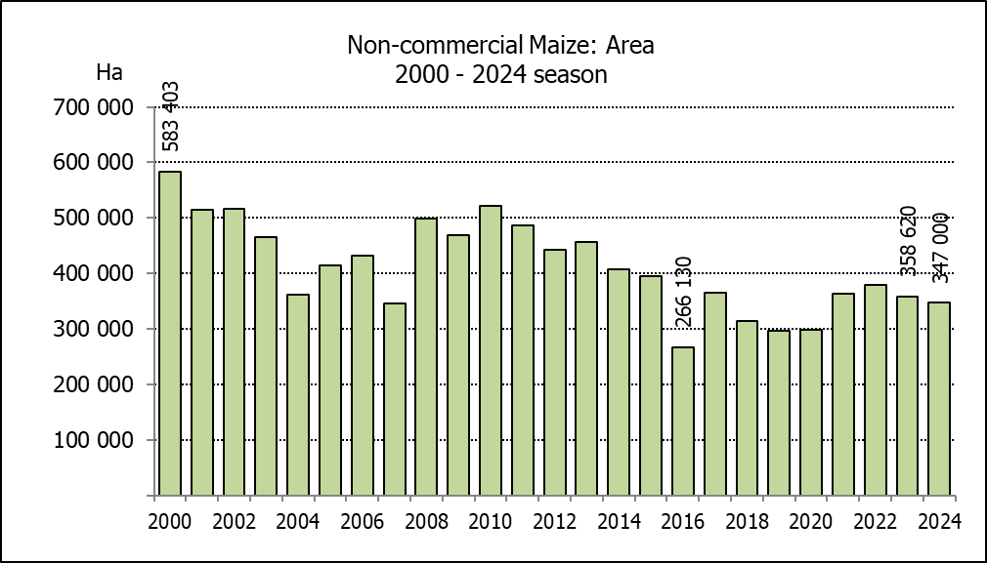
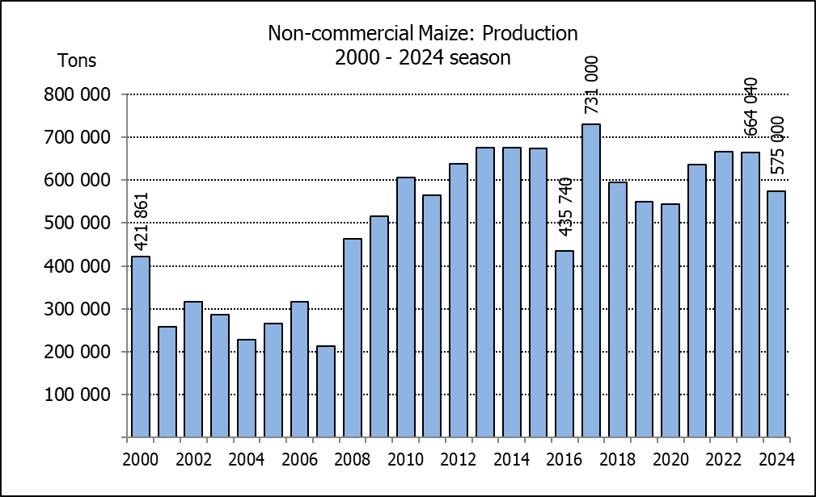
NIE-KOMMERSIëLE MIELIES – VOORLOPIGE OPPERVLAKTE- EN PRODUKSIESKATTING: 2024
CROP/GEWAS | Area planted/  Opp beplant  2024 | Production/  Produksie  2024 | Area planted/  Opp beplant  2023 | Final crop/  Finale oes  2023 | Change/  Verandering
CROP/GEWAS | Ha | Tons | Ha | Tons | %
CROP/GEWAS | (A) | (B) | (C) | (D) | (B) ÷ (D)
Non-commercial agriculture/Nie-kommersiële landbou:
White maize/Witmielies | 267 570 | 407 500 | 278 655 | 472 765 | -13,80
Yellow maize/Geelmielies | 79 430 | 167 500 | 79 965 | 191 275 | -12,43
Maize/Mielies | 347 000 | 575 000 | 358 620 | 664 040 | -13,41
The area planted to maize in the non-commercial agricultural sector is estimated at 347 000 ha, which represents a decrease of 3,24%, compared to the 358 620 ha of the previous season. The expected maize crop for this sector is 575 000 tons, which is 13,41% less than the 664 040 tons of last season. It is important to note that about 46% of the maize produced in the non-commercial sector, is planted in the Eastern Cape, followed by KwaZulu-Natal with 22%.
Die voorlopige oppervlakte beplant met mielies in die nie-kommersiële landbou-sektor word geskat op 347 000 ha, wat ’n afname van 3,24% verteenwoordig in vergelyking met die 358 620 ha van die vorige seisoen. Die verwagte mielie-oes van dié sektor is 575 000 ton, wat 13,41% minder is as die 664 040 ton van die vorige seisoen. Dit is belangrik om daarop te let dat ongeveer 46% van die mielies wat geproduseer word in die nie-kommersiële sektor, in die Oos-Kaap geplant word, gevolg deur KwaZulu-Natal met 22%.

The intentions to plant winter cereals for the 2024 production season is hereby released. /
Hiermee word die voorneme om wintergewasse te plant vir die 2024 produksie-seisoen vrygestel.
WINTERGEWASSE – VOORNEME OM TE PLANT: 2024
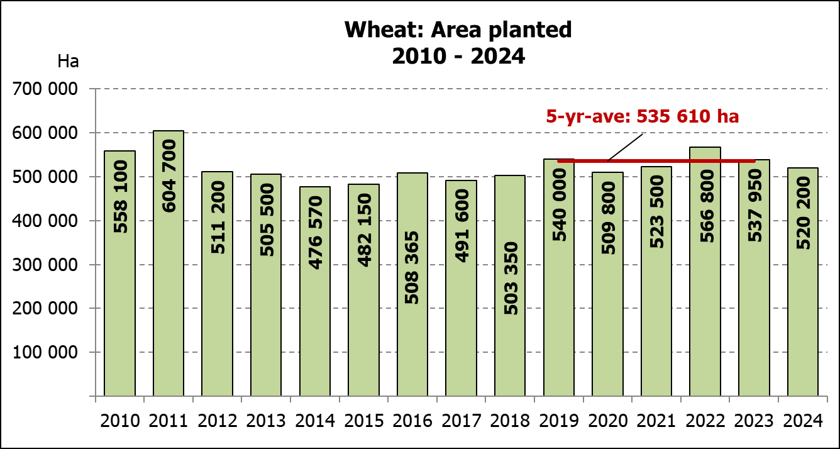
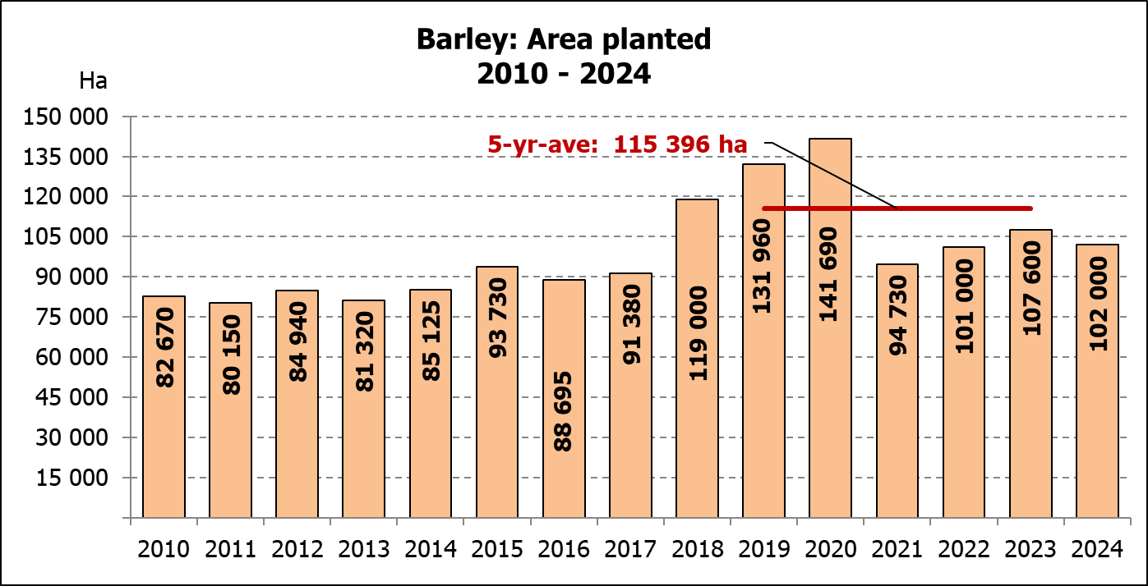
WINTER CEREALS –INTENTIONS TO PLANT: 2024
GEWAS/CROP | Voorneme/  Intentions*  2024 | Opp beplant/  Area planted  2023 | Finale skatting/  Final estimate  2023 | Verandering/  Change
GEWAS/CROP | Ha | Ha | Tons | %
GEWAS/CROP | (A) | (B) | (C) | (A) ÷ (B)
Wheat/Koring | 520 200 | 537 950 | 2 078 025 | -3,3%
Malting barley/Moutgars | 102 000 | 107 600 | 376 195 | -5,2%
Canola/Kanola | 141 100 | 131 200 | 237 450 | 7,5%
Cereal oats/Hawermout | 20 500 | 27 500 | 40 250 | -25,5%
Sweet lupines/Soetlupine | 15 000 | 16 000 | 16 000 | -6,3%
Total winter cereals/Totaal wintergewasse | 798 800 | 820 250 | 2 747 920 | -2,6%
* Based on conditions at the middle of April 2024 / Gebaseer op toestande soos teen middel April 2024.
KORING – VOORNEME OM TE PLANT: 2024
WHEAT – INTENTIONS TO PLANT: 2024
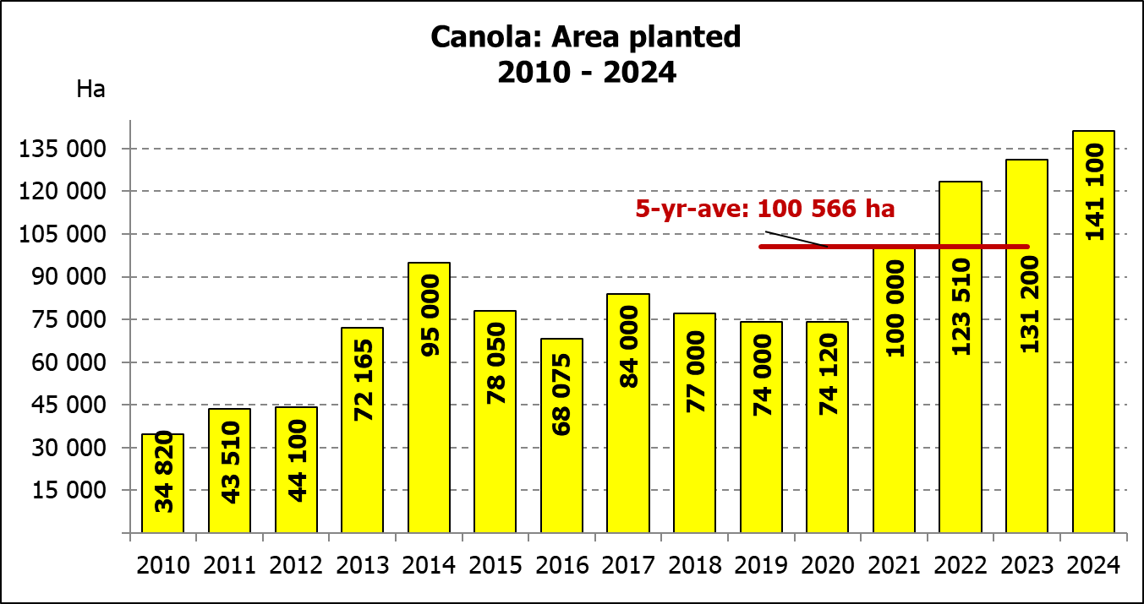
Provinsie/  Province | Voorneme/  Intentions  Ha | Opp beplant/  Area planted  Ha | Finale skatting/  Final estimate  Tons
Provinsie/  Province | 2024 | 2023 | 2023
Wes-Kaap/Western Cape | 370 000 | 365 000 | 1 095 000
Noord-Kaap/Northern Cape | 40 000 | 40 000 | 296 000
Vrystaat/Free State | 55 000 | 72 000 | 288 000
Oos-Kaap/Eastern Cape | 5 000 | 6 300 | 40 950
KwaZulu-Natal | 8 000 | 8 500 | 56 950
Mpumalanga | 3 700 | 4 200 | 28 560
Limpopo | 25 000 | 30 000 | 198 000
Gauteng | 1 000 | 950 | 6 365
Noordwes/North West | 12 500 | 11 000 | 68 200
Totaal/Total | 520 200 | 537 950 | 2 078 025
2024: Intentions/Voornemens

INTENTIONS TO PLANT WINTER CROPS FOR 2024 / VOORNEME OM WINTERGEWASSE AAN TE PLANT VIR 2024

Winter cereal crops – 2024  Producers’ intentions to plant winter cereals are mainly based on the results of a non-probability survey conducted by the Directorate: Statistics and Economic Analysis of the Department of Agriculture, Land Reform and Rural Development and reflects the position as at the middle of April 2024. Inputs were also received from the representatives of the respective Provincial Departments of Agriculture.  The figures for wheat represent the total number of hectares that are intended to be planted for grain, excluding any hectares that will be planted for fodder and grazing.  Early indications are that producers intend to plant 520 200 ha of wheat for the 2024 production season. This is 3,30% or 17 750 ha less than the 537 950 ha planted to wheat in 2023.  The main producing areas are within the Western Cape with 370 000 ha (71%), followed by the Free State with 55 000 ha (11%) and the Northern Cape with 40 000 ha (8%).  The expected area planted to malting barley is 102 000 ha, which is 5,20% or 5 600 ha less than the 107 600 ha of the previous year. The expected area planted to canola is also 141 100 ha, which is 7,55% or 9 900 ha more than the 131 200 ha planted in 2023. Producers intend to plant 20 500 ha of cereal oats, which is 25,45% or 7 000 ha less than the 27 500 ha of the previous season. The expected area planted to sweet lupines is 15 000 ha, which is 6,25% or 1 000 ha less than the previous season.  Please note that the preliminary area estimate of winter crops for 2024 will be released on 26 July 2024. |  | Wintergewasse – 2024  Produsente se voorneme om wintergewasse te plant is hoofsaaklik gebaseer op die resultate van ’n nie-ewekansige opname onderneem deur die Direktoraat: Statistiek en Ekonomiese Analise van die Departement van Landbou, Grondhervorming en Landelike Ontwikkeling en weerspieël die situasie teen die middel van April 2024. Insette is ook ontvang vanaf die verteenwoordigers van die onderskeie Provinsiale Departemente van Landbou.  Die syfers vir koring verteenwoordig die totale aantal hektare wat werklik beplant gaan word vir graan, uitgesluit alle hektare wat beplant gaan word vir groenvoer en weiding.  Vroeë aanduidings is dat produsente van voorneme is om 520 200 ha koring te plant vir die 2024-produksie-seisoen. Dit is 3,30% of 17 750 ha minder koring aangeplant as die 537 950 ha in 2023.  Die grootste produserende gebiede is in die Wes-Kaap, met 370 000 ha (71%), gevolg deur die Vrystaat met 55 000 ha (11%) en die Noord-Kaap met  40 000 ha (8%).  Die verwagte aanplantings van moutgars is 102 000 ha – 5,20% of 5 600 ha minder as die 107 600 ha van die vorige jaar. Die verwagte aanplantings van kanola is ook 141 000 ha, wat 7,55% of 9 900 ha meer is as die 131 200 ha wat aangeplant was in 2023. Produsente is van voorneme om 20 500 ha hawermout te plant, wat 25,45% of 7 000 ha minder is as die 27 500 ha van die vorige seisoen. Die verwagte aanplantings van soetlupine is 15 000 ha, wat 6,25% of 1 000 ha minder is as die vorige seisoen.  Neem asseblief kennis dat die voorlopige oppervlakteskatting vir wintergewasse vir 2023 op 26 Julie 2024 vrygestel sal word.
Information is available on the internet at http:// www.dalrrd.gov.za/statistics or http://www.sagis.org.za, as from 14:30 on the date of the relevant meeting of the Crop Estimates Committee. |  | Inligting is beskikbaar op die internet by http://www.dalrrd.gov.za/statistics of by http://www.sagis.org.za, vanaf 14:30 op die dag van die toepaslike vergadering van die Oesskattingskomitee.

