 | crop estimates committee | 
 | oesskattingskomitee
From/Van: Mr Baldwin Netshifhefhe
Tel: 012 319 8043  Fax/Faks: 012 319 8031  E-mail/E-pos: BaldwinN@daff.gov.za
Web page/Webblad: www.daff.gov.za/statistics and economic reports or www.sagis.org.za/CEC: Crop Estimates
EMBARGO: 14:30

The area planted estimate and third production forecast for summer crops for 2020 is hereby released.
Hiermee word die oppervlakte- en derde produksieskatting vir somergewasse vir 2020 vrygestel.

SUMMER CROPS – AREA PLANTED AND THIRD PRODUCTION FORECAST: 2020
SOMERGEWASSE – OPPERVLAKTE- EN DERDE PRODUKSIESKATTING: 2020
CROP/GEWAS | Area planted/  Opp beplant  2020 | 3rd forecast/  3de skatting  2020 | 2ndforecast/  2de skatting  2020 | Area planted/  Opp beplant  2019 | Final crop/  Finale oes  2019 | Change/  Verandering/
CROP/GEWAS | Ha | Tons | Tons | Ha | Tons | %
CROP/GEWAS | (A) | (B) | (C) | (D) | (E) | (B) ÷ (C)
Commercial/Kommersieël:
White maize/Witmielies | 1 616 300 | 8 779 470 | 8 523 465 | 1 298 400 | 5 545 000 | +3,00
Yellow maize/Geelmielies | 994 500 | 6 442 050 | 6 285 885 | 1 002 100 | 5 730 000 | +2,48
Total Maize/Totale Mielies | 2 610 800 | 15 221 520 | 14 809 350 | 2 300 500 | 11 275 000 | +2,78
Sunflower seed/Sonneblomsaad | 500 300 | 731 210 | 731 210 | 515 350 | 678 000 | -
Soybeans/Sojabone | 705 000 | 1 290 750 | 1 269 150 | 730 500 | 1 170 345 | +1,70
Groundnuts/Grondbone | 37 500 | 62 470 | 56 060 | 20 050 | 19 400 | +11,43
Sorghum | 42 500 | 138 885 | 132 810 | 50 500 | 127 000 | +4,57
Dry beans/Droëbone | 50 150 | 71 380 | 72 910 | 59 300 | 66 355 | -2,10
TOTAL/TOTAAL | 3 946 250 | 17 516 215 | 17 071 490 | 3 676 200 | 13 336 100 | +2,61
Note: Estimate is for calendar year, e.g. production season 2019/20 = 2020
Nota: Skatting is vir kalenderjaar, bv. produksie-seisoen 2019/20 = 2020

29 April 2020

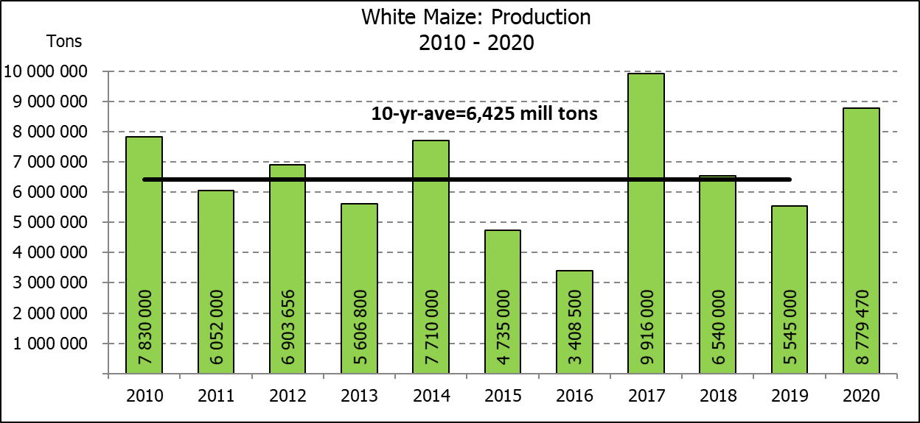

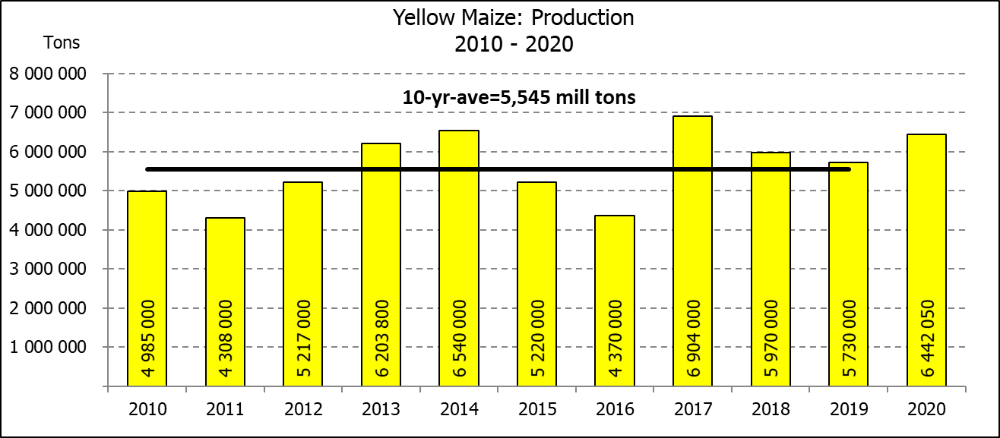

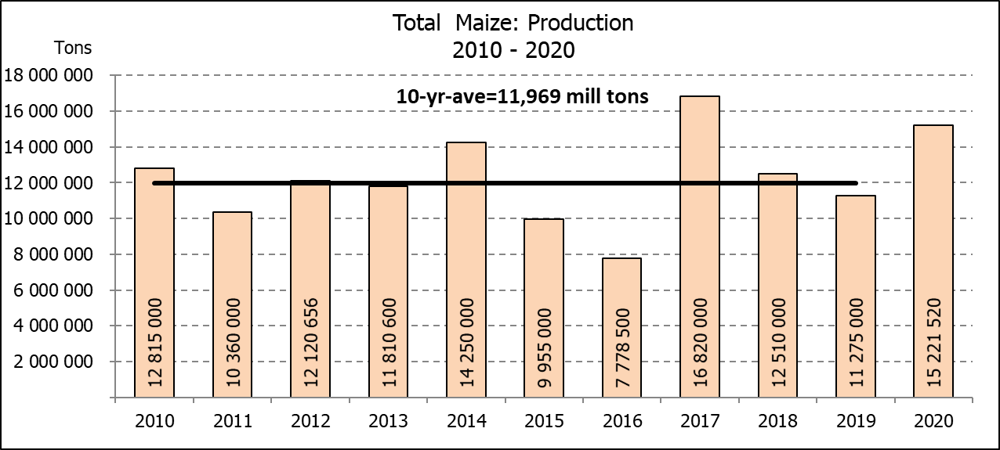

WHITE AND YELLOW MAIZE – AREA PLANTED AND THIRD PRODUCTION FORECAST: 2020
WIT- EN GEELMIELIES – OPPERVLAKTE EN DERDE PRODUKSIESKATTING: 2020

Provinsie/  Province | Area planted/  Oppervlakte beplant  2020 |  |  | 3rd forecast/  3de skatting  2020 |  |  | Area planted/  Oppervlakte beplant  2019 |  |  | Final crop/  Finale oes  2019
Provinsie/  Province | White/  Wit  Ha | Yellow/  Geel  Ha | Total/  Totaal  Ha | White/  Wit  Tons | Yellow/  Geel  Tons | Total/  Totaal  Tons | White/  Wit  Ha | Yellow/  Geel  Ha | Total/  Totaal  Ha | White/  Wit  Tons | Yellow/  Geel  Tons | Total/  Totaal  Tons
Western Cape/Wes-Kaap | 400 | 3 400 | 3 800 | 3 600 | 30 600 | 34 200 | 400 | 3 400 | 3 800 | 3 600 | 30 600 | 34 200
Northern Cape/Noord-Kaap | 3 400 | 43 100 | 46 500 | 40 120 | 624 950 | 665 070 | 3 400 | 43 500 | 46 900 | 39 500 | 630 750 | 670 250
Free State/Vrystaat | 855 000 | 365 000 | 1 220 000 | 4 788 000 | 2 044 000 | 6 832 000 | 650 000 | 380 000 | 1 030 000 | 2 795 000 | 1 758 000 | 4 553 000
Eastern Cape/Oos-Kaap | 5 500 | 17 000 | 22 500 | 36 300 | 119 000 | 155 300 | 3 800 | 10 200 | 14 000 | 23 000 | 69 750 | 92 750
KwaZulu-Natal | 47 000 | 55 000 | 102 000 | 310 200 | 429 000 | 739 200 | 45 000 | 54 000 | 99 000 | 270 000 | 399 600 | 669 600
Mpumalanga | 160 000 | 353 000 | 513 000 | 952 000 | 2 294 500 | 3 246 500 | 145 000 | 338 000 | 483 000 | 797 500 | 1 977 300 | 2 774 800
Limpopo | 15 000 | 18 000 | 33 000 | 105 000 | 126 000 | 231 000 | 12 800 | 18 000 | 30 800 | 83 200 | 117 000 | 200 200
Gauteng | 55 000 | 50 000 | 105 000 | 335 500 | 315 000 | 650 500 | 48 000 | 60 000 | 108 000 | 259 200 | 348 000 | 607 200
North West/Noordwes | 475 000 | 90 000 | 565 000 | 2 208 750 | 459 000 | 2 667 750 | 390 000 | 95 000 | 485 000 | 1 274 000 | 399 000 | 1 673 000
Total/Totaal | 1 616 300 | 994 500 | 2 610 800 | 8 779 470 | 6 442 050 | 15 221 520 | 1 298 400 | 1 002 100 | 2 300 500 | 5 545 000 | 5 730 000 | 11 275 000

SUNFLOWER SEED – AREA PLANTED AND THIRD PRODUCTION FORECAST: 2020
SONNEBLOMSAAD – OPPERVLAKTE EN DERDE PRODUKSIESKATTING: 2020

Province/  Provinsie | Area planted/  Opp beplant  Ha | 3rd forecast/  3de skatting  Tons | Area planted/  Opp beplant  Ha | Final crop/  Finale oes  Tons
Province/  Provinsie | 2020 | 2020 | 2019 | 2019
Western Cape/Wes-Kaap | - | - | - | -
Northern Cape/Noord-Kaap | 1 200 | 1 440 | 950 | 1 140
Free State/Vrystaat | 260 000 | 416 000 | 270 000 | 391 500
Eastern Cape/Oos-Kaap | 300 | 750 | 100 | 260
KwaZulu-Natal | - | - | - | -
Mpumalanga | 2 800 | 3 920 | 4 500 | 4 500
Limpopo | 65 000 | 61 750 | 61 000 | 61 000
Gauteng | 4 000 | 5 200 | 3 800 | 3 800
North West/Noordwes | 167 000 | 242 150 | 175 000 | 215 800
Total/Totaal | 500 300 | 731 210 | 515 350 | 678 000
SOYBEANS – AREA PLANTED AND THIRD PRODUCTION FORECAST: 2020
SOJABONE – OPPERVLAKTE EN DERDE PRODUKSIESKATTING: 2020

Province/  Provinsie | Area planted/  Opp beplant  Ha | 3rd forecast/  3de skatting Tons | Area planted/  Opp beplant  Ha | Final crop/  Finale oes  Tons
Province/  Provinsie | 2020 | 2020 | 2019 | 2019
Western Cape/Wes-Kaap |  |  | 100 | 10
Northern Cape/Noord-Kaap | 2 000 | 7 000 | 1 550 | 5 425
Free State/Vrystaat | 315 000 | 535 500 | 301 000 | 391 300
Eastern Cape/Oos-Kaap | 1 500 | 3 000 | 1 150 | 1 380
KwaZulu-Natal | 35 000 | 105 000 | 33 000 | 99 000
Mpumalanga | 260 000 | 442 000 | 310 000 | 511 500
Limpopo | 15 500 | 48 050 | 16 200 | 46 980
Gauteng | 36 000 | 70 200 | 31 500 | 66 150
North West/Noordwes | 40 000 | 80 000 | 36 000 | 48 600
Total/Totaal | 705 000 | 1 290 750 | 730 500 | 1 170 345

GROUNDNUTS – AREA PLANTED AND THIRD PRODUCTION FORECAST: 2020
GRONDBONE – OPPERVLAKTE EN DERDE PRODUKSIESKATTING: 2020

Province/  Provinsie | Area planted/  Opp beplant  Ha | 3rd forecast/  3de skatting  Tons | Area planted/  Opp beplant  Ha | Final crop/  Finale oes  Tons
Province/  Provinsie | 2020 | 2020 | 2019 | 2019
Western Cape/Wes-Kaap | - | - | - | -
Northern Cape/Noord-Kaap | 1 200 | 3 300 | 1 200 | 2 520
Free State/Vrystaat | 11 000 | 20 350 | 8 000 | 9 775
Eastern Cape/Oos-Kaap | - | - | - | -
KwaZulu-Natal | - | - | - | -
Mpumalanga | - | - | - | -
Limpopo | 2 900 | 5 220 | 1 850 | 3 530
Gauteng | - | - | - | -
North West/Noordwes | 22 400 | 33 600 | 9 000 | 3 575
Total/Totaal | 37 500 | 62 470 | 20 050 | 19 400

SORGHUM – AREA PLANTED AND THIRD PRODUCTION FORECAST: 2020
SORGHUM – HERSIENE OPPERVLAKTE EN DERDE PRODUKSIESKATTING: 2020

Province/  Provinsie | Area planted/  Opp beplant  Ha | 3rd forecast/  3de skatting Tons | Area planted/  Opp beplant  Ha | Final crop/  Finale oes  Tons
Province/  Provinsie | 2020 | 2020 | 2019 | 2019
Western Cape/Wes-Kaap | - | - | - | -
Northern Cape/Noord-Kaap | - | - | - | -
Free State/Vrystaat | 8 000 | 29 600 | 8 000 | 23 600
Eastern Cape/Oos-Kaap | - | - | - | -
KwaZulu-Natal | 1 200 | 3 000 | 500 | 1 500
Mpumalanga | 8 500 | 41 650 | 7 500 | 36 000
Limpopo | 16 000 | 35 200 | 25 000 | 46 125
Gauteng | 300 | 960 | 1 000 | 3 200
North West/Noordwes | 8 500 | 28 475 | 8 500 | 16 575
Total/Totaal | 42 500 | 138 885 | 50 500 | 127 000

DRY BEANS – AREA PLANTED AND THIRD PRODUCTION FORECAST: 2020
DROëBONE – OPPERVLAKTE EN DERDE PRODUKSIESKATTING: 2020

Province/  Provinsie | Area planted/  Opp beplant  Ha | 3rd forecast/  3de skatting Tons | Area planted/  Opp beplant  Ha | Final crop/  Finale oes  Tons
Province/  Provinsie | 2020 | 2020 | 2019 | 2019
Western Cape/Wes-Kaap | 100 | 150 | 100 | 180
Northern Cape/Noord-Kaap | 350 | 700 | 1 000 | 1 400
Free State/Vrystaat | 24 000 | 31 200 | 27 000 | 28 350
Eastern Cape/Oos-Kaap | 200 | 300 | 400 | 720
KwaZulu-Natal | 2 900 | 3 770 | 3 500 | 4 025
Mpumalanga | 6 600 | 8 580 | 7 500 | 6 750
Limpopo | 8 400 | 16 800 | 7 800 | 12 480
Gauteng | 600 | 780 | 1 500 | 1 950
North West/Noordwes | 7 000 | 9 100 | 10 500 | 10 500
Total/Totaal | 50 150 | 71 380 | 59 300 | 66 355

CONFIDENTIALITY ISSUES that CEC members are committed to adhere to on the day of the meeting
- Personal items such as laptops, handbags, cell phones, etc. are not allowed in the venue during the meeting
- No member is allowed to leave the meeting before 12:00 in order to prevent disclosure of the information
- The embargo time for the release of crop estimates information is 14:30
- No member is allowed to discuss crop estimates information with anyone other than a member of the Committee before the embargo time
- Only the Chairperson, or a member appointed by the Chairperson, may release the figures to the media
- Members must regard the detail of any information that was collected for and/or discussed during the meeting, as confidential
- Individual information received for crop estimate purposes is treated strictly confidential, and is not divulged for any other purposes

AREA ESTIMATE AND THIRD PRODUCTION FORECAST OF SUMMER CROPS (2020 PRODUCTION SEASON)/
OPPERVLAKTE- EN DERDE PRODUKSIESKATTING VIR SOMERGEWASSE (2020 PRODUKSIE-SEISOEN)
29 APRIL 2020

Summer field crops – 2020  Commercial maize: The size of the expected commercial maize crop has been set at 15,222 mill. tons, which is 2,78% or 412 170 tons more than the previous forecast of 14,809 mill. tons. The area estimate for maize is 2,611 mill. ha, while the expected yield is 5,83 t/ha.  The estimated maize crop is 35% bigger than the 2019 crop. The three main maize producing areas, namely the Free State, Mpumalanga and North West provinces are expected to produce 84% of the 2020 crop.  The area estimate for white maize is 1,616 mill. ha and for yellow maize the area estimate is 994 500 ha.  The production forecast of white maize is 8,779 mill. tons, which is 3,00% or 256 005 tons more than the 8,523 mill. tons of the previous forecast. The yield for white maize is 5,43 t/ha. In the case of yellow maize the production forecast is 6,442 mill. tons, which is 2,48% or 156 165 tons more than the 6,286 mill. tons of the previous forecast. The yield for yellow maize is 6,48 t/ha.  The yield per ha for the Mpumalanga province was based on scientific and objective results provided by the ARC. Please note that the objective results for the Free State and North West provinces will be available in May 2020.  Sunflower seed: The production forecast for sunflower seed remained unchanged at 731 210 tons. The area estimate for sunflower seed is 500 300 ha, while the expected yield is 1,46 t/ha.  Other crops: The production forecast for soybeans increased by 1,70% or 21 600 tons to 1,291 mill. tons. The estimated area planted to soybeans is 705 000 ha and the expected yield is 1,83 t/ha.  The expected groundnut crop has been set at 62 470 tons, which is 11,43% or 6 410 tons more than the previous forecast of 56 060 tons. For groundnuts, the area estimate is 37 500 ha, with an expected yield of 1,67 t/ha.  The production forecast for sorghum is 138 885 tons, which is 4,57% or 6 075 tons more than the 132 810 tons of the previous forecast. The area estimate for sorghum is 42 500 ha and the expected yield is 3,27 t/ha.  In the case of dry beans, the production forecast is 71 380 tons. The area estimate of dry beans is 50 150 ha, with an expected yield of 1,42 t/ha.  Please note that the fourth production forecast for summer field crops for 2020 will be released on 27 May 2020. |  | Somergewasse – 2020  Kommersiële mielies: Die grootte van die verwagte kommersiële mielie-oes is op 15,222 milj. ton gestel, wat 2,78% of 412 170 ton meer is as die vorige skatting van 14,809 milj. ton. Die skatting van die oppervlakte onder mielies is 2,611 milj. ha, terwyl die verwagte opbrengs 5,83 t/ha is.  Die geskatte mielie-oes is 35% groter as die 2019-oes. Die drie belangrikste mielieproduserende gebiede, nl. die Vrystaat, Mpumalanga en Noordwes provinsies, gaan na verwagting 84% van die 2020-oes produseer.  Die oppervlak onder witmielies is 1,616 milj. ha en vir geelmielies is die oppervlak 994 500 ha.  Die produksieskatting van witmielies is 8,779 milj. ton, 3,00% of 256 005 ton meer as die 8,523 milj. ton van die vorige skatting. Die opbrengs van witmielies is 5,43 t/ha. In die geval van geelmielies is die produksieskatting 6,442 milj. ton, wat 2,48% of 156 165 ton meer is as die 6,286 milj. ton van die vorige skatting. Die opbrengs van geelmielies is 6,48 t/ha.  Die opbrengs-bepaling per ha vir die Mpumalanga provinsie is gebaseer op wetenskaplike en objektiewe resultate verstrek deur die LNR. Neem kennis dat die objektiewe resultate vir die Vrystaat en Noordwes provinsies, in Mei 2020 gerapporteer sal word.  Sonneblomsaad: Die produksieskatting vir sonneblomsaad is onveranderd gelaat op 731 210 ton. Die oppervlakteskatting vir sonneblomsaad is 500 300 ha, terwyl die verwagte opbrengs 1,46 t/ha is.  Ander gewasse: Die produksieskatting van sojabone is verhoog met 1,70% of 21 600 ton na 1,291 milj. ton. Die geskatte oppervlakte beplant van sojabone is 705 000 ha en die verwagte opbrengs is 1,83 t/ha.  Die verwagte grondbone-oes is op 62 470 ton gestel, wat 11,43% of 6 410 ton meer is as die vorige skatting van 56 060 ton. Vir grondbone is die oppervlakteskatting 37 500 ha, terwyl the verwagte opbrengs 1,67 t/ha is.  Die produksieskatting van sorghum is 138 885 ton, wat 4,57% of 6 075 ton meer is as die 132 810 ton van die vorige skatting. Die oppervlakteskatting vir sorghum is 42 500 ha, en die verwagte opbrengs is 3,27 t/ha.  In die geval van droëbone is die produksieskatting 71 380 ton. Die oppervlakte beplant met droëbone is 50 150 ha, en die verwagte opbrengs is 1,42 t/ha.  Neem asseblief kennis dat die vierde produksieskatting vir somergewasse vir 2020, op 27 Mei 2020 vrygestel sal word.

The intentions to plant winter cereals for the 2020 production season is hereby released. /
Hiermee word die voorneme om wintergewasse te plant vir die 2020 produksie-seisoen vrygestel.
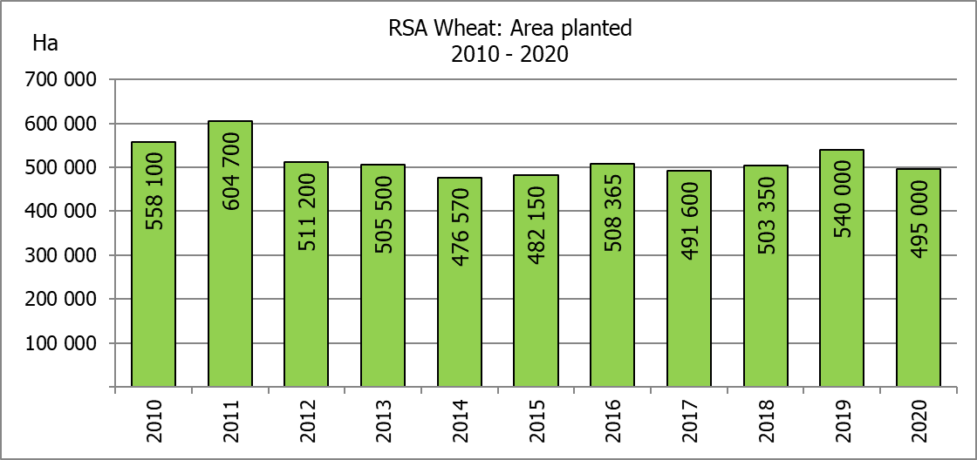
WINTERGEWASSE – VOORNEME OM TE PLANT: 2020
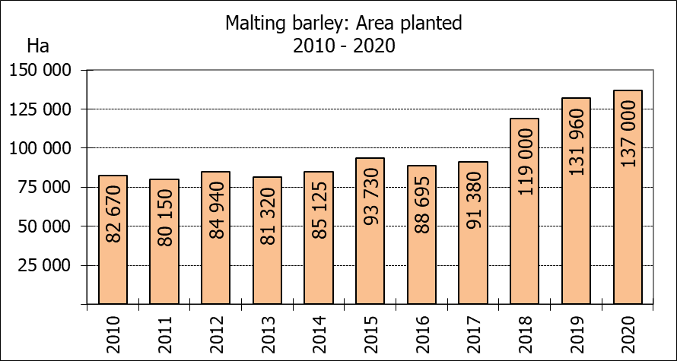
WINTER CEREALS –INTENTIONS TO PLANT: 2020
GEWAS/CROP | Voorneme/  Intentions*  2020 | Opp beplant/  Area planted  2019 | Finale skatting/  Final estimate  2019 | Verandering/  Change
GEWAS/CROP | Ha | Ha | Tons | %
GEWAS/CROP | (A) | (B) | (C) | (A) ÷ (B)
Wheat/Koring | 495 000 | 540 000 | 1 501 675 | -8,33
Malting barley/Moutgars | 137 000 | 131 960 | 345 080 | +3,82
Canola/Kanola | 72 000 | 74 000 | 96 200 | -2,70
Cereal oats/Hawermout | 23 500 | 21 000 | 15 540 | +11,90

* Based on conditions at the middle of April 2020 / Gebaseer op toestande soos teen middel April 2020.
KORING – VOORNEME OM TE PLANT: 2020
WHEAT – INTENTIONS TO PLANT: 2020
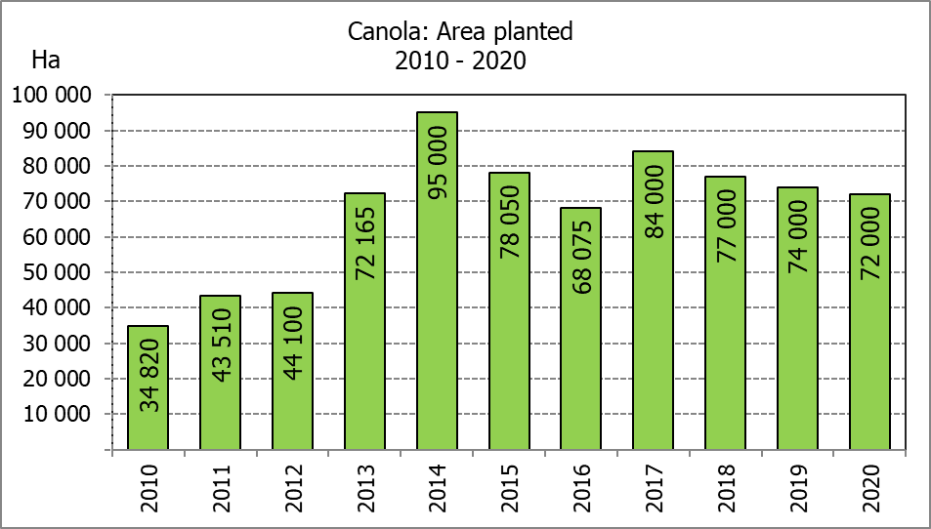
Provinsie/  Province | Voorneme/  Intentions  Ha | Opp beplant/  Area planted  Ha | Finale skatting/  Final estimate  Tons
Provinsie/  Province | 2020 | 2019 | 2019
Wes-Kaap/Western Cape | 320 000 | 325 000 | 633 750
Noord-Kaap/Northern Cape | 35 500 | 37 500 | 262 500
Vrystaat/Free State | 90 000 | 128 000 | 313 600
Oos-Kaap/Eastern Cape | 3 200 | 3 100 | 15 500
KwaZulu-Natal | 7 800 | 7 500 | 45 750
Mpumalanga | 3 500 | 4 000 | 25 200
Limpopo | 21 000 | 20 000 | 118 000
Gauteng | 1 000 | 1 400 | 8 400
Noordwes/North West | 13 000 | 13 500 | 78 975
Totaal/Total | 495 000 | 540 000 | 1 501 675

INTENTIONS TO PLANT WINTER CROPS FOR 2020 / VOORNEME OM WINTERGEWASSE AAN TE PLANT VIR 2020

Winter cereal crops – 2020  Producers’ intentions to plant winter cereals are based on the results of a non-probability survey conducted by the Directorate: Statistics and Economic Analysis of the Department of Agriculture, Land Reform and Rural Development and reflects the position as at the middle of April 2020.  The figures for wheat represent the total number of hectares that are intended to be planted for grain, excluding any hectares that will be planted for fodder and grazing.  Early indications are that producers intend to plant 495 000 ha of wheat for the 2020 production season. This is 8,33% or 45 000 ha less than the 540 000 ha planted to wheat in 2019.  The main producing areas are within the Western Cape with 320 000 ha (65%), followed by the Free State with 90 000 ha (18%) and the Northern Cape with 35 500 ha (7%).  The expected area planted to malting barley is 137 000 ha, which is 3,82% or 5 040 ha more than the 131 960 ha of the previous year. The expected area planted to canola is 72 000 ha, which is 2,70% or 2 000 ha less than the 74 000 ha planted in 2019. Producers intend to plant 23 500 ha of cereal oats, which is 11,90 or 2 500 ha more than the 21 000 ha of the previous season.  Please note that the preliminary area estimate of winter crops for 2020 will be released on 29 July 2020. |  | Wintergewasse – 2020  Produsente se voorneme om wintergewasse te plant is gebaseer op die resultate van ’n nie-ewekansige opname onderneem deur die Direktoraat: Statistiek en Ekonomiese Analise van die Departement van Landbou, Grondhervorming en Landelike Ontwikkeling en weerspieël die situasie teen die middel van April 2020.  Die syfers vir koring verteenwoordig die totale aantal hektare wat werklik beplant gaan word vir graan, uitgesluit alle hektare wat beplant gaan word vir groenvoer en weiding.  Vroeë aanduidings is dat produsente van voorneme is om 495 000 ha koring te plant vir die 2020-produksie-seisoen. Dit is 8,33% of 45 000 ha minder koring aangeplant as die 540 000 ha in 2019.  Die grootste produserende gebiede is in die Wes-Kaap, met 320 000 ha (65%), gevolg deur die Vrystaat met 90 000 ha (18%) en die Noord-Kaap met 35 500 ha (7%).  Die verwagte aanplantings van moutgars is 137 000 ha – 3,82% of 5 040 ha meer as die 131 960 ha van die vorige jaar. Die verwagte aanplantings van kanola is 72 000 ha, wat 2,70% of 2 000 ha minder is as die 74 000 ha wat aangeplant was in 2019. Produsente is van voorneme om 23 500 ha hawermout te plant, wat 11,90% of 2 500 ha meer is as die 21 000 ha van die vorige seisoen.  Neem asseblief kennis dat die voorlopige oppervlakteskatting vir wintergewasse vir 2020 op 29 Julie 2020 vrygestel sal word.
Information is available on the internet at http://www.daff.gov.za/links/crop estimates or http://www.sagis.org.za, as from 14:30 on the date of the relevant meeting of the Crop Estimates Committee. |  | Inligting is beskikbaar op die internet by http://www.daff.gov.za/links/crop estimates of by http://www.sagis.org.za, vanaf 14:30 op die dag van die toepaslike vergadering van die Oesskattingskomitee.

