 | crop estimates committee | 
 | oesskattingskomitee
From/Van: Mr Baldwin Netshifhefhe
Tel: 012 319 8043  Fax/Faks: 012 319 8031  E-mail/E-pos: BaldwinN@daff.gov.za
Web page/Webblad: www.daff.gov.za/statistics and economic reports or www.sagis.org.za/CEC: Crop Estimates
EMBARGO: 14:30

The area planted estimate and third production forecast for summer crops for 2019 is hereby released.
Hiermee word die oppervlakte- en derde produksieskatting vir somergewasse vir 2019 vrygestel.

SUMMER CROPS – AREA PLANTED AND THIRD PRODUCTION FORECAST: 2019
SOMERGEWASSE – OPPERVLAKTE- EN DERDE PRODUKSIESKATTING: 2019
CROP/GEWAS | Area planted/  Opp beplant  2019 | 3rd forecast/  3de skatting  2019 | 2nd forecast/  2de skatting  2019 | Area planted/  Opp beplant  2018 | Final crop/  Finale oes  2018 | Change/  Verandering/
CROP/GEWAS | Ha | Tons | Tons | Ha | Tons | %
CROP/GEWAS | (A) | (B) | (C) | (D) | (E) | (B) ÷ (C)
Commercial/Kommersieël:
White maize/Witmielies | 1 298 400 | 5 286 540 | 5 220 540 | 1 268 100 | 6 540 000 | +1,26
Yellow maize/Geelmielies | 1 002 100 | 5 368 820 | 5 340 170 | 1 050 750 | 5 970 000 | +0,54
Total Maize/Totale Mielies | 2 300 500 | 10 655 360 | 10 560 710 | 2 318 850 | 12 510 000 | +0,90
Sunflower seed/Sonneblomsaad | 515 350 | 611 140 | 563 590 | 601 500 | 862 000 | +8,44
Soybeans/Sojabone | 730 500 | 1 295 845 | 1 276 035 | 787 200 | 1 540 000 | +1,55
Groundnuts/Grondbone | 20 050 | 22 705 | 20 100 | 56 300 | 57 000 | +12,96
Sorghum | 50 500 | 165 850 | 163 400 | 28 800 | 115 000 | +1,50
Dry beans/Droëbone | 59 300 | 72 450 | 70 950 | 53 360 | 69 360 | +2,11
TOTAL/TOTAAL | 3 676 200 | 12 823 350 | 12 654 785 | 3 846 010 | 15 153 360 | +1,33
Note: Estimate is for calendar year, e.g. production season 2018/19 = 2019
Nota: Skatting is vir kalenderjaar, bv. produksie-seisoen 2018/19 = 2019

25 April 2019

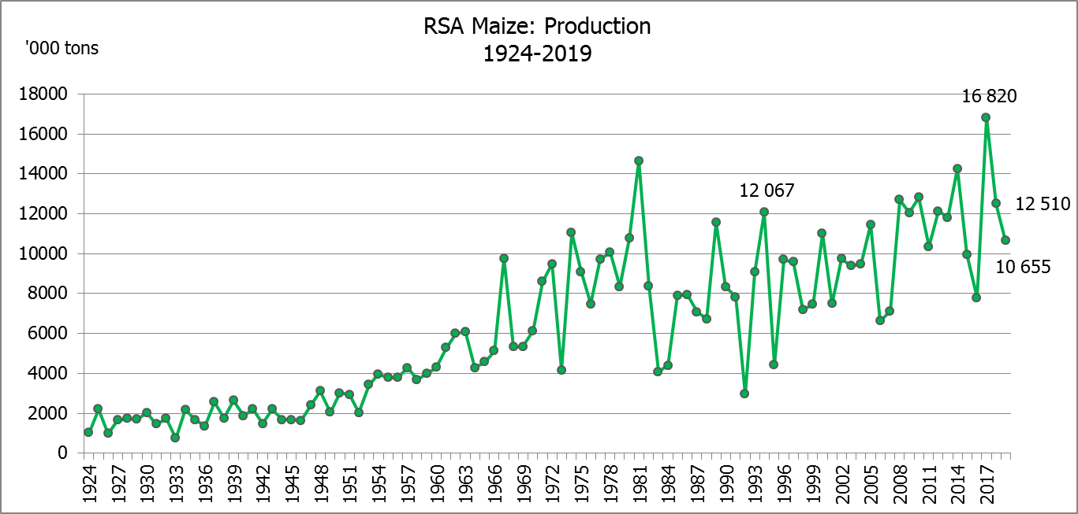

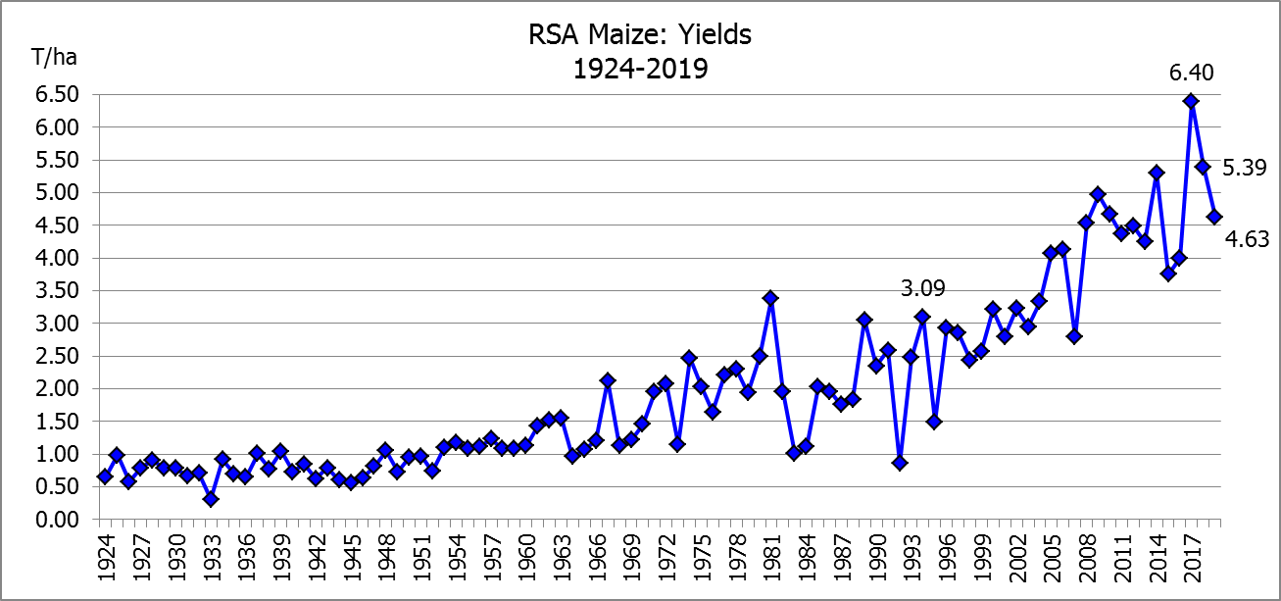

WHITE AND YELLOW MAIZE – AREA PLANTED AND THIRD PRODUCTION FORECAST: 2019
WIT- EN GEELMIELIES – OPPERVLAKTE EN DERDE PRODUKSIESKATTING: 2019

Provinsie/  Province | Area planted/  Oppervlakte beplant  2019 |  |  | 3rd forecast/  3de skatting  2019 |  |  | Area planted/  Oppervlakte beplant  2018 |  |  | Final crop/  Finale oes  2018
Provinsie/  Province | White/  Wit  Ha | Yellow/  Geel  Ha | Total/  Totaal  Ha | White/  Wit  Tons | Yellow/  Geel  Tons | Total/  Totaal  Tons | White/  Wit  Ha | Yellow/  Geel  Ha | Total/  Totaal  Ha | White/  Wit  Tons | Yellow/  Geel  Tons | Total/  Totaal  Tons
Western Cape/Wes-Kaap | 400 | 3 400 | 3 800 | 3 600 | 30 600 | 34 200 | 0 | 3 750 | 3 750 | 0 | 33 750 | 33 750
Northern Cape/Noord-Kaap | 3 400 | 43 500 | 46 900 | 39 440 | 626 400 | 665 840 | 3 600 | 43 000 | 46 600 | 41 300 | 628 000 | 669 300
Free State/Vrystaat | 650 000 | 380 000 | 1 030 000 | 2 567 500 | 1 596 000 | 4 163 500 | 644 000 | 410 000 | 1 054 000 | 3 350 000 | 1 925 000 | 5 275 000
Eastern Cape/Oos-Kaap | 3 800 | 10 200 | 14 000 | 22 800 | 67 320 | 90 120 | 3 500 | 11 000 | 14 500 | 21 700 | 71 500 | 93 200
KwaZulu-Natal | 45 000 | 54 000 | 99 000 | 270 000 | 378 000 | 648 000 | 45 000 | 50 000 | 95 000 | 280 000 | 380 000 | 660 000
Mpumalanga | 145 000 | 338 000 | 483 000 | 812 000 | 1 859 000 | 2 671 000 | 140 000 | 340 000 | 480 000 | 812 000 | 2 005 000 | 2 817 000
Limpopo | 12 800 | 18 000 | 30 800 | 83 200 | 117 000 | 200 200 | 12 000 | 21 000 | 33 000 | 90 000 | 141 700 | 231 700
Gauteng | 48 000 | 60 000 | 108 000 | 240 000 | 324 000 | 564 000 | 50 000 | 62 000 | 112 000 | 275 000 | 356 500 | 631 500
North West/Noordwes | 390 000 | 95 000 | 485 000 | 1 248 000 | 370 500 | 1 618 500 | 370 000 | 110 000 | 480 000 | 1 670 000 | 428 550 | 2 098 550
Total/Totaal | 1 298 400 | 1 002 100 | 2 300 500 | 5 286 540 | 5 368 820 | 10 655 360 | 1 268 100 | 1 050 750 | 2 318 850 | 6 540 000 | 5 970 000 | 12 510 000

SUNFLOWER SEED – AREA PLANTED AND THIRD PRODUCTION FORECAST: 2019
SONNEBLOMSAAD – OPPERVLAKTE EN DERDE PRODUKSIESKATTING: 2019

Province/  Provinsie | Area planted/  Opp beplant  Ha | 3rd forecast/  3de skatting  Tons | Area planted/  Opp beplant  Ha | Final crop/  Finale oes  Tons
Province/  Provinsie | 2019 | 2019 | 2018 | 2018
Western Cape/Wes-Kaap | - | - | 100 | 100
Northern Cape/Noord-Kaap | 950 | 1 140 | 1 600 | 1 920
Free State/Vrystaat | 270 000 | 351 000 | 314 000 | 490 000
Eastern Cape/Oos-Kaap | 100 | 250 | - | -
KwaZulu-Natal | - | - | - | -
Mpumalanga | 4 500 | 4 500 | 2 300 | 2 180
Limpopo | 61 000 | 57 950 | 45 000 | 36 000
Gauteng | 3 800 | 3 800 | 5 500 | 5 600
North West/Noordwes | 175 000 | 192 500 | 233 000 | 326 200
Total/Totaal | 515 350 | 611 140 | 601 500 | 862 000
SOYBEANS – AREA PLANTED AND THIRD PRODUCTION FORECAST: 2019
SOJABONE – OPPERVLAKTE EN DERDE PRODUKSIESKATTING: 2019

Province/  Provinsie | Area planted/  Opp beplant  Ha | 3rd forecast/  3de skatting  Tons | Area planted/  Opp beplant  Ha | Final crop/  Finale oes  Tons
Province/  Provinsie | 2019 | 2019 | 2018 | 2018
Western Cape/Wes-Kaap | 100 | 10 | 800 | 1 200
Northern Cape/Noord-Kaap | 1 550 | 5 425 | 3 000 | 10 500
Free State/Vrystaat | 301 000 | 451 500 | 345 000 | 552 000
Eastern Cape/Oos-Kaap | 1 150 | 1 380 | 2 400 | 2 900
KwaZulu-Natal | 33 000 | 102 300 | 40 000 | 124 000
Mpumalanga | 310 000 | 573 500 | 310 000 | 672 700
Limpopo | 16 200 | 46 980 | 20 000 | 54 000
Gauteng | 31 500 | 66 150 | 30 000 | 61 500
North West/Noordwes | 36 000 | 48 600 | 36 000 | 61 200
Total/Totaal | 730 500 | 1 295 845 | 787 200 | 1 540 000

GROUNDNUTS – AREA PLANTED AND THIRD PRODUCTION FORECAST: 2019
GRONDBONE – OPPERVLAKTE EN DERDE PRODUKSIESKATTING: 2019

Province/  Provinsie | Area planted/  Opp beplant  Ha | 3rd forecast/  3de skatting  Tons | Area planted/  Opp beplant  Ha | Final crop/  Finale oes  Tons
Province/  Provinsie | 2019 | 2019 | 2018 | 2018
Western Cape/Wes-Kaap | - | - | - | -
Northern Cape/Noord-Kaap | 1 200 | 2 760 | 2 800 | 7 000
Free State/Vrystaat | 11 500 | 10 925 | 22 000 | 21 150
Eastern Cape/Oos-Kaap | - | - | - | -
KwaZulu-Natal | - | - | - | -
Mpumalanga | - | - | - | -
Limpopo | 1 850 | 4 070 | 3 500 | 7 350
Gauteng | - | - | - | -
North West/Noordwes | 5 500 | 4 950 | 28 000 | 21 500
Total/Totaal | 20 050 | 22 705 | 56 300 | 57 000

SORGHUM – AREA PLANTED AND THIRD PRODUCTION FORECAST: 2019
SORGHUM – OPPERVLAKTE EN DERDE PRODUKSIESKATTING: 2019

Province/  Provinsie | Area planted/  Opp beplant  Ha | 3rd forecast/  3de skatting  Tons | Area planted/  Opp beplant  Ha | Final crop/  Finale oes  Tons
Province/  Provinsie | 2019 | 2019 | 2018 | 2018
Western Cape/Wes-Kaap | - | - | - | -
Northern Cape/Noord-Kaap | - | - | - | -
Free State/Vrystaat | 8 000 | 30 400 | 6 300 | 25 200
Eastern Cape/Oos-Kaap | - | - | - | -
KwaZulu-Natal | 500 | 1 750 | 500 | 2 200
Mpumalanga | 7 500 | 37 500 | 7 500 | 40 500
Limpopo | 25 000 | 67 500 | 5 000 | 15 500
Gauteng | 1 000 | 3 200 | 1 500 | 4 950
North West/Noordwes | 8 500 | 25 500 | 8 000 | 26 650
Total/Totaal | 50 500 | 165 850 | 28 800 | 115 000

DRY BEANS – AREA PLANTED AND THIRD PRODUCTION FORECAST: 2019
DROëBONE – OPPERVLAKTE EN DERDE PRODUKSIESKATTING: 2019

Province/  Provinsie | Area planted/  Opp beplant  Ha | 3rd forecast/  3de skatting  Tons | Area planted/  Opp beplant  Ha | Final crop/  Finale oes  Tons
Province/  Provinsie | 2019 | 2019 | 2018 | 2018
Western Cape/Wes-Kaap | 100 | 200 | 20 | 30
Northern Cape/Noord-Kaap | 1 000 | 2 000 | 540 | 1 080
Free State/Vrystaat | 27 000 | 28 350 | 26 000 | 28 600
Eastern Cape/Oos-Kaap | 400 | 800 | 300 | 450
KwaZulu-Natal | 3 500 | 4 200 | 3 000 | 3 600
Mpumalanga | 7 500 | 7 500 | 7 000 | 9 800
Limpopo | 7 800 | 15 600 | 7 500 | 15 000
Gauteng | 1 500 | 2 250 | 1 000 | 1 200
North West/Noordwes | 10 500 | 11 550 | 8 000 | 9 600
Total/Totaal | 59 300 | 72 450 | 53 360 | 69 360

CONFIDENTIALITY ISSUES that CEC members are committed to adhere to on the day of the meeting
- Personal items such as laptops, handbags, cell phones, etc. are not allowed in the venue during the meeting
- No member is allowed to leave the meeting before 12:00 in order to prevent disclosure of the information
- The embargo time for the release of crop estimates information is 14:30
- No member is allowed to discuss crop estimates information with anyone other than a member of the Committee before the embargo time
- Only the Chairperson, or a member appointed by the Chairperson, may release the figures to the media
- Members must regard the detail of any information that was collected for and/or discussed during the meeting, as confidential
- Individual information received for crop estimate purposes is treated strictly confidential, and is not divulged for any other purposes

AREA ESTIMATE AND THIRD PRODUCTION FORECAST OF SUMMER CROPS (2019 PRODUCTION SEASON)/
OPPERVLAKTE- EN DERDE PRODUKSIESKATTING VIR SOMERGEWASSE (2019 PRODUKSIE-SEISOEN)
25 APRIL 2019

Summer field crops – 2019  Commercial maize: The size of the expected commercial maize crop has been set at 10,655 mill. tons, which is 0,90% or 94 650 tons more than the previous forecast of 10,561 mill. tons. The area estimate for maize is 2,301 mill. ha, while the expected yield is 4,63 t/ha.  The estimated maize crop is 15% smaller than the 2018 crop. The three main maize producing areas, namely the Free State, Mpumalanga and North West provinces are expected to produce 79% of the 2019 crop.  The area estimate for white maize is1,298 mill. ha and for yellow maize the area estimate is1,002 mill. ha.  The production forecast of white maize is 5,287 mill. tons, which is 1,26% or 66 000 tons more than the 5,221 mill. tons of the previous forecast. The yield for white maize is 4,07 t/ha. In the case of yellow maize the production forecast is 5,369 mill. tons, which is 0,54% or 28 650 tons more than the 5,340 mill. tons of the previous forecast. The yield for yellow maize is 5,36 t/ha.  The yield per ha for the Mpumalanga province was based on scientific and objective results provided by the ARC. Please note that the objective results for the Free State and North West provinces will be available in May 2019.  Sunflower seed: The production forecast for sunflower seed is 611 140 tons, which is 8,44% or 47 550 tons more than the previous forecast of 563 590 tons. The area estimate for sunflower seed is 515 350 ha, while the expected yield is 1,19 t/ha.  Other crops: The production forecast for soybeans has been set at 1,296 mill. tons, which is 1,55% or 19 810 tons higher than the 1,276 mill. tons of the previous forecast. The estimated area planted to soybeans is 730 500 ha and the expected yield is 1,77 t/ha.  The expected groundnut crop increased by 12,96% or 2 605 tons, from 20 100 tons to 22 705 tons, with an expected yield of 1,13 t/ha. Please note that a correction was made with regard to the area planted to groundnuts in the Free State (3 500 ha added) and North West (3 500 ha deducted) provinces. The national area estimate for groundnuts has remained unchanged at 20 050 ha.  The production forecast for sorghum is 165 850 tons, which is 1,50% or 2 450 tons more than the 163 400 tons of the previous forecast. The area estimate for sorghum is 50 500 ha and the expected yield is 3,28 t/ha.  In the case of dry beans, the production forecast also increased slightly by 1 500 tons, from 70 950 tons to 72 450 tons. The area estimate of dry beans is 59 300 ha, with an expected yield of 1,22 t/ha.  Please note that the fourth production forecast for summer field crops for 2019 will be released on 28 May 2019. |  | Somergewasse – 2019  Kommersiële mielies: Die grootte van die verwagte kommersiële mielie-oes is op 10,655 milj. ton gestel, wat 0,90% of 94 650 ton meer is as die vorige skatting van 10,561 milj. ton. Die skatting van die oppervlakte onder mielies is 2,301 milj. ha, terwyl die verwagte opbrengs 4,63 t/ha is.  Die geskatte mielie-oes is 15% kleiner as die 2018-oes. Die drie belangrikste mielieproduserende gebiede, nl. die Vrystaat, Mpumalanga en Noordwes provinsies, gaan na verwagting 79% van die 2019-oes produseer.  Die oppervlak onder witmielies is 1,298 milj. ha en vir geelmielies is die oppervlak 1,002 milj. ha.  Die produksieskatting van witmielies is 5,287 milj. ton, 1,26% of 66 000 ton meer as die 5,221 milj. ton van die vorige skatting. Die opbrengs van witmielies is 4,07 t/ha. In die geval van geelmielies is die produksieskatting 5,369 milj. ton, wat 0,54% of 28 650 ton meer is as die 5,340 milj. ton van die vorige skatting. Die opbrengs van geelmielies is 5,36 t/ha.  Die opbrengs-bepaling per ha vir die Mpumalanga provinsie is gebaseer op wetenskaplike en objektiewe resultate verstrek deur die LNR. Neem kennis dat die objektiewe resultate vir die Vrystaat en Noordwes provinsies, in Mei 2019 gerapporteer sal word.  Sonneblomsaad: Die produksieskatting vir sonneblomsaad is 611 140 ton, wat 8,44% of 47 550 ton meer is as die vorige skatting se 563 590 ton. Die oppervlakteskatting vir sonneblomsaad is 515 350 ha, terwyl die verwagte opbrengs 1,19 t/ha is.  Ander gewasse: Die produksieskatting van sojabone is op 1,296 milj. ton gestel, wat 1,55% of 19 810 ton hoër is as die 1,276 milj. ton van die vorige skatting. Die geskatte oppervlakte beplant van sojabone is 730 500 ha en die verwagte opbrengs is 1,77 t/ha.  Die verwagte grondbone-oes het met 12,96% of 2 605 ton toegeneem, vanaf 20 100 ton na 22 705 ton, terwyl the verwagte opbrengs 1,13 t/ha is. Neem asseblief kennis dat ‘n korreksie gemaak is ten opigte van die oppervlakte beplant met grondbone in die Vrystaat (3 500 ha bygevoeg) en Noordwes (3 500 ha afgetrek) provinsies. Die nasionale oppervlakteskatting vir grondbone is wel onveranderd gelaat op 20 050 ha.  Die produksieskatting van sorghum is 165 850 ton, wat 1,50% of 2 450 ton meer is as die 163 400 ton van die vorige skatting. Die oppervlakteskatting vir sorghum is 50 500 ha, en die verwagte opbrengs is 3,28 t/ha.  In die geval van droëbone het die produksieskatting effens met 1 500 ton toegeneem, vanaf 70 950 ton na 72 450 ton. Die oppervlakte beplant met droëbone is 59 300 ha, en die verwagte opbrengs is 1,22 t/ha.  Neem asseblief kennis dat die vierde produksieskatting vir somergewasse vir 2019, op 28 Mei 2019 vrygestel sal word.
Information is available on the internet at http://www.daff.gov.za/statistics and economic reports or http://www.sagis.org.za, as from 14:30 on the date of the relevant meeting of the Crop Estimates Committee. |  | Inligting is beskikbaar op die internet by http://www.daff.gov.za/statistics and economic reports of by http://www.sagis.org.za, vanaf 14:30 op die dag van die toepaslike vergadering van die Oesskattingskomitee.

The intentions to plant winter cereals for the 2019 production season is hereby released. /
Hiermee word die voorneme om wintergewasse te plant vir die 2019 produksie-seisoen vrygestel.
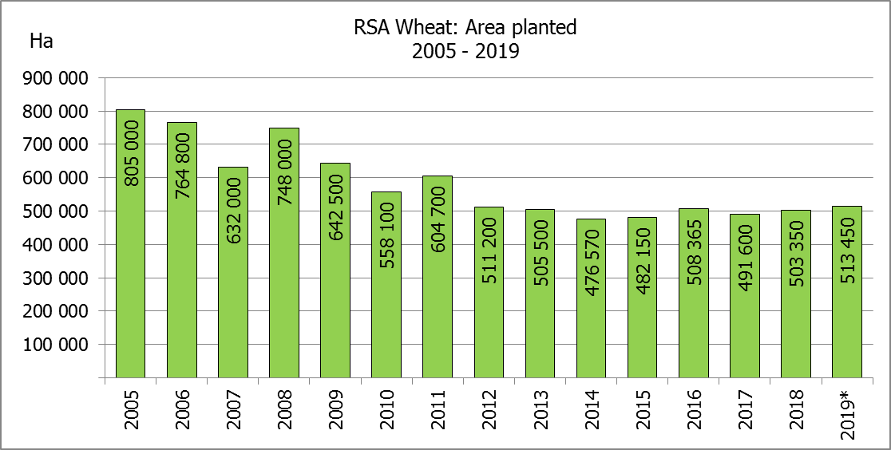
WINTERGEWASSE – VOORNEME OM TE PLANT: 2019
WINTER CEREALS –INTENTIONS TO PLANT: 2019
GEWAS/CROP | Voorneme/  Intentions*  2019 | Opp beplant/  Area planted  2018 | Finale skatting/  Final estimate  2018 | Verandering/  Change
GEWAS/CROP | Ha | Ha | Tons | %
GEWAS/CROP | (A) | (B) | (C) | (A) ÷ (B)
Koring/Wheat | 513 450 | 503 350 | 1 841 050 | +2,01
Moutgars/Malting barley | 118 500 | 119 000 | 421 790 | -0,42
Kanola/Canola | 80 000 | 77 000 | 103 950 | 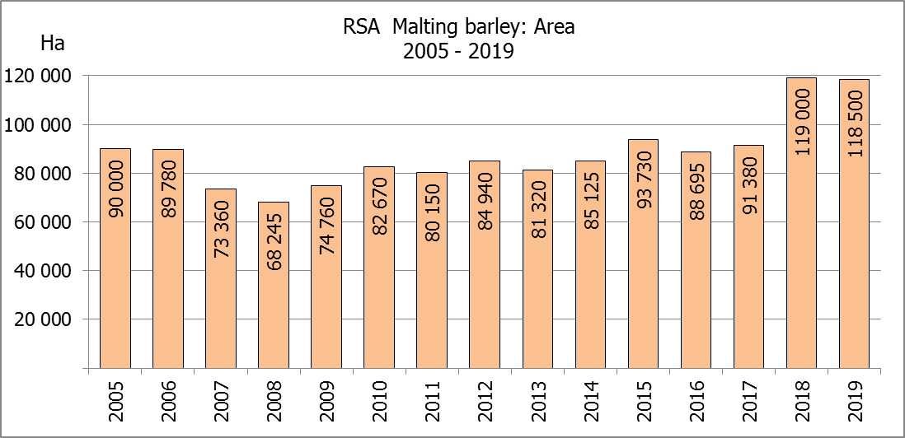  +3,90
Totaal/Total | 711 950 | 699 350 | 2 366 790 | +1,80

* Based on conditions at the middle of April 2019 / Gebaseer op toestande soos teen middel April 2019.
KORING – VOORNEME OM TE PLANT: 2019
WHEAT – INTENTIONS TO PLANT: 2019

Provinsie/  Province | Voorneme/  Intentions  Ha | Opp beplant/  Area planted  Ha | Finale skatting/  Final estimate  Tons
Provinsie/  Province | 2019 | 2018 | 2018
Wes-Kaap/Western Cape | 324 000 | 318 000 | 890 400
Noord-Kaap/Northern Cape | 34 000 | 38 000 | 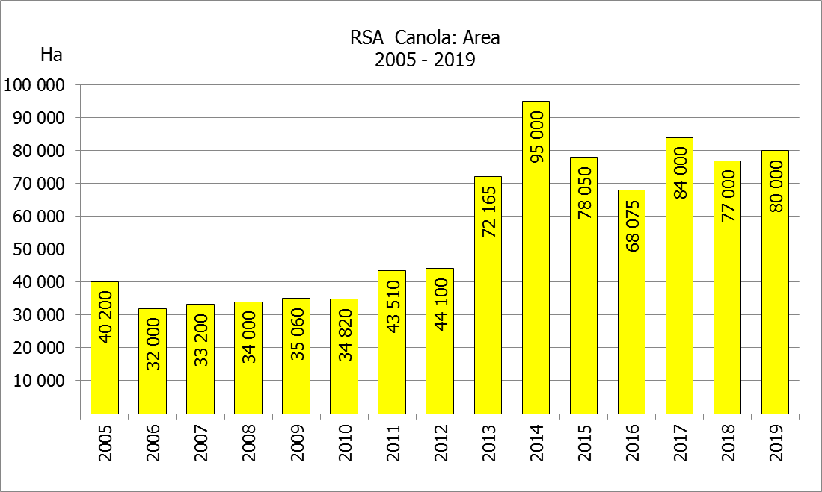  294 500
Vrystaat/Free State | 105 000 | 100 000 | 360 000
Oos-Kaap/Eastern Cape | 3 500 | 1 650 | 10 725
KwaZulu-Natal | 7 500 | 7 000 | 43 400
Mpumalanga | 3 450 | 3 500 | 22 225
Limpopo | 22 000 | 20 000 | 128 000
Gauteng | 1 000 | 1 200 | 7 800
Noordwes/North West | 13 000 | 14 000 | 84 000
Totaal/Total | 513 450 | 503 350 | 1 841 050

INTENTIONS TO PLANT WINTER CROPS FOR 2019 / VOORNEME OM WINTERGEWASSE AAN TE PLANT VIR 2019

Winter cereal crops – 2019  Producers’ intentions to plant winter cereals are based on the results of a non-probability survey conducted by the Directorate: Statistics and Economic Analysis of the Department of Agriculture, Forestry and Fisheries and reflects the position as at the middle of April 2019.  The figures for wheat represent the total number of hectares that are intended to be planted for grain, excluding any hectares that will be planted for fodder and grazing.  Early indications are that producers intend to plant 513 450 ha of wheat for the 2019 production season. This is 2,01% or 10 100 ha more than the 503 350 ha planted to wheat in 2018.  The main producing areas are within the Western Cape with 324 000 ha (63%), followed by the Free State with 105 000 ha (20%) and the Northern Cape with 34 000 ha (7%).  The expected area planted to malting barley is 118 500 ha, which is 0,42% or 500 ha less than the 119 000 ha of the previous year. The expected area planted to canola is 80 000 ha, which is 3,90% or 3 000 ha more than the 77 000 ha planted in 2018.  Please note that the preliminary area estimate of winter crops for 2019 will be released on 25 July 2019. |  | Wintergewasse – 2019  Produsente se voorneme om wintergewasse te plant is gebaseer op die resultate van ’n nie-ewekansige opname onderneem deur die Direktoraat: Statistiek en Ekonomiese Analise van die Departement van Landbou, Bosbou en Visserye en weerspieël die situasie teen die middel van April 2019.  Die syfers vir koring verteenwoordig die totale aantal hektare wat werklik beplant gaan word vir graan, uitgesluit alle hektare wat beplant gaan word vir groenvoer en weiding.  Vroeë aanduidings is dat produsente van voorneme is om 513 450 ha koring te plant vir die 2019-produksie-seisoen. Dit is 2,01% of 10 100 ha meer koring aangeplant as doe 503 350 ha in 2018.  Die grootste produserende gebiede is in die Wes-Kaap, met 324 000 ha (63%), gevolg deur die Vrystaat met 105 000 ha (20%) en die Noord-Kaap met 34 000 ha (7%).  Die verwagte aanplantings van moutgars is 118 500 ha – 0,42% of 500 ha minder as die 119 000 ha van die vorige jaar. Die verwagte aanplantings van kanola is 80 000 ha, wat 3,90% of 3 000 ha meer is as die 77 000 ha wat aangeplant was in 2018.  Neem asseblief kennis dat die voorlopige oppervlakteskatting vir wintergewasse vir 2019 op 25 Julie 2019 vrygestel sal word.
Information is available on the internet at http://www.daff.gov.za/links/crop estimates or http://www.sagis.org.za, as from 14:30 on the date of the relevant meeting of the Crop Estimates Committee. |  | Inligting is beskikbaar op die internet by http://www.daff.gov.za/links/crop estimates of by http://www.sagis.org.za, vanaf 14:30 op die dag van die toepaslike vergadering van die Oesskattingskomitee.

