 | crop estimates committee | 
 | oesskattingskomitee
From/Van: M. Ellen Matsei
Tel: 012 319 8454  Fax/Faks: 012 319 8031  E-mail/E-pos: DAS@daff.gov.za
Web page/Webblad: www.daff.gov.za/statistics and economic reports or www.sagis.org.za/CEC: Crop Estimates
EMBARGO: 15:30

The area planted estimate and third production forecast for summer crops for 2018 is hereby released.
Hiermee word die oppervlakte- en derde produksieskatting vir somergewasse vir 2018 vrygestel.

SUMMER CROPS – AREA PLANTED AND THIRD PRODUCTION FORECAST: 2018
SOMERGEWASSE – OPPERVLAKTE- EN DERDE PRODUKSIESKATTING: 2018
CROP/GEWAS | Area planted/  Opp beplant  2018 | 3rd forecast/  3de skatting  2018 | 2nd forecast/  2de skatting  2018 | Area planted/  Opp beplant  2017 | Final crop/  Finale oes  2017 | Change/  Verandering
CROP/GEWAS | Ha | Tons | Tons | Ha | Tons | %
CROP/GEWAS | (A) | (B) | (C) | (D) | (E) | (B) ÷ (C)
Commercial/Kommersieel:
White maize/Witmielies | 1 268 100 | 6 629 660 | 6 363 100 | 1 643 100 | 9 916 000 | +4,2
Yellow maize/Geelmielies | 1 050 750 | 6 197 150 | 6 057 400 | 985 500 | 6 904 000 | +2,3
Total Maize/Totale Mielies | 2 318 850 | 12 826 810 | 12 420 500 | 2 628 600 | 16 820 000 | +3,3
Sunflower seed/Sonneblomsaad | 601 500 | 792 255 | 749 205 | 635 750 | 874 000 | +5,8
Soybeans/Sojabone | 787 200 | 1 430 300 | 1 394 800 | 573 950 | 1 316 000 | +2,6
Groundnuts/Grondbone | 56 300 | 80 600 | 80 600 | 56 000 | 92 050 | -
Sorghum | 28 800 | 84 750 | 84 750 | 42 350 | 152 000 | -
Dry beans/Droëbone | 53 360 | 65 610 | 68 210 | 45 050 | 68 525 | -3,8
Non-Commercial Maize/Nie-Kommersiële Mielies
Total Maize/Totaal Mielies | 314 835 | 593 975 | N/a | 366 650 | 731 000
Maize/Mielies: Commercial/Kommersieël + Non-Commercial/Nie-Kommersieël
Total Maize RSA/Totaal Mielies RSA | 2 633 685 | 13 420 785 | N/a | 2 995 250 | 17 551 000
Note: Estimate is for calendar year, e.g. production season 2017/18 = 2018
Nota: Skatting is vir kalenderjaar, bv. produksie-seisoen 2017/18 = 2018
The Crop Estimates Committee comprises officials of the following institutions:
Department of Agriculture, Forestry and Fisheries; Provincial Departments of Agriculture; various ARC-Institutes (Soil, Climate and Water; Small Grains Institute;
and Grain Crops Institute); BFAP and Statistics SA.

25 April 2018

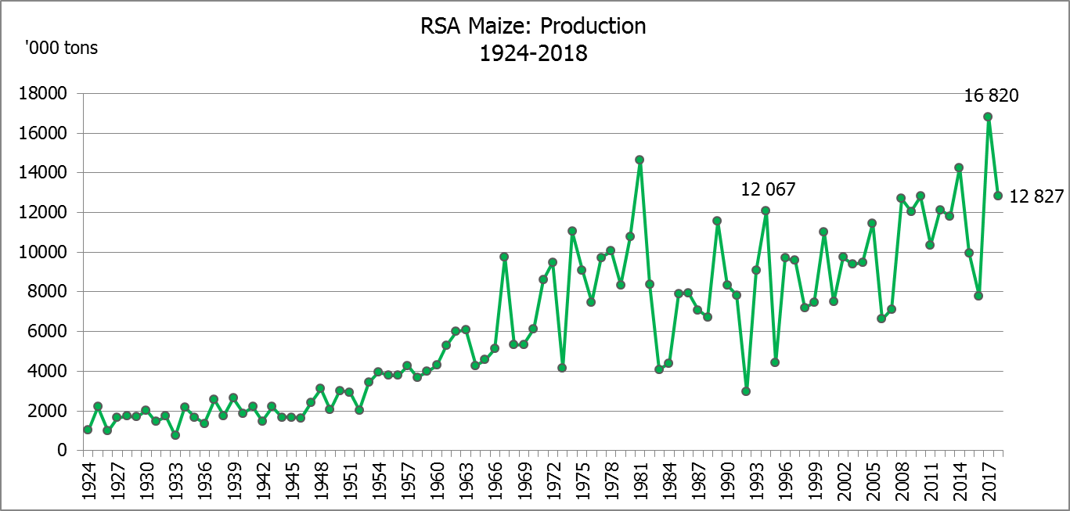

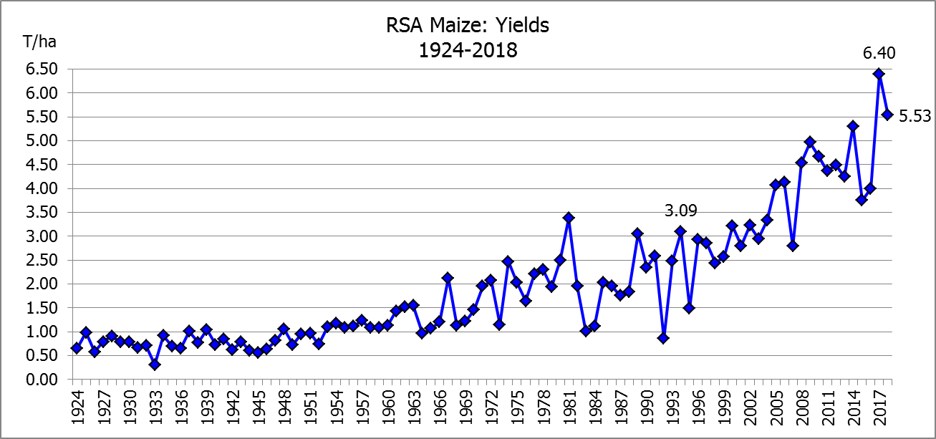

WHITE AND YELLOW MAIZE – AREA PLANTED AND THIRD PRODUCTION FORECAST: 2018
WIT- EN GEELMIELIES – OPPERVLAKTE EN DERDE PRODUKSIESKATTING: 2018

Provinsie/  Province | Area planted/  Oppervlakte beplant  2018 |  |  | 3rd forecast/  3de skatting  2018 |  |  | Area planted/  Oppervlakte beplant  2017 |  |  | Final crop/  Finale oes  2017
Provinsie/  Province | White/  Wit  Ha | Yellow/  Geel  Ha | Total/  Totaal  Ha | White/  Wit  Tons | Yellow/  Geel  Tons | Total/  Totaal  Tons | White/  Wit  Ha | Yellow/  Geel  Ha | Total/  Totaal  Ha | White/  Wit  Tons | Yellow/  Geel  Tons | Total/  Totaal  Tons
Western Cape/Wes-Kaap | 0 | 3 750 | 3 750 | 0 | 33 750 | 33 750 | 200 | 2 000 | 2 200 | 2 000 | 20 000 | 22 000
Northern Cape/Noord-Kaap | 3 600 | 43 000 | 46 600 | 41 760 | 636 400 | 678 160 | 3 500 | 45 000 | 48 500 | 46 200 | 666 000 | 712 200
Free State/Vrystaat | 644 000 | 410 000 | 1 054 000 | 3 413 200 | 2 091 000 | 5 504 200 | 805 000 | 355 000 | 1 160 000 | 5 110 000 | 2 252 000 | 7 362 000
Eastern Cape/Oos-Kaap | 3 500 | 11 000 | 14 500 | 21 700 | 71 500 | 93 200 | 4 400 | 9 500 | 13 900 | 30 800 | 66 500 | 97 300
KwaZulu-Natal | 45 000 | 50 000 | 95 000 | 292 500 | 380 000 | 672 500 | 50 000 | 50 000 | 100 000 | 350 000 | 390 000 | 740 000
Mpumalanga | 140 000 | 340 000 | 480 000 | 840 000 | 2 040 000 | 2 880 000 | 160 000 | 330 000 | 490 000 | 1 088 000 | 2 342 500 | 3 430 500
Limpopo | 12 000 | 21 000 | 33 000 | 84 000 | 142 800 | 226 800 | 40 000 | 24 000 | 64 000 | 300 000 | 192 000 | 492 000
Gauteng | 50 000 | 62 000 | 112 000 | 290 000 | 378 200 | 668 200 | 60 000 | 60 000 | 120 000 | 390 000 | 414 000 | 804 000
North West/Noordwes | 370 000 | 110 000 | 480 000 | 1 646 500 | 423 500 | 2 070 000 | 520 000 | 110 000 | 630 000 | 2 599 000 | 561 000 | 3 160 000
Total/Totaal | 1 268 100 | 1 050 750 | 2 318 850 | 6 629 660 | 6 197 150 | 12 826 810 | 1 643 100 | 985 500 | 2 628 600 | 9 916 000 | 6 904 000 | 16 820 000

SUNFLOWER SEED – AREA PLANTED AND THIRD PRODUCTION FORECAST: 2018
SONNEBLOMSAAD – OPPERVLAKTE EN DERDE PRODUKSIESKATTING: 2018

Province/  Provinsie | Area planted/  Opp beplant  Ha | 3rd forecast/  3de skatting  Tons | Area planted/  Opp beplant  Ha | Final crop/  Finale oes  Tons
Province/  Provinsie | 2018 | 2018 | 2017 | 2017
Western Cape/Wes-Kaap | 100 | 100 | - | -
Northern Cape/Noord-Kaap | 1 600 | 1 920 | 250 | 400
Free State/Vrystaat | 314 000 | 455 300 | 330 000 | 478 000
Eastern Cape/Oos-Kaap | - | - | - | -
KwaZulu-Natal | - | - | 300 | 300
Mpumalanga | 2 300 | 2 185 | 2 200 | 2 300
Limpopo | 45 000 | 36 000 | 90 000 | 85 500
Gauteng | 5 500 | 5 500 | 3 000 | 3 000
North West/Noordwes | 233 000 | 291 250 | 210 000 | 304 500
Total/Totaal | 601 500 | 792 255 | 635 750 | 874 000

SOYBEANS – AREA PLANTED AND THIRD PRODUCTION FORECAST: 2018
SOJABONE – OPPERVLAKTE EN DERDE PRODUKSIESKATTING: 2018

Province/  Provinsie | Area planted/  Opp beplant  Ha | 3rd forecast/  3de skatting  Tons | Area planted/  Opp beplant  Ha | Final crop/  Finale oes  Tons
Province/  Provinsie | 2018 | 2018 | 2017 | 2017
Western Cape/Wes-Kaap | 800 | 1 200 | 700 | 1 050
Northern Cape/Noord-Kaap | 3 000 | 9 900 | 3 000 | 10 500
Free State/Vrystaat | 345 000 | 517 500 | 240 000 | 504 000
Eastern Cape/Oos-Kaap | 2 400 | 2 400 | 1 850 | 2 775
KwaZulu-Natal | 40 000 | 124 000 | 30 500 | 89 605
Mpumalanga | 310 000 | 604 500 | 241 000 | 554 300
Limpopo | 20 000 | 55 000 | 8 500 | 29 750
Gauteng | 30 000 | 60 000 | 25 400 | 71 120
North West/Noordwes | 36 000 | 55 800 | 23 000 | 52 900
Total/Totaal | 787 200 | 1 430 300 | 573 950 | 1 316 000
GROUNDNUTS – AREA PLANTED AND THIRD PRODUCTION FORECAST: 2018
GRONDBONE – OPPERVLAKTE EN DERDE PRODUKSIESKATTING: 2018

Province/  Provinsie | Area planted/  Opp beplant  Ha | 3rd forecast/  3de skatting  Tons | Area planted/  Opp beplant  Ha | Final crop/  Finale oes  Tons
Province/  Provinsie | 2018 | 2018 | 2017 | 2017
Western Cape/Wes-Kaap | - | - | - | -
Northern Cape/Noord-Kaap | 2 800 | 8 400 | 4 000 | 14 000
Free State/Vrystaat | 22 000 | 33 000 | 22 000 | 34 100
Eastern Cape/Oos-Kaap | - | - | - | -
KwaZulu-Natal | - | - | - | -
Mpumalanga | - | - | - | -
Limpopo | 3 500 | 7 000 | 3 000 | 4 800
Gauteng | - | - | - | -
North West/Noordwes | 28 000 | 32 200 | 27 000 | 39 150
Total/Totaal | 56 300 | 80 600 | 56 000 | 92 050

SORGHUM – AREA PLANTED AND THIRD PRODUCTION FORECAST: 2018
SORGHUM – OPPERVLAKTE EN DERDE PRODUKSIESKATTING: 2018

Province/  Provinsie | Area planted/  Opp beplant  Ha | 3rd forecast/  3de skatting  Tons | Area planted/  Opp beplant  Ha | Final crop/  Finale oes  Tons
Province/  Provinsie | 2018 | 2018 | 2017 | 2017
Western Cape/Wes-Kaap | - | - | - | -
Northern Cape/Noord-Kaap | - | - | - | -
Free State/Vrystaat | 6 300 | 18 900 | 7 700 | 24 640
Eastern Cape/Oos-Kaap | - | - | - | -
KwaZulu-Natal | 500 | 1 750 | 400 | 1 520
Mpumalanga | 7 500 | 36 000 | 12 000 | 62 400
Limpopo | 5 000 | 6 000 | 18 000 | 50 400
Gauteng | 1 500 | 4 500 | 750 | 2 400
North West/Noordwes | 8 000 | 17 600 | 3 500 | 10 640
Total/Totaal | 28 800 | 84 750 | 42 350 | 152 000

DRY BEANS – AREA PLANTED AND THIRD PRODUCTION FORECAST: 2018
DROëBONE – OPPERVLAKTE EN DERDE PRODUKSIESKATTING: 2018

Province/  Provinsie | Area planted/  Opp beplant  Ha | 3rd forecast/  3de skatting  Tons | Area planted/  Opp beplant  Ha | Final crop/  Finale oes  Tons
Province/  Provinsie | 2018 | 2018 | 2017 | 2017
Western Cape/Wes-Kaap | 20 | 30 | 100 | 150
Northern Cape/Noord-Kaap | 540 | 1 080 | 650 | 1 300
Free State/Vrystaat | 26 000 | 28 600 | 20 000 | 32 000
Eastern Cape/Oos-Kaap | 300 | 450 | 300 | 450
KwaZulu-Natal | 3 000 | 3 600 | 4 500 | 5 400
Mpumalanga | 7 000 | 9 800 | 5 500 | 8 525
Limpopo | 7 500 | 11 250 | 7 000 | 12 950
Gauteng | 1 000 | 1 200 | 1 500 | 2 250
North West/Noordwes | 8 000 | 9 600 | 5 500 | 5 500
Total/Totaal | 53 360 | 65 610 | 45 050 | 68 525

CONFIDENTIALITY ISSUES that CEC members are committed to adhere to on the day of the meeting
- Personal items such as laptops, handbags, cell phones, etc. are not allowed in the venue during the meeting
- No member is allowed to leave the meeting before 12:00 in order to prevent disclosure of the information
- The embargo time for the release of crop estimates information is 15:30
- No member is allowed to discuss crop estimates information with anyone other than a member of the Committee before the embargo time
- Only the Chairperson, or a member appointed by the Chairperson, may release the figures to the media
- Members must regard the detail of any information that was collected for and/or discussed during the meeting, as confidential
- Individual information received for crop estimate purposes is treated strictly confidential, and is not divulged for any other purposes

AREA ESTIMATE AND THIRD PRODUCTION FORECAST OF SUMMER CROPS (2018 PRODUCTION SEASON)/
OPPERVLAKTE- EN DERDE PRODUKSIESKATTING VIR SOMERGEWASSE (2018 PRODUKSIE-SEISOEN)
25 APRIL 2018

Summer field crops – 2018  Commercial maize: The size of the expected commercial maize crop has been set at 12,827 mill. tons, which is 3,27% or 406 310 tons more than the previous forecast of 12,420 mill. tons. The area estimate for maize is 2,319 mill. ha, while the expected yield is 5,53 t/ha.  The estimated maize crop is 24% smaller than the 2017 crop, which was the highest crop ever (16,820 mill. tons). The three main maize producing areas, namely the Free State, Mpumalanga and North West provinces are expected to produce 82% of the 2018 crop.  The area estimate for white maize is 1,268 mill. ha and for yellow maize the area estimate is 1,051 mill. ha.  The production forecast of white maize is 6,630 mill. tons, which is 4,19% or 266 560 tons more than the 6,363 mill. tons of the previous forecast. The yield for white maize is 5,23 t/ha. In the case of yellow maize the production forecast is 6,197 mill. tons, which is 2,31% or 139 750 tons more than the 6,057 mill. tons of the previous forecast. The yield for yellow maize is 5,90 t/ha.  The yield per ha for the Mpumalanga province was based on scientific and objective results provided by the ARC. Please note that the objective results for the Free State and North West provinces will be available in May 2018.  Sunflower seed: The production forecast for sunflower seed is 792 255 tons, which is 5,75% or 43 050 tons more than the 749 205 tons of the previous forecast. The area estimate for sunflower seed is 601 500 ha, while the expected yield is 1,32 t/ha.  Other crops: The production forecast for soybeans is 1,430 mill. tons, which is 2,55% or 35 500 tons more than the 1,395 mill. tons of the previous forecast. It is the largest soybean crop produced in the history of SA. The estimated area planted to soybeans is 787 200 ha and the expected yield is 1,82 t/ha.  The expected groundnut crop remained unchanged at 80 600 tons. The area estimate is 56 300 ha and the expected yield is 1,43 t/ha.  The production forecast for sorghum also remained unchanged at 84 750 tons, whilst the area estimate for sorghum is 28 800 ha. The expected yield is 2,94 t/ha.  In the case of dry beans, the production forecast is 65 610 tons, which is 3,81% or 2 600 tons less than the 68 210 tons of the previous forecast. The area estimate of dry beans is 53 360 ha, with an expected yield of 1,23 t/ha.  Please note that the fourth production forecast for summer field crops for 2018 will be released on 29 May 2018. |  | Somergewasse – 2018  Kommersiële mielies: Die grootte van die verwagte kommersiële mielie-oes is op 12,827 milj. ton gestel, wat 3,27% of 406 310 ton meer is as die vorige skatting van 12,420 milj. ton. Die skatting van die oppervlakte onder mielies is 2,319 milj. ha, terwyl die verwagte opbrengs 5,53 t/ha is.  Die geskatte mielie-oes is 24% kleiner as die 2017-oes, wat die grootste oes nog ooit was (16,820 milj. ton). Die drie belangrikste mielieproduserende gebiede, nl. die Vrystaat, Mpumalanga en Noordwes provinsies, gaan na verwagting 82% van die 2018-oes produseer.  Die oppervlak onder witmielies is 1,268 milj. ha en vir geelmielies is die oppervlak 1,051 milj. ha.  Die produksieskatting van witmielies is 6,630 milj. ton, wat 4,19% of 266 560 ton meer is as die 6,363 milj. ton van die vorige skatting. Die opbrengs van witmielies is 5,23 t/ha. In die geval van geelmielies is die produksieskatting 6,197 milj. ton, wat 2,31% of 139 750 ton meer is as die 6,057 milj. ton van die vorige skatting. Die opbrengs van geelmielies is 5,90 t/ha.  Die opbrengs-bepaling per ha vir die Mpumalanga provinsie is gebaseer op wetenskaplike en objektiewe resultate verstrek deur die LNR. Neem kennis dat die objektiewe resultate vir die Vrystaat en Noordwes provinsies, in Mei 2018 gerapporteer sal word.  Sonneblomsaad: Die produksieskatting vir sonneblomsaad is 792 255 ton, wat 5,75% of 43 050 ton meer is as die 749 205 ton van die vorige skatting. Die oppervlakteskatting vir sonneblomsaad is 601 500 ha, terwyl die verwagte opbrengs 1,32 t/ha is.  Ander gewasse: Die produksieskatting van sojabone is 1,430 milj. ton, wat 2,55% of 35 500 ton meer is as die 1,395 milj. ton van die vorige skatting. Dit is die grootste sojaboon-oes nog geproduseer in die geskiedenis van SA. Die geskatte oppervlakte beplant met sojabone is 787 200 ha en die verwagte opbrengs is 1,82 t/ha.  Die verwagte grondbone-oes is onveranderd gelaat op 80 600 ton. Die oppervlakteskatting is 56 300 ha, terwyl die verwagte opbrengs 1,43 t/ha is.  Die produksieskatting van sorghum is ook onveranderd gelaat op 84 750 ton, terwyl die oppervlakteskatting vir sorghum 28 800 ha is. Die verwagte opbrengs is 2,94 t/ha.  In die geval van droëbone is die produksieskatting 65 610 ton, wat 3,81% of 2 600 ton minder is as die 68 210 ton van die vorige skatting. Die oppervlakte beplant met droëbone is 53 360 ha, en die verwagte opbrengs is 1,23 t/ha.  Neem asseblief kennis dat die vierde produksieskatting vir somergewasse vir 2018, op 29 Mei 2018 vrygestel sal word.

The non-commercial agricultural sectors’ production estimate for maize for 2018 is hereby released. /
Hiermee word die nie-kommersiële landbou-sektor se produksieskatting vir mielies vir 2018 vrygestel.

NON-COMMERCIAL MAIZE – PRELIMINARY AREA PLANTED AND PRODUCTION ESTIMATE: 2018
NIE-KOMMERSIëLE MIELIES – VOORLOPIGE OPPERVLAKTE- EN PRODUKSIESKATTING: 2018
CROP/GEWAS | Area planted/  Opp beplant  2018 | Production/  Produksie  2018 | Area planted/  Opp beplant  2017 | Final crop/  Finale oes  2017 | 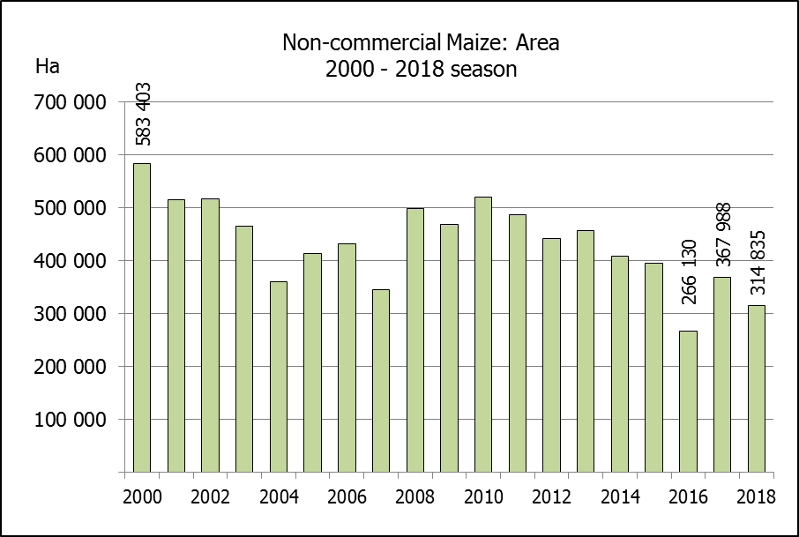  Change/  Verandering
CROP/GEWAS | Ha | Tons | Ha | Tons | %
CROP/GEWAS | (A) | (B) | (C) | (D) | (B) ÷ (D)
Non-commercial agriculture/Nie-kommersiële landbou:
White maize/Witmielies | 236 644 | 414 162 | 248 500 | 463 600 | -10,66
Yellow maize/Geelmielies | 78 191 | 179 813 | 118 150 | 267 400 | -32,76
Maize/Mielies | 314 835 | 593 975 | 366 650 | 731 000 | -18,74
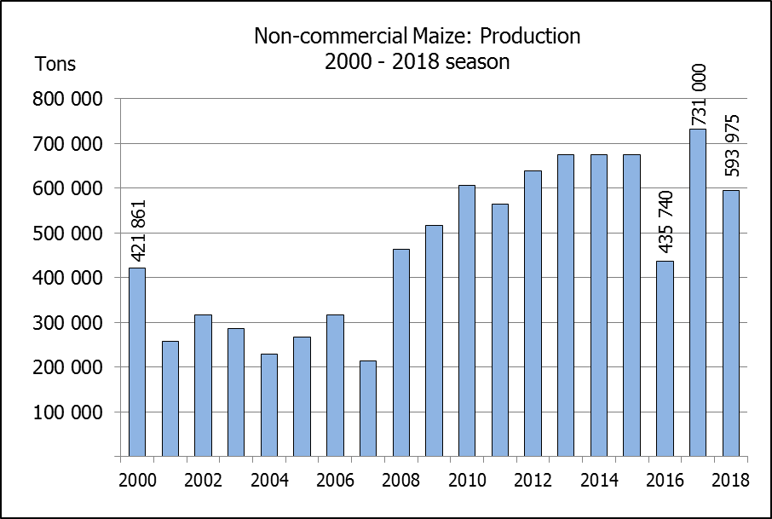
The preliminary area planted to maize in the non-commercial agricultural sector is estimated at 314 835 ha, which represents a decrease of 14,13%, compared to the 366 650 ha of the previous season. The expected maize crop for this sector is 593 975 tons, which is 18,74% less than the 731 000 tons of last season. It is important to note that about 40% of the maize produced in the non-commercial sector, is planted in the Eastern Cape.
Die voorlopige oppervlakte beplant met mielies in die nie-kommersiële landbou-sektor word geskat op 314 835 ha, wat ‘n afname van 14,13 % verteenwoordig in vergelyking met die 366 650 ha van die vorige seisoen. Die verwagte mielie-oes van dié sektor is 593 975 ton, wat 18,74% minder is as die 731 000 ton van die vorige seisoen. Dit is belangrik om daarop te let dat ongeveer 40% van die mielies wat geproduseer word in die nie-kommersiële sektor, in die Oos-Kaap geplant word.

The intentions to plant winter cereals for the 2018 production season is hereby released. /
Hiermee word die voorneme om wintergewasse te plant vir die 2018 produksie-seisoen vrygestel.
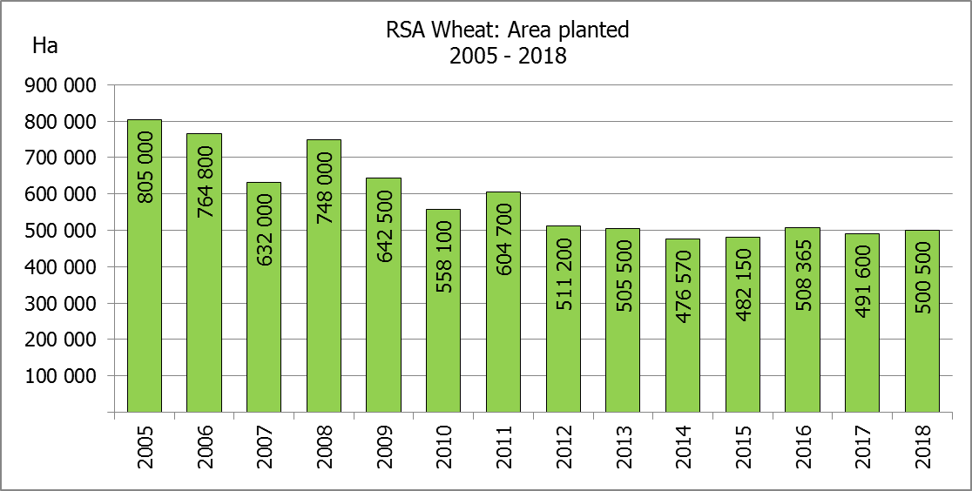
WINTERGEWASSE – VOORNEME OM TE PLANT: 2018
WINTER CEREALS –INTENTIONS TO PLANT: 2018
GEWAS/CROP | Voorneme/  Intentions*  2018 | Opp beplant/  Area planted  2017 | Finale skatting/  Final estimate  2017 | Verandering/  Change
GEWAS/CROP | Ha | Ha | Tons | %
GEWAS/CROP | (A) | (B) | (C) | (A) ÷ (B)
Koring/Wheat | 500 500 | 491 600 | 1 524 750 | +1,8
Moutgars/Malting barley | 95 700 | 91 380 | 307 064 | +4,7
Kanola/Canola | 78 500 | 84 000 | 93 468 | 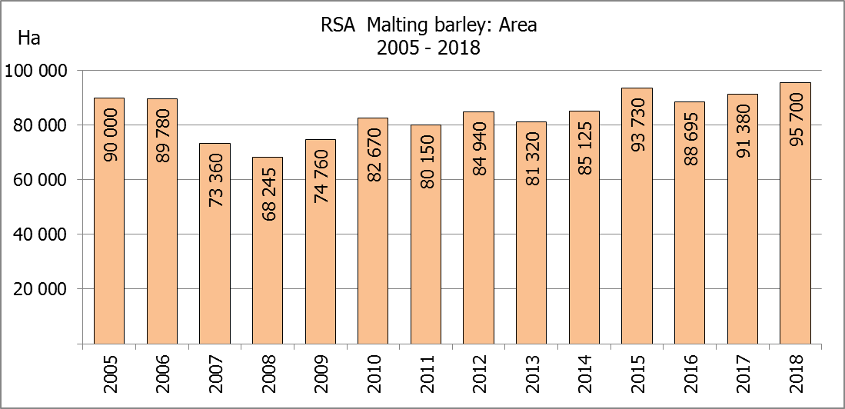  -6,6
Totaal/Total | 674 700 | 666 980 | 1 925 282 | +1,2

* Based on conditions at the middle of April 2018 / Gebaseer op toestande soos teen middel April 2018.
KORING – VOORNEME OM TE PLANT: 2018
WHEAT – INTENTIONS TO PLANT: 2018

Provinsie/  Province | Voorneme/  Intentions  Ha | Opp beplant/  Area planted  Ha | Finale skatting/  Final estimate  Tons
Provinsie/  Province | 2018 | 2017 | 2017
Wes-Kaap/Western Cape | 320 000 | 326 000 | 586 800
Noord-Kaap/Northern Cape | 37 000 | 38 000 | 311 600
Vrystaat/Free State | 95 000 | 80 000 | 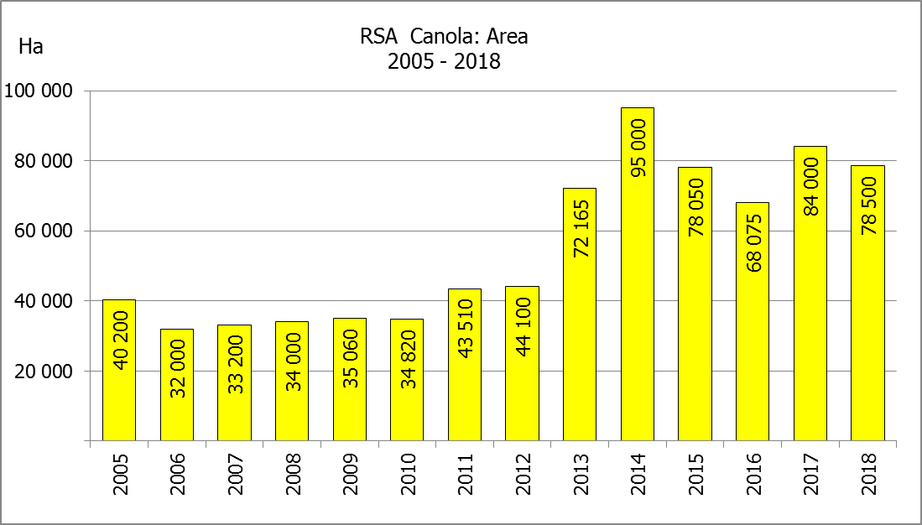  328 000
Oos-Kaap/Eastern Cape | 2 000 | 1 900 | 9 500
KwaZulu-Natal | 6 500 | 7 500 | 45 750
Mpumalanga | 3 500 | 4 000 | 25 200
Limpopo | 22 000 | 20 000 | 130 000
Gauteng | 500 | 700 | 4 200
Noordwes/North West | 14 000 | 13 500 | 83 700
Totaal/Total | 500 500 | 491 600 | 1 524 750

* Based on conditions at the middle of April 2018 / Gebaseer op toestande soos teen middel April 2018.

INTENTIONS TO PLANT WINTER CROPS FOR 2018 / VOORNEME OM WINTERGEWASSE AAN TE PLANT VIR 2018

Winter cereal crops – 2018  Producers’ intentions to plant winter cereals are based on the results of a non-probability survey conducted by the Directorate: Statistics and Economic Analysis of the Department of Agriculture, Forestry and Fisheries and reflects the position as at the middle of April 2018.  The figures for wheat represent the total number of hectares that are intended to be planted for grain, excluding any hectares that will be planted for fodder and grazing.  Early indications are that producers intend to plant 500 500 ha of wheat for the 2018 production season. This is 1,81% or 8 900 ha more than 491 600 ha planted to wheat in 2017.  The main producing areas are within the Western Cape with 320 000 ha (64%), followed by the Free State with 95 000 ha (19%) and the Northern Cape with 37 000 ha (7%).  The expected area planted to malting barley is 95 700 ha, which is 4,73% or 4 320 ha more than the 91 380 ha of the previous year. The expected area planted to canola is 78 500 ha, which is 6,55% or 5 500 ha less than the 84 000 ha planted in 2017.  Please note that the preliminary area estimate of winter crops for 2018 will be released on 26 July 2018. |  | Wintergewasse – 2018  Produsente se voorneme om wintergewasse te plant is gebaseer op die resultate van ’n nie-ewekansige opname onderneem deur die Direktoraat: Statistiek en Ekonomiese Analise van die Departement van Landbou, Bosbou en Visserye en weerspieël die situasie teen die middel van April 2018.  Die syfers vir koring verteenwoordig die totale aantal hektare wat werklik beplant gaan word vir graan, uitgesluit alle hektare wat beplant gaan word vir groenvoer en weiding.  Vroeë aanduidings is dat produsente van voorneme is om 500 500 ha koring te plant vir die 2018-produksie-seisoen. Dit is 1,81% of 8 900 ha meer koring aangeplant as in 2017.  Die grootste produserende gebiede is in die Wes-Kaap, met 320 000 ha (64%), gevolg deur die Vrystaat met 95 000 ha (19%) en die Noord-Kaap met 37 000 ha (7%).  Die verwagte aanplantings van moutgars is 95 700 ha – 4,73% of 4 320 ha meer as die 91 380 ha van die vorige jaar. Die verwagte aanplantings van kanola is 78 500 ha, wat 6,55% of 5 500 ha minder is as die 84 000 ha wat aangeplant was in 2017.  Neem asseblief kennis dat die voorlopige oppervlakteskatting vir wintergewasse vir 2018 op 26 Julie 2018 vrygestel sal word.
Information is available on the internet at http://www.daff.gov.za/links/crop estimates or http://www.sagis.org.za, as from 15:30 on the date of the relevant meeting of the Crop Estimates Committee. |  | Inligting is beskikbaar op die internet by http://www.daff.gov.za/links/crop estimates of by http://www.sagis.org.za, vanaf 15:30 op die dag van die toepaslike vergadering van die Oesskattingskomitee.

