 | crop estimates committee | 
 | oesskattingskomitee
From/Van: Mr Baldwin Netshifhefhe
Tel: 012 319 8043/32  Fax/Faks: 012 319 8031  E-mail/E-pos: BaldwinN@nda.gov.za
Web page/Webblad: www.dalrrd.gov.za/old website/statistics and economic reports or
www.sagis.org.za/CEC: Crop Estimates EMBARGO: 14:30

The area planted estimate and third production forecast for summer crops for 2025 is hereby released.
Hiermee word die oppervlakte- en derde produksieskatting vir somergewasse vir 2025 vrygestel.

SUMMER CROPS – AREA PLANTED AND THIRD PRODUCTION FORECAST: 2025
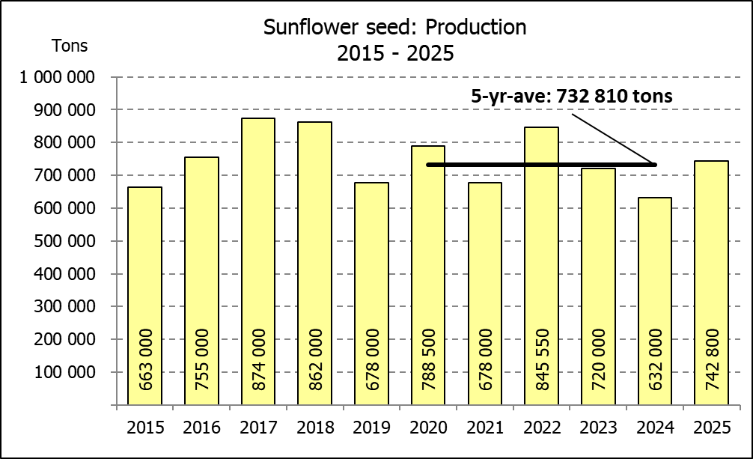
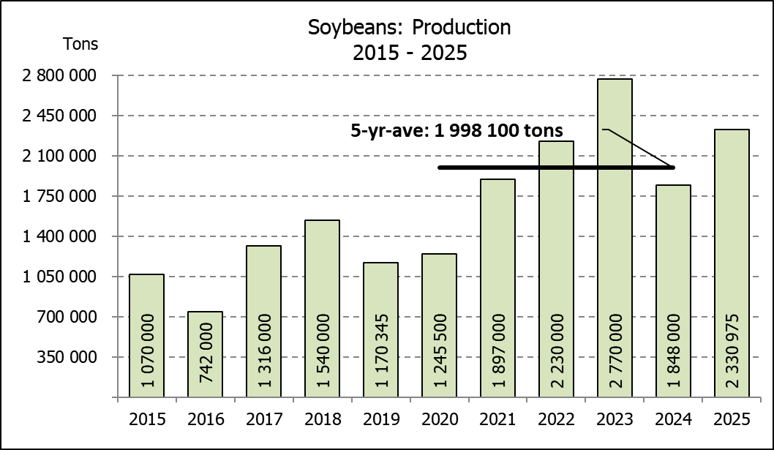
SOMERGEWASSE – OPPERVLAKTE- EN DERDE PRODUKSIESKATTING: 2025
CROP/GEWAS | Area planted/ | 3rd forecast/ | 2nd forecast/ | Area planted/ | Final crop/ | Change/
CROP/GEWAS | Opp beplant | 3de skatting | 2de skatting | Opp beplant | Finale oes | Verandering
CROP/GEWAS | 2025 | 2025 | 2025 | 2024 | 2024
CROP/GEWAS | Ha | Tons | Tons | Ha | Tons | %
CROP/GEWAS | (A) | (B) | (C) | (D) | (E) | (B) ÷ (C)
Commercial/Kommersieël:
White maize/Witmielies | 1 599 700 | 7 756 700 | 7 695 200 | 1 554 750 | 6 055 000 | 0,80%
Yellow maize/Geelmielies | 997 000 | 6 907 100 | 6 863 400 | 1 081 500 | 6 795 000 | 0,64%
Total Maize/Totale Mielies | 2 596 700 | 14 663 800 | 14 558 600 | 2 636 250 | 12 850 000 | 0,72%
Sunflower seed/Sonneblomsaad | 555 700 | 742 800 | 770 500 | 529 000 | 632 000 | -3,60%
Soybeans/Sojabone | 1 151 000 | 2 330 975 | 2 389 925 | 1 150 500 | 1 848 000 | -2,47%
Groundnuts/Grondbone | 48 125 | 64 595 | 66 929 | 41 200 | 52 000 | -3,49%
Sorghum | 41 150 | 137 970 | 137 435 | 42 100 | 98 000 | 0,39%
Dry beans/Droëbone | 45 620 | 70 540 | 79 007 | 39 550 | 50 495 | -10,72%
TOTAL/TOTAAL | 4 438 295 | 18 010 680 | 18 002 396 | 4 438 600 | 15 530 495 | 0,05%
Non-Commercial Maize/Nie-Kommersiële Mielies
Total Maize/Totale Mielies | 358 000 | 621 500 | N/A | 347 000 | 575 000 | N/A
Maize/Mielies: Commercial/Kommersieël + Non-Commercial/Nie-Kommersieël
Total Maize RSA/Totaal Mielies RSA | 2 954 700 | 15 285 300 | N/A | 2 983 250 | 13 425 000 | N/A
Note: Estimate is for calendar year, e.g. production season 2024/25 = 2025
Nota: Skatting is vir kalenderjaar, bv. produksie-seisoen 2024/25 = 2025
The Crop Estimates Committee comprises officials of the following institutions:
Department of Agriculture, Land Reform and Rural Development; Provincial Departments of Agriculture; various ARC-Institutes (Soil, Climate and Water; Small Grains Institute; and
Grain Crops Institute); BFAP and Statistics SA.
30 April 2025
The Crop Estimates Committee comprises officials of the following institutions:
Department of Agriculture, Land Reform and Rural Development; Provincial Departments of Agriculture; various ARC-Institutes (Soil, Climate and Water; Small Grains Institute; and Grain Crops Institute); BFAP and Statistics SA.

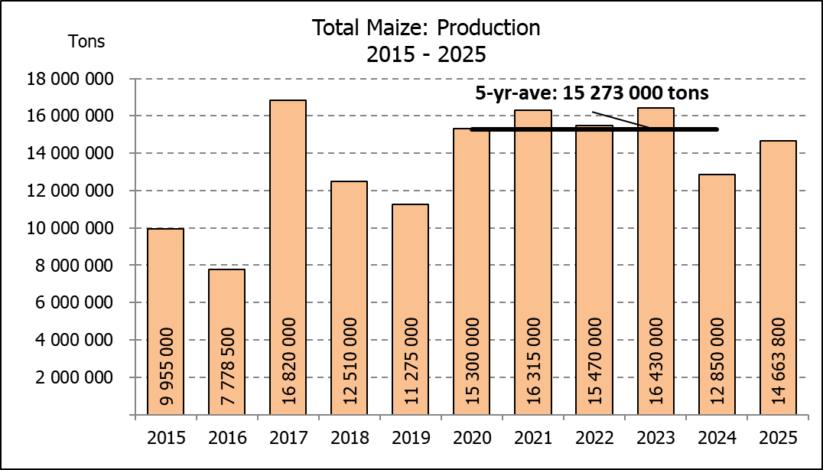

WHITE AND YELLOW MAIZE – AREA PLANTED AND THIRD PRODUCTION FORECAST: 2025
WIT- EN GEELMIELIES – OPPERVLAKTE EN DERDE PRODUKSIESKATTING: 2025

Provinsie/ | Area planted/ |  |  | 3rd forecast/ |  |  | Area planted/ |  |  |  | Final crop/
Province | Oppervlakte beplant |  |  | 3de skatting |  |  | Oppervlakte beplant |  |  |  | Finale oes
 | 2025 |  |  | 2025 |  |  | 2024 |  |  |  | 2024
 | White/ | Yellow/ | Total/ | White/ | Yellow/ | Total/ | White/ | Yellow/ | Total/ | White/ |  | Yellow/ | Total/
 | Wit | Geel | Totaal | Wit | Geel | Totaal | Wit | Geel | Totaal | Wit |  | Geel | Totaal
 | Ha | Ha | Ha | Tons | Tons | Tons | Ha | Ha | Ha | Tons |  | Tons | Tons
Western Cape/Wes-Kaap | 200 | 3 500 | 3 700 | 1 900 | 32 900 | 34 800 | 250 | 3 500 | 3 750 | 2 300 |  | 32 200 | 34 500
Northern Cape/Noord-Kaap | 1 500 | 42 000 | 43 500 | 18 750 | 651 000 | 669 750 | 1 500 | 42 000 | 43 500 | 18 900 |  | 648 900 | 667 800
Free State/Vrystaat | 850 000 | 345 000 | 1 195 000 | 3 952 500 | 1 983 750 | 5 936 250 | 835 000 | 415 000 | 1 250 000 | 3 385 000 |  | 1 992 000 | 5 377 000
Eastern Cape/Oos-Kaap | 6 000 | 28 000 | 34 000 | 41 400 | 210 000 | 251 400 | 6 000 | 27 000 | 33 000 | 40 800 |  | 191 700 | 232 500
KwaZulu-Natal | 50 000 | 66 000 | 116 000 | 305 000 | 561 000 | 866 000 | 47 000 | 67 000 | 114 000 | 286 700 |  | 576 200 | 862 900
Mpumalanga | 162 000 | 362 000 | 524 000 | 1 004 400 | 2 497 800 | 3 502 200 | 160 000 | 360 000 | 520 000 | 984 000 |  | 2 490 000 | 3 474 000
Limpopo | 10 000 | 18 500 | 28 500 | 69 000 | 149 850 | 218 850 | 11 000 | 15 000 | 26 000 | 74 800 |  | 120 000 | 194 800
Gauteng | 55 000 | 57 000 | 112 000 | 341 000 | 393 300 | 734 300 | 54 000 | 62 000 | 116 000 | 292 500 |  | 415 500 | 708 000
North West/Noordwes | 465 000 | 75 000 | 540 000 | 2 022 750 | 427 500 | 2 450 250 | 440 000 | 90 000 | 530 000 | 970 000 |  | 328 500 | 1 298 500
Total/Totaal | 1 599 700 | 997 000 | 2 596 700 | 7 756 700 | 6 907 100 | 14 663 800 | 1 554 750 | 1 081 500 | 2 636 250 | 6 055 000 |  | 6 795 000 | 12 850 000

SUNFLOWER SEED – AREA PLANTED AND THIRD PRODUCTION FORECAST: 2025
SONNEBLOMSAAD – OPPERVLAKTE EN DERDE PRODUKSIESKATTING: 2025

Province/ | Area planted/ | 3rd forecast/ | Area planted/ | Final crop/
Provinsie | Opp beplant | 3de skatting | Opp beplant | Finale oes
 | Ha | Tons | Ha | Tons
 | 2025 | 2025 | 2024 | 2024
Western Cape/Wes-Kaap | 0 | 0 | 0 | 0
Northern Cape/Noord-Kaap | 1 000 | 2 300 | 2 000 | 4 600
Free State/Vrystaat | 264 500 | 383 525 | 255 000 | 354 000
Eastern Cape/Oos-Kaap | 700 | 1 400 | 700 | 1 400
KwaZulu-Natal | 1 000 | 2 000 | 300 | 600
Mpumalanga | 2 500 | 3 625 | 3 500 | 4 900
Limpopo | 90 000 | 85 500 | 90 000 | 63 000
Gauteng | 1 000 | 1 200 | 2 500 | 3 000
North West/Noordwes | 195 000 | 263 250 | 175 000 | 200 500
Total/Totaal | 555 700 | 742 800 | 529 000 | 632 000
SOYBEANS – AREA PLANTED AND THIRD PRODUCTION FORECAST: 2025
SOJABONE – OPPERVLAKTE EN DERDE PRODUKSIESKATTING: 2025
Province/ | Area planted/ | 3rd forecast/ | Area planted/ | Final crop/
Provinsie | Opp beplant | 3de skatting | Opp beplant | Finale oes
 | Ha | Tons | Ha | Tons
 | 2025 | 2025 | 2024 | 2024
Western Cape/Wes-Kaap | 0 | 0 | 0 | 0
Northern Cape/Noord-Kaap | 2 000 | 7 000 | 1 200 | 4 380
Free State/Vrystaat | 565 000 | 1 101 750 | 545 000 | 688 960
Eastern Cape/Oos-Kaap | 5 500 | 15 675 | 5 300 | 14 310
KwaZulu-Natal | 47 000 | 173 900 | 47 000 | 173 900
Mpumalanga | 315 000 | 598 500 | 320 000 | 624 000
Limpopo | 16 500 | 51 150 | 21 000 | 72 450
Gauteng | 52 000 | 109 200 | 56 000 | 84 000
North West/Noordwes | 148 000 | 273 800 | 155 000 | 186 000
Total/Totaal | 1 151 000 | 2 330 975 | 1 150 500 | 1 848 000

GROUNDNUTS – AREA PLANTED AND THIRD PRODUCTION FORECAST: 2025
GRONDBONE – OPPERVLAKTE EN DERDE PRODUKSIESKATTING: 2025

Province/ | Area planted/ | 3rd forecast/ | Area planted/ | Final crop/
Provinsie | Opp beplant | 3de skatting | Opp beplant | Finale oes
 | Ha | Tons | Ha | Tons
 | 2025 | 2025 | 2024 | 2024
Western Cape/Wes-Kaap | 0 | 0 | 0 | 0
Northern Cape/Noord-Kaap | 3 100 | 8 525 | 4 200 | 8 610
Free State/Vrystaat | 21 700 | 30 380 | 17 000 | 26 305
Eastern Cape/Oos-Kaap | 0 | 0 | 0 | 0
KwaZulu-Natal | 175 | 228 | 300 | 495
Mpumalanga | 0 | 0 | 0 | 0
Limpopo | 1 650 | 2 888 | 1 700 | 4 590
Gauteng | 0 | 0 | 0 | 0
North West/Noordwes | 21 500 | 22 575 | 18 000 | 12 000
Total/Totaal | 48 125 | 64 595 | 41 200 | 52 000

SORGHUM – AREA PLANTED AND THIRD PRODUCTION FORECAST: 2025
SORGHUM – OPPERVLAKTE EN DERDE PRODUKSIESKATTING: 2025

Province/ | Area planted/ | 3rd forecast/ | Area planted/ | Final crop/
Provinsie | Opp beplant | 3de skatting | Opp beplant | Finale oes
 | Ha | Tons | Ha | Tons
 | 2025 | 2025 | 2024 | 2024
Western Cape/Wes-Kaap | 0 | 0 | 0 | 0
Northern Cape/Noord-Kaap | 0 | 0 | 0 | 0
Free State/Vrystaat | 12 800 | 44 800 | 11 500 | 19 740
Eastern Cape/Oos-Kaap | 200 | 600 | 100 | 300
KwaZulu-Natal | 100 | 380 | 100 | 350
Mpumalanga | 9 200 | 43 240 | 8 300 | 36 520
Limpopo | 13 000 | 30 550 | 18 000 | 35 100
Gauteng | 850 | 3 400 | 100 | 390
North West/Noordwes | 5 000 | 15 000 | 4 000 | 5 600
Total/Totaal | 41 150 | 137 970 | 42 100 | 98 000

DRY BEANS – AREA PLANTED AND THIRD PRODUCTION FORECAST: 2025
DROëBONE – OPPERVLAKTE EN DERDE PRODUKSIESKATTING: 2025

Province/ | Area planted/ | 3rd forecast/ | Area planted/ | Final crop/
Provinsie | Opp beplant | 3de skatting | Opp beplant | Finale oes
 | Ha | Tons | Ha | Tons
 | 2025 | 2025 | 2024 | 2024
Western Cape/Wes-Kaap | 100 | 200 | 100 | 220
Northern Cape/Noord-Kaap | 950 | 2 185 | 500 | 900
Free State/Vrystaat | 17 500 | 21 000 | 13 500 | 10 800
Eastern Cape/Oos-Kaap | 200 | 400 | 200 | 440
KwaZulu-Natal | 3 000 | 3 900 | 2 100 | 2 730
Mpumalanga | 2 320 | 4 060 | 2 600 | 4 680
Limpopo | 11 100 | 23 310 | 12 200 | 23 790
Gauteng | 950 | 1 235 | 850 | 935
North West/Noordwes | 9 500 | 14 250 | 7 500 | 6 000
Total/Totaal | 45 620 | 70 540 | 39 550 | 50 495

CONFIDENTIALITY ISSUES that CEC members are committed to adhere to on the day of the meeting
- Personal items such as laptops, handbags, cell phones, etc. are not allowed in the venue during the meeting
- No member is allowed to leave the meeting before 12:00 in order to prevent disclosure of the information
- The embargo time for the release of crop estimates information is 14:30
- No member is allowed to discuss crop estimates information with anyone other than a member of the Committee before the embargo time
- Only the Chairperson, or a member appointed by the Chairperson, may release the figures to the media
- Members must regard the detail of any information that was collected for and/or discussed during the meeting, as confidential
- Individual information received for crop estimate purposes is treated strictly confidential, and is not divulged for any other purposes

AREA ESTIMATE AND THIRD PRODUCTION FORECAST OF SUMMER CROPS (2025PRODUCTION SEASON)/
OPPERVLAKTE- EN DERDE PRODUKSIESKATTING VIR SOMERGEWASSE (2025 PRODUKSIE-SEISOEN)
30 APRIL 2025

Summer field crops – 2025  Commercial maize: The size of the expected commercial maize crop has been set at 14,664 mill. tons, which is 0,72% or 105 200 tons more than the previous forecast of 14,559 mill. tons. The expected yield for maize is 5,65 t/ha.  The estimated maize crop is 14,12% or 1,814 mill. tons larger than the 2024 crop. The three main maize producing areas, namely the Free State, Mpumalanga and North West provinces are expected to produce 81% of the 2025 crop.  The production forecast of white maize is 7,757 mill. tons, which is 0,80% or  61 500 tons more than the 7,695 mill. tons of the previous forecast. The area estimate for white maize is 1,600 mill. ha and the expected yield is 4,85 t/ha.  In the case of yellow maize, the production forecast is 6,907 mill. tons, which is 0,64% or 43 700 tons more than the 6,863 mill. tons of the previous forecast. The area estimate for yellow maize is 997 000 ha and the yield is 6,93 t/ha.  The yield per ha for the Mpumalanga province was based on scientific and objective results provided by the ARC. Please note that the objective results for the Free State and North West provinces will be available in May 2025.  Other summer crops:  Sunflower seed: The production forecast for sunflower seed is 742 800 tons, which is 3,60% or 27 700 tons less than the previous forecast of 770 500 tons. The area estimate for sunflower seed is 555 700 ha, while the expected yield is 1,34 t/ha.  Other crops: The production forecast for soybeans decreased by 2,47% or 58 950 tons from 2,390 mill. tons to 2,331 mill. tons. The estimated area planted to soybeans is 1,151 mill. ha, with an expected yield of 2,03 t/ha.  The expected groundnut crop has been set at 64 595 tons, which is 3,49% or 2 334 tons less than the previous forecast of 66 929 tons. For groundnuts, the area estimate is 48 125 ha, with an expected yield of 1,34 t/ha.  The production forecast for sorghum is 137 970 tons, which is 0,39% or 535 tons more than the 137 435 tons of the previous forecast. The area estimate for sorghum is 41 150 ha and the expected yield is 3,35 t/ha.  In the case of dry beans, the production forecast decreased by 10,72% or 8 467 tons, from 79 007 tons to 70 540 tons. The area estimate of dry beans is 45 620 ha, with an expected yield of 1,55 t/ha.  Please note that the fourth production forecast for summer field crops for 2025 will be released on 27 May 2025. |  | Somergewasse – 2025  Kommersiële mielies: Die grootte van die verwagte kommersiële mielie-oes is op 14,664 milj. ton gestel, wat 0,72% of 105 200 ton meer is as die vorige skatting van 14,559 milj. ton. Die verwagte opbrengs van mielies is 5,65 t/ha.  Die geskatte mielie-oes is 14,12% of 1,814 milj. ton meer as die 2024-oes. Die drie belangrikste mielieproduserende gebiede, nl. die Vrystaat, Mpumalanga en Noordwes provinsies, gaan na verwagting 81% van die 2025-oes produseer.  Die produksieskatting van witmielies is 7,757 milj. ton, wat 0,80% of 61 500 ton meer is as die 7,695 milj. ton van die vorige skatting. Die oppervlakteskatting vir witmielies is 1,600 milj. ha en die verwagte opbrengs is 4,85 t/ha.  In die geval van geelmielies is die produksieskatting 6,907 milj. ton, wat 0,64% of  43 700 ton meer is as die 6,863 milj. ton van die vorige skatting. Die oppervlakteskatting vir geelmielies is 997 000 ha en die opbrengs is 6,93 t/ha.  Die opbrengs-bepaling per ha vir die Mpumalanga provinsie is gebaseer op wetenskaplike en objektiewe resultate verstrek deur die LNR. Neem kennis dat die objektiewe resultate vir die Vrystaat en Noordwes provinsies, in Mei 2025 gerapporteer sal word.  Ander somergewasse:  Sonneblomsaad: Die produksieskatting vir sonneblomsaad is 742 800 ton, wat 3,60% of 27 700 ton minder is as die vorige skatting van 770 500 ton. Die oppervlakteskatting vir sonneblomsaad is 555 700 ha, terwyl die verwagte opbrengs 1,34 t/ha is.  Ander gewasse: Die produksieskatting van sojabone is verlaag met 2,47% of 58 950 ton, van 2,390 milj. ton na 2,331 milj. ton. Die geskatte oppervlakte beplant van sojabone is 1,151 milj. ha, met ‘n verwagte opbrengs van 2,03 t/ha.  Die verwagte grondbone-oes is op 64 595 ton gestel, wat 3,49% of 2 334 ton minder is as die vorige skatting van 66 929 ton. Vir grondbone is die oppervlakteskatting 48 125 ha, terwyl die verwagte opbrengs 1,34 t/ha is.  Die produksieskatting van sorghum is 137 970 ton, wat 0,39% of 535 ton meer is as die 137 435 ton van die vorige skatting. Die oppervlakteskatting vir sorghum is 41 150 ha, en die verwagte opbrengs is 3,35 t/ha.  In die geval van droëbone is die produksieskatting verlaag met 10,72% of 8 467 ton, vanaf 79 007 ton na 70 540 ton. Die oppervlakte beplant met droëbone is 45 620 ha, en die verwagte opbrengs is 1,55 t/ha.  Neem asseblief kennis dat die vierde produksieskatting vir somergewasse vir 2025, op 27 Mei 2025 vrygestel sal word.
Information is available on the internet at http:// www.dalrrd.gov.za/old website/statistics or http://www.sagis.org.za, as from 14:30 on the date of the relevant meeting of the Crop Estimates Committee. |  | Inligting is beskikbaar op die internet by http://www.dalrrd.gov.za/old website/statistics of by http://www.sagis.org.za, vanaf 14:30 op die dag van die toepaslike vergadering van die Oesskattingskomitee.

The non-commercial agricultural sectors’ production estimate for maize for 2025 is hereby released. /
Hiermee word die nie-kommersiële landbou-sektor se produksieskatting vir mielies vir 2025 vrygestel.

NON-COMMERCIAL MAIZE – PRELIMINARY AREA PLANTED AND PRODUCTION ESTIMATE: 2025
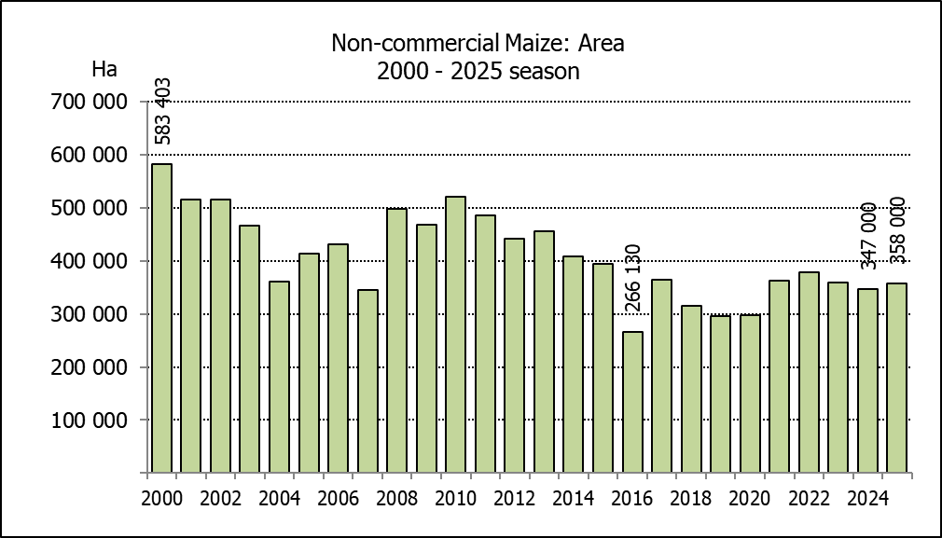
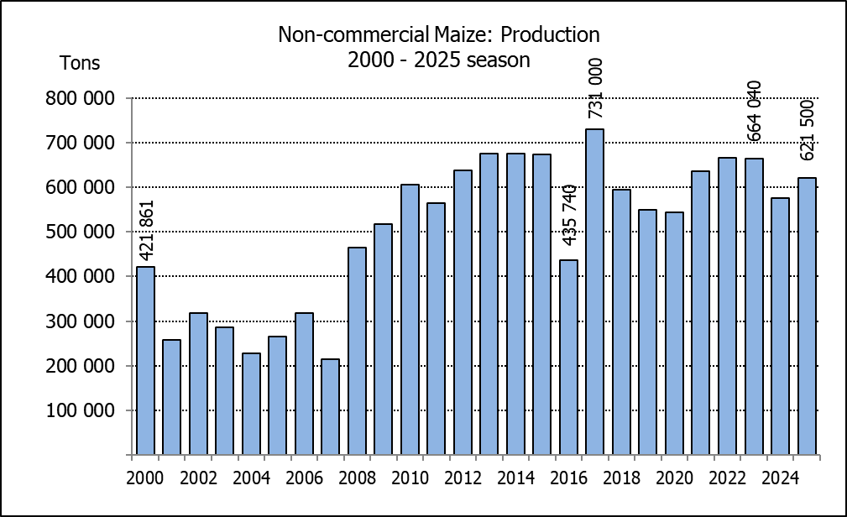
NIE-KOMMERSIëLE MIELIES – VOORLOPIGE OPPERVLAKTE- EN PRODUKSIESKATTING: 2025
CROP/GEWAS | Area planted/  Opp beplant  2025 | Production/  Produksie  2025 | Area planted/  Opp beplant  2024 | Final crop/  Finale oes  2024 | Change/  Verandering
CROP/GEWAS | Ha | Tons | Ha | Tons | %
CROP/GEWAS | (A) | (B) | (C) | (D) | (B) ÷ (D)
Non-commercial agriculture/Nie-kommersiële landbou:
White maize/Witmielies | 275 150 | 439 700 | 267 570 | 407 500 | +7,90
Yellow maize/Geelmielies | 82 850 | 181 800 | 79 430 | 167 500 | +8,54
Maize/Mielies | 358 000 | 621 500 | 347 000 | 575 000 | +8,09
The area planted to maize in the non-commercial agricultural sector is estimated at 358 000 ha, which represents an increase of 3,17%, compared to the 347 000 ha of the previous season. The expected maize crop for this sector is 621 500 tons, which is 8,09% more than the 575 000 tons of last season. It is important to note that about 46,75% of the maize produced in the non-commercial sector, is planted in the Eastern Cape, followed by KwaZulu-Natal with 20,88% and then Limpopo with 20,65%.
Die voorlopige oppervlakte beplant met mielies in die nie-kommersiële landbou-sektor word geskat op 358 000 ha, wat ’n toename van 3,17% verteenwoordig in vergelyking met die 347 000 ha van die vorige seisoen. Die verwagte mielie-oes van dié sektor is 621 500 ton, wat 8,09% meer is as die 575 000 ton van die vorige seisoen. Dit is belangrik om daarop te let dat ongeveer 46,75% van die mielies wat geproduseer word in die nie-kommersiële sektor, in die Oos-Kaap geplant word, gevolg deur KwaZulu-Natal met 20,88% en dan Limpopo met 20,65%.

The intentions to plant winter cereals for the 2025 production season is hereby released. /
Hiermee word die voorneme om wintergewasse te plant vir die 2025 produksie-seisoen vrygestel.
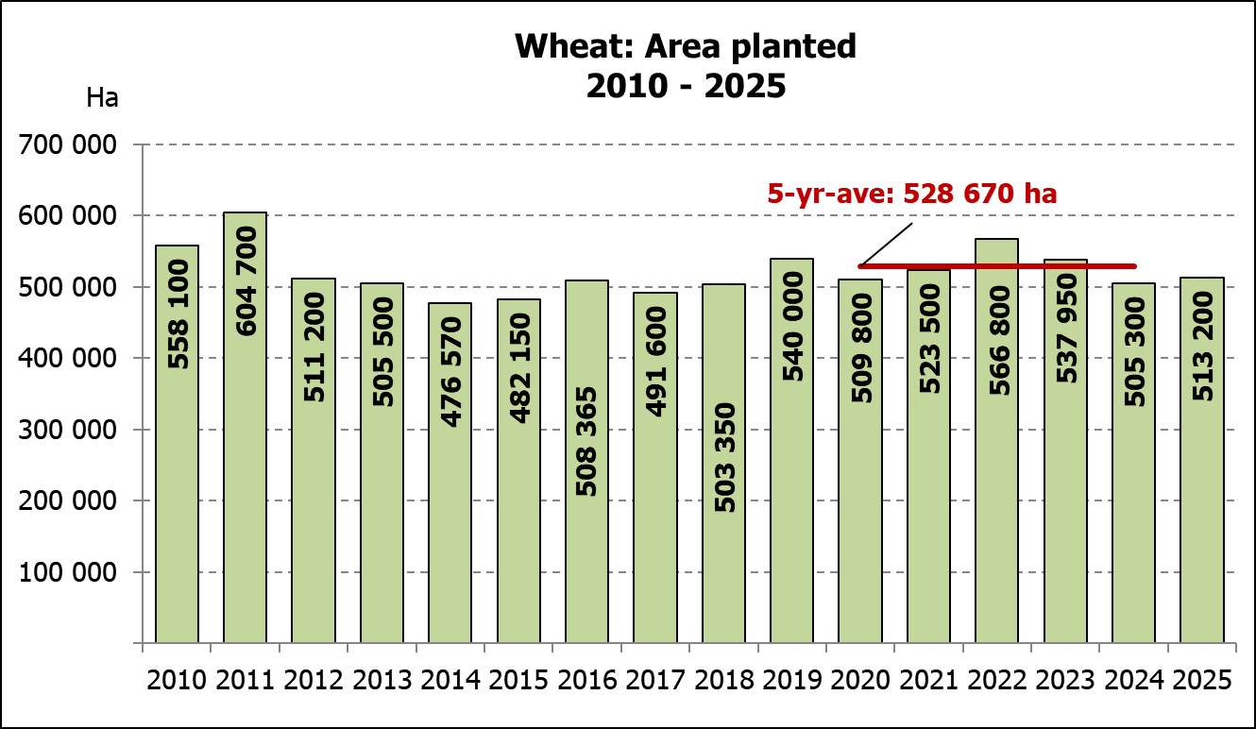
WINTERGEWASSE – VOORNEME OM TE PLANT: 2025
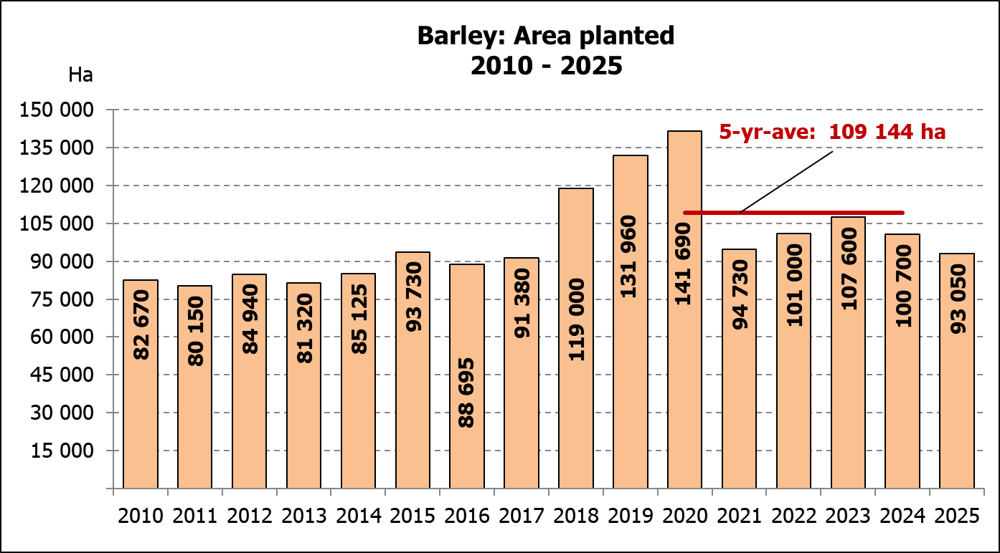
WINTER CEREALS –INTENTIONS TO PLANT: 2025
GEWAS/CROP | Voorneme*/  Intentions*  2025 | Opp beplant/  Area planted  2024 | Final estimate/  Finale skatting  2024 | Verandering/  Change
GEWAS/CROP | Ha | Ha | Tons | %
GEWAS/CROP |  |  | as on 27 Feb 2025/  soos op 27 Feb 2025 | %
 | (A) | (B) | (C) | (A) ÷ (B)
Wheat/Koring | 513 200 | 505 300 | 1 924 890 | 1,56%
Malting barley/Moutgars | 93 050 | 100 700 | 374 000 | -7,60%
Canola/Kanola | 166 500 | 165 750 | 288 200 | 0,45%
Cereal oats/Hawermout | 34 520 | 31 000 | 42 800 | 11,35%
Sweet lupines/Soetlupine | 20 700 | 16 000 | 19 200 | 29,38%
Total winter cereals/Totaal wintergewasse | 827 970 | 818 750 | 2 649 090 | 1,13%
* Based on conditions at the middle of April 2025 / Gebaseer op toestande soos teen middel April 2025.
KORING – VOORNEME OM TE PLANT: 2025
WHEAT – INTENTIONS TO PLANT: 2025
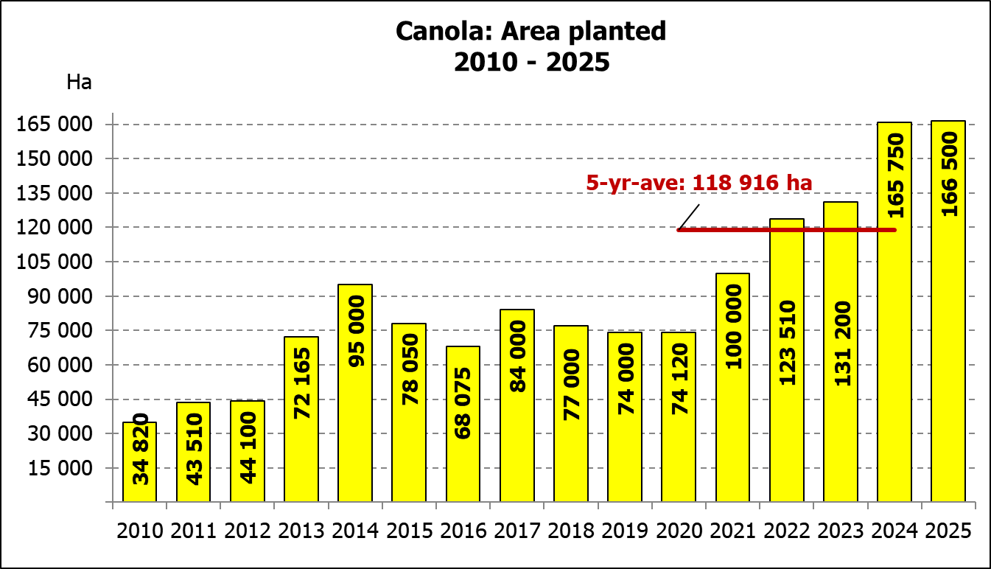
Provinsie/  Province | Voorneme/  Intentions  Ha | Opp beplant/  Area planted  Ha | Finale skatting/  Final estimate  Tons
Provinsie/  Province | 2025 | 2024 | 2024
Wes-Kaap/Western Cape | 371 000 | 368 000 | 1 067 200
Noord-Kaap/Northern Cape | 38 000 | 38 000 | 296 400
Vrystaat/Free State | 55 000 | 49 000 | 225 400
Oos-Kaap/Eastern Cape | 3 800 | 5 000 | 34 500
KwaZulu-Natal | 8 400 | 8 300 | 52 290
Mpumalanga | 3 500 | 3 500 | 24 500
Limpopo | 22 000 | 20 500 | 143 500
Gauteng | 1 000 | 1 000 | 6 700
Noordwes/North West | 10 500 | 12 000 | 74 400
Totaal/Total | 513 200 | 505 300 | 1 924 890

2025: Intentions/Voornemens

INTENTIONS TO PLANT WINTER CROPS FOR 2025 / VOORNEME OM WINTERGEWASSE AAN TE PLANT VIR 2025

Winter cereal crops – 2025  Producers’ intentions to plant winter cereals are mainly based on the results of a non-probability survey conducted by the Directorate: Statistics and Economic Analysis of the Department of Agriculture and reflects the position as at the middle of April 2025. Inputs were also received from the representatives of the respective Provincial Departments of Agriculture.  The figures for wheat represent the total number of hectares that are intended to be planted for grain, excluding any hectares that will be planted for fodder and grazing.  Early indications are that producers intend to plant 513 200 ha of wheat for the 2025 production season. This is 1,56% or 7 900 ha more than the 505 300 ha planted to wheat in 2024.  The main producing areas are within the Western Cape with 371 000 ha (72%), followed by the Free State with 55 000 ha (11%) and the Northern Cape with 38 000 ha (7%).  The expected area planted to malting barley is 93 050 ha, which is 7,60% or 7 650 ha less than the 100 700 ha of the previous year. The expected area planted to canola is also 166 500 ha, which is 0,45% or 750 ha more than the 165 750 ha planted in 2024. Producers intend to plant 34 520 ha of cereal oats, which is 11,35% or 3 520 ha more than the 31 000 ha of the previous season. The expected area planted to sweet lupines is 20 700 ha, which is 29,38% or 4 700 ha more than the previous season.  Please note that the preliminary area estimate of winter crops for 2025 will be released on 29 July 2025. |  | Wintergewasse – 2025  Produsente se voorneme om wintergewasse te plant is hoofsaaklik gebaseer op die resultate van ’n nie-ewekansige opname onderneem deur die Direktoraat: Statistiek en Ekonomiese Analise van die Departement van Landbou en weerspieël die situasie teen die middel van April 2025. Insette is ook ontvang vanaf die verteenwoordigers van die onderskeie Provinsiale Departemente van Landbou.  Die syfers vir koring verteenwoordig die totale aantal hektare wat werklik beplant gaan word vir graan, uitgesluit alle hektare wat beplant gaan word vir groenvoer en weiding.  Vroeë aanduidings is dat produsente van voorneme is om 513 200 ha koring te plant vir die 2025-produksie-seisoen. Dit is 1,56% of 7 900 ha meer koring aangeplant as die 505 300 ha in 2024.  Die grootste produserende gebiede is in die Wes-Kaap, met 371 000 ha (72%), gevolg deur die Vrystaat met 55 000 ha (11%) en die Noord-Kaap met  38 000 ha (7%).  Die verwagte aanplantings van moutgars is 93 050 ha – 7,60% of 7 650 ha minder as die 100 700 ha van die vorige jaar. Die verwagte aanplantings van kanola is ook 166 500 ha, wat 0,45% of 750 ha meer is as die 165 750 ha wat aangeplant was in 2024. Produsente is van voorneme om 34 520 ha hawermout te plant, wat 11,35% of 3 520 ha meer is as die 31 000 ha van die vorige seisoen. Die verwagte aanplantings van soetlupine is 20 700 ha, wat 29,38% of 4 700 ha meer is as die vorige seisoen.  Neem asseblief kennis dat die voorlopige oppervlakteskatting vir wintergewasse vir 2025 op 29 Julie 2025 vrygestel sal word.
Information is available on the internet at http:// www.dalrrd.gov.za/statistics or http://www.sagis.org.za, as from 14:30 on the date of the relevant meeting of the Crop Estimates Committee. |  | Inligting is beskikbaar op die internet by http://www.dalrrd.gov.za/statistics of by http://www.sagis.org.za, vanaf 14:30 op die dag van die toepaslike vergadering van die Oesskattingskomitee.

