 | crop estimates committee
 | oesskattingskomitee
From/Van: Mr Baldwin Netshifhefhe  Tel: 012 319 8043/32 E-mail/E-pos: BaldwinN@dalrrd.gov.za  Web page/Webblad: www.dalrrd.gov.za/statistics and economic reports or  www.sagis.org.za/CEC: Crop Estimates EMBARGO: 14:30 |  |  | 

The area planted estimate and final production estimate for summer crops for 2022 is hereby released.
Hiermee word die oppervlakte- en finale produksieskatting vir somergewasse vir 2022 vrygestel.

SUMMER CROPS – AREA PLANTED AND FINAL PRODUCTION ESTIMATE: 2022
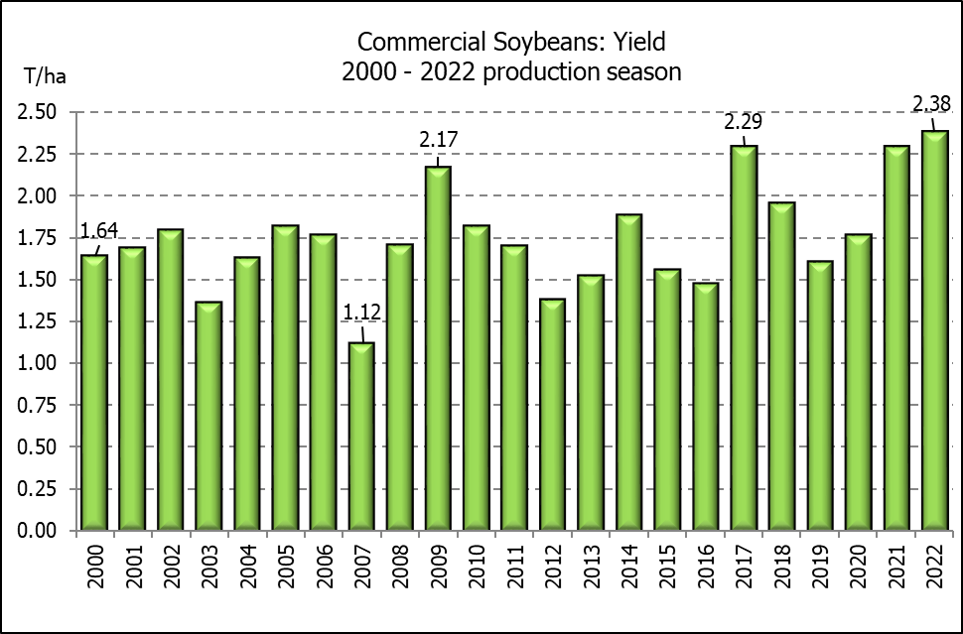
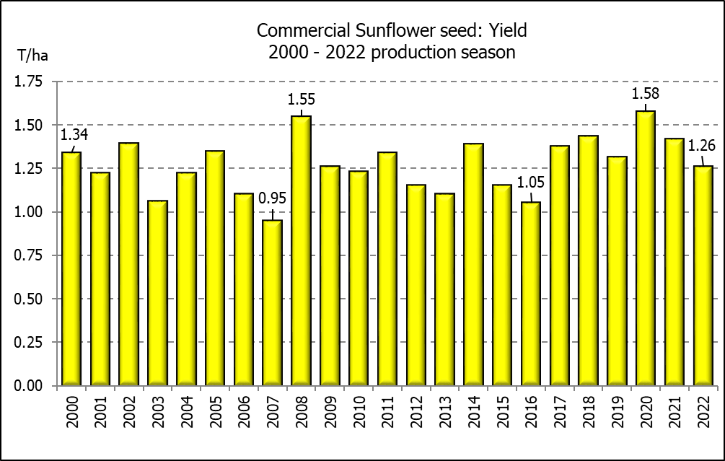
SOMERGEWASSE – OPPERVLAKTE- EN FINALE PRODUKSIESKATTING: 2022
CROP/GEWAS | Area planted/  Opp beplant  2022 | Final estimate/  Finale skatting  2022 | 9th forecast/  9de skatting  2022 | Area planted/  Opp beplant  2021 | Final crop/  Finale oes  2021 | Change/  Verandering/
CROP/GEWAS | Ha | Tons | Tons | Ha | Tons | %
CROP/GEWAS | (A) | (B) | (C) | (D) | (E) | (B) ÷ (C)
Commercial/Kommersieel:
White maize/Witmielies | 1 575 000 | 7 789 750 | 7 789 750 | 1 691 900 | 8 600 000 | -
Yellow maize/Geelmielies | 1 048 000 | 7 597 450 | 7 539 350 | 1 063 500 | 7 715 000 | +0,77
Total Maize/Totale Mielies | 2 623 000 | 15 387 200 | 15 329 100 | 2 755 400 | 16 315 000 | +0,38
Sunflower seed/Sonneblomsaad | 670 700 | 845 550 | 845 550 | 477 800 | 678 000 | -
Soybeans/Sojabone | 925 300 | 2 201 000 | 2 201 000 | 827 100 | 1 897 000 | -
Groundnuts/Grondbone | 43 400 | 49 000 | 49 000 | 38 550 | 64 300 | -
Sorghum | 37 200 | 103 140 | 110 700 | 49 200 | 215 000 | -6,83
Dry beans/Droëbone | 42 900 | 52 590 | 52 590 | 47 390 | 57 672 | -
Non-Commercial Maize/Nie-Kommersiële Mielies
Total Maize/Totale Mielies | 378 800 | 667 000 | 667 000 | 362 900 | 636 440 | -
Maize/Mielies: Commercial/Kommersieël + Non-Commercial/Nie-Kommersieël
Total Maize RSA/Totaal Mielies RSA | 3 001 800 | 16 054 200 | 15 996 100 | 3 118 300 | 16 951 440 | +0,36

Note: Estimate is for calendar year, e.g. production season 2021/22 = 2022
Nota: Skatting is vir kalenderjaar, bv. produksie-seisoen 2021/22 = 2022
29 November 2022
The Crop Estimates Committee comprises officials of the following institutions:
Department of Agriculture, Land Reform and Rural Development, Provincial Departments of Agriculture; various ARC-Institutes (Soil, Climate and Water; Small Grains Institute;
Grain Crops Institute); BFAP and Statistics SA.
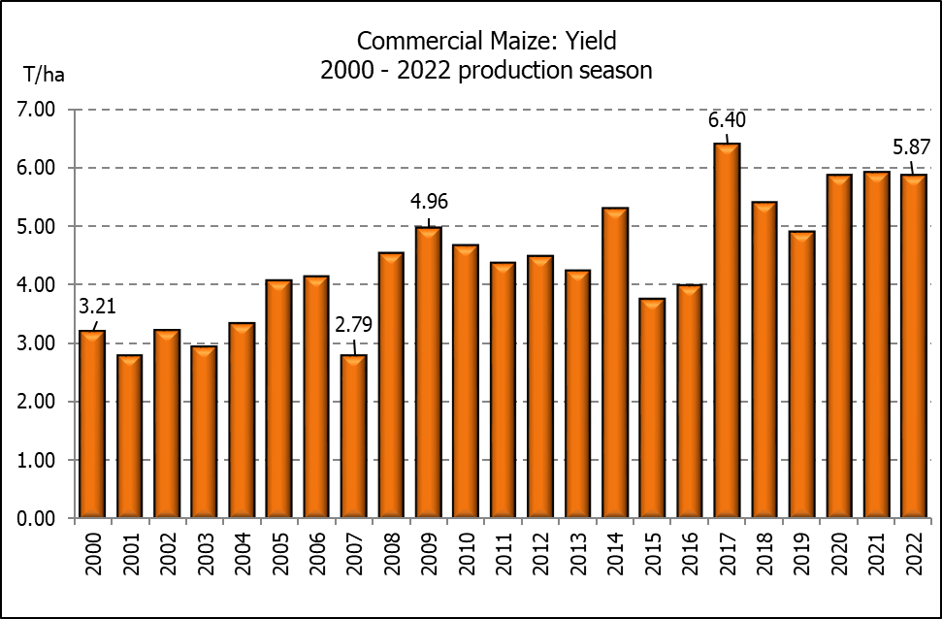

WHITE AND YELLOW MAIZE – AREA PLANTED AND FINAL PRODUCTION ESTIMATE: 2022
WIT- EN GEELMIELIES – OPPERVLAKTE EN FINALE PRODUKSIESKATTING: 2022

Provinsie/  Province | Area planted/  Oppervlakte beplant  2022 |  |  | Final estimate/  Finale skatting  2022 |  |  | Area planted/  Oppervlakte beplant  2021 |  |  | Final crop/  Finale oes  2021
Provinsie/  Province | White/  Wit  Ha | Yellow/  Geel  Ha | Total/  Totaal  Ha | White/  Wit  Tons | Yellow/  Geel  Tons | Total/  Totaal  Tons | White/  Wit  Ha | Yellow/  Geel  Ha | Total/  Totaal  Ha | White/  Wit  Tons | Yellow/  Geel  Tons | Total/  Totaal  Tons
Western Cape/Wes-Kaap | 500 | 3 500 | 4 000 | 4 750 | 32 900 | 37 650 | 500 | 3 500 | 4 000 | 4 800 | 33 300 | 38 100
Northern Cape/Noord-Kaap | 3 000 | 42 000 | 45 000 | 36 000 | 672 000 | 708 000 | 3 400 | 41 000 | 44 400 | 40 300 | 627 300 | 667 600
Free State/Vrystaat | 826 500 | 398 000 | 1 224 500 | 3 801 900 | 2 547 200 | 6 349 100 | 907 500 | 420 000 | 1 327 500 | 4 492 000 | 2 542 000 | 7 034 000
Eastern Cape/Oos-Kaap | 6 000 | 20 500 | 26 500 | 40 800 | 157 850 | 198 650 | 6 000 | 18 000 | 24 000 | 39 000 | 133 200 | 172 200
KwaZulu-Natal | 52 000 | 59 000 | 111 000 | 322 400 | 489 700 | 812 100 | 50 000 | 55 000 | 105 000 | 310 000 | 451 000 | 761 000
Mpumalanga | 165 000 | 350 000 | 515 000 | 1 072 500 | 2 537 500 | 3 610 000 | 165 000 | 360 000 | 525 000 | 1 100 500 | 2 820 000 | 3 920 500
Limpopo | 15 500 | 25 000 | 40 500 | 102 300 | 202 500 | 304 800 | 16 500 | 21 000 | 37 500 | 112 200 | 172 200 | 284 400
Gauteng | 56 500 | 56 000 | 112 500 | 361 600 | 403 200 | 764 800 | 58 000 | 50 000 | 108 000 | 371 200 | 380 000 | 751 200
North West/Noordwes | 450 000 | 94 000 | 544 000 | 2 047 500 | 554 600 | 2 602 100 | 485 000 | 95 000 | 580 000 | 2 130 000 | 556 000 | 2 686 000
Total/Totaal | 1 575 000 | 1 048 000 | 2 623 000 | 7 789 750 | 7 597 450 | 15 387 200 | 1 691 900 | 1 063 500 | 2 755 400 | 8 600 000 | 7 715 000 | 16 315 000

SUNFLOWER SEED – AREA PLANTED AND FINAL PRODUCTION ESTIMATE: 2022
SONNEBLOMSAAD – OPPERVLAKTE EN FINALE PRODUKSIESKATTING: 2022

Province/  Provinsie | Area planted/  Opp beplant  Ha | Final estimate/  Finale skatting  Tons | Area planted/  Opp beplant  Ha | Final crop/  Finale oes  Tons
Province/  Provinsie | 2022 | 2022 | 2021 | 2021
Western Cape/Wes-Kaap | - | - | - | -
Northern Cape/Noord-Kaap | 2 500 | 6 250 | 1 100 | 1 320
Free State/Vrystaat | 357 000 | 499 800 | 235 000 | 352 500
Eastern Cape/Oos-Kaap | 300 | 750 | 300 | 450
KwaZulu-Natal | - | - | - | -
Mpumalanga | 3 500 | 5 250 | 3 500 | 5 250
Limpopo | 110 000 | 77 000 | 76 500 | 76 500
Gauteng | 2 400 | 3 000 | 4 400 | 5 720
North West/Noordwes | 195 000 | 253 500 | 157 000 | 236 260
Total/Totaal | 670 700 | 845 550 | 477 800 | 678 000
SOYBEANS – AREA PLANTED AND FINAL PRODUCTION ESTIMATE: 2022
SOJABONE – OPPERVLAKTE EN FINALE PRODUKSIESKATTING: 2022

Province/  Provinsie | Area planted/  Opp beplant  Ha | Final estimate/  Finale skatting  Tons | Area planted/  Opp beplant  Ha | Final crop/  Finale oes  Tons
Province/  Provinsie | 2022 | 2022 | 2021 | 2021
Western Cape/Wes-Kaap | - | - | - | -
Northern Cape/Noord-Kaap | 800 | 3 000 | 1 000 | 3 500
Free State/Vrystaat | 415 000 | 892 250 | 365 000 | 766 500
Eastern Cape/Oos-Kaap | 3 000 | 9 000 | 3 100 | 9 300
KwaZulu-Natal | 39 000 | 146 250 | 36 000 | 129 600
Mpumalanga | 300 000 | 705 000 | 290 000 | 644 550
Limpopo | 22 500 | 76 500 | 20 500 | 71 750
Gauteng | 45 000 | 99 000 | 42 000 | 105 000
North West/Noordwes | 100 000 | 270 000 | 69 500 | 166 800
Total/Totaal | 925 300 | 2 201 000 | 827 100 | 1 897 000

GROUNDNUTS – AREA PLANTED AND FINAL PRODUCTION ESTIMATE: 2022
GRONDBONE – OPPERVLAKTE EN FINALE PRODUKSIESKATTING: 2022

Province/  Provinsie | Area planted/  Opp beplant  Ha | Final estimate/  Finale skatting  Tons | Area planted/  Opp beplant  Ha | Final crop/  Finale oes  Tons
Province/  Provinsie | 2022 | 2022 | 2021 | 2021
Western Cape/Wes-Kaap | - | - | - | -
Northern Cape/Noord-Kaap | 2 400 | 6 000 | 1 500 | 3 900
Free State/Vrystaat | 19 000 | 20 900 | 16 000 | 26 450
Eastern Cape/Oos-Kaap | - | - | - | -
KwaZulu-Natal | - | - | 50 | 50
Mpumalanga | - | - | - | -
Limpopo | 2 000 | 5 100 | 3 000 | 6 900
Gauteng | - | - | - | -
North West/Noordwes | 20 000 | 17 000 | 18 000 | 27 000
Total/Totaal | 43 400 | 49 000 | 38 550 | 64 300

SORGHUM – AREA PLANTED AND FINAL PRODUCTION ESTIMATE: 2022
SORGHUM – OPPERVLAKTE EN FINALE PRODUKSIESKATTING: 2022

Province/  Provinsie | Area planted/  Opp beplant  Ha | Final estimate/  Finale skatting  Tons | Area planted/  Opp beplant  Ha | Final crop/  Finale oes  Tons
Province/  Provinsie | 2022 | 2022 | 2021 | 2021
Western Cape/Wes-Kaap | - | - | - | -
Northern Cape/Noord-Kaap | - | - | - | -
Free State/Vrystaat | 7 800 | 15 600 | 10 500 | 45 675
Eastern Cape/Oos-Kaap | - | - | - | -
KwaZulu-Natal | 200 | 740 | 500 | 2 300
Mpumalanga | 9 000 | 45 000 | 9 400 | 57 325
Limpopo | 15 000 | 30 000 | 17 000 | 61 200
Gauteng | 200 | 800 | 300 | 1 350
North West/Noordwes | 5 000 | 11 000 | 11 500 | 47 150
Total/Totaal | 37 200 | 103 140 | 49 200 | 215 000

DRY BEANS – AREA PLANTED AND FINAL PRODUCTION ESTIMATE: 2022
DROëBONE – OPPERVLAKTE EN FINALE PRODUKSIESKATTING: 2022

Province/  Provinsie | Area planted/  Opp beplant  Ha | Final estimate/  Finale skatting  Tons | Area planted/  Opp beplant  Ha | Final crop/  Finale oes  Tons
Province/  Provinsie | 2022 | 2022 | 2021 | 2021
Western Cape/Wes-Kaap | 100 | 150 | 100 | 150
Northern Cape/Noord-Kaap | 600 | 1 080 | 350 | 700
Free State/Vrystaat | 15 500 | 13 950 | 22 000 | 16 500
Eastern Cape/Oos-Kaap | 200 | 300 | 200 | 300
KwaZulu-Natal | 2 300 | 2 760 | 3 000 | 3 900
Mpumalanga | 6 000 | 6 600 | 6 500 | 9 750
Limpopo | 10 400 | 18 200 | 8 000 | 16 000
Gauteng | 800 | 800 | 840 | 1 092
North West/Noordwes | 7 000 | 8 750 | 6 400 | 9 280
Total/Totaal | 42 900 | 52 590 | 47 390 | 57 672

CONFIDENTIALITY ISSUES that CEC members are committed to adhere to on the day of the meeting
- Personal items such as laptops, handbags, cell phones, etc. are not allowed in the venue during the meeting
- No member is allowed to leave the meeting before 12:00 in order to prevent disclosure of the information
- The embargo time for the release of crop estimates information is 14:30
- No member is allowed to discuss crop estimates information with anyone other than a member of the Committee before the embargo time
- Only the Chairperson, or a member appointed by the Chairperson, may release the figures to the media
- Members must regard the detail of any information that was collected for and/or discussed during the meeting, as confidential
- Individual information received for crop estimate purposes is treated strictly confidential, and is not divulged for any other purposes

AREA ESTIMATE AND FINAL PRODUCTION ESTIMATE OF SUMMER CROPS (2022 PRODUCTION SEASON)/
OPPERVLAKTE- EN FINALE PRODUKSIESKATTING VIR SOMERGEWASSE (2022 PRODUKSIE-SEISOEN)
29 NOVEMBER 2022

Summer field crops – 2022  Commercial maize: The size of the expected commercial maize crop has been set at 15,387 mill. tons. The area estimate for maize is 2,623 mill. ha, while the expected yield is 5,87 t/ha.  The estimated maize crop is 6% smaller than the 2021 crop. The three main maize producing areas, namely the Free State, Mpumalanga and North West provinces are expected to produce 82% of the 2022 crop.  The area estimate for white maize is 1,575 mill. ha and for yellow maize the area estimate is 1,048 mill. ha.  The production estimate for white maize remained unchanged at 7,790 mill. tons. The yield for white maize is 4,95 t/ha. In the case of yellow maize the production estimate is 7,597 mill. tons, which is 0,77% or 58 100 tons more than the previous forecast of 7,539 mill. tons. The yield for yellow maize is 7,25 t/ha.  Sunflower seed: The production estimate for sunflower seed remained unchanged at 845 550 tons. The area estimate for sunflower seed is 670 700 ha, while the expected yield is 1,26 t/ha.  Other crops: The production estimate for soybeans also remained unchanged at 2,201 mill. tons. The estimated area planted to soybeans is 925 300 ha and the expected yield is 2,38 t/ha.  The expected groundnut crop remained unchanged at 49 000 tons. For groundnuts, the area estimate is 43 400 ha, with an expected yield of 1,13 t/ha.  The production estimate for sorghum is 103 140 tons, which is 6,83% or 7 560 tons less than the previous forecast of 110 700 tons. The area estimate for sorghum is 37 200 ha and the expected yield is 2,77 t/ha.  In the case of dry beans, the production estimate remained unchanged at 52 590 tons. The area estimate of dry beans is 42 900 ha, with an expected yield of 1,23 t/ha.  Please note that the preliminary area estimate for summer field crops for 2023, will be released on 26 January 2023. |  | Somergewasse – 2022  Kommersiële mielies: Die grootte van die verwagte kommersiële mielie-oes is 15,387 milj. ton. Die skatting van die oppervlakte onder mielies is 2,623 milj. ha, terwyl die verwagte opbrengs 5,87 t/ha is.  Die geskatte mielie-oes is 6% kleiner as die 2021-oes. Die drie belangrikste mielieproduserende gebiede, nl. die Vrystaat, Mpumalanga en Noordwes provinsies, gaan na verwagting 82% van die 2022-oes produseer.  Die oppervlak onder witmielies is 1,575 milj. ha en vir geelmielies is die oppervlak 1,048 milj. ha.  Die produksieskatting van witmielies is onveranderd gelaat op 7,790 milj. ton. Die opbrengs van witmielies is 4,95 t/ha. In die geval van geelmielies is die produksieskatting 7,597 milj. ton, wat 0,77% of 58 100 ton meer is as die vorige skatting van 7,539 milj. ton. Die opbrengs van geelmielies is 7,25 t/ha.  Sonneblomsaad: Die produksieskatting vir sonneblomsaad is onveranderd gelaat op 845 550 ton. Die oppervlakteskatting vir sonneblomsaad is 670 700 ha, terwyl die verwagte opbrengs 1,26 t/ha is.  Ander gewasse: Die produksieskatting van sojabone is ook onveranderd gelaat op 2,201 milj. ton gestel. Die geskatte oppervlakte beplant met sojabone is 925 300 ha en die verwagte opbrengs is 2,38 t/ha.  Die verwagte grondbone-oes is onveranderd gelaat op 49 000 ton. Vir grondbone is die oppervlakteskatting 43 400 ha, terwyl the verwagte opbrengs 1,13 t/ha is.  Die produksieskatting van sorghum is 103 140 ton, wat 6,83% of 7 560 ton minder is as die vorige skatting van 110 700 ton. Die oppervlakteskatting vir sorghum is 37 200 ha, en die verwagte opbrengs is 2,77 t/ha.  In die geval van droëbone is die produksieskatting onveranderd gelaat op 52 590 ton. Die oppervlakte beplant met droëbone is 42 900 ha en die verwagte opbrengs is 1,23 t/ha.  Neem asseblief kennis dat die voorlopige oppervlakskatting vir somergewasse vir 2023, op 26 Januarie 2023 vrygestel sal word.

The non-commercial agricultural sectors’ production estimate for maize for 2022 is hereby released. /
Hiermee word die nie-kommersiële landbou-sektor se produksieskatting vir mielies vir 2022 vrygestel.

NON-COMMERCIAL MAIZE – AREA PLANTED AND PRODUCTION ESTIMATE: 2022
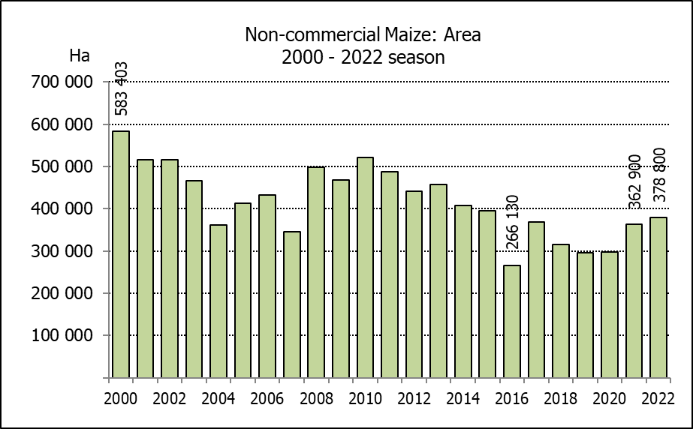
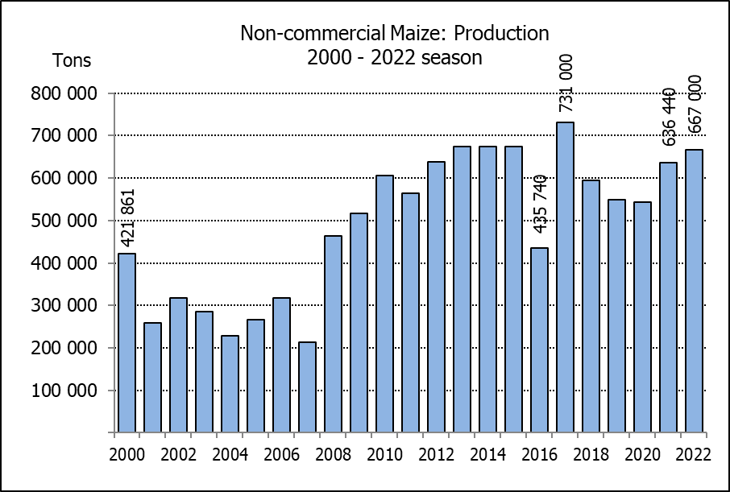
NIE-KOMMERSIëLE MIELIES – OPPERVLAKTE- EN PRODUKSIESKATTING: 2022
CROP/GEWAS | Area planted/  Opp beplant  2022 | Production/  Produksie  2022 | Area planted/  Opp beplant  2021 | Final crop/  Finale oes  2021 | Change/  Verandering
CROP/GEWAS | Ha | Tons | Ha | Tons | %
CROP/GEWAS | (A) | (B) | (C) | (D) | (B) ÷ (D)
Non-commercial agriculture/Nie-kommersiële landbou:
White maize/Witmielies | 296 950 | 482 000 | 276 100 | 445 335 | +8,23
Yellow maize/Geelmielies | 81 850 | 185 000 | 86 800 | 191 105 | -3,19
Maize/Mielies | 378 800 | 667 000 | 362 900 | 636 440 | +4,80
The area planted to maize in the non-commercial agricultural sector is estimated at 378 800 ha, which represents an increase of 4,38%, compared to the 362 900 ha of the previous season. The expected maize crop for this sector is 667 000 tons, which is 4,80% more than the 636 440 tons of last season. It is important to note that about 47% of the maize produced in the non-commercial sector, is planted in the Eastern Cape, followed by KwaZulu-Natal with 22%.
Die oppervlakte beplant met mielies in die nie-kommersiële landbou-sektor word geskat op 378 800 ha, wat ’n toename van 4,38% verteenwoordig in vergelyking met die 362 900 ha van die vorige seisoen. Die verwagte mielie-oes van dié sektor is 667 000 ton, wat 4,80% meer is as die 636 440 ton van die vorige seisoen. Dit is belangrik om daarop te let dat ongeveer 47% van die mielies wat geproduseer word in die nie-kommersiële sektor, in die Oos-Kaap geplant word, gevolg deur KwaZulu-Natal met 22%.

The area estimate and fourth production forecast for winter cereals for 2022 is hereby released. /
Hiermee word die oppervlakteskatting en vierde produksieskatting vir wintergewasse vir 2022 vrygestel.

WINTER CEREALS – AREA PLANTED ESTIMATE AND FOURTH PRODUCTION FORECAST: 2022 PRODUCTION SEASON
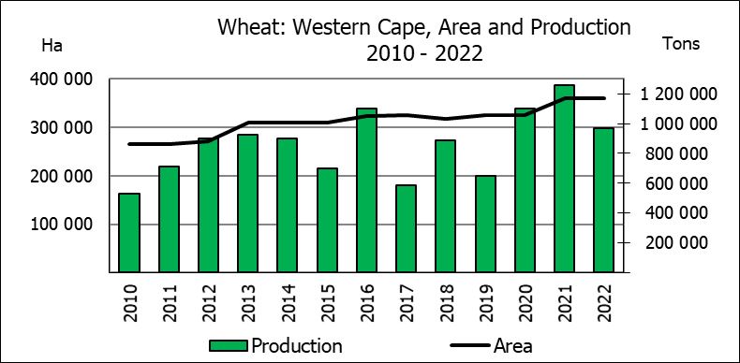
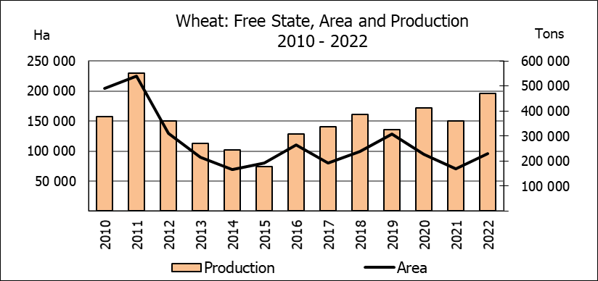
WINTERGEWASSE – OPPERVLAKTESKATTING EN VIERDE PRODUKSIESKATTING: 2022-PRODUKSIESEISOEN
CROP/GEWAS | Area planted/  Opp beplant  2022 | 4th forecast/  4de skatting 2022 | 3rd forecast/  3de skatting 2022 | Area planted/  Opp beplant  2021 | Final crop/  Finale oes  2021 | Change/  Verandering
CROP/GEWAS | Ha | Tons | Tons | Ha | Tons | %
CROP/GEWAS | (A) | (B) | (C) | (D) | (E) | (B) ÷ (C)
Commercial/Kommersieel:
Wheat/Koring | 566 800 | 2 225 895 | 2 210 095 | 523 500 | 2 285 000 | +0,7
Barley/Gars¹⁾ | 101 000 | 356 850 | 365 850 | 94 730 | 334 000 | -2,5
Canola/Kanola | 123 510 | 210 530 | 198 230 | 100 000 | 198 100 | +6,2
Oats/Hawer¹⁾ | 27 000 | 37 700 | 37 700 | 36 250 | 59 000 | -
Sweet lupines/Soetlupine | 21 000 | 16 800 | 16 800 | 22 000 | 28 600 | -
1) Commercial only. Excluding barley or oats used as pasture, silage, hay and/or on the farm as fodder for livestock /
Slegs kommersieël. Uitgesluit gars of hawer wat gebruik word as weiding, kuilvoer, hooi en/of op die plaas as voer vir vee.

WHEAT – AREA PLANTED ESTIMATE AND FOURTH PRODUCTION FORECAST: 2022 PRODUCTION SEASON
KORING – OPPERVLAKTESKATTING EN VIERDE PRODUKSIESKATTING: 2022-PRODUKSIESEISOEN
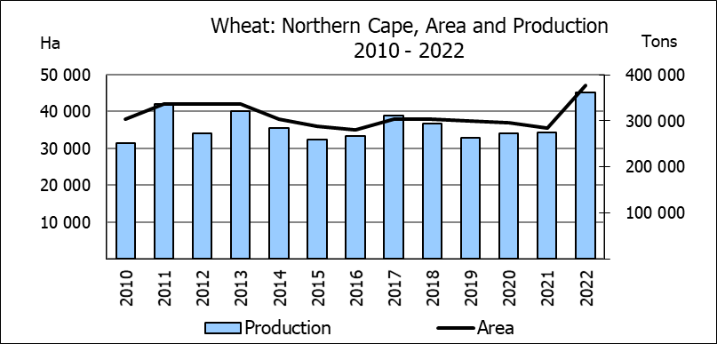
Province/  Provinsie | Area planted/  Opp beplant  Ha | 4th forecast/  4de skatting  Tons | Area planted/  Opp beplant  Ha | Final crop/  Finale oes  Tons
Province/  Provinsie | 2022 | 2022 | 2021 | 2021
Western Cape/Wes-Kaap | 360 000 | 972 000 | 360 000 | 1 260 000
Northern Cape/Noord-Kaap | 47 000 | 361 900 | 35 500 | 275 125
Free State/Vrystaat | 96 000 | 470 400 | 70 000 | 360 000
Eastern Cape/Oos-Kaap | 6 000 | 40 200 | 3 800 | 25 080
KwaZulu-Natal | 9 200 | 60 720 | 8 500 | 56 950
Mpumalanga | 4 000 | 27 600 | 4 100 | 28 300
Limpopo | 29 000 | 188 500 | 26 500 | 176 220
Gauteng | 1 100 | 7 425 | 1 100 | 7 425
North West/Noordwes | 14 500 | 97 150 | 14 000 | 95 900
Total/Totaal | 566 800 | 2 225 895 | 523 500 | 2 285 000
AREA ESTIMATE AND FOURTH PRODUCTION FORECAST OF WINTER CROPS (2022) /
OPPERVLAKTESKATTING EN VIERDE PRODUKSIESKATTING VAN WINTERGEWASSE (2022)
29 NOVEMBER 2022

Winter cereal crops - 2022 production season  Wheat: The expected production of wheat is 2,226 mill. tons, which is 0,71% or 15 800 tons more than the previous forecast of 2,210 mill. tons, whilst the expected yield is 3,93 t/ha.  The expected production in the Western Cape is unchanged at 972 000 tons (44%), compared to the previous forecast. In the Free State, the expected production also remained unchanged at 470 400 tons (21%) and in the Northern Cape, the expected production is 361 900 tons (16%), which is 2,67% or 9 400 tons more than the previous forecast.  The area estimate for wheat is 566 800 ha. An estimated 360 000 ha or 64 % is planted in the Western Cape, 96 000 ha or 17 % in the Free State and 47 000 ha or 8 % in the Northern Cape.  Other crops: The production forecast for barley is estimated at 356 850 tons, which is 2,46% or 9 000 tons less than the previous forecast of 365 850 tons. The area planted is estimated at 101 000 ha, while the expected yield is 3,53 t/ha.  The expected canola crop is 210 530 tons, an increase of 6,20% or 12 300 tons compared to the previous month’s forecast. The area estimate for canola is 123 510 ha, with an expected yield of 1,70 t/ha.  The expected crop for oats for the 2022 season is 37 700 tons and the area planted is 27 000 ha. The expected yield is 1,40 t/ha.  In the case of sweet lupines, the production forecast is unchanged at 16 800 tons. The area estimate of sweet lupines is 21 000 ha, with an expected yield of 0,80 t/ha.  Please note that the fifth production forecast for winter cereals for 2022 will be released on 21 December 2022. |  | Wintergewasse - 2022 produksie-seisoen  Koring: Die verwagte produksie vir koring is 2,226 milj. ton, wat 0,71% of 15 800 ton meer is as die vorige skatting van 2,210 milj. ton, terwyl die verwagte opbrengs 3,93 t/ha is.  Die verwagte produksie in die Wes-Kaap is onveranderd gelaat op 972 000 ton (44%), vergeleke met die vorige maand se skatting. Vir die Vrystaat is die verwagte produksie ook onveranderd gelaat op 470 400 ton (21%) en in die Noord-Kaap, is die verwagte produksie 361 900 ton (16%), wat 2,67% of 9 400 ton meer is as die vorige skatting.  Die oppervlakteskatting vir koring is 566 800 ha. Die beraamde oppervlakte geplant in die Wes-Kaap is 360 000 ha of 64 %, die Vrystaat is 96 000 ha of 17 % en 47 000 ha of 8 % is in die Noord-Kaap.  Ander gewasse: Die produksieskatting vir gars is 356 850 ton, wat 2,46% of 9 000 ton minder is as die vorige skatting van 365 850 ton. Die oppervlakte beplant word beraam op 101 000 ha, terwyl die verwagte opbrengs 3,53 t/ha beloop.  Die verwagte kanola-oes is 210 530 ton, ’n styging van 6,20% of 12 300 ton vergeleke met die vorige maand se skatting. Die oppervlakteskatting vir kanola is 123 510 ha, met ŉ verwagte opbrengs van 1,70 t/ha.  Die verwagte oes vir hawer vir die 2022-seisoen is 37 700 ton en die oppervlakteskatting is 27 000 ton. Die verwagte opbrengs is 1,40 t/ha.  In die geval van soetlupine is die produksieskatting onveranderd gelaat op 16 800 ton. Die oppervlakte beplant met soetlupine is 21 000 ha, en die verwagte opbrengs is 0,80 t/ha.  Neem asseblief kennis dat die vyfde produksieskatting vir wintergewasse vir 2022 op 21 Desember 2022 vrygestel sal word.

Information is available on the internet at http://www.dalrrd.gov.za/links/crop estimates or http://www.sagis.org.za, as from 14:30 on the date of the relevant meeting of the Crop Estimates Committee. |  | Inligting is beskikbaar op die internet by http://www.dalrrd.gov.za/links/crop estimates of by http://www.sagis.org.za, vanaf 14:30 op die dag van die toepaslike vergadering van die Oesskattingskomitee.

