 | crop estimates committee
 | oesskattingskomitee
From/Van: Mr Baldwin Netshifhefhe  Tel: 012 319 8043/32  Fax/Faks: 012 319 8031  E-mail/E-pos: BaldwinN@dalrrd.gov.za  Web page/Webblad: www.dalrrd.gov.za/statistics and economic reports or  www.sagis.org.za/CEC: Crop Estimates EMBARGO: 14:30 |  |  | 

The area planted estimate and second production forecast for summer crops for 2022 is hereby released.
Hiermee word die oppervlakte- en tweede produksieskatting vir somergewasse vir 2022 vrygestel.

SUMMER CROPS – AREA PLANTED AND SECOND PRODUCTION FORECAST: 2022
SOMERGEWASSE – OPPERVLAKTE- EN TWEEDE PRODUKSIESKATTING: 2022
CROP/GEWAS | Area planted/  Opp beplant  2022 | 2nd forecast/  2de skatting  2022 | 1st forecast/  1ste skatting  2022 | Area planted/  Opp beplant  2021 | Final crop/  Finale oes  2021 | Change/  Verandering/
CROP/GEWAS | Ha | Tons | Tons | Ha | Tons | %
CROP/GEWAS | (A) | (B) | (C) | (D) | (E) | (B) ÷ (C)
Commercial/Kommersieel:
White maize/Witmielies | 1 575 000 | 7 569 550 | 7 535 100 | 1 691 900 | 8 600 000 | +0,46
Yellow maize/Geelmielies | 1 048 000 | 7 114 500 | 6 992 850 | 1 063 500 | 7 715 000 | +1,74
Total Maize/Totale Mielies | 2 623 000 | 14 684 050 | 14 527 950 | 2 755 400 | 16 315 000 | +1,07
Sunflower seed/Sonneblomsaad | 670 700 | 959 450 | 914 350 | 477 800 | 678 000 | +4,93
Soybeans/Sojabone | 925 300 | 1 885 850 | 1 821 400 | 827 100 | 1 897 000 | +3,54
Groundnuts/Grondbone | 43 400 | 74 250 | 69 200 | 38 550 | 64 300 | +7,30
Sorghum | 37 200 | 137 220 | 146 590 | 49 200 | 215 000 | -6,39
Dry beans/Droëbone | 42 900 | 59 690 | 59 690 | 47 390 | 57 672 | -
TOTAL/TOTAAL | 4 342 500 | 17 800 510 | 17 539 180 | 4 195 440 | 19 226 972 | +1,49
Note: Estimate is for calendar year, e.g. production season 2021/22 = 2022
Nota: Skatting is vir kalenderjaar, bv. produksie-seisoen 2021/22 = 2022

28 March / Maart 2022

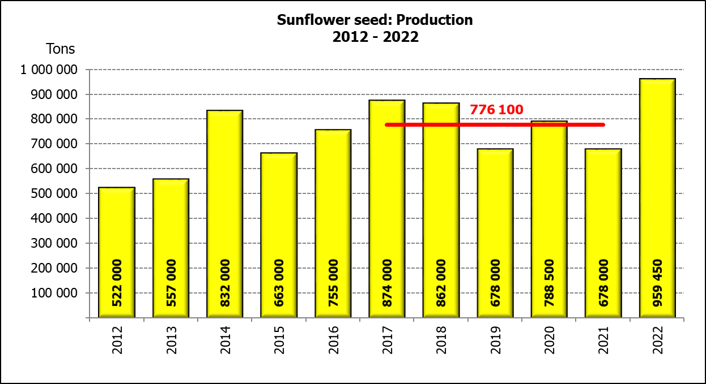

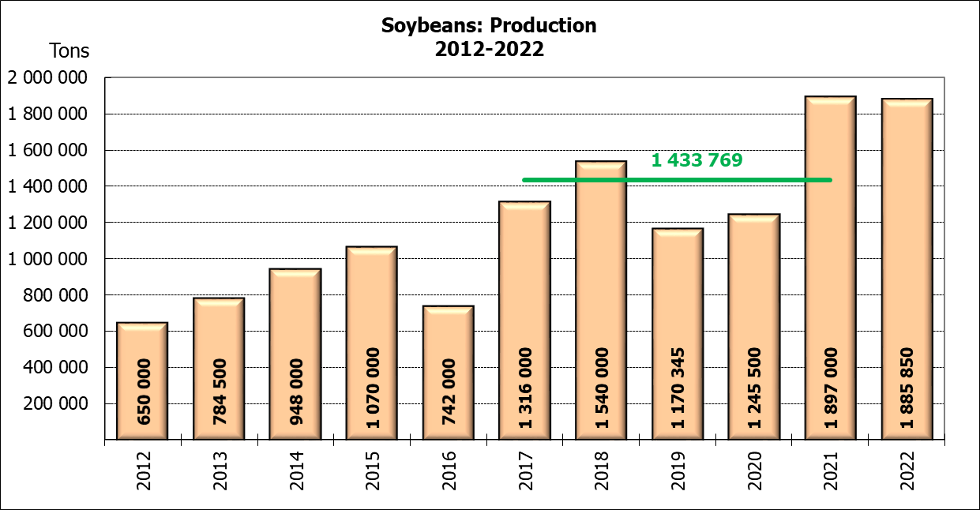

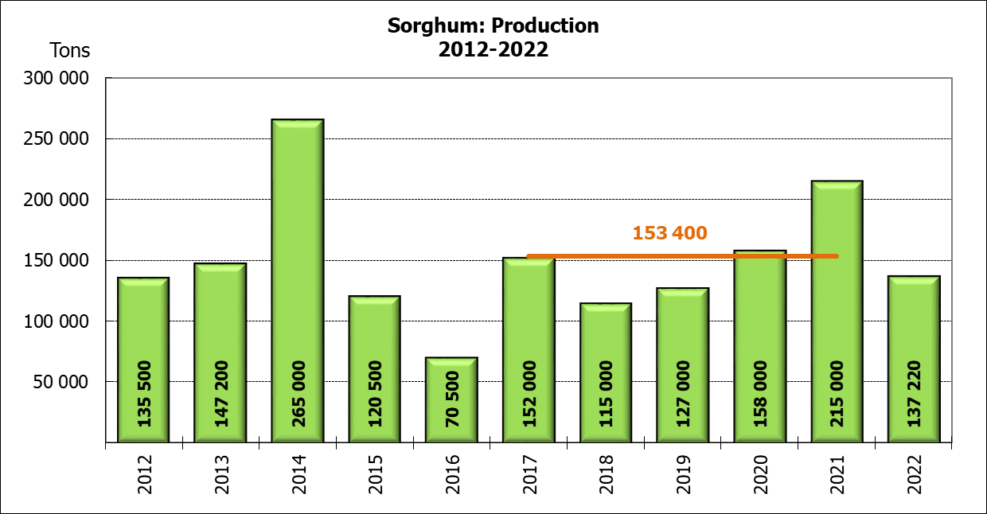

WHITE AND YELLOW MAIZE – AREA PLANTED AND SECOND PRODUCTION FORECAST: 2022
WIT- EN GEELMIELIES – OPPERVLAKTE EN TWEEDE PRODUKSIESKATTING: 2022

Provinsie/  Province | Area planted/  Oppervlakte beplant  2022 |  |  | 2nd forecast/  2de skatting  2022 |  |  | Area planted/  Oppervlakte beplant  2021 |  |  | Final crop/  Finale oes  2021
Provinsie/  Province | White/  Wit  Ha | Yellow/  Geel  Ha | Total/  Totaal  Ha | White/  Wit  Tons | Yellow/  Geel  Tons | Total/  Totaal  Tons | White/  Wit  Ha | Yellow/  Geel  Ha | Total/  Totaal  Ha | White/  Wit  Tons | Yellow/  Geel  Tons | Total/  Totaal  Tons
Western Cape/Wes-Kaap | 500 | 3 500 | 4 000 | 4 750 | 32 900 | 37 650 | 500 | 3 500 | 4 000 | 4 800 | 33 300 | 38 100
Northern Cape/Noord-Kaap | 3 000 | 42 000 | 45 000 | 36 000 | 651 000 | 687 000 | 3 400 | 41 000 | 44 400 | 40 300 | 627 300 | 667 600
Free State/Vrystaat | 826 500 | 398 000 | 1 224 500 | 3 719 250 | 2 427 800 | 6 147 050 | 907 500 | 420 000 | 1 327 500 | 4 492 000 | 2 542 000 | 7 034 000
Eastern Cape/Oos-Kaap | 6 000 | 20 500 | 26 500 | 39 000 | 143 500 | 182 500 | 6 000 | 18 000 | 24 000 | 39 000 | 133 200 | 172 200
KwaZulu-Natal | 52 000 | 59 000 | 111 000 | 312 000 | 460 200 | 772 200 | 50 000 | 55 000 | 105 000 | 310 000 | 451 000 | 761 000
Mpumalanga | 165 000 | 350 000 | 515 000 | 1 072 500 | 2 327 500 | 3 400 000 | 165 000 | 360 000 | 525 000 | 1 100 500 | 2 820 000 | 3 920 500
Limpopo | 15 500 | 25 000 | 40 500 | 100 750 | 200 000 | 300 750 | 16 500 | 21 000 | 37 500 | 112 200 | 172 200 | 284 400
Gauteng | 56 500 | 56 000 | 112 500 | 350 300 | 364 000 | 714 300 | 58 000 | 50 000 | 108 000 | 371 200 | 380 000 | 751 200
North West/Noordwes | 450 000 | 94 000 | 544 000 | 1 935 000 | 507 600 | 2 442 600 | 485 000 | 95 000 | 580 000 | 2 130 000 | 556 000 | 2 686 000
Total/Totaal | 1 575 000 | 1 048 000 | 2 623 000 | 7 569 550 | 7 114 500 | 14 684 050 | 1 691 900 | 1 063 500 | 2 755 400 | 8 600 000 | 7 715 000 | 16 315 000

SUNFLOWER SEED – AREA PLANTED AND SECOND PRODUCTION FORECAST: 2022
SONNEBLOMSAAD – OPPERVLAKTE EN TWEEDE PRODUKSIESKATTING: 2022

Province/  Provinsie | Area planted/  Opp beplant  Ha | 2nd forecast/  2de skatting  Tons | Area planted/  Opp beplant  Ha | Final crop/  Finale oes  Tons
Province/  Provinsie | 2022 | 2022 | 2021 | 2021
Western Cape/Wes-Kaap | - | - | - | -
Northern Cape/Noord-Kaap | 2 500 | 3 000 | 1 100 | 1 320
Free State/Vrystaat | 357 000 | 535 500 | 235 000 | 352 500
Eastern Cape/Oos-Kaap | 300 | 450 | 300 | 450
KwaZulu-Natal | - | - | - | -
Mpumalanga | 3 500 | 5 250 | 3 500 | 5 250
Limpopo | 110 000 | 110 000 | 76 500 | 76 500
Gauteng | 2 400 | 3 000 | 4 400 | 5 720
North West/Noordwes | 195 000 | 302 250 | 157 000 | 236 260
Total/Totaal | 670 700 | 959 450 | 477 800 | 678 000
SOYBEANS – AREA PLANTED AND SECOND PRODUCTION FORECAST: 2022
SOJABONE – OPPERVLAKTE EN TWEEDE PRODUKSIESKATTING: 2022

Province/  Provinsie | Area planted/  Opp beplant  Ha | 2nd forecast/  2de skatting  Tons | Area planted/  Opp beplant  Ha | Final crop/  Finale oes  Tons
Province/  Provinsie | 2022 | 2022 | 2021 | 2021
Western Cape/Wes-Kaap | - | - | - | -
Northern Cape/Noord-Kaap | 800 | 2 800 | 1 000 | 3 500
Free State/Vrystaat | 415 000 | 788 500 | 365 000 | 766 500
Eastern Cape/Oos-Kaap | 3 000 | 9 000 | 3 100 | 9 300
KwaZulu-Natal | 39 000 | 134 550 | 36 000 | 129 600
Mpumalanga | 300 000 | 570 000 | 290 000 | 644 550
Limpopo | 22 500 | 76 500 | 20 500 | 71 750
Gauteng | 45 000 | 94 500 | 42 000 | 105 000
North West/Noordwes | 100 000 | 210 000 | 69 500 | 166 800
Total/Totaal | 925 300 | 1 885 850 | 827 100 | 1 897 000

GROUNDNUTS – AREA PLANTED AND SECOND PRODUCTION FORECAST: 2022
GRONDBONE – OPPERVLAKTE EN TWEEDE PRODUKSIESKATTING: 2022

Province/  Provinsie | Area planted/  Opp beplant  Ha | 2nd forecast/  2de skatting  Tons | Area planted/  Opp beplant  Ha | Final crop/  Finale oes  Tons
Province/  Provinsie | 2022 | 2022 | 2021 | 2021
Western Cape/Wes-Kaap | - | - | - | -
Northern Cape/Noord-Kaap | 2 400 | 7 200 | 1 500 | 3 900
Free State/Vrystaat | 19 000 | 33 250 | 16 000 | 26 450
Eastern Cape/Oos-Kaap | - | - | - | -
KwaZulu-Natal | - | - | 50 | 50
Mpumalanga | - | - | - | -
Limpopo | 2 000 | 5 800 | 3 000 | 6 900
Gauteng | - | - | - | -
North West/Noordwes | 20 000 | 28 000 | 18 000 | 27 000
Total/Totaal | 43 400 | 74 250 | 38 550 | 64 300

SORGHUM – AREA PLANTED AND SECOND PRODUCTION FORECAST: 2022
SORGHUM – OPPERVLAKTE EN TWEEDE PRODUKSIESKATTING: 2022

Province/  Provinsie | Area planted/  Opp beplant  Ha | 2nd forecast/  2de skatting  Tons | Area planted/  Opp beplant  Ha | Final crop/  Finale oes  Tons
Province/  Provinsie | 2022 | 2022 | 2021 | 2021
Western Cape/Wes-Kaap | - | - | - | -
Northern Cape/Noord-Kaap | - | - | - | -
Free State/Vrystaat | 7 800 | 28 080 | 10 500 | 45 675
Eastern Cape/Oos-Kaap | - | - | - | -
KwaZulu-Natal | 200 | 840 | 500 | 2 300
Mpumalanga | 9 000 | 45 000 | 9 400 | 57 325
Limpopo | 15 000 | 45 000 | 17 000 | 61 200
Gauteng | 200 | 800 | 300 | 1 350
North West/Noordwes | 5 000 | 17 500 | 11 500 | 47 150
Total/Totaal | 37 200 | 137 220 | 49 200 | 215 000

DRY BEANS – AREA PLANTED AND SECOND PRODUCTION FORECAST: 2022
DROëBONE – OPPERVLAKTE EN TWEEDE PRODUKSIESKATTING: 2022

Province/  Provinsie | Area planted/  Opp beplant  Ha | 2nd forecast/  2de skatting  Tons | Area planted/  Opp beplant  Ha | Final crop/  Finale oes  Tons
Province/  Provinsie | 2022 | 2022 | 2021 | 2021
Western Cape/Wes-Kaap | 100 | 150 | 100 | 150
Northern Cape/Noord-Kaap | 600 | 1 200 | 350 | 700
Free State/Vrystaat | 15 500 | 15 500 | 22 000 | 16 500
Eastern Cape/Oos-Kaap | 200 | 300 | 200 | 300
KwaZulu-Natal | 2 300 | 2 760 | 3 000 | 3 900
Mpumalanga | 6 000 | 9 000 | 6 500 | 9 750
Limpopo | 10 400 | 20 800 | 8 000 | 16 000
Gauteng | 800 | 880 | 840 | 1 092
North West/Noordwes | 7 000 | 9 100 | 6 400 | 9 280
Total/Totaal | 42 900 | 59 690 | 47 390 | 57 672

CONFIDENTIALITY ISSUES that CEC members are committed to adhere to on the day of the meeting
- Personal items such as laptops, handbags, cell phones, etc. are not allowed in the venue during the meeting
- No member is allowed to leave the meeting before 12:00 in order to prevent disclosure of the information
- The embargo time for the release of crop estimates information is 14:30
- No member is allowed to discuss crop estimates information with anyone other than a member of the Committee before the embargo time
- Only the Chairperson, or a member appointed by the Chairperson, may release the figures to the media
- Members must regard the detail of any information that was collected for and/or discussed during the meeting, as confidential
- Individual information received for crop estimate purposes is treated strictly confidential, and is not divulged for any other purposes

AREA ESTIMATE AND SECOND PRODUCTION FORECAST OF SUMMER CROPS (2022 PRODUCTION SEASON)/
OPPERVLAKTE- EN TWEEDE PRODUKSIESKATTING VIR SOMERGEWASSE (2022 PRODUKSIE-SEISOEN)
28 MARCH / MAART 2022

Summer field crops – 2022  Commercial maize: The size of the expected commercial maize crop has been set at 14,684 mill. tons, which is 1,07% or 156 100 tons more than the previous forecast of 14,528 mill. tons. The revised area estimate for maize is 2,623 mill. ha, while the expected yield is 5,60 t/ha.  The estimated maize crop is 10% smaller than the 2021 crop. The three main maize producing areas, namely the Free State, Mpumalanga and North West provinces are expected to produce 82% of the 2022 crop.  The revised area estimate for white maize is 1,575 mill. ha and for yellow maize the area estimate is 1,048 mill. ha.  The production forecast of white maize is 7,570 mill. tons, which is 0,46% or 34 450 tons more than the 7,535 mill. tons of the previous forecast. The yield for white maize is 4,81 t/ha. In the case of yellow maize the production forecast is 7,114 mill. tons, which is 1,74% or 121 650 tons more than the 6,993 mill. tons of the previous forecast. The yield for yellow maize is 6,79 t/ha.  Please note that information from the objective yield survey by the ARC for the Mpumalanga province will be available in April 2022; and for the Free State and North West provinces in May 2022. The current yield figures are mainly obtained from producers in the different provinces.  Sunflower seed: The production forecast for sunflower seed is 959 450 tons, which is 4,93% or 45 100 tons more than the previous forecast of 914 350 tons. The revised area estimate for sunflower seed is 670 700 ha, while the expected yield is 1,43 t/ha.  Other crops: The production forecast for soybeans increased by 3,54% or 64 450 tons to 1,886 mill. tons. The revised estimated area planted to soybeans is 925 300 ha and the expected yield is 2,04 t/ha.  The expected groundnut crop has been set at 74 250 tons, which is 7,30% or 5 050 tons more than the previous forecast of 69 200 tons. For groundnuts, the area estimate is 43 400 ha, with an expected yield of 1,71 t/ha.  The production forecast for sorghum is 137 220 tons, which is 6,39% or 9 370 tons less than the 146 590 tons of the previous forecast. The revised area estimate for sorghum is 37 200 ha and the expected yield is 3,69 t/ha.  In the case of dry beans, the production forecast is 59 690 tons. The area estimate of dry beans is 42 900 ha, with an expected yield of 1,39 t/ha.  Please note that the third production forecast for summer field crops for 2022 will be released on 26 April 2022. |  | Somergewasse – 2022  Kommersiële mielies: Die grootte van die verwagte kommersiële mielie-oes is op 14,684 milj. ton gestel, wat 1,07% of 156 100 ton meer is as die vorige skatting van 14,528 milj. ton. Die hersiene skatting van die oppervlakte onder mielies is 2,623 milj. ha, terwyl die verwagte opbrengs 5,60 t/ha is.  Die geskatte mielie-oes is 10% kleiner as die 2021-oes. Die drie belangrikste mielieproduserende gebiede, nl. die Vrystaat, Mpumalanga en Noordwes provinsies, gaan na verwagting 82% van die 2022-oes produseer.  Die hersiene oppervlak onder witmielies is 1,575 milj. ha en vir geelmielies is die oppervlak 1,048 milj. ha.  Die produksieskatting van witmielies is 7,570 milj. ton, 0,46% of 34 450 ton meer as die 7,535 milj. ton van die vorige skatting. Die opbrengs van witmielies is 4,81 t/ha. In die geval van geelmielies is die produksieskatting 7,114 milj. ton, wat 1,74% of 121 650 ton meer is as die 6,993 milj. ton van die vorige skatting. Die opbrengs van geelmielies is 6,79 t/ha.  Neem kennis dat inligting van die objektiewe opbrengs-opname van die LNR vir die Mpumalanga provinsie, in April 2022 gerapporteer word en vir die Vrystaat en Noordwes provinsies in Mei 2022. Die huidige opbrengs syfers is hoofsaaklik verkry vanaf produsente in die verskillende provinsies.  Sonneblomsaad: Die produksieskatting vir sonneblomsaad is 959 450 ton, wat 4,93% of 45 100 ton meer is as die vorige skatting van 914 350 ton. Die hersiene oppervlakteskatting vir sonneblomsaad is 670 700 ha, terwyl die verwagte opbrengs 1,43 t/ha is.  Ander gewasse: Die produksieskatting van sojabone is verhoog met 3,54% of 64 450 ton na 1,886 milj. ton. Die geskatte oppervlakte beplant van sojabone is 925 300 ha en die verwagte opbrengs is 2,04 t/ha.  Die verwagte grondbone-oes is op 74 250 ton gestel, wat 7,30% of 5 050 ton meer is as die vorige skatting van 69 200 ton. Vir grondbone is die oppervlakteskatting 43 400 ha, terwyl the verwagte opbrengs 1,71 t/ha is.  Die produksieskatting van sorghum is 137 220 ton, wat 6,39% of 9 370 ton minder is as die 146 590 ton van die vorige skatting. Die hersiene oppervlakteskatting vir sorghum is 37 200 ha, en die verwagte opbrengs is 3,69 t/ha.  In die geval van droëbone is die produksieskatting 59 690 ton. Die oppervlakte beplant met droëbone is 42 900 ha, en die verwagte opbrengs is 1,39 t/ha.  Neem asseblief kennis dat die derde produksieskatting vir somergewasse vir 2022, op 26 April 2022 vrygestel sal word.

