 | crop estimates committee | 
 | oesskattingskomitee
From/Van: Mr Baldwin Netshifhefhe
Tel: 012 319 8043/32 E-mail/E-pos: BaldwinN@nda.gov.za
Web page/Webblad: www.dalrrd.gov.za/old website/statistics and economic reports or
www.sagis.org.za/CEC: Crop Estimates EMBARGO: 14:30

The area planted estimate and fifth production forecast for summer crops for 2025 is hereby released.
Hiermee word die oppervlakte- en vyfde produksieskatting vir somergewasse vir 2025 vrygestel.

SUMMER CROPS – AREA PLANTED AND FIFTH PRODUCTION FORECAST: 2025
SOMERGEWASSE – OPPERVLAKTE- EN VYFDE PRODUKSIESKATTING: 2025
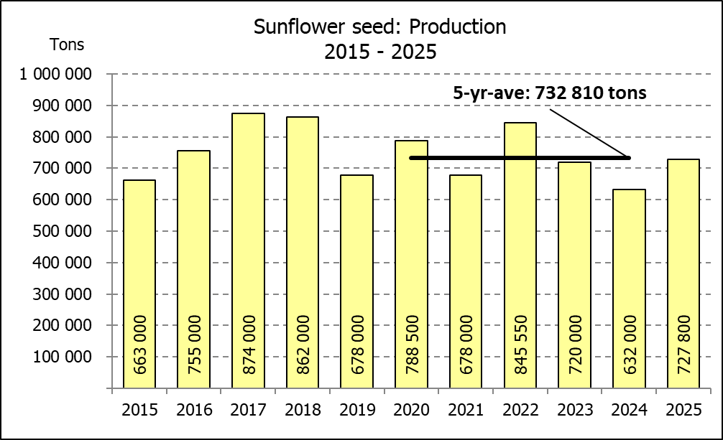
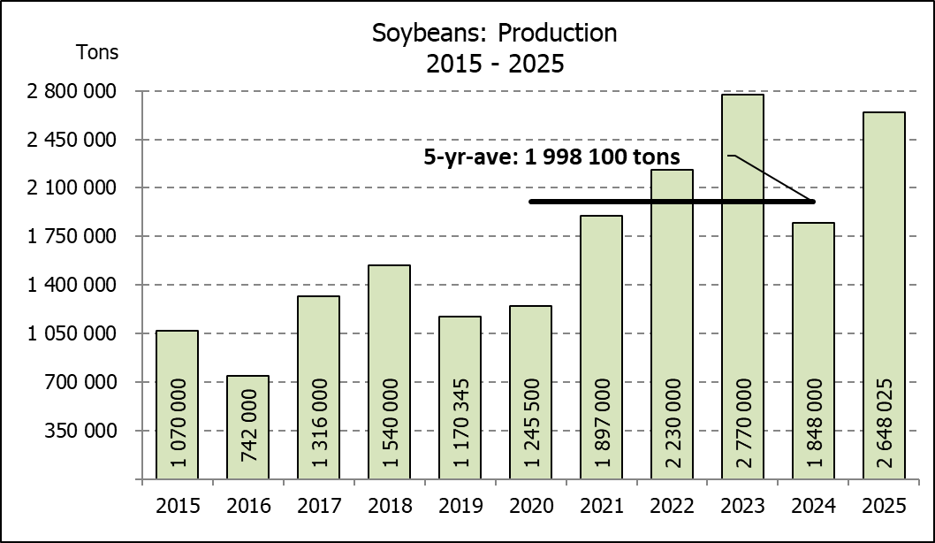
CROP/GEWAS | Area planted/ | 5th forecast/ | 4th forecast/ | Area planted/ | Final crop/ | Change/
CROP/GEWAS | Opp beplant | 5de skatting | 4de skatting | Opp beplant | Finale oes | Verandering
CROP/GEWAS | 2025 | 2025 | 2025 | 2024 | 2024
CROP/GEWAS | Ha | Tons | Tons | Ha | Tons | %
CROP/GEWAS | (A) | (B) | (C) | (D) | (E) | (B) ÷ (C)
Commercial/Kommersieël:
White maize/Witmielies | 1 599 700 | 7 648 450 | 7 648 450 | 1 554 750 | 6 055 000 | 0,00%
Yellow maize/Geelmielies | 997 000 | 7 134 800 | 6 995 500 | 1 081 500 | 6 795 000 | 1,99%
Total Maize/Totale Mielies | 2 596 700 | 14 783 250 | 14 643 950 | 2 636 250 | 12 850 000 | 0,95%
Sunflower seed/Sonneblomsaad | 555 700 | 727 800 | 727 800 | 529 000 | 632 000 | 0,00%
Soybeans/Sojabone | 1 151 000 | 2 648 025 | 2 330 975 | 1 150 500 | 1 848 000 | 13,60%
Groundnuts/Grondbone | 48 125 | 63 510 | 63 510 | 41 200 | 52 000 | 0,00%
Sorghum | 41 150 | 137 970 | 137 970 | 42 100 | 98 000 | 0,00%
Dry beans/Droëbone | 45 620 | 74 299 | 71 415 | 39 550 | 50 495 | 4,04%
TOTAL/TOTAAL | 4 438 295 | 18 434 854 | 17 975 620 | 4 438 600 | 15 530 495 | 2,55%
Non-Commercial Maize/Nie-Kommersiële Mielies
Total Maize/Totale Mielies | 358 000 | 621 500 | 621 500 | 347 000 | 575 000 | 0,00%
Maize/Mielies: Commercial/Kommersieël + Non-Commercial/Nie-Kommersieël
Total Maize RSA/Totaal Mielies RSA | 2 954 700 | 15 404 750 | 15 265 450 | 2 983 250 | 13 425 000 | 0,91%
Note: Estimate is for calendar year, e.g. production season 2024/25 = 2025
Nota: Skatting is vir kalenderjaar, bv. produksie-seisoen 2024/25 = 2025
27 June/Junie 2025
The Crop Estimates Committee comprises officials of the following institutions:
Department of Agriculture; Provincial Departments of Agriculture; various ARC-Institutes (Soil, Climate and Water; Small Grains Institute; and Grain Crops Institute); BFAP and Statistics SA.
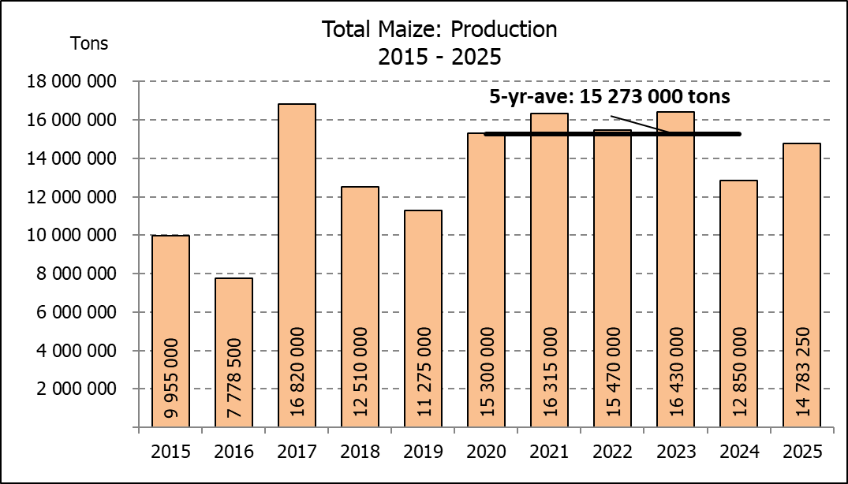

WHITE AND YELLOW MAIZE – AREA PLANTED AND FIFTH PRODUCTION FORECAST: 2025
WIT- EN GEELMIELIES – OPPERVLAKTE EN VYFDE PRODUKSIESKATTING: 2025

Provinsie/ | Area planted/ |  |  | 5th forecast/ |  |  | Area planted/ |  |  |  | Final crop/
Province | Oppervlakte beplant |  |  | 5de skatting |  |  | Oppervlakte beplant |  |  |  | Finale oes
 | 2025 |  |  | 2025 |  |  | 2024 |  |  |  | 2024
 | White/ | Yellow/ | Total/ | White/ | Yellow/ | Total/ | White/ | Yellow/ | Total/ | White/ |  | Yellow/ | Total/
 | Wit | Geel | Totaal | Wit | Geel | Totaal | Wit | Geel | Totaal | Wit |  | Geel | Totaal
 | Ha | Ha | Ha | Tons | Tons | Tons | Ha | Ha | Ha | Tons |  | Tons | Tons
Western Cape/Wes-Kaap | 200 | 3 500 | 3 700 | 1 900 | 32 900 | 34 800 | 250 | 3 500 | 3 750 | 2 300 |  | 32 200 | 34 500
Northern Cape/Noord-Kaap | 1 500 | 42 000 | 43 500 | 18 750 | 648 900 | 667 650 | 1 500 | 42 000 | 43 500 | 18 900 |  | 648 900 | 667 800
Free State/Vrystaat | 850 000 | 345 000 | 1 195 000 | 3 867 500 | 2 070 000 | 5 937 500 | 835 000 | 415 000 | 1 250 000 | 3 385 000 |  | 1 992 000 | 5 377 000
Eastern Cape/Oos-Kaap | 6 000 | 28 000 | 34 000 | 41 400 | 210 000 | 251 400 | 6 000 | 27 000 | 33 000 | 40 800 |  | 191 700 | 232 500
KwaZulu-Natal | 50 000 | 66 000 | 116 000 | 305 000 | 574 200 | 879 200 | 47 000 | 67 000 | 114 000 | 286 700 |  | 576 200 | 862 900
Mpumalanga | 162 000 | 362 000 | 524 000 | 1 004 400 | 2 606 400 | 3 610 800 | 160 000 | 360 000 | 520 000 | 984 000 |  | 2 490 000 | 3 474 000
Limpopo | 10 000 | 18 500 | 28 500 | 69 000 | 149 850 | 218 850 | 11 000 | 15 000 | 26 000 | 74 800 |  | 120 000 | 194 800
Gauteng | 55 000 | 57 000 | 112 000 | 341 000 | 407 550 | 748 550 | 54 000 | 62 000 | 116 000 | 292 500 |  | 415 500 | 708 000
North West/Noordwes | 465 000 | 75 000 | 540 000 | 1 999 500 | 435 000 | 2 434 500 | 440 000 | 90 000 | 530 000 | 970 000 |  | 328 500 | 1 298 500
Total/Totaal | 1 599 700 | 997 000 | 2 596 700 | 7 648 450 | 7 134 800 | 14 783 250 | 1 554 750 | 1 081 500 | 2 636 250 | 6 055 000 |  | 6 795 000 | 12 850 000

SUNFLOWER SEED – AREA PLANTED AND FIFTH PRODUCTION FORECAST: 2025
SONNEBLOMSAAD – OPPERVLAKTE EN VYFDE PRODUKSIESKATTING: 2025

Province/ | Area planted/ | 5th forecast/ | Area planted/ | Final crop/
Provinsie | Opp beplant | 5de skatting | Opp beplant | Finale oes
 | Ha | Tons | Ha | Tons
 | 2025 | 2025 | 2024 | 2024
Western Cape/Wes-Kaap | 0 | 0 | 0 | 0
Northern Cape/Noord-Kaap | 1 000 | 2 300 | 2 000 | 4 600
Free State/Vrystaat | 264 500 | 383 525 | 255 000 | 354 000
Eastern Cape/Oos-Kaap | 700 | 1 400 | 700 | 1 400
KwaZulu-Natal | 1 000 | 2 000 | 300 | 600
Mpumalanga | 2 500 | 3 625 | 3 500 | 4 900
Limpopo | 90 000 | 90 000 | 90 000 | 63 000
Gauteng | 1 000 | 1 200 | 2 500 | 3 000
North West/Noordwes | 195 000 | 243 750 | 175 000 | 200 500
Total/Totaal | 555 700 | 727 800 | 529 000 | 632 000
SOYBEANS – AREA PLANTED AND FIFTH PRODUCTION FORECAST: 2025
SOJABONE – OPPERVLAKTE EN VYFDE PRODUKSIESKATTING: 2025
Province/ | Area planted/ | 5th forecast/ | Area planted/ | Final crop/
Provinsie | Opp beplant | 5de skatting | Opp beplant | Finale oes
 | Ha | Tons | Ha | Tons
 | 2025 | 2025 | 2024 | 2024
Western Cape/Wes-Kaap | 0 | 0 | 0 | 0
Northern Cape/Noord-Kaap | 2 000 | 7 200 | 1 200 | 4 380
Free State/Vrystaat | 565 000 | 1 243 000 | 545 000 | 688 960
Eastern Cape/Oos-Kaap | 5 500 | 16 500 | 5 300 | 14 310
KwaZulu-Natal | 47 000 | 188 000 | 47 000 | 173 900
Mpumalanga | 315 000 | 708 750 | 320 000 | 624 000
Limpopo | 16 500 | 51 975 | 21 000 | 72 450
Gauteng | 52 000 | 114 400 | 56 000 | 84 000
North West/Noordwes | 148 000 | 318 200 | 155 000 | 186 000
Total/Totaal | 1 151 000 | 2 648 025 | 1 150 500 | 1 848 000

GROUNDNUTS – AREA PLANTED AND FIFTH PRODUCTION FORECAST: 2025
GRONDBONE – OPPERVLAKTE EN VYFDE PRODUKSIESKATTING: 2025

Province/ | Area planted/ | 5th forecast/ | Area planted/ | Final crop/
Provinsie | Opp beplant | 5de skatting | Opp beplant | Finale oes
 | Ha | Tons | Ha | Tons
 | 2025 | 2025 | 2024 | 2024
Western Cape/Wes-Kaap | 0 | 0 | 0 | 0
Northern Cape/Noord-Kaap | 3 100 | 8 525 | 4 200 | 8 610
Free State/Vrystaat | 21 700 | 29 295 | 17 000 | 26 305
Eastern Cape/Oos-Kaap | 0 | 0 | 0 | 0
KwaZulu-Natal | 175 | 228 | 300 | 495
Mpumalanga | 0 | 0 | 0 | 0
Limpopo | 1 650 | 2 888 | 1 700 | 4 590
Gauteng | 0 | 0 | 0 | 0
North West/Noordwes | 21 500 | 22 575 | 18 000 | 12 000
Total/Totaal | 48 125 | 63 510 | 41 200 | 52 000

SORGHUM – AREA PLANTED AND FIFTH PRODUCTION FORECAST: 2025
SORGHUM – OPPERVLAKTE EN VYFDE PRODUKSIESKATTING: 2025

Province/ | Area planted/ | 5th forecast/ | Area planted/ | Final crop/
Provinsie | Opp beplant | 5de skatting | Opp beplant | Finale oes
 | Ha | Tons | Ha | Tons
 | 2025 | 2025 | 2024 | 2024
Western Cape/Wes-Kaap | 0 | 0 | 0 | 0
Northern Cape/Noord-Kaap | 0 | 0 | 0 | 0
Free State/Vrystaat | 12 800 | 44 800 | 11 500 | 19 740
Eastern Cape/Oos-Kaap | 200 | 600 | 100 | 300
KwaZulu-Natal | 100 | 380 | 100 | 350
Mpumalanga | 9 200 | 43 240 | 8 300 | 36 520
Limpopo | 13 000 | 30 550 | 18 000 | 35 100
Gauteng | 850 | 3 400 | 100 | 390
North West/Noordwes | 5 000 | 15 000 | 4 000 | 5 600
Total/Totaal | 41 150 | 137 970 | 42 100 | 98 000

DRY BEANS – AREA PLANTED AND FIFTH PRODUCTION FORECAST: 2025
DROëBONE – OPPERVLAKTE EN VYFDE PRODUKSIESKATTING: 2025

Province/ | Area planted/ | 5th forecast/ | Area planted/ | Final crop/
Provinsie | Opp beplant | 5de skatting | Opp beplant | Finale oes
 | Ha | Tons | Ha | Tons
 | 2025 | 2025 | 2024 | 2024
Western Cape/Wes-Kaap | 100 | 200 | 100 | 220
Northern Cape/Noord-Kaap | 950 | 2 185 | 500 | 900
Free State/Vrystaat | 17 500 | 23 625 | 13 500 | 10 800
Eastern Cape/Oos-Kaap | 200 | 400 | 200 | 440
KwaZulu-Natal | 3 000 | 4 500 | 2 100 | 2 730
Mpumalanga | 2 320 | 3 944 | 2 600 | 4 680
Limpopo | 11 100 | 23 865 | 12 200 | 23 790
Gauteng | 950 | 1 330 | 850 | 935
North West/Noordwes | 9 500 | 14 250 | 7 500 | 6 000
Total/Totaal | 45 620 | 74 299 | 39 550 | 50 495

CONFIDENTIALITY ISSUES that CEC members are committed to adhere to on the day of the meeting
- Personal items such as laptops, handbags, cell phones, etc. are not allowed in the venue during the meeting (if in-person meeting)
- No member is allowed to leave the meeting before 12:00 in order to prevent disclosure of the information
- The embargo time for the release of crop estimates information is 14:30
- No member is allowed to discuss crop estimates information with anyone other than a member of the Committee before the embargo time
- Only the Chairperson, or a member appointed by the Chairperson, may release the figures to the media
- Members must regard the detail of any information that was collected for and/or discussed during the meeting, as confidential
- Individual information received for crop estimate purposes is treated strictly confidential, and is not divulged for any other purposes

AREA ESTIMATE AND FIFTH PRODUCTION FORECAST OF SUMMER CROPS (2025 PRODUCTION SEASON)/
OPPERVLAKTE- EN VYFDE PRODUKSIESKATTING VIR SOMERGEWASSE (2025 PRODUKSIE-SEISOEN)
27 JUNE / JUNIE 2025

Summer field crops – 2025  Commercial maize: The size of the expected commercial maize crop has been set at 14,783 mill. tons, which is 0,95% or 139 300 tons more than the previous forecast of 14,644 mill. tons. The expected yield for maize is 5,69 t/ha.  The estimated maize crop is 15,04% or 1,933 mill. tons larger than the 2024 crop. The three main maize producing areas, namely the Free State, Mpumalanga and North West provinces are expected to produce 81% of the 2025 crop.  The production forecast of white maize remained unchanged at 7,648 mill. tons. The area estimate for white maize is 1,600 mill. ha and the expected yield is 4,78 t/ha.  In the case of yellow maize, the production forecast is 7,135 mill. tons, which is 1,99% or 139 300 tons more than the 6,996 mill. tons of the previous forecast. The area estimate for yellow maize is 997 000 ha and the yield is 7,16 t/ha.  Other summer crops:  Sunflower seed: The production forecast for sunflower seed remained unchanged at 727 800 tons. The area estimate for sunflower seed is 555 700 ha, while the expected yield is 1,31 t/ha.  Other crops: The production forecast for soybeans is 2,648 mill. tons, which is 13,60% or 317 050 tons more than the 2,331 mill. tons of the previous forecast. The estimated area planted to soybeans is 1,151 mill. ha, with an expected yield of 2,30 t/ha.  The expected groundnut crop also remained unchanged at 63 510 tons. For groundnuts, the area estimate is 48 125 ha, with an expected yield of 1,32 t/ha.  The production forecast for sorghum remained unchanged at 137 970 tons. The area estimate for sorghum is 41 150 ha and the expected yield is 3,35 t/ha.  In the case of dry beans, the production forecast increased by 4,04% or 2 884 tons, from 71 415 tons to 74 299 tons. The area estimate of dry beans is 45 620 ha, with an expected yield of 1,63 t/ha.  Please note that the sixth production forecast for summer field crops for 2025, as well as the preliminary area planted estimate for winter cereals for 2025, will be released on 29 July 2025. |  | Somergewasse – 2025  Kommersiële mielies: Die grootte van die verwagte kommersiële mielie-oes is op 14,783 milj. ton gestel, wat 0,95% of 139 300 ton meer is as die vorige skatting van 14,644 milj. ton. Die verwagte opbrengs van mielies is 5,69 t/ha.  Die geskatte mielie-oes is 15,04% of 1,933 milj. ton meer as die 2024-oes. Die drie belangrikste mielieproduserende gebiede, nl. die Vrystaat, Mpumalanga en Noordwes provinsies, gaan na verwagting 81% van die 2025-oes produseer.  Die produksieskatting van witmielies is onveranderd gelaat op 7,648 milj. ton. Die oppervlakteskatting vir witmielies is 1,600 milj. ha en die verwagte opbrengs is 4,78 t/ha.  In die geval van geelmielies is die produksieskatting 7,135 milj. ton, wat 1,99% of 139 300 ton meer is as die 6,996 milj. ton van die vorige skatting. Die oppervlakteskatting vir geelmielies is 997 000 ha en die opbrengs is 7,16 t/ha.  Ander somergewasse:  Sonneblomsaad: Die produksieskatting vir sonneblomsaad is onveranderd gelaat op 727 800 ton. Die oppervlakteskatting vir sonneblomsaad is 555 700 ha, terwyl die verwagte opbrengs 1,31 t/ha is.  Ander gewasse: Die produksieskatting van sojabone is op 2,648 milj. ton gestel, wat 13,60% of 317 050 ton meer is as die vorige skatting van 2,331 milj. ton. Die geskatte oppervlakte beplant van sojabone is 1,151 milj. ha, met ‘n verwagte opbrengs van 2,30 t/ha.  Die verwagte grondbone-oes is ook onveranderd gelaat op 63 510. Vir grondbone is die oppervlakteskatting 48 125 ha, terwyl die verwagte opbrengs 1,32 t/ha is.  Die produksieskatting van sorghum is onveranderd gelaat op 137 970 ton. Die oppervlakteskatting vir sorghum is 41 150 ha, en die verwagte opbrengs is 3,35 t/ha.  In die geval van droëbone is die produksieskatting verhoog met 4,04% of 2 884 ton, vanaf 71 415 ton na 74 299 ton. Die oppervlakte beplant met droëbone is 45 620 ha, en die verwagte opbrengs is 1,63 t/ha.  Neem asseblief kennis dat die sesde produksieskatting vir somergewasse vir 2025, asook die voorlopige oppervlakte skatting vir wintergrane vir 2025, op 29 Julie 2025 vrygestel sal word.
Information is available on the internet at http:// www.dalrrd.gov.za/old website/statistics or http://www.sagis.org.za, as from 14:30 on the date of the relevant meeting of the Crop Estimates Committee. |  | Inligting is beskikbaar op die internet by http://www.dalrrd.gov.za/old website/statistics of by http://www.sagis.org.za, vanaf 14:30 op die dag van die toepaslike vergadering van die Oesskattingskomitee.

The non-commercial agricultural sectors’ production estimate for maize for 2025 is hereby released. /
Hiermee word die nie-kommersiële landbou-sektor se produksieskatting vir mielies vir 2025 vrygestel.

NON-COMMERCIAL MAIZE – AREA PLANTED AND PRODUCTION ESTIMATE: 2025
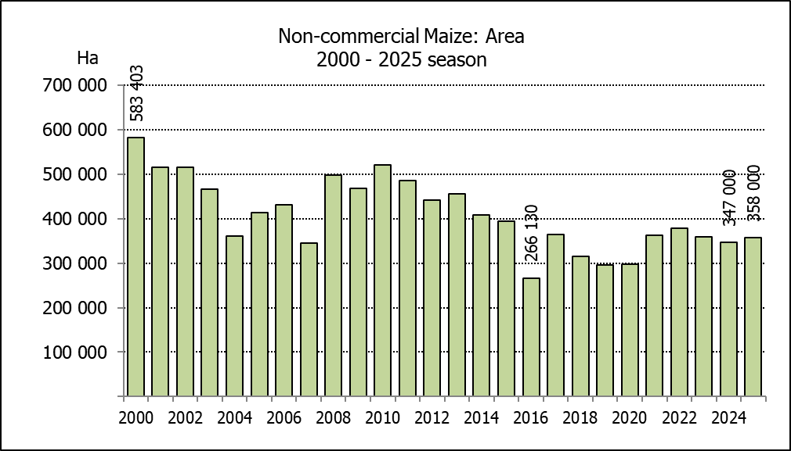
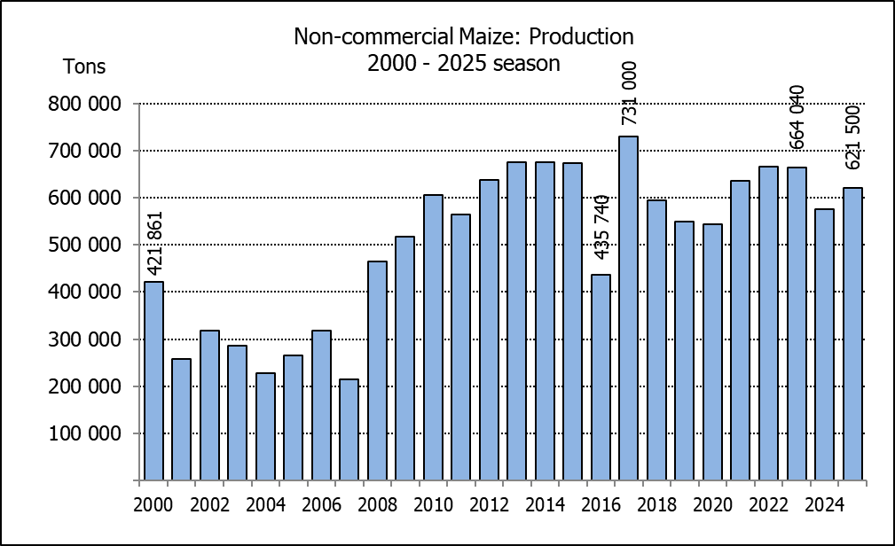
NIE-KOMMERSIëLE MIELIES – OPPERVLAKTE- EN PRODUKSIESKATTING: 2025
CROP/GEWAS | Area planted/  Opp beplant  2025 | Production/  Produksie  2025 | Area planted/  Opp beplant  2024 | Final crop/  Finale oes  2024 | Change/  Verandering
CROP/GEWAS | Ha | Tons | Ha | Tons | %
CROP/GEWAS | (A) | (B) | (C) | (D) | (B) ÷ (D)
Non-commercial agriculture/Nie-kommersiële landbou:
White maize/Witmielies | 275 150 | 439 700 | 267 570 | 407 500 | +7,90
Yellow maize/Geelmielies | 82 850 | 181 800 | 79 430 | 167 500 | +8,54
Maize/Mielies | 358 000 | 621 500 | 347 000 | 575 000 | +8,09
The area planted to maize in the non-commercial agricultural sector is estimated at 358 000 ha, which represents an increase of 3,17%, compared to the 347 000 ha of the previous season. The expected maize crop for this sector is 621 500 tons, which is 8,09% more than the 575 000 tons of last season. It is important to note that about 46,75% of the maize produced in the non-commercial sector, is planted in the Eastern Cape, followed by KwaZulu-Natal with 20,88% and then Limpopo with 20,65%.
Die voorlopige oppervlakte beplant met mielies in die nie-kommersiële landbou-sektor word geskat op 358 000 ha, wat ’n toename van 3,17% verteenwoordig in vergelyking met die 347 000 ha van die vorige seisoen. Die verwagte mielie-oes van dié sektor is 621 500 ton, wat 8,09% meer is as die 575 000 ton van die vorige seisoen. Dit is belangrik om daarop te let dat ongeveer 46,75% van die mielies wat geproduseer word in die nie-kommersiële sektor, in die Oos-Kaap geplant word, gevolg deur KwaZulu-Natal met 20,88% en dan Limpopo met 20,65%.

