 | crop estimates committee
 | oesskattingskomitee
From/Van: Mr Baldwin Netshifhefhe  Tel: 012 319 8043/32 E-mail/E-pos: BaldwinN@dalrrd.gov.za  Web page/Webblad: www.dalrrd.gov.za/statistics and economic reports or  www.sagis.org.za/CEC: Crop Estimates EMBARGO: 14:30 |  |  | 

The intentions’ of producers to plant summer crops for 2023 is hereby released. /
Hiermee word produsente se voorneme om somergewasse te plant vir 2023 vrygestel.

SUMMER CROPS – INTENTIONS TO PLANT: 2023
SOMERGEWASSE – VOORNEME OM TE PLANT: 2023
CROP/GEWAS | Intentions/  Voorneme  2023 | Area planted/  Opp beplant  2022 | Ninth estimate/  Negende skatting  2022 | Change/  Verandering/
CROP/GEWAS | Ha | Ha | Tons | %
CROP/GEWAS | soos middel Okt 2022/  as mid Oct 2022 |  | as on 26 Oct 2022/  soos op 26 Okt 2022
CROP/GEWAS | (A) | (B) | (C) | (A) ÷ (B)
Commercial/Kommersieël:
White maize/Witmielies | 1 502 000 | 1 575 000 | 7 789 750 | -4,6
Yellow maize/Geelmielies | 1 089 000 | 1 048 000 | 7 539 350 | +3,9
Maize/Mielies | 2 591 000 | 2 623 000 | 15 329 100 | -1,2
Sunflower seed/Sonneblomsaad | 580 500 | 670 700 | 845 550 | -13,4
Soybeans/Sojabone | 1 075 000 | 925 300 | 2 201 000 | +16,2
Groundnuts/Grondbone | 34 500 | 43 400 | 49 000 | -20,5
Sorghum | 33 100 | 37 200 | 110 700 | -11,0
Dry beans/Droëbone | 37 200 | 42 900 | 52 590 | -13,3
TOTAL/TOTAAL | 4 351 300 | 4 342 500 | 18 587 940 | +0,2
Note: Estimate is for calendar year, e.g. production season 2022/23 = 2023
Nota: Skatting is vir kalenderjaar, bv. produksie-seisoen 2022/23 = 2023

The Crop Estimates Committee comprises officials of the following institutions:
Department of Agriculture, Land Reform and Rural Development, Provincial Departments of Agriculture; various ARC-Institutes (Soil, Climate and Water; Small Grains Institute;
Grain Crops Institute); BFAP and Statistics SA.
26 October/Oktober 2022
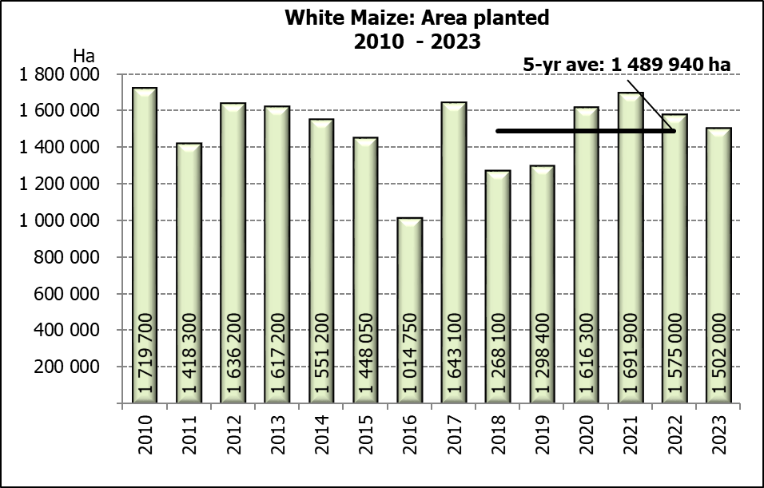

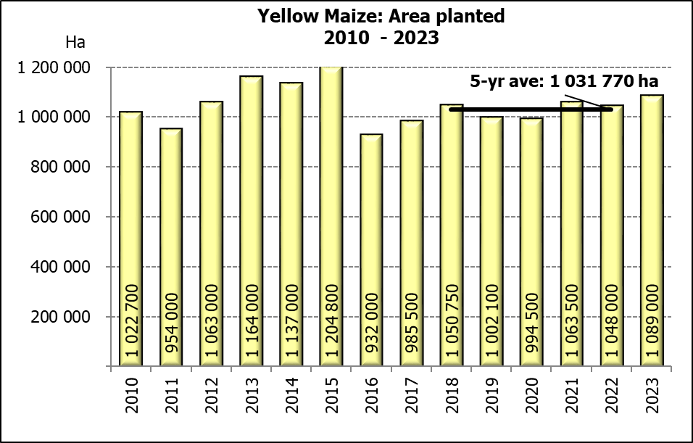

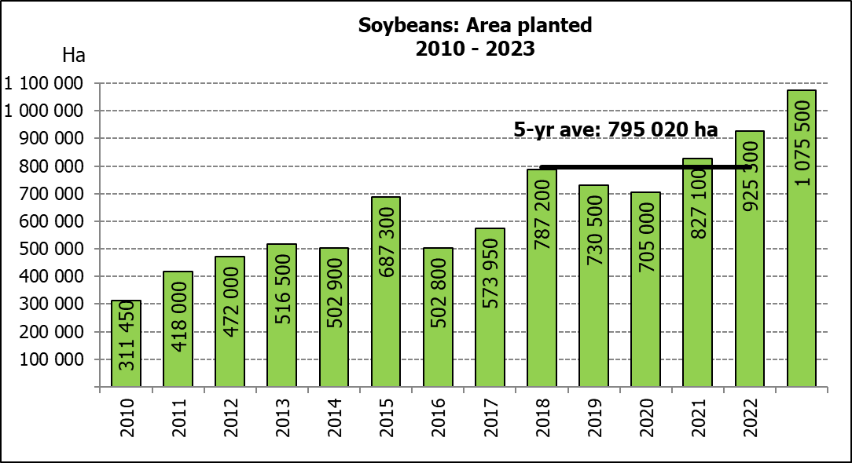

WHITE AND YELLOW MAIZE – INTENTIONS TO PLANT: 2023
WIT- EN GEELMIELIES – VOORNEME OM TE PLANT: 2023
Provinsie/  Province | Intentions (Area planted)/  Voorneme (Oppervlakte beplant)  2023 |  |  | Area planted/  Oppervlakte beplant  2022 |  |  | Ninth estimate¹⁾/  Negende skatting¹⁾  2022
Provinsie/  Province | White/  Wit  Ha | Yellow/  Geel  Ha | Total/  Totaal  Ha | White/  Wit  Ha | Yellow/  Geel  Ha | Total/  Totaal  Ha | White/  Wit  Tons | Yellow/  Geel  Tons | Total/  Totaal  Tons
Western Cape/Wes-Kaap | 250 | 3 500 | 3 750 | 500 | 3 500 | 4 000 | 4 750 | 32 900 | 37 650
Northern Cape/Noord-Kaap | 3 000 | 41 000 | 44 000 | 3 000 | 42 000 | 45 000 | 36 000 | 672 000 | 708 000
Free State/Vrystaat | 780 000 | 430 000 | 1 210 000 | 826 500 | 398 000 | 1 224 500 | 3 801 900 | 2 547 200 | 6 349 100
Eastern Cape/Oos-Kaap | 5 750 | 25 000 | 30 750 | 6 000 | 20 500 | 26 500 | 40 800 | 157 850 | 198 650
KwaZulu-Natal | 50 000 | 60 000 | 110 000 | 52 000 | 59 000 | 111 000 | 322 400 | 489 700 | 812 100
Mpumalanga | 152 000 | 359 000 | 511 000 | 165 000 | 350 000 | 515 000 | 1 072 500 | 2 485 000 | 3 557 500
Limpopo | 16 000 | 23 500 | 39 500 | 15 500 | 25 000 | 40 500 | 102 300 | 202 500 | 304 800
Gauteng | 55 000 | 52 000 | 107 000 | 56 500 | 56 000 | 112 500 | 361 600 | 397 600 | 759 200
North West/Noordwes | 440 000 | 95 000 | 535 000 | 450 000 | 94 000 | 544 000 | 2 047 500 | 554 600 | 2 602 100
Total/Totaal | 1 502 000 | 1 089 000 | 2 591 000 | 1 575 000 | 1 048 000 | 2 623 000 | 7 789 750 | 7 539 350 | 15 329 100

- 26 October 2022
SUNFLOWER SEED –INTENTIONS TO PLANT: 2023
SONNEBLOMSAAD – VOORNEME OM TE PLANT: 2023
Province/  Provinsie | Area planted/  Opp beplant  Ha | Area planted/  Opp beplant  Ha | Ninth estimate¹⁾/  Negende skatting¹⁾  Tons
Province/  Provinsie | 2023 | 2022 | 2022
Western Cape/Wes-Kaap | - | - | -
Northern Cape/Noord-Kaap | 1 100 | 2 500 | 6 250
Free State/Vrystaat | 290 000 | 357 000 | 499 800
Eastern Cape/Oos-Kaap | 200 | 300 | 750
KwaZulu-Natal | - | - | -
Mpumalanga | 3 000 | 3 500 | 5 250
Limpopo | 114 000 | 110 000 | 77 000
Gauteng | 2 200 | 2 400 | 3 000
North West/Noordwes | 170 000 | 195 000 | 253 500
Total/Totaal | 580 500 | 670 700 | 845 550
- 26 October 2022

SOYBEANS – INTENTIONS TO PLANT: 2023
SOJABONE – VOORNEME OM TE PLANT: 2023
Province/  Provinsie | Area planted/  Opp beplant  Ha | Area planted/  Opp beplant  Ha | Ninth estimate¹⁾/  Negende skatting¹⁾  Tons
Province/  Provinsie | 2022 | 2021 | 2021
Western Cape/Wes-Kaap | - | - | -
Northern Cape/Noord-Kaap | 1 500 | 800 | 3 000
Free State/Vrystaat | 520 000 | 415 000 | 892 250
Eastern Cape/Oos-Kaap | 3 500 | 3 000 | 9 000
KwaZulu-Natal | 42 500 | 39 000 | 146 250
Mpumalanga | 315 000 | 300 000 | 705 000
Limpopo | 25 000 | 22 500 | 76 500
Gauteng | 48 000 | 45 000 | 99 000
North West/Noordwes | 120 000 | 100 000 | 270 000
Total/Totaal | 1 075 500 | 925 300 | 2 201 000
- 26 October 2022

INTENTIONS TO PLANT SUMMER CROPS (2023) / VOORNEME OM SOMERGEWASSE TE PLANT (2023)
Producers intentions to plant summer crops are based on the results of a non-probability survey conducted by the Directorate: Statistics and Economic Analysis of the Department of Agriculture, Land Reform and Rural Development and reflects the position as at the middle of October 2022.  According to the results of the survey, commercial producers intend to plant 2,591 mill. ha of maize for 2023, which is 1,2% or 32 000 ha less than the 2,623 mill. ha planted last season.  The figures show that producers intend to plant 1,502 mill. ha to white maize, which is 73 000 ha (4,6%) less than in the previous season. In the case of yellow maize, the expected plantings are 1,089 mill. ha, which is 41 000 ha (3,9%) more than in the previous season.  In the case of sunflower seed, the expected area planted is estimated at 580 500 ha, which is 13,4% or 90 200 ha less than the 670 700 ha planted last season.  The intended plantings of soybeans shows an increase of 16,2% or 150 200 ha compared to the previous season – from 925 300 ha to 1,076 mill. ha.  The expected plantings of groundnuts will decrease by 20,5% or 8 900 ha, from 43 400 ha to 34 500 ha.  The intended plantings of sorghum is expected to decrease by 11,0% or 4 100 ha to 33 100 ha, compared to the previous season.  The expected plantings of dry beans is estimated at 37 200 ha, which is 13,3% or 5 700 ha less than in the previous season.  Please note that the preliminary area planted estimate for summer grains for 2023 will be released on 26 January 2023. |  | Produsente se voorneme om somergewasse te plant is gebaseer op die resultate van ’n nie-ewekansige opname onderneem deur die Direktoraat: Statistiek en Ekonomiese Analise van die Departement van Landbou, Grondhervorming en Landelike Ontwikkeling en weerspieël die situasie teen die middel van Oktober 2022.  Volgens die resultate van die opname, is kommersiele produsente van voorneme om 2,591 milj. ha mielies vir 2023 te plant, wat 1,2% of 32 000 ha minder is as die 2,623 milj. ha aangeplant verlede seisoen.  Die syfers toon dat produsente van voorneme is om 1,502 milj. ha witmielies aan te plant, wat 73 000 ha (4,6%) minder is as in die vorige seisoen. In die geval met geelmielies is die verwagte aanplantings 1,089 milj. ha, wat 41 000 ha (3,9%) meer is as in die vorige seisoen.  In die geval van sonneblomsaad word die verwagte aanplantings beraam op 580 500 ha, wat 13,4% of 90 200 ha minder is as die 670 700 ha aangeplant verlede seisoen.  Die voorgenome sojaboon-aanplantings toon ’n toename van 16,2% of 150 200 ha, in vergelyking met die vorige seisoen - vanaf 925 300 ha tot 1,076 milj. ha.  Die verwagte aanplantings van grondbone gaan afneem met 20,5% of 8 900 ha, van 43 400 ha tot 34 500 ha.  Die voorgenome aanplantings van sorghum sal na verwagting afneem met 11,0% of 4 100 ha na 33 100 ha, in vergelyking met die vorige seisoen.  Die verwagte aanplantings van droëbone word beraam op 37 200 ha, wat 13,3% of 5 700 ha minder is as in die vorige seisoen.  Neem asseblief kennis dat die voorlopige oppervlakteskatting vir somergewasse vir 2023 op 26 Januarie 2023 vrygestel sal word.

The area planted estimate and ninth production forecast for summer crops for 2022 is hereby released.
Hiermee word die oppervlakte- en negende produksieskatting vir somergewasse vir 2022 vrygestel.

SUMMER CROPS – AREA PLANTED AND NINTH PRODUCTION FORECAST: 2022
SOMERGEWASSE – OPPERVLAKTE- EN NEGENDE PRODUKSIESKATTING: 2022
CROP/GEWAS | Area planted/  Opp beplant  2022 | 9th forecast/  9de skatting  2022 | 8th forecast/  8ste skatting  2022 | Area planted/  Opp beplant  2021 | Final crop/  Finale oes  2021 | Change/  Verandering/
CROP/GEWAS | Ha | Tons | Tons | Ha | Tons | %
CROP/GEWAS | (A) | (B) | (C) | (D) | (E) | (B) ÷ (C)
Commercial/Kommersieel:
White maize/Witmielies | 1 575 000 | 7 789 750 | 7 789 750 | 1 691 900 | 8 600 000 | -
Yellow maize/Geelmielies | 1 048 000 | 7 539 350 | 7 470 050 | 1 063 500 | 7 715 000 | +0,93
Total Maize/Totale Mielies | 2 623 000 | 15 329 100 | 15 259 800 | 2 755 400 | 16 315 000 | +0,45
Sunflower seed/Sonneblomsaad | 670 700 | 845 550 | 845 550 | 477 800 | 678 000 | -
Soybeans/Sojabone | 925 300 | 2 201 000 | 2 201 000 | 827 100 | 1 897 000 | -
Groundnuts/Grondbone | 43 400 | 49 000 | 49 000 | 38 550 | 64 300 | -
Sorghum | 37 200 | 110 700 | 123 700 | 49 200 | 215 000 | -10,51
Dry beans/Droëbone | 42 900 | 52 590 | 52 590 | 47 390 | 57 672 | -
Non-Commercial Maize/Nie-Kommersiële Mielies
Total Maize/Totale Mielies | 378 800 | 667 000 | 667 000 | 362 900 | 636 440 | -
Maize/Mielies: Commercial/Kommersieël + Non-Commercial/Nie-Kommersieël
Total Maize RSA/Totaal Mielies RSA | 3 001 800 | 15 996 100 | 15 926 800 | 3 118 300 | 16 951 440 | +0,44

Note: Estimate is for calendar year, e.g. production season 2021/22 = 2022
Nota: Skatting is vir kalenderjaar, bv. produksie-seisoen 2021/22 = 2022
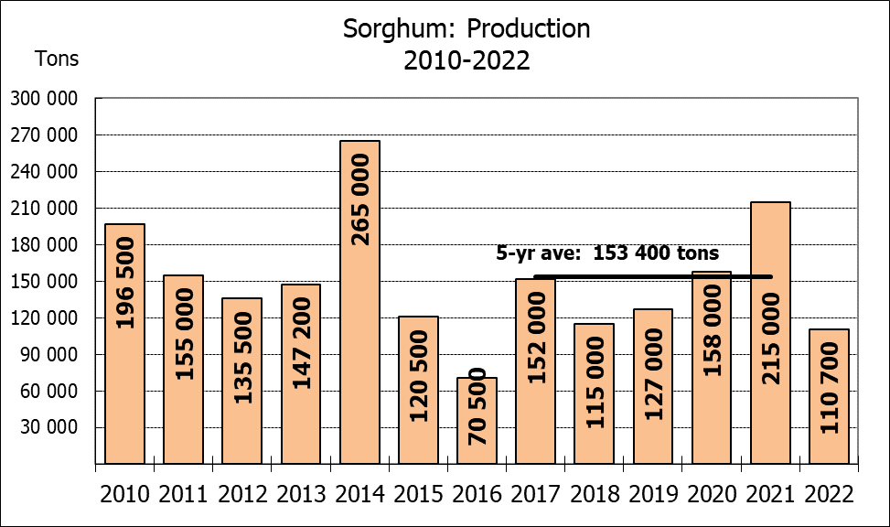

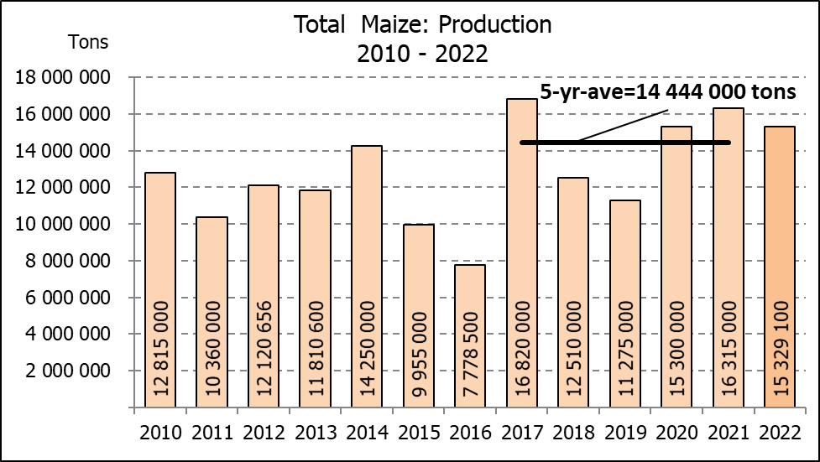
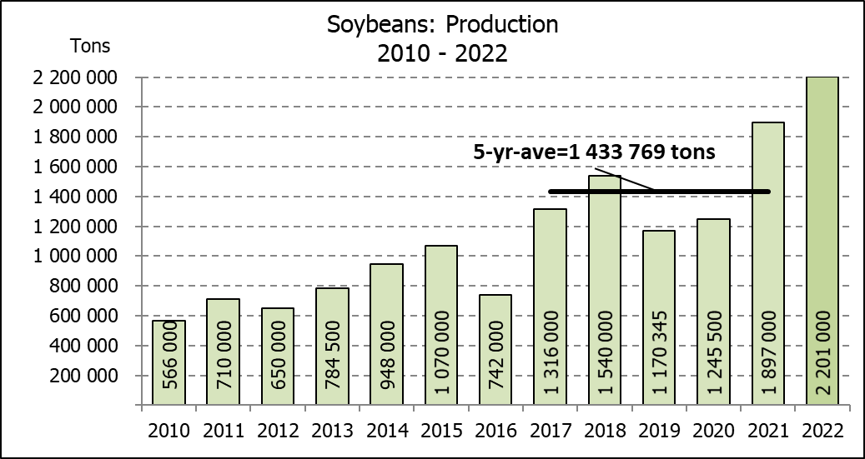

WHITE AND YELLOW MAIZE – AREA PLANTED AND NINTH PRODUCTION FORECAST: 2022
WIT- EN GEELMIELIES – OPPERVLAKTE EN NEGENDE PRODUKSIESKATTING: 2022

Provinsie/  Province | Area planted/  Oppervlakte beplant  2022 |  |  | 9th forecast/  9de skatting  2022 |  |  | Area planted/  Oppervlakte beplant  2021 |  |  | Final crop/  Finale oes  2021
Provinsie/  Province | White/  Wit  Ha | Yellow/  Geel  Ha | Total/  Totaal  Ha | White/  Wit  Tons | Yellow/  Geel  Tons | Total/  Totaal  Tons | White/  Wit  Ha | Yellow/  Geel  Ha | Total/  Totaal  Ha | White/  Wit  Tons | Yellow/  Geel  Tons | Total/  Totaal  Tons
Western Cape/Wes-Kaap | 500 | 3 500 | 4 000 | 4 750 | 32 900 | 37 650 | 500 | 3 500 | 4 000 | 4 800 | 33 300 | 38 100
Northern Cape/Noord-Kaap | 3 000 | 42 000 | 45 000 | 36 000 | 672 000 | 708 000 | 3 400 | 41 000 | 44 400 | 40 300 | 627 300 | 667 600
Free State/Vrystaat | 826 500 | 398 000 | 1 224 500 | 3 801 900 | 2 547 200 | 6 349 100 | 907 500 | 420 000 | 1 327 500 | 4 492 000 | 2 542 000 | 7 034 000
Eastern Cape/Oos-Kaap | 6 000 | 20 500 | 26 500 | 40 800 | 157 850 | 198 650 | 6 000 | 18 000 | 24 000 | 39 000 | 133 200 | 172 200
KwaZulu-Natal | 52 000 | 59 000 | 111 000 | 322 400 | 489 700 | 812 100 | 50 000 | 55 000 | 105 000 | 310 000 | 451 000 | 761 000
Mpumalanga | 165 000 | 350 000 | 515 000 | 1 072 500 | 2 485 000 | 3 557 500 | 165 000 | 360 000 | 525 000 | 1 100 500 | 2 820 000 | 3 920 500
Limpopo | 15 500 | 25 000 | 40 500 | 102 300 | 202 500 | 304 800 | 16 500 | 21 000 | 37 500 | 112 200 | 172 200 | 284 400
Gauteng | 56 500 | 56 000 | 112 500 | 361 600 | 397 600 | 759 200 | 58 000 | 50 000 | 108 000 | 371 200 | 380 000 | 751 200
North West/Noordwes | 450 000 | 94 000 | 544 000 | 2 047 500 | 554 600 | 2 602 100 | 485 000 | 95 000 | 580 000 | 2 130 000 | 556 000 | 2 686 000
Total/Totaal | 1 575 000 | 1 048 000 | 2 623 000 | 7 789 750 | 7 539 350 | 15 329 100 | 1 691 900 | 1 063 500 | 2 755 400 | 8 600 000 | 7 715 000 | 16 315 000

SUNFLOWER SEED – AREA PLANTED AND NINTH PRODUCTION FORECAST: 2022
SONNEBLOMSAAD – OPPERVLAKTE EN NEGENDE PRODUKSIESKATTING: 2022

Province/  Provinsie | Area planted/  Opp beplant  Ha | 9th forecast/  9de skatting  Tons | Area planted/  Opp beplant  Ha | Final crop/  Finale oes  Tons
Province/  Provinsie | 2022 | 2022 | 2021 | 2021
Western Cape/Wes-Kaap | - | - | - | -
Northern Cape/Noord-Kaap | 2 500 | 6 250 | 1 100 | 1 320
Free State/Vrystaat | 357 000 | 499 800 | 235 000 | 352 500
Eastern Cape/Oos-Kaap | 300 | 750 | 300 | 450
KwaZulu-Natal | - | - | - | -
Mpumalanga | 3 500 | 5 250 | 3 500 | 5 250
Limpopo | 110 000 | 77 000 | 76 500 | 76 500
Gauteng | 2 400 | 3 000 | 4 400 | 5 720
North West/Noordwes | 195 000 | 253 500 | 157 000 | 236 260
Total/Totaal | 670 700 | 845 550 | 477 800 | 678 000
SOYBEANS – AREA PLANTED AND NINTH PRODUCTION FORECAST: 2022
SOJABONE – OPPERVLAKTE EN NEGENDE PRODUKSIESKATTING: 2022

Province/  Provinsie | Area planted/  Opp beplant  Ha | 9th forecast/  9de skatting  Tons | Area planted/  Opp beplant  Ha | Final crop/  Finale oes  Tons
Province/  Provinsie | 2022 | 2022 | 2021 | 2021
Western Cape/Wes-Kaap | - | - | - | -
Northern Cape/Noord-Kaap | 800 | 3 000 | 1 000 | 3 500
Free State/Vrystaat | 415 000 | 892 250 | 365 000 | 766 500
Eastern Cape/Oos-Kaap | 3 000 | 9 000 | 3 100 | 9 300
KwaZulu-Natal | 39 000 | 146 250 | 36 000 | 129 600
Mpumalanga | 300 000 | 705 000 | 290 000 | 644 550
Limpopo | 22 500 | 76 500 | 20 500 | 71 750
Gauteng | 45 000 | 99 000 | 42 000 | 105 000
North West/Noordwes | 100 000 | 270 000 | 69 500 | 166 800
Total/Totaal | 925 300 | 2 201 000 | 827 100 | 1 897 000

GROUNDNUTS – AREA PLANTED AND NINTH PRODUCTION FORECAST: 2022
GRONDBONE – OPPERVLAKTE EN NEGENDE PRODUKSIESKATTING: 2022

Province/  Provinsie | Area planted/  Opp beplant  Ha | 9th forecast/  9de skatting  Tons | Area planted/  Opp beplant  Ha | Final crop/  Finale oes  Tons
Province/  Provinsie | 2022 | 2022 | 2021 | 2021
Western Cape/Wes-Kaap | - | - | - | -
Northern Cape/Noord-Kaap | 2 400 | 6 000 | 1 500 | 3 900
Free State/Vrystaat | 19 000 | 20 900 | 16 000 | 26 450
Eastern Cape/Oos-Kaap | - | - | - | -
KwaZulu-Natal | - | - | 50 | 50
Mpumalanga | - | - | - | -
Limpopo | 2 000 | 5 100 | 3 000 | 6 900
Gauteng | - | - | - | -
North West/Noordwes | 20 000 | 17 000 | 18 000 | 27 000
Total/Totaal | 43 400 | 49 000 | 38 550 | 64 300

SORGHUM – AREA PLANTED AND NINTH PRODUCTION FORECAST: 2022
SORGHUM – OPPERVLAKTE EN NEGENDE PRODUKSIESKATTING: 2022

Province/  Provinsie | Area planted/  Opp beplant  Ha | 9th forecast/  9de skatting  Tons | Area planted/  Opp beplant  Ha | Final crop/  Finale oes  Tons
Province/  Provinsie | 2022 | 2022 | 2021 | 2021
Western Cape/Wes-Kaap | - | - | - | -
Northern Cape/Noord-Kaap | - | - | - | -
Free State/Vrystaat | 7 800 | 17 160 | 10 500 | 45 675
Eastern Cape/Oos-Kaap | - | - | - | -
KwaZulu-Natal | 200 | 740 | 500 | 2 300
Mpumalanga | 9 000 | 45 000 | 9 400 | 57 325
Limpopo | 15 000 | 34 500 | 17 000 | 61 200
Gauteng | 200 | 800 | 300 | 1 350
North West/Noordwes | 5 000 | 12 500 | 11 500 | 47 150
Total/Totaal | 37 200 | 110 700 | 49 200 | 215 000

DRY BEANS – AREA PLANTED AND NINTH PRODUCTION FORECAST: 2022
DROëBONE – OPPERVLAKTE EN NEGENDE PRODUKSIESKATTING: 2022

Province/  Provinsie | Area planted/  Opp beplant  Ha | 9th forecast/  9de skatting  Tons | Area planted/  Opp beplant  Ha | Final crop/  Finale oes  Tons
Province/  Provinsie | 2022 | 2022 | 2021 | 2021
Western Cape/Wes-Kaap | 100 | 150 | 100 | 150
Northern Cape/Noord-Kaap | 600 | 1 080 | 350 | 700
Free State/Vrystaat | 15 500 | 13 950 | 22 000 | 16 500
Eastern Cape/Oos-Kaap | 200 | 300 | 200 | 300
KwaZulu-Natal | 2 300 | 2 760 | 3 000 | 3 900
Mpumalanga | 6 000 | 6 600 | 6 500 | 9 750
Limpopo | 10 400 | 18 200 | 8 000 | 16 000
Gauteng | 800 | 800 | 840 | 1 092
North West/Noordwes | 7 000 | 8 750 | 6 400 | 9 280
Total/Totaal | 42 900 | 52 590 | 47 390 | 57 672

CONFIDENTIALITY ISSUES that CEC members are committed to adhere to on the day of the meeting
- Personal items such as laptops, handbags, cell phones, etc. are not allowed in the venue during the meeting
- No member is allowed to leave the meeting before 12:00 in order to prevent disclosure of the information
- The embargo time for the release of crop estimates information is 14:30
- No member is allowed to discuss crop estimates information with anyone other than a member of the Committee before the embargo time
- Only the Chairperson, or a member appointed by the Chairperson, may release the figures to the media
- Members must regard the detail of any information that was collected for and/or discussed during the meeting, as confidential
- Individual information received for crop estimate purposes is treated strictly confidential, and is not divulged for any other purposes

AREA ESTIMATE AND NINTH PRODUCTION FORECAST OF SUMMER CROPS (2022 PRODUCTION SEASON)/
OPPERVLAKTE- EN NEGENDE PRODUKSIESKATTING VIR SOMERGEWASSE (2022 PRODUKSIE-SEISOEN)
26 OCTOBER / OKTOBER 2022

Summer field crops – 2022  Commercial maize: The size of the expected commercial maize crop has been set at 15,329 mill. tons. The area estimate for maize is 2,623 mill. ha, while the expected yield is 5,84 t/ha.  The estimated maize crop is 6% smaller than the 2021 crop. The three main maize producing areas, namely the Free State, Mpumalanga and North West provinces are expected to produce 82% of the 2022 crop.  The area estimate for white maize is 1,575 mill. ha and for yellow maize the area estimate is 1,048 mill. ha.  The production forecast for white maize remained unchanged at 7,790 mill. tons. The yield for white maize is 4,95 t/ha. In the case of yellow maize the production forecast is 7,539 mill. tons, which is 0,93% or 69 300 tons more than the previous forecast of 7,470 mill. tons. The yield for yellow maize is 7,19 t/ha.  Sunflower seed: The production forecast for sunflower seed remained unchanged at 845 550 tons. The area estimate for sunflower seed is 670 700 ha, while the expected yield is 1,26 t/ha.  Other crops: The production forecast for soybeans remained unchanged at 2,201 mill. tons. The estimated area planted to soybeans is 925 300 ha and the expected yield is 2,38 t/ha.  The expected groundnut crop also remained unchanged at 49 000 tons. For groundnuts, the area estimate is 43 400 ha, with an expected yield of 1,13 t/ha.  The production forecast for sorghum is 110 700 tons, which is 10,51% or 13 000 tons less than the previous forecast of 123 700 tons. The area estimate for sorghum is 37 200 ha and the expected yield is 2,98 t/ha.  In the case of dry beans, the production forecast remained unchanged at 52 590 tons. The area estimate of dry beans is 42 900 ha, with an expected yield of 1,23 t/ha.  Please note that the final production estimate for summer field crops for 2022, will be released on 29 November 2022. |  | Somergewasse – 2022  Kommersiële mielies: Die grootte van die verwagte kommersiële mielie-oes is 15,329 milj. ton. Die skatting van die oppervlakte onder mielies is 2,623 milj. ha, terwyl die verwagte opbrengs 5,84 t/ha is.  Die geskatte mielie-oes is 6% kleiner as die 2021-oes. Die drie belangrikste mielieproduserende gebiede, nl. die Vrystaat, Mpumalanga en Noordwes provinsies, gaan na verwagting 82% van die 2022-oes produseer.  Die oppervlak onder witmielies is 1,575 milj. ha en vir geelmielies is die oppervlak 1,048 milj. ha.  Die produksieskatting van witmielies is onveranderd gelaat op 7,790 milj. ton. Die opbrengs van witmielies is 4,95 t/ha. In die geval van geelmielies is die produksieskatting 7,539 milj. ton, wat 0,93% of 69 300 ton meer is as die vorige skatting van 7,470 milj. ton. Die opbrengs van geelmielies is 7,19 t/ha.  Sonneblomsaad: Die produksieskatting vir sonneblomsaad is onveranderd gelaat op 845 550 ton. Die oppervlakteskatting vir sonneblomsaad is 670 700 ha, terwyl die verwagte opbrengs 1,26 t/ha is.  Ander gewasse: Die produksieskatting van sojabone is onveranderd gelaat op 2,201 milj. ton gestel. Die geskatte oppervlakte beplant met sojabone is 925 300 ha en die verwagte opbrengs is 2,38 t/ha.  Die verwagte grondbone-oes is ook onveranderd gelaat op 49 000 ton. Vir grondbone is die oppervlakteskatting 43 400 ha, terwyl the verwagte opbrengs 1,13 t/ha is.  Die produksieskatting van sorghum is 110 700 ton, wat 10,51% of 13 000 ton minder is as die vorige skatting van 123 700 ton. Die oppervlakteskatting vir sorghum is 37 200 ha, en die verwagte opbrengs is 2,98 t/ha.  In die geval van droëbone is die produksieskatting onveranderd gelaat op 52 590 ton. Die oppervlakte beplant met droëbone is 42 900 ha en die verwagte opbrengs is 1,23 t/ha.  Neem asseblief kennis dat die finale produksieskatting vir somergewasse vir 2022, op 29 November 2022 vrygestel sal word..

The non-commercial agricultural sectors’ production estimate for maize for 2022 is hereby released. /
Hiermee word die nie-kommersiële landbou-sektor se produksieskatting vir mielies vir 2022 vrygestel.

NON-COMMERCIAL MAIZE – AREA PLANTED AND PRODUCTION ESTIMATE: 2022
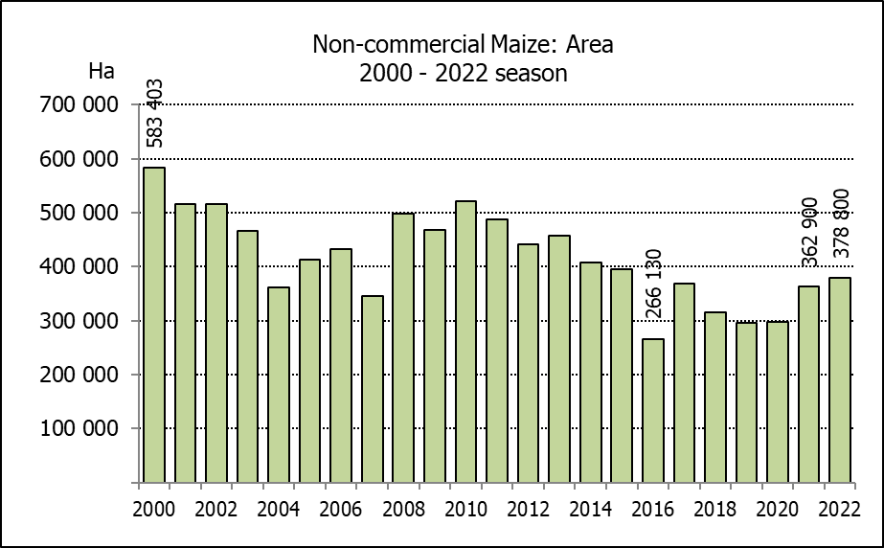
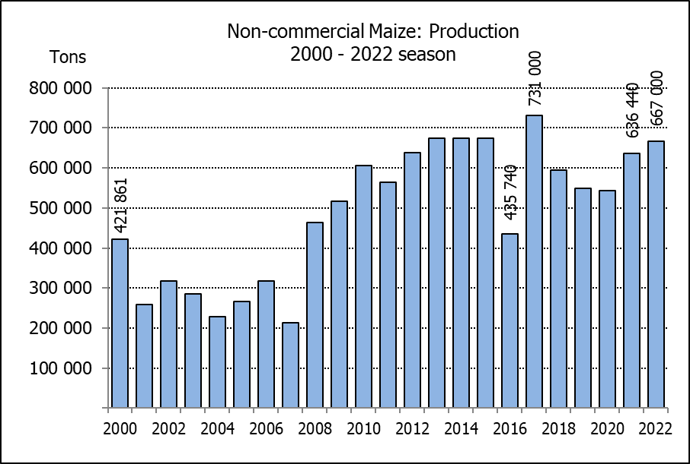
NIE-KOMMERSIëLE MIELIES – OPPERVLAKTE- EN PRODUKSIESKATTING: 2022
CROP/GEWAS | Area planted/  Opp beplant  2022 | Production/  Produksie  2022 | Area planted/  Opp beplant  2021 | Final crop/  Finale oes  2021 | Change/  Verandering
CROP/GEWAS | Ha | Tons | Ha | Tons | %
CROP/GEWAS | (A) | (B) | (C) | (D) | (B) ÷ (D)
Non-commercial agriculture/Nie-kommersiële landbou:
White maize/Witmielies | 296 950 | 482 000 | 276 100 | 445 335 | +8,23
Yellow maize/Geelmielies | 81 850 | 185 000 | 86 800 | 191 105 | -3,19
Maize/Mielies | 378 800 | 667 000 | 362 900 | 636 440 | +4,80
The area planted to maize in the non-commercial agricultural sector is estimated at 378 800 ha, which represents an increase of 4,38%, compared to the 362 900 ha of the previous season. The expected maize crop for this sector is 667 000 tons, which is 4,80% more than the 636 440 tons of last season. It is important to note that about 47% of the maize produced in the non-commercial sector, is planted in the Eastern Cape, followed by KwaZulu-Natal with 22%.
Die oppervlakte beplant met mielies in die nie-kommersiële landbou-sektor word geskat op 378 800 ha, wat ’n toename van 4,38% verteenwoordig in vergelyking met die 362 900 ha van die vorige seisoen. Die verwagte mielie-oes van dié sektor is 667 000 ton, wat 4,80% meer is as die 636 440 ton van die vorige seisoen. Dit is belangrik om daarop te let dat ongeveer 47% van die mielies wat geproduseer word in die nie-kommersiële sektor, in die Oos-Kaap geplant word, gevolg deur KwaZulu-Natal met 22%.

The area estimate and third production forecast for winter cereals for 2022 is hereby released. /
Hiermee word die oppervlakteskatting en derde produksieskatting vir wintergewasse vir 2022 vrygestel.

WINTER CEREALS – AREA PLANTED ESTIMATE AND THIRD PRODUCTION FORECAST: 2022 PRODUCTION SEASON
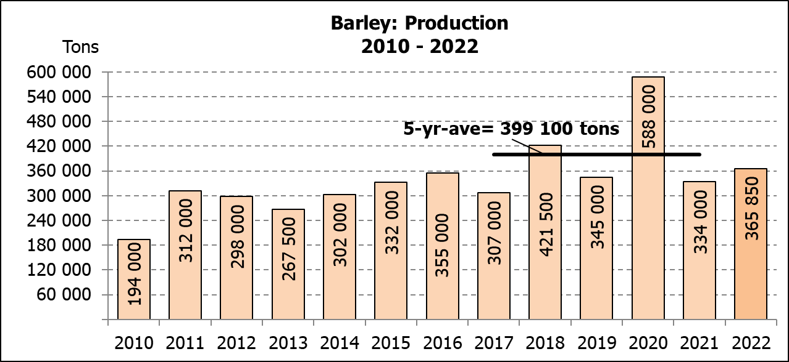
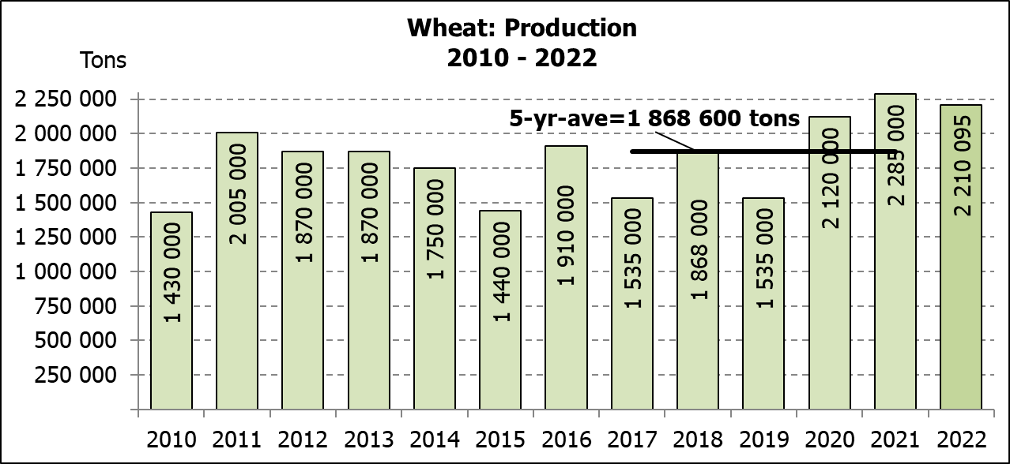
WINTERGEWASSE – OPPERVLAKTESKATTING EN DERDE PRODUKSIESKATTING: 2022-PRODUKSIESEISOEN
CROP/GEWAS | Area planted/  Opp beplant  2022 | 3rd forecast/  3de skatting 2022 | 2nd forecast/  2de skatting 2022 | Area planted/  Opp beplant  2021 | Final crop/  Finale oes  2021 | Change/  Verandering
CROP/GEWAS | Ha | Tons | Tons | Ha | Tons | %
CROP/GEWAS | (A) | (B) | (C) | (D) | (E) | (B) ÷ (C)
Commercial/Kommersieel:
Wheat/Koring | 566 800 | 2 210 095 | 2 218 775 | 523 500 | 2 285 000 | -0,4
Barley/Gars¹⁾ | 101 000 | 365 850 | 365 850 | 94 730 | 334 000 | -
Canola/Kanola | 123 510 | 198 230 | 198 230 | 100 000 | 198 100 | -
Oats/Hawer¹⁾ | 27 000 | 37 700 | 41 600 | 36 250 | 59 000 | -9,4
Sweet lupines/Soetlupine | 21 000 | 16 800 | 16 800 | 22 000 | 28 600 | -
1) Commercial only. Excluding barley or oats used as pasture, silage, hay and/or on the farm as fodder for livestock /
Slegs kommersieël. Uitgesluit gars of hawer wat gebruik word as weiding, kuilvoer, hooi en/of op die plaas as voer vir vee.

WHEAT – AREA PLANTED ESTIMATE AND THIRD PRODUCTION FORECAST: 2022 PRODUCTION SEASON
KORING – OPPERVLAKTESKATTING EN DERDE PRODUKSIESKATTING: 2022-PRODUKSIESEISOEN
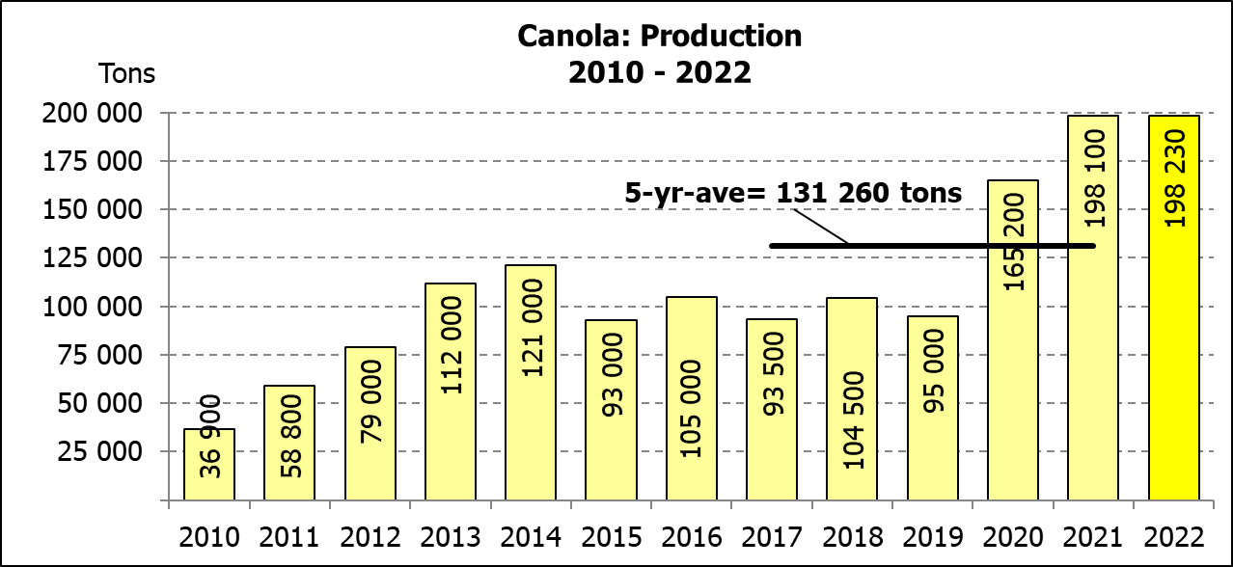
Province/  Provinsie | Area planted/  Opp beplant  Ha | 3rd forecast/  3de skatting  Tons | Area planted/  Opp beplant  Ha | Final crop/  Finale oes  Tons
Province/  Provinsie | 2022 | 2022 | 2021 | 2021
Western Cape/Wes-Kaap | 360 000 | 972 000 | 360 000 | 1 260 000
Northern Cape/Noord-Kaap | 47 000 | 352 500 | 35 500 | 275 125
Free State/Vrystaat | 96 000 | 470 400 | 70 000 | 360 000
Eastern Cape/Oos-Kaap | 6 000 | 40 200 | 3 800 | 25 080
KwaZulu-Natal | 9 200 | 60 720 | 8 500 | 56 950
Mpumalanga | 4 000 | 27 000 | 4 100 | 28 300
Limpopo | 29 000 | 182 700 | 26 500 | 176 220
Gauteng | 1 100 | 7 425 | 1 100 | 7 425
North West/Noordwes | 14 500 | 97 150 | 14 000 | 95 900
Total/Totaal | 566 800 | 2 210 095 | 523 500 | 2 285 000
AREA ESTIMATE AND THIRD PRODUCTION FORECAST OF WINTER CROPS (2022) /
OPPERVLAKTESKATTING EN DERDE PRODUKSIESKATTING VAN WINTERGEWASSE (2022)
26 OCTOBER / OKTOBER 2022

Winter cereal crops - 2022 production season  Wheat: The expected production of wheat is 2,210 mill. tons, which is 0,39% or 8 680 tons less than the previous forecast of 2,219 mill. tons, whilst the expected yield is 3,90 t/ha.  The expected production in the Western Cape is unchanged at 972 000 tons (44%), compared to the previous forecast. In the Free State, the expected production is now 470 400 tons (21%) compared to the 480 000 tons of the previous month. In the Northern Cape, 352 500 tons (16%) is expected to be produced – unchanged from the previous month.  The area estimate for wheat is 566 800 ha. An estimated 360 000 ha or 64 % is planted in the Western Cape, 96 000 ha or 17 % in the Free State and 47 000 ha or 8 % in the Northern Cape.  Other crops: The production forecast for barley remained unchanged at 365 850 tons. The area planted is estimated at 101 000 ha, while the expected yield is 3,62 t/ha.  The expected canola crop also remained unchanged at 198 230 tons. The area estimate for canola is 123 510 ha, with an expected yield of 1,60 t/ha.  The expected crop for oats for the 2022 season is 37 700 tons and the area planted is 27 000 ha. The expected yield is 1,40 t/ha.  In the case of sweet lupines, the production forecast is unchanged at 16 800 tons. The area estimate of sweet lupines is 21 000 ha, with an expected yield of 0,80 t/ha.  Please note that the fourth production forecast for winter cereals for 2022 will be released on 29 November 2022. |  | Wintergewasse - 2022 produksie-seisoen  Koring: Die verwagte produksie vir koring is 2,210 milj. ton, wat 0,39% of 8 680 ton minder is as die vorige skatting van 2,219 milj. ton, terwyl die verwagte opbrengs 3,90 t/ha is.  Die verwagte produksie in die Wes-Kaap is onveranderd op 972 000 ton (44%) in vergelyking met die vorige skatting. In die Vrystaat is die verwagte produksie 470 400 ton (21%) in vergelyking met die vorige maand se 480 000 ton. In die Noord-Kaap is die beraamde produksie 352 500 ton (16%) – onveranderd van die vorige maand.  Die oppervlakteskatting vir koring is 566 800 ha. Die beraamde oppervlakte geplant in die Wes-Kaap is 360 000 ha of 64 %, die Vrystaat is 96 000 ha of 17 % en 47 000 ha of 8 % is in die Noord-Kaap.  Ander gewasse: Die produksieskatting vir gars is onveranderd gelaat op 365 850 ton. Die oppervlakte beplant word beraam op 101 000 ha, terwyl die verwagte opbrengs 3,62 t/ha beloop.  Die verwagte kanola-oes is ook onveranderd gelaat op 198 230 ton. Die oppervlakteskatting vir kanola is 123 510 ha, met ŉ verwagte opbrengs van 1,60 t/ha.  Die verwagte oes vir hawer vir die 2022-seisoen is 37 700 ton en die oppervlakteskatting is 27 000 ton. Die verwagte opbrengs is 1,40 t/ha.  In die geval van soetlupine is die produksieskatting onveranderd gelaat op 16 800 ton. Die oppervlakte beplant met soetlupine is 21 000 ha, en die verwagte opbrengs is 0,80 t/ha.  Neem asseblief kennis dat die vierde produksieskatting vir wintergewasse vir 2022 op 29 November 2022 vrygestel sal word.

Information is available on the internet at http://www.dalrrd.gov.za/links/crop estimates or http://www.sagis.org.za, as from 14:30 on the date of the relevant meeting of the Crop Estimates Committee. |  | Inligting is beskikbaar op die internet by http://www.dalrrd.gov.za/links/crop estimates of by http://www.sagis.org.za, vanaf 14:30 op die dag van die toepaslike vergadering van die Oesskattingskomitee.

