
crop estimates committee
oesskattingskomitee
From/Van: Mr Baldwin Netshifhefhe
 Tel: 012 319 8043/32  E-mail/E-pos: BaldwinN@dalrrd.gov.za
 Web page/Webblad: www.dalrrd.gov.za/Old Website/Statistics and Economic Reports or
www.sagis.org.za/CEC: Crop Estimates
EMBARGO: 14:30

15 May 2025

THE FINAL AREA PLANTED AND CROP PRODUCTION FIGURES OF WINTER CEREALS FOR THE 2024 PRODUCTION SEASON

At a meeting held on 15 May 2025, the Crop Estimates Liaison Committee (CELC) oversaw the process for the finalisation of the crop production figures of commercial wheat, barley, canola and oats for 2024.
The estimated total production figures as released by the national Crop Estimates Committee (CEC) were revised, using the published figures of the South Africa Grain Information Services (SAGIS) of actual deliveries as the basis for the calculations. The figures from the wheat utilisation survey to determine on-farm usage and retentions, which was conducted by the Department of Agriculture (DOA), were added to the SAGIS delivery figures to calculate the final crop production figures.
Comparing the final calculated crop figures with the numbers set by the CEC during February 2025, the size of the commercial wheat crop is now 1 930 000 tons, which is 5 110 tons or 0,27% more than the final crop estimate figure of 1 924 890 tons. For barley the recalculated crop size is 372 250 tons, which is 1 750 tons or 0,47% lower than the final crop estimate figure of 374 000 tons. The final recalculated canola crop estimate figure is 290 400 tons, which is higher (2 200 tons or 0,76%) than the final crop estimate figure of 288 200 tons. The final recalculated oats crop estimate figure is 43 400 tons, which is 600 tons or 1,40% higher than the final crop estimate figure of 42 800 tons.
CELC accepted the final recalculated crop production figures for 2024 (please refer to the figures in the accompanying tables).
The CEC would like to thank all producers and industry role-players who provided information on a regular basis to improve the accuracy of the crop estimates. Producers, who do not participate in the Department’s monthly survey, are requested as a matter of urgency to make an effort to contribute to the crop estimates process.

FINAL AREA PLANTED AND CROP FIGURES OF WINTER CEREALS FOR THE 2024 PRODUCTION SEASON
CROP | FINAL  AREA PLANTED  HA  (A) | FINAL  CROP  TONS  (B) | CEC  AREA PLANTED¹⁾  HA  (C) | CEC  FINAL ESTIMATE¹⁾  TONS  (D) | FINAL CROP  vs  FINAL ESTIMATE  %  (B) ÷ (D)
Wheat | 505 300 | 1 930 000 | 505 300 | 1 924 890 | 0,27
Barley | 100 700 | 372 250 | 100 700 | 374 000 | -0,47
Canola | 165 750 | 290 400 | 165 750 | 288 200 | 0,76
Oats | 31 000 | 43 400 | 31 000 | 42 800 | 1,40
- As estimated by the CEC on 27 February 2025

THE CALCULATION OF THE FINAL WINTER CEREAL CROPS FOR THE 2024 PRODUCTION SEASON IS AS FOLLOWS:
CROP | Final crop | Producer deliveries  reported by SAGIS¹⁾  (Oct 2024 - March 2025) | Estimated  future deliveries  (April – Sep 2025) | Retentions on farms for own use/seed²⁾
CROP | Tons
Wheat | 1 930 000 | 1 828 021 | 61 479 | 40 500
Barley | 372 250 | 368 982 | 2 268 | 1 000
Canola | 290 400 | 290 031 | 269 | 100
Oats | 43 400 | 41 797 | 1 603 | 0
- SAGIS producer deliveries relate to the current crop.
- Based on a survey undertaken by the Directorate: Statistics and Economic Analysis of the Department of Agriculture.

WHEAT DEVIATION: FINAL ESTIMATE vs THE FINAL CROP (2005 – 2024)

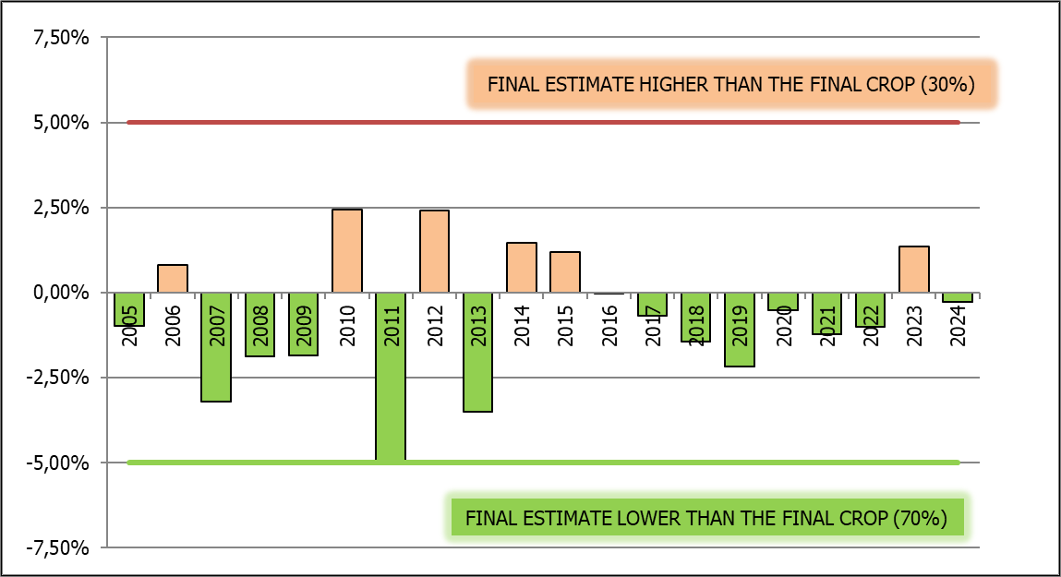
5% norm
of accuracy

