 | crop estimates committee | 
 | oesskattingskomitee
From/Van: Mr Baldwin Netshifhefhe
Tel: 012 319 8043  Fax/Faks: 012 319 8031  E-mail/E-pos: BaldwinN@daff.gov.za
Web page/Webblad: www.daff.gov.za/statistics and economic reports or www.sagis.org.za/CEC: Crop Estimates
EMBARGO: 14:30

The revised area planted estimate and first production forecast for summer crops for 2019 is hereby released.
Hiermee word die hersiene oppervlakte- en eerste produksieskatting vir somergewasse vir 2019 vrygestel.

SUMMER CROPS – REVISED AREA PLANTED AND FIRST PRODUCTION FORECAST: 2019
SOMERGEWASSE – HERSIENE OPPERVLAKTE- EN EERSTE PRODUKSIESKATTING: 2019
CROP/GEWAS | Area planted/  Opp beplant  2019 | 1stforecast/  1ste skatting  2019 | Area planted/  Opp beplant  2018 | Final crop/  Finale oes  2018 | Change/  Verandering/
CROP/GEWAS | Ha | Tons | Ha | Tons | %
CROP/GEWAS | (A) | (B) | (C) | (D) | (B) ÷ (D)
Commercial/Kommersieël:
White maize/Witmielies | 1 298 200 | 5 152 900 | 1 268 100 | 6 540 000 | -21,2
Yellow maize/Geelmielies | 1 003 600 | 5 357 120 | 1 050 750 | 5 970 000 | -10,3
Total Maize/Totale Mielies | 2 301 800 | 10 510 020 | 2 318 850 | 12 510 000 | -16,0
Sunflower seed/Sonneblomsaad | 515 350 | 563 590 | 601 500 | 862 000 | -34,6
Soybeans/Sojabone | 730 500 | 1 276 035 | 787 200 | 1 540 000 | -17,1
Groundnuts/Grondbone | 20 050 | 20 100 | 56 300 | 57 000 | -64,7
Sorghum | 50 500 | 168 400 | 28 800 | 115 000 | +46,4
Dry beans/Droëbone | 59 300 | 70 950 | 53 360 | 69 360 | +2,3
TOTAL/TOTAAL | 3 677 500 | 12 609 095 | 3 846 010 | 15 153 360 | -16,8
Note: Estimate is for calendar year, e.g. production season 2018/19 = 2019
Nota: Skatting is vir kalenderjaar, bv. produksie-seisoen 2018/19 = 2019

27 February / Februarie 2019
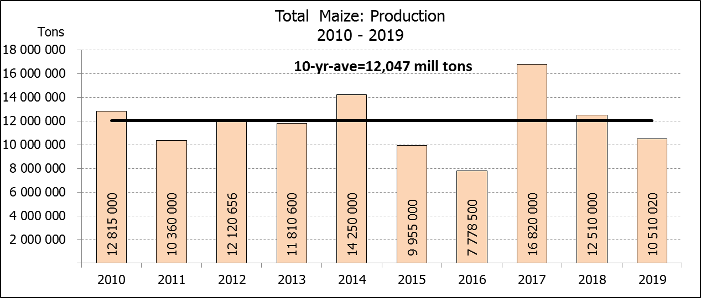

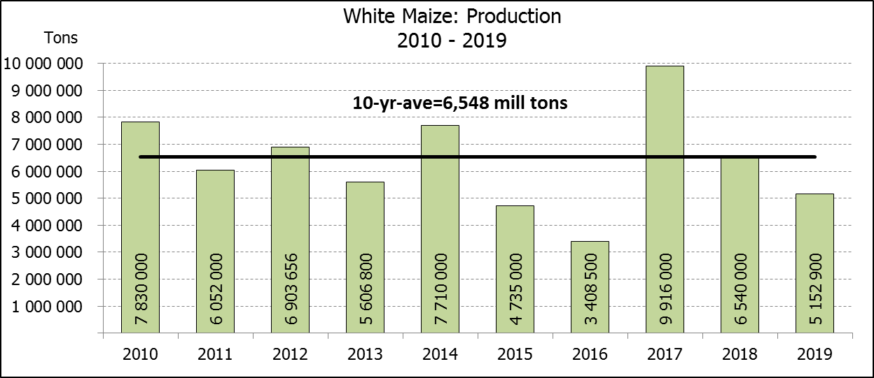
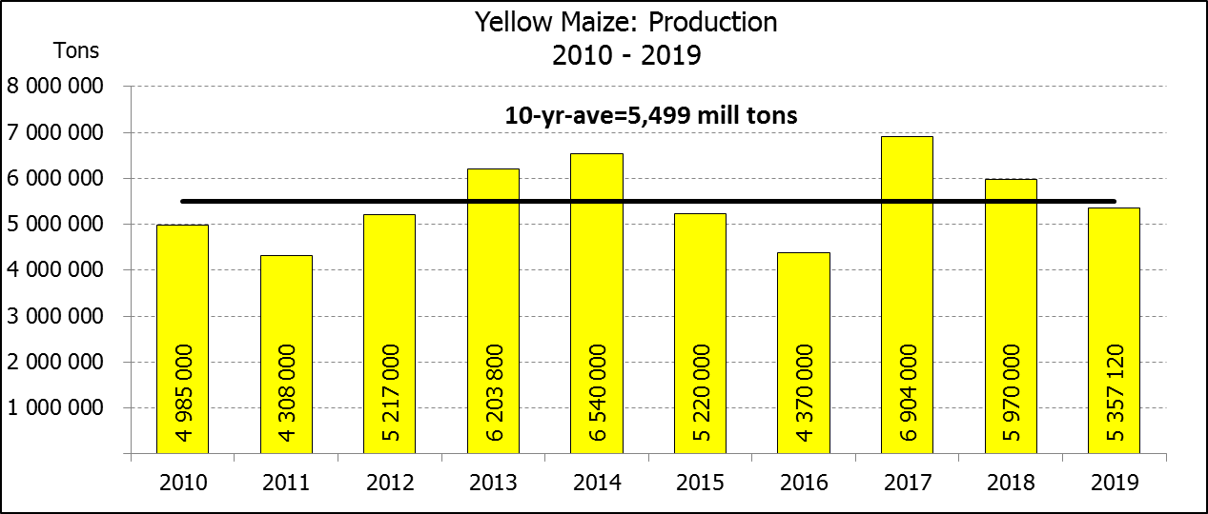

WHITE AND YELLOW MAIZE – REVISED AREA PLANTED AND FIRST PRODUCTION FORECAST: 2019
WIT- EN GEELMIELIES – HERSIENE OPPERVLAKTE EN EERSTE PRODUKSIESKATTING: 2019

Provinsie/  Province | Area planted/  Oppervlakte beplant  2019 |  |  | 1st forecast/  1ste skatting  2019 |  |  | Area planted/  Oppervlakte beplant  2018 |  |  | Final crop/  Finale oes  2018
Provinsie/  Province | White/  Wit  Ha | Yellow/  Geel  Ha | Total/  Totaal  Ha | White/  Wit  Tons | Yellow/  Geel  Tons | Total/  Totaal  Tons | White/  Wit  Ha | Yellow/  Geel  Ha | Total/  Totaal  Ha | White/  Wit  Tons | Yellow/  Geel  Tons | Total/  Totaal  Tons
Western Cape/Wes-Kaap | 400 | 3 400 | 3 800 | 3 600 | 30 600 | 34 200 | 0 | 3 750 | 3 750 | 0 | 33 750 | 33 750
Northern Cape/Noord-Kaap | 3 200 | 45 000 | 48 200 | 36 800 | 639 000 | 675 800 | 3 600 | 43 000 | 46 600 | 41 300 | 628 000 | 669 300
Free State/Vrystaat | 650 000 | 380 000 | 1 030 000 | 2 470 000 | 1 596 000 | 4 066 000 | 644 000 | 410 000 | 1 054 000 | 3 350 000 | 1 925 000 | 5 275 000
Eastern Cape/Oos-Kaap | 3 800 | 10 200 | 14 000 | 22 800 | 67 320 | 90 120 | 3 500 | 11 000 | 14 500 | 21 700 | 71 500 | 93 200
KwaZulu-Natal | 45 000 | 54 000 | 99 000 | 265 500 | 378 000 | 643 500 | 45 000 | 50 000 | 95 000 | 280 000 | 380 000 | 660 000
Mpumalanga | 145 000 | 338 000 | 483 000 | 783 000 | 1 825 200 | 2 608 200 | 140 000 | 340 000 | 480 000 | 812 000 | 2 005 000 | 2 817 000
Limpopo | 12 800 | 18 000 | 30 800 | 83 200 | 117 000 | 200 200 | 12 000 | 21 000 | 33 000 | 90 000 | 141 700 | 231 700
Gauteng | 48 000 | 60 000 | 108 000 | 240 000 | 324 000 | 564 000 | 50 000 | 62 000 | 112 000 | 275 000 | 356 500 | 631 500
North West/Noordwes | 390 000 | 95 000 | 485 000 | 1 248 000 | 380 000 | 1 628 000 | 370 000 | 110 000 | 480 000 | 1 670 000 | 428 550 | 2 098 550
Total/Totaal | 1 298 200 | 1 003 600 | 2 301 800 | 5 152 900 | 5 357 120 | 10 510 020 | 1 268 100 | 1 050 750 | 2 318 850 | 6 540 000 | 5 970 000 | 12 510 000

SUNFLOWER SEED – REVISED AREA PLANTED AND FIRST PRODUCTION FORECAST: 2019
SONNEBLOMSAAD – HERSIENE OPPERVLAKTE EN EERSTE PRODUKSIESKATTING: 2019

Province/  Provinsie | Area planted/  Opp beplant  Ha | 1st forecast/  1ste skatting  Tons | Area planted/  Opp beplant  Ha | Final crop/  Finale oes  Tons
Province/  Provinsie | 2019 | 2019 | 2018 | 2018
Western Cape/Wes-Kaap | - | - | 100 | 100
Northern Cape/Noord-Kaap | 950 | 1 140 | 1 600 | 1 920
Free State/Vrystaat | 270 000 | 324 000 | 314 000 | 490 000
Eastern Cape/Oos-Kaap | 100 | 250 | - | -
KwaZulu-Natal | - | - | - | -
Mpumalanga | 4 500 | 4 500 | 2 300 | 2 180
Limpopo | 61 000 | 54 900 | 45 000 | 36 000
Gauteng | 3 800 | 3 800 | 5 500 | 5 600
North West/Noordwes | 175 000 | 175 000 | 233 000 | 326 200
Total/Totaal | 515 350 | 563 590 | 601 500 | 862 000
SOYBEANS – REVISED AREA PLANTED AND FIRST PRODUCTION FORECAST: 2019
SOJABONE – HERSIENE OPPERVLAKTE EN EERSTE PRODUKSIESKATTING: 2019

Province/  Provinsie | Area planted/  Opp beplant  Ha | 1st forecast/  1ste skatting  Tons | Area planted/  Opp beplant  Ha | Final crop/  Finale oes  Tons
Province/  Provinsie | 2019 | 2019 | 2018 | 2018
Western Cape/Wes-Kaap | 100 | 200 | 800 | 1 200
Northern Cape/Noord-Kaap | 1 550 | 5 425 | 3 000 | 10 500
Free State/Vrystaat | 301 000 | 436 450 | 345 000 | 552 000
Eastern Cape/Oos-Kaap | 1 150 | 1 380 | 2 400 | 2 900
KwaZulu-Natal | 33 000 | 102 300 | 40 000 | 124 000
Mpumalanga | 310 000 | 573 500 | 310 000 | 672 700
Limpopo | 16 200 | 46 980 | 20 000 | 54 000
Gauteng | 31 500 | 63 000 | 30 000 | 61 500
North West/Noordwes | 36 000 | 46 800 | 36 000 | 61 200
Total/Totaal | 730 500 | 1 276 035 | 787 200 | 1 540 000

GROUNDNUTS – REVISED AREA PLANTED AND FIRST PRODUCTION FORECAST: 2019
GRONDBONE – HERSIENE OPPERVLAKTE EN EERSTE PRODUKSIESKATTING: 2019

Province/  Provinsie | Area planted/  Opp beplant  Ha | 1st forecast/  1ste skatting  Tons | Area planted/  Opp beplant  Ha | Final crop/  Finale oes  Tons
Province/  Provinsie | 2019 | 2019 | 2018 | 2018
Western Cape/Wes-Kaap | - | - | - | -
Northern Cape/Noord-Kaap | 1 200 | 2 400 | 2 800 | 7 000
Free State/Vrystaat | 8 000 | 6 800 | 22 000 | 21 150
Eastern Cape/Oos-Kaap | - | - | - | -
KwaZulu-Natal | - | - | - | -
Mpumalanga | - | - | - | -
Limpopo | 1 850 | 3 700 | 3 500 | 7 350
Gauteng | - | - | - | -
North West/Noordwes | 9 000 | 7 200 | 28 000 | 21 500
Total/Totaal | 20 050 | 20 100 | 56 300 | 57 000

SORGHUM – REVISED AREA PLANTED AND FIRST PRODUCTION FORECAST: 2019
SORGHUM – HERSIENE OPPERVLAKTE EN EERSTE PRODUKSIESKATTING: 2019

Province/  Provinsie | Area planted/  Opp beplant  Ha | 1st forecast/  1ste skatting  Tons | Area planted/  Opp beplant  Ha | Final crop/  Finale oes  Tons
Province/  Provinsie | 2019 | 2019 | 2018 | 2018
Western Cape/Wes-Kaap | - | - | - | -
Northern Cape/Noord-Kaap | - | - | - | -
Free State/Vrystaat | 8 000 | 28 800 | 6 300 | 25 200
Eastern Cape/Oos-Kaap | - | - | - | -
KwaZulu-Natal | 500 | 1 750 | 500 | 2 200
Mpumalanga | 7 500 | 37 500 | 7 500 | 40 500
Limpopo | 25 000 | 72 500 | 5 000 | 15 500
Gauteng | 1 000 | 3 200 | 1 500 | 4 950
North West/Noordwes | 8 500 | 24 650 | 8 000 | 26 650
Total/Totaal | 50 500 | 168 400 | 28 800 | 115 000

DRY BEANS – REVISED AREA PLANTED AND FIRST PRODUCTION FORECAST: 2019
DROëBONE – HERSIENE OPPERVLAKTE EN EERSTE PRODUKSIESKATTING: 2019

Province/  Provinsie | Area planted/  Opp beplant  Ha | 1st forecast/  1ste skatting  Tons | Area planted/  Opp beplant  Ha | Final crop/  Finale oes  Tons
Province/  Provinsie | 2019 | 2019 | 2018 | 2018
Western Cape/Wes-Kaap | 100 | 200 | 20 | 30
Northern Cape/Noord-Kaap | 1 000 | 2 000 | 540 | 1 080
Free State/Vrystaat | 27 000 | 28 350 | 26 000 | 28 600
Eastern Cape/Oos-Kaap | 400 | 800 | 300 | 450
KwaZulu-Natal | 3 500 | 4 200 | 3 000 | 3 600
Mpumalanga | 7 500 | 6 000 | 7 000 | 9 800
Limpopo | 7 800 | 15 600 | 7 500 | 15 000
Gauteng | 1 500 | 2 250 | 1 000 | 1 200
North West/Noordwes | 10 500 | 11 550 | 8 000 | 9 600
Total/Totaal | 59 300 | 70 950 | 53 360 | 69 360

CONFIDENTIALITY ISSUES that CEC members are committed to adhere to on the day of the meeting
- Personal items such as laptops, handbags, cell phones, etc. are not allowed in the venue during the meeting
- No member is allowed to leave the meeting before 12:00 in order to prevent disclosure of the information
- The embargo time for the release of crop estimates information is 14:30
- No member is allowed to discuss crop estimates information with anyone other than a member of the Committee before the embargo time
- Only the Chairperson, or a member appointed by the Chairperson, may release the figures to the media
- Members must regard the detail of any information that was collected for and/or discussed during the meeting, as confidential
- Individual information received for crop estimate purposes is treated strictly confidential, and is not divulged for any other purposes

REVISED AREA ESTIMATE AND FIRST PRODUCTION FORECAST OF SUMMER CROPS (2019 PRODUCTION SEASON)/
HERSIENE OPPERVLAKTE- EN EERSTE PRODUKSIESKATTING VIR SOMERGEWASSE (2019 PRODUKSIE-SEISOEN)
27 FEBRUARY 2019 / 27 FEBRUARIE 2019

Summer field crops – 2019  Commercial maize: The revised area estimate for maize is 2 301 800 ha, which is 0,74% or 17 050 ha less than the 2 318 850 ha planted for the previous season, but 1,45% or 32 900 ha more than the preliminary area estimate of 2 268 900 ha released in January 2019.  The expected commercial maize crop is 10 510 020 tons, which is 15,99% or 1 999 980 tons less than the 12 510 000 tons of the previous season (2018). The yield for maize is 4,57 t/ha.  The area planted figures are mainly based on information obtained from the Producer Independent Crop Estimation System (PICES), conducted by the National Crop Statistics Consortium (NCSC) for Free State, KwaZulu-Natal, Mpumalanga, Limpopo, Gauteng and North West provinces.  Please note that information from the objective yield survey by the NCSC for the Mpumalanga province will be available in April 2019; and for the Free State and North West provinces in May 2019. The current yield figures are mainly obtained from producers in the different provinces.  The area estimate for white maize is 1 298 200 ha, which represents an increase of 2,37% or 30 100 ha compared to the 1 268 100 ha planted last season. The production forecast of white maize is 5 152 900 tons, which is 21,21% or 1 387 100 tons less than the 6 540 000 tons of last season. The yield for white maize is 3,97 t/ha.  In the case of yellow maize, the area estimate is 1 003 600 ha, which is 4,49% or 47 150 ha less than the 1 050 750 ha planted last season. The yellow maize production forecast is 5 357 120 tons, which is 10,27% or 612 880 tons less than the 5 970 000 tons of last season. The yield for yellow maize is 5,34 t/ha.  Other summer crops:  Sunflower seed: The revised area estimate for sunflower seed is 515 350 ha, which is 14,32% or 86 150 ha less than the 601 500 ha planted the previous season. The production forecast for sunflower seed is 563 590 tons, which is 34,62% or 298 410 tons less than the 862 000 tons of the previous season. The expected yield is 1,09 t/ha.  Other crops: It is estimated that 730 500 ha have been planted to soybeans, which represents a decrease of 7,20% or 56 700 ha compared to the 787 200 ha planted last season. The production forecast is 1 276 035 tons, which is 17,14% or 263 965 tons less than the 1 540 000 tons of the previous season. The expected yield is 1,75 t/ha.  For groundnuts, the area estimate is 20 050 ha, which is 64,39% or 36 250 ha less than the 56 300 ha planted for the previous season. The expected crop is 20 100 tons – which is 64,74% or 36 900 tons less than the 57 000 tons of last season. The expected yield is 1,00 t/ha.  The area estimate for sorghum increased by 75,35% or 21 700 ha, from 28 800 ha to 50 500 ha against the previous season. The production forecast for sorghum is 168 400 tons, which is 46,43% or 53 400 tons more than the 115 000 tons of the previous season. The expected yield is 3,33 t/ha.  For dry beans, the area estimate is 59 300 ha, which is 11,13% or 5 940 ha more than the 53 360 ha planted for the previous season. The production forecast is 70 950 tons, which is 2,29% or 1 590 tons more than the 69 360 tons of the previous season. The expected yield is 1,20 t/ha.  Please note that the second production forecast for summer field crops for 2019 will be released on 26 March 2019. |  | Somergewasse – 2019  Kommersiële mielies: Die hersiene skatting van die oppervlakte onder mielies beloop 2 301 800 ha, wat 0,74% of 17 050 ha minder is as die 2 318 850 ha wat verlede seisoen aangeplant is, maar 1,45% of 32 900 ha meer as die voorlopige oppervlakteskatting van 2 268 900 ha soos vrygestel in Januarie 2019.  Die verwagte kommersiële mielie-oes is 10 510 020 ton, wat 15,99% of 1 999 980 ton minder is as die 12 510 000 ton van die vorige seisoen (2018). Die opbrengs van mielies is 4,57 t/ha.  Die oppervlakte beplant syfers is hoofsaaklik verkry vanaf die Produsente Onafhanklike Oesskattingstelsel (PICES), soos deur die Nasionale Oesskattingskonsortium gerapporteer vir Vrystaat, KwaZulu-Natal, Mpumalanga, Limpopo, Gauteng en Noordwes provinsies.  Neem kennis dat inligting van die objektiewe opbrengs-opname van die Konsortium vir die Mpumalanga provinsie, in April 2019 gerapporteer word en vir die Vrystaat en Noordwes provinsies in Mei 2019. Die huidige opbrengs syfers is hoofsaaklik verkry vanaf produsente in die verskillende provinsies.  Die oppervlak onder witmielies is 1 298 200 ha, wat ’n toename van 2,37% of 30 100 ha verteenwoordig vergeleke met die 1 268 100 ha die vorige seisoen. Die produksieskatting van witmielies is 5 152 900 ton, wat 21,21% of 1 387 100 ton minder is as die 6 540 000 ton van die vorige seisoen. Die opbrengs van witmielies is 3,97 t/ha.  In die geval van geelmielies is die oppervlakteskatting 1 003 600 ha, wat 4,49% of 47 150 ha minder is as die 1 050 750 ha geplant die vorige seisoen. Die produksieskatting van geelmielies is 5 357 120 ton, wat 10,27% of 612 880 ton minder is as die 5 970 000 ton van die vorige seisoen. Die opbrengs van geelmielies is 5,34 t/ha.  Ander somergewasse:  Sonneblomsaad: Die hersiene oppervlakteskatting vir sonneblomsaad is 515 350 ha, wat 14,32% of 86 150 ha minder is as die 601 500 ha aangeplant die vorige seisoen. Die produksieskatting vir sonneblomsaad is 563 590 ton, wat 34,62% of 298 410 ton minder is as die 862 000 ton van die vorige seisoen. Die verwagte opbrengs is 1,09 t/ha.  Ander gewasse: Die geskatte oppervlakte beplant met sojabone is 730 500 ha, wat ’n afname van 7,20% of 56 700 ha verteenwoordig vergeleke met die 787 200 ha geplant die vorige seisoen. Die produksieskatting is 1 276 035 ton, wat 17,14% of 263 965 ton minder is as die 1 540 000 ton van die vorige seisoen. Die verwagte opbrengs is 1,75 t/ha.  Vir grondbone is die oppervlakteskatting 20 050 ha, wat 64,39% of 36 250 ha minder is as die 56 300 ha geplant vir die vorige seisoen. Die verwagte grondbone-oes is 20 100 ton – 64,74% of 36 900 ton minder as die 57 000 ton van die vorige seisoen. Die verwagte opbrengs is 1,00 t/ha.  Die oppervlakteskatting vir sorghum het toegeneem met 75,35% of 21 700 ha, van 28 800 ha tot 50 500 ha teenoor die vorige seisoen. Die produksieskatting van sorghum is 168 400 ton – 46,43% of 53 400 ton meer as die 115 000 ton van die vorige seisoen. Die verwagte opbrengs is 3,33 t/ha.  Vir droëbone is die geskatte oppervlakte beplant 59 300 ha, wat 11,13% of 5 940 ha meer is as die 53 360 ha geplant vir die vorige seisoen. Die produksieskatting is 70 950 ton, wat 2,29% of 1 590 ton meer is as die 69 360 ton van die vorige seisoen. Die verwagte opbrengs is 1,20 t/ha.  Neem asseblief kennis dat die tweede produksieskatting vir somergewasse vir 2019, op 26 Maart 2019 vrygestel sal word.
The area estimate and final production estimate for winter cereals for the 2018 is hereby released. /
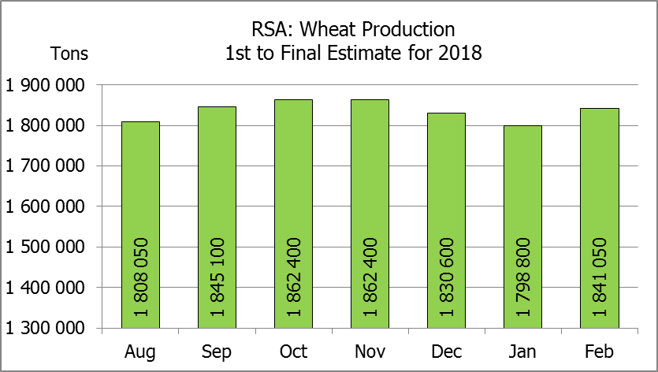
Hiermee word die oppervlakteskatting en finale produksieskatting vir wintergewasse vir 2018 vrygestel.
WINTER CEREALS – AREA PLANTED ESTIMATE AND FINAL PRODUCTION ESTIMATE: 2018
WINTERGEWASSE – OPPERVLAKTE- EN FINALE PRODUKSIESKATTING: 2018
CROP/GEWAS | Area planted/  Opp beplant  2018 | Final estimate/  Finale skatting  2018 | 6th forecast/  6de skatting  2018 | Area planted/  Opp beplant  2017 | Final crop/  Finale oes  2017 | Change/  Verandering
CROP/GEWAS | Ha | Tons | Tons | Ha | Tons | %
CROP/GEWAS | (A) | (B) | (C) | (D) | (E) | (B) ÷ (C)
Commercial/Kommersieel:
Wheat/Koring | 503 350 | 1 841 050 | 1 798 800 | 491 600 | 1 535 000 | +2,4
Malting barley/Moutgars | 119 000 | 421 790 | 421 790 | 91 380 | 307 000 | -
Canola/Kanola | 77 000 | 103 950 | 103 950 | 84 000 | 93 500 | 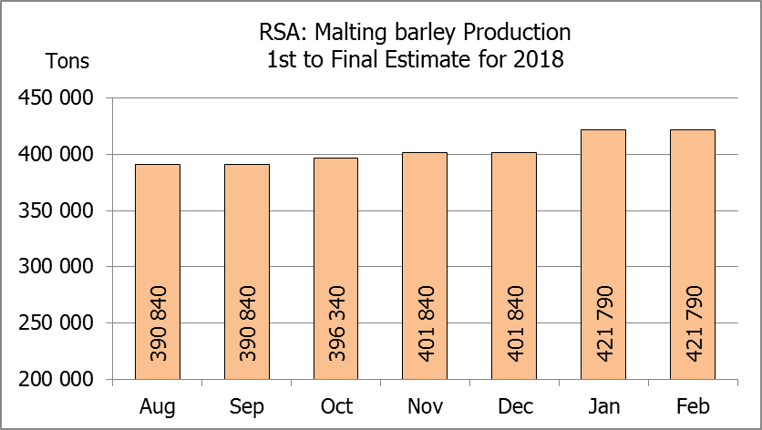  -
Total/Totaal | 699 350 | 2 366 790 | 2 324 540 | 666 980 | 1 935 500 | +1,8
* Note: Estimate is for calendar year, e.g. production season 2018 = 2018
* Nota: Skatting is vir kalenderjaar, bv. produksie-seisoen 2018 = 2018
WHEAT – AREA PLANTED ESTIMATE AND FINAL PRODUCTION ESTIMATE: 2018
KORING – OPPERVLAKTE- EN FINALE PRODUKSIESKATTING: 2018
Province/  Provinsie | Area planted/  Opp beplant  Ha | Final estimate/  Finale skatting  Tons | Area planted/  Opp beplant  Ha | Final crop/  Finale oes  Tons
Province/  Provinsie | 2018 | 2018 | 2017 | 2017
Western Cape/Wes-Kaap | 318 000 | 890 400 | 326 000 | 586 800
Northern Cape/Noord-Kaap | 38 000 | 294 500 | 38 000 | 311 650
Free State/Vrystaat | 100 000 | 360 000 | 80 000 | 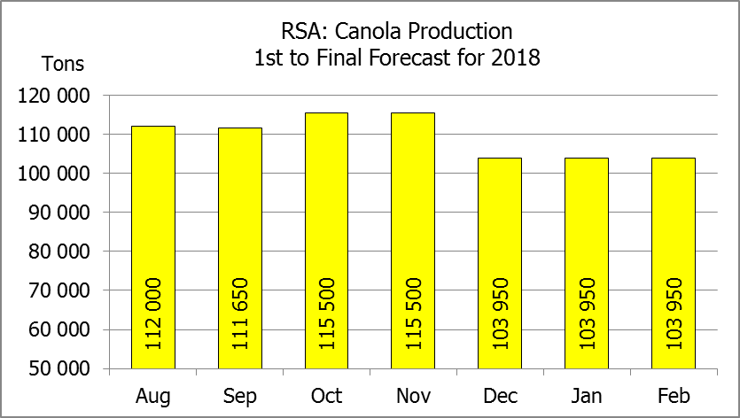  336 000
Eastern Cape/Oos-Kaap | 1 650 | 10 725 | 1 900 | 9 500
KwaZulu-Natal | 7 000 | 43 400 | 7 500 | 45 750
Mpumalanga | 3 500 | 22 225 | 4 000 | 25 400
Limpopo | 20 000 | 128 000 | 20 000 | 132 000
Gauteng | 1 200 | 7 800 | 700 | 4 200
North West/Noordwes | 14 000 | 84 000 | 13 500 | 83 700
Total/Totaal | 503 350 | 1 841 050 | 491 600 | 1 535 000

AREA ESTIMATE AND FINAL PRODUCTION ESTIMATE OF WINTER CROPS (2018) /
OPPERVLAKTESKATTING EN FINALE PRODUKSIESKATTING VAN WINTERGEWASSE (2018)
27 FEBRUARY / FEBRUARIE 2019
Winter cereal crops - 2018 production season  Wheat: The expected commercial production of wheat is 1,841 mill. tons, which is 2,35% or 42 250 tons more than the previous forecast of 1,799 mill. tons. The expected yield is 3,66 t/ha.  The area estimate for wheat is 503 350 ha.  Other crops: The production forecast for malting barley remained unchanged at 421 790 tons. The current crop of 421 790 tons is the highest crop ever produced in the RSA. The area planted is estimated at 119 000 ha, while the expected yield is 3,54 t/ha.  The expected canola crop remained unchanged at 103 950 tons. The area estimate for canola is 77 000 ha, with an expected yield of 1,35 t/ha.  Please note that the intentions to plant winter cereals for 2019 will be released on 25 April 2019. |  | Wintergewasse - 2018 produksie-seisoen  Koring: Die verwagte kommersiële produksie vir koring is 1,841 milj. ton, wat 2,35% of 42 250 ton meer is as die vorige skatting van 1,799 milj. ton. Die verwagte opbrengs is 3,66 t/ha.  Die oppervlakteskatting vir koring is 503 350 ha.  Ander gewasse: Die produksieskatting vir moutgars is onveranderd gelaat op 421 790 ton. Die huidige skatting van 421 790 ton is die hoogste oes nog ooit geproduseer in die RSA. Die oppervlakte beplant is beraam op 119 000 ha, terwyl die verwagte opbrengs 3,54 t/ha beloop.  Die verwagte kanola-oes is onveranderd gelaat op 103 950 ton. Die oppervlakteskatting vir kanola is 77 000 ha, met ŉ verwagte opbrengs van 1,35 t/ha.  Neem asseblief kennis dat die voorneme om wintergewasse te plant vir 2019 op 25 April 2019 vrygestel sal word.

Information is available on the internet at http://www.daff.gov.za/statistics and economic reports or http://www.sagis.org.za, as from 14:30 on the date of the relevant meeting of the Crop Estimates Committee. |  | Inligting is beskikbaar op die internet by http://www.daff.gov.za/statistics and economic reports of by http://www.sagis.org.za, vanaf 14:30 op die dag van die toepaslike vergadering van die Oesskattingskomitee.
CONFIDENTIALITY ISSUES that CEC members are committed to adhere to on the day of the meeting
- Personal items such as laptops, handbags, cell phones, etc. are not allowed in the venue during the meeting
- No member is allowed to leave the meeting before 12:00 in order to prevent disclosure of the information
- The embargo time for the release of crop estimates information is 14:30
- No member is allowed to discuss crop estimates information with anyone other than a member of the Committee before the embargo time
- Only the Chairperson, or a member appointed by the Chairperson, may release the figures to the media
- Members must regard the detail of any information that was collected for and/or discussed during the meeting, as confidential
- Individual information received for crop estimate purposes is treated strictly confidential, and is not divulged for any other purposes

