South African Grain Information Service NPC

INTRODUCING SAGIS

Background

The South African Grain Information Service (SAGIS), a non-profit company, was established on 11 November 1997, after the deregulation of the marketing and control boards in South Africa, to supply the grain and oilseeds industry with essential market information.

The four industries, which are served by SAGIS, are:
- Maize (white and yellow separate)
- Oilseeds (sunflower, soybean, canola & groundnuts)
- Winter cereal (wheat, barley & oats)
- Sorghum

Before deregulation the control boards of the four industries managed the information service. The Marketing of Agricultural Products Act, 1996 brought an end to single channel marketing and the control boards. Role-players, however, realised the importance of reliable information for the functioning of a free market and have co-operated to establish SAGIS.

The main goal of SAGIS is the gathering, processing, analysing and timeous distribution of reliable agronomic information to all role-players. SAGIS is also entrusted with other functions, for example the monitoring of import tariffs, audit certificates for minimum market access, etc.

How is SAGIS empowered to obtain information?
Market participants (co-workers), e.g., storers, processors, importers and exporters of above grains and oilseeds, are statutory compelled under the Marketing Act of Agricultural Products, Act 47 of 1996, to register with SAGIS and to submit information.
A co-worker that does not adhere to the requirements of the statutory measure is guilty of an offence and can be prosecuted. Fortunately co-workers realise the importance of reliable information and co-operates mostly by submitting returns timeously and regularly.

Number of market participants supplying information

The total number of co-workers changes continuously due to the entry of new market participants or the exit of existing firms that close their doors. The number of co-workers and number of returns that are submitted are published in the annual report of SAGIS. (A copy of the annual report is available on the web.)

Notwithstanding co-workers who are statutory compelled to supply information, various other partners provide information on a voluntary basis. This is used as a measure of control to evaluate the information for completeness and reliability before it is released.

Structures in which SAGIS is involved

- Forums

Market participants of each of the four industries established forums where role-players meet for matters of mutual interest, inter alia market information. With regard to information the forums make recommendations to:
- The NAMC regarding the needs of the industry and, if necessary, that SAGIS is to provide the function.
- The Trust of each industry concerning the funding of the function.

- Trusts

The Trusts of the four industries are registered as members of SAGIS and each Trust annually appoints two directors as well as one alternate director. SAGIS is also funded by the relevant Trusts.

- Directors

The Board of Directors gives the direction and the General Manager reports to the Board.

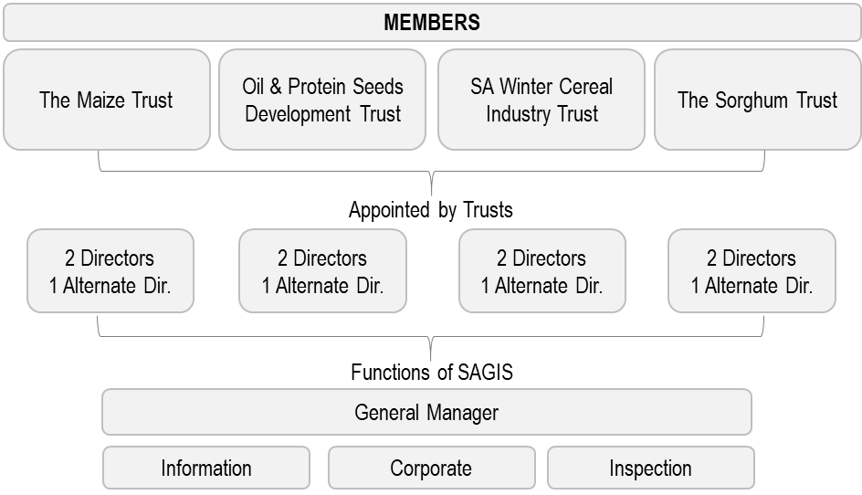

- Government institutions

SAGIS liaise and work close with different government bodies like ITAC, DALRRD, PDA’s, DTI, etc. on matters such as tariffs, crop estimates and the supplying of market information.

- The structures of SAGIS

The main functions of SAGIS are executed by the following departments:
- Information: Gather, process, analyse and disseminate information.
- Inspection: Stocktaking and auditing of the information received to verify for the correctness, completeness, consistency and reliability.
- Corporate: Administration, finances and personnel matters.

- Sundry external structures

There are several external structures, such as the associations of role-players (e.g., AGBIZ Grain, NCM, SACB, Grain SA, etc.), harbour authorities, Spoornet, consultants, research institutions, etc. with which SAGIS regularly liaises.

Data and information provided by SAGIS

Here under is some of the information / data released to role-players and published on the SAGIS website:

- Monthly data (Whole grain & oilseeds). This includes:
- Monthly data
  - Producer deliveries (per province)
  - Imports & Exports
  - Utilization (Human, Animal feed & Industrial)
- Grain Transport per component

- Monthly products data – Manufactured, Imports and Exports (maize, wheat and oilseeds)

- Weekly information:
- Imports and Exports (Wheat & Maize)
- Intentions to import and export (Maize & Wheat)
- Producer deliveries (Wheat, Maize, Sunflower seed & Soybeans)

- Import tariffs on wheat and maize

- Parity prices

- Historic Information (SAGIS and Non-SAGIS) - Some data dates back as far as 1936
- Producer deliveries, Consumption, Imports and Exports
- Historic summary: Hectares & Production
- Price Information
- Parity prices
- Population data

- Weekly Bulletin: A collection of local and international information such as prices, stock, import parity prices, etc.

The Monthly data and Weekly Bulletin are distributed on request, but the information is published on the website.

Reliability and integrity of information

Various actions are continuously executed to verify the reliability of the information. These actions include, inter alia:

- Internal control measures
Controls and cross references on the returns and in the computer system as well as internal audits:
Verifying information with data obtained from sources that are not statutory compelled (e.g., harbour authorities, WFP, PPECB, Spoornet, DTI, etc.).

- External control measures
Auditing of the source documents of co-workers and stocktaking by the inspectors of SAGIS, as well as continuous negotiations with possible external sources to participate.

- Sundries
The stock figures of SAGIS are the physical stock stored in commercial structures at a given point in time. This stock is not necessarily available for marketing as it might include whole grain/oilseeds that have already been contracted.

The Crop Estimates Committee (CEC) of the Department of Agriculture Land Reform and Rural Development (DALRRD) is responsible for the national crop estimates. This can, for various reasons, differ from SAGIS' producer deliveries. SAGIS' producer deliveries represent deliveries by producers in commercial structures on premises of co-workers registered with SAGIS and, therefore, do not include retentions on farms.

Users of SAGIS data / information

The users of SAGIS information can be categorised mainly into three sectors:

- Primary producers
- What to plant?
- Input management?
- How much to plant?
- When to market and how much?
- What prices can be expected?
- Traders / processors
- Availability of local products
- Imports / exports planning
- Policy makers
- Trade agreements
- Food security
- Development of new producers
Contact details
Office hours of SAGIS are Monday to Friday, from 07:00 until 16:00.

Postnet Suite 534, Private Bag X1, The Willows, 0041  Grain Building, 2nd Floor  477 Witherite Street, The Willows, 0040 | Tel +27 (12) 941 2050  Fax +27 (12) 349-9200  E-Mail: info@sagis.org.za  Web address: http://www.sagis.org.za

For informed decision making

